primerJinn – a tool for rationally designing multiplex PCR primer sets and in silico PCR.

Jason D Limberis^{1*}, John Z Metcalfe¹
¹Division of Pulmonary and Critical Care Medicine, Zuckerberg San Francisco General Hospital and Trauma Centre, University of California, San Francisco, San Francisco, CA, USA

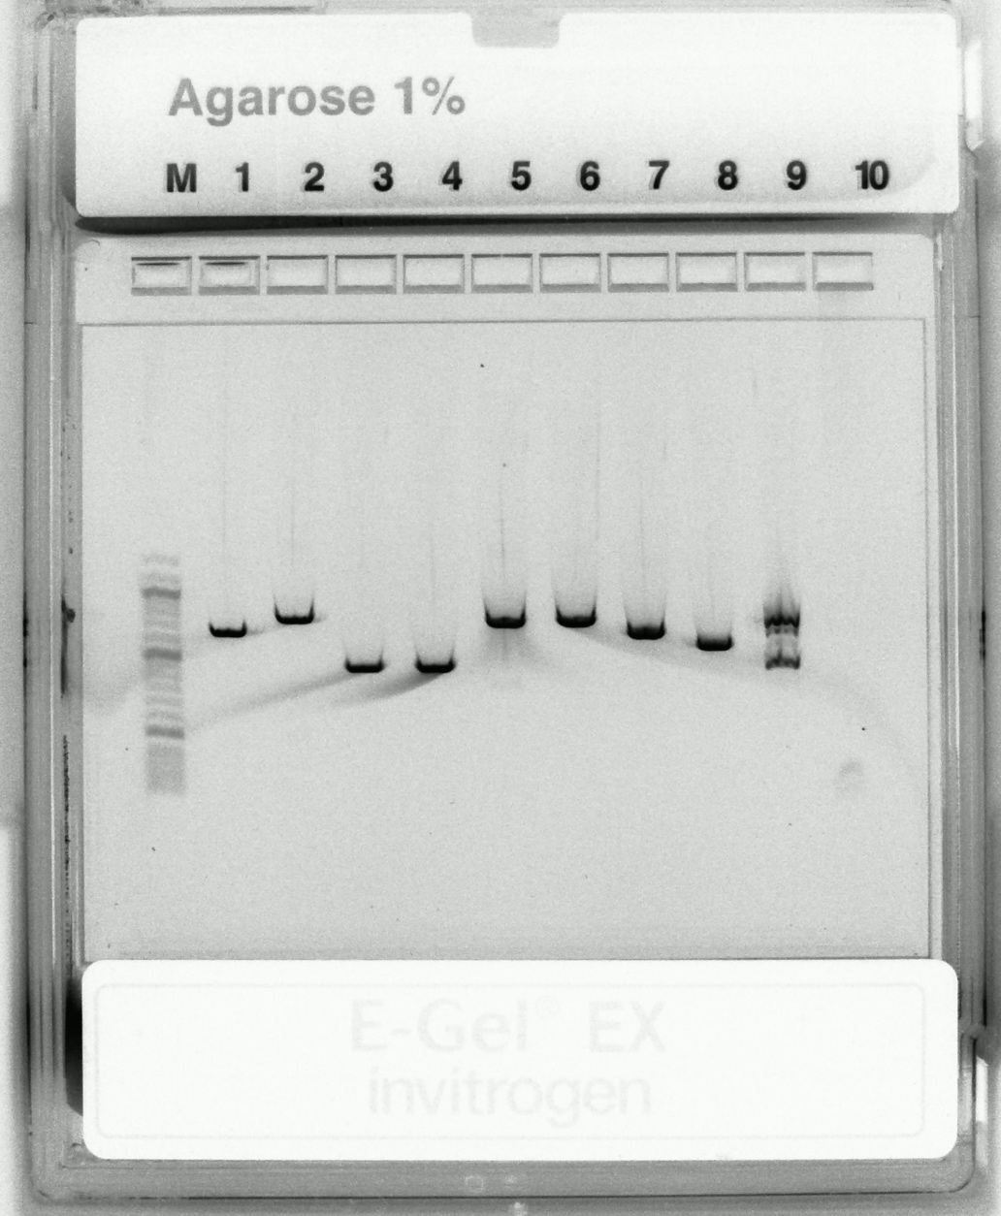

Figure S1: Uncropped electrophoresis gel as shown in Figure 1.

