Methods for supplemental materials
GFP examination
Lentiviral transfection efficacy was visualized using GFP expression once puromycin-selected cultures began propagating. Brightfield, GFP, and merge images were acquired on the BioRad ZOE imager.
CyQuant proliferation assay
Proliferation kinetics were quantified using CyQuant Red per manufacturer's instructions. EVEC and shFXN hBMVEC were seeded at 5,000 cells per well of a 96-well plate and left to adhere for 24 hours. At 24-, 48-, 72-, and 96-hours post-plating, cells were incubated with the nuclear dye and background suppressor in growth media per manufacturer instructions for 1hr at 37°C. Cell abundance as represented by RFU was quantified at 622nm excitation and 645nm emission, respectively on the Cytation5 (Biotek). Cell proliferation as a function of time was calculated by normalizing each day to the “starting” concentration of the 24hr timepoint. A linear regression equation was fit to the growth curve to determine the kinetics of cell growth of each line, and the slopes compared.

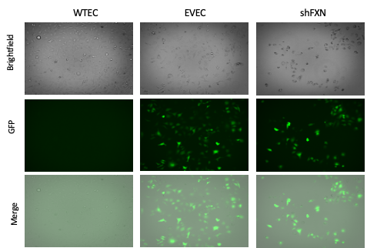

Supplemental Figure 1. GFP expression confirms integration of lentivirus. GFP is absent in non-transfected Wild-Type Endothelial Cells (WTEC) but present in lentiviral-transfected Empty Vector Endothelial Cells (EVEC) and shFXN.

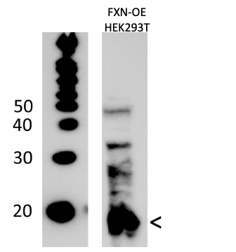
Supplemental Figure 2. Validation of FXN antibody. 20µg FXN-overexpression HEK293T lysate is electrophoresed and probed for FXN for validation of bands evident with α-FXN primary antibody (Thermo Fisher PA5-13411). The ~18kDa major band designated by the arrowhead is used for protein expression analysis in our experiments.

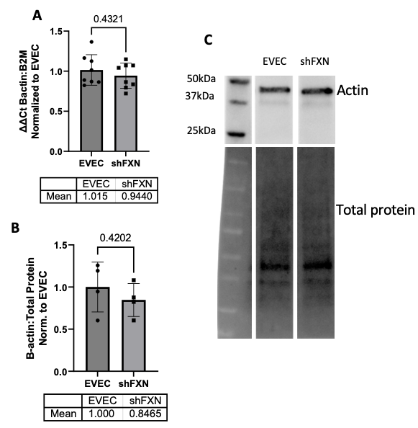
Supplemental Figure 3. Loss of F-actin in shFXN hBMVEC is not due to transcriptional or translational defects. (A) hBMVEC RNA was reverse transcribed and amplified for β-actin and Beta-2-microglobulin (B2M) as a housekeeping control, transcript abundance was quantified using the ΔΔCt method normalized to the empty vector endothelial cells (EVECs). (B) Total protein lysates were electrophoresed, transferred to PVDF, and quantified for total protein using stain-free technology. The blot was probed for α-β-actin and normalized to total protein. Band intensity is quantified by densitometry and further normalized to the values of the EVEC controls. (C) Representative blot shown. (A) EVEC and shFXN; n= 8. (B) EVEC and shFXN; n=4.

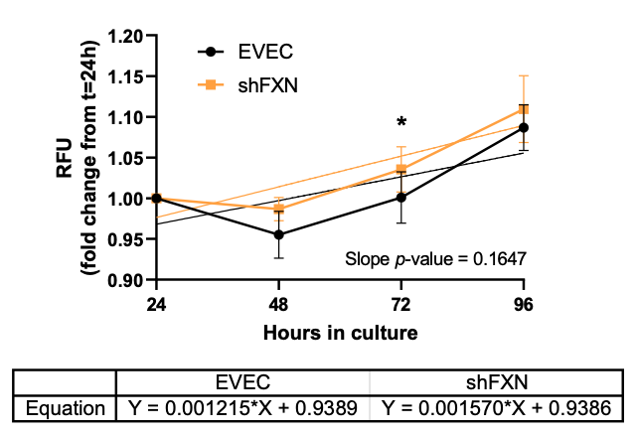
Supplemental Figure 4. shFXN are not proliferatively deficient. hBMVEC are plated at 5,000 cells per well and quantified for nuclear content at 24-, 48-, 72-, and 96-hours post-plating using CyQuant Direct Red (ThermoFisher). All following days are normalized to the starting concentration at 24hr for a growth curve. The linear portion of the curves (48-96hr) are analyzed via linear regression (shown with dotted lines), with statistical comparison of slope values. Student’s T-test α =0.05; ns = not significant, * p < 0.05. EVEC; n= 14 and shFXN; n= 16.

