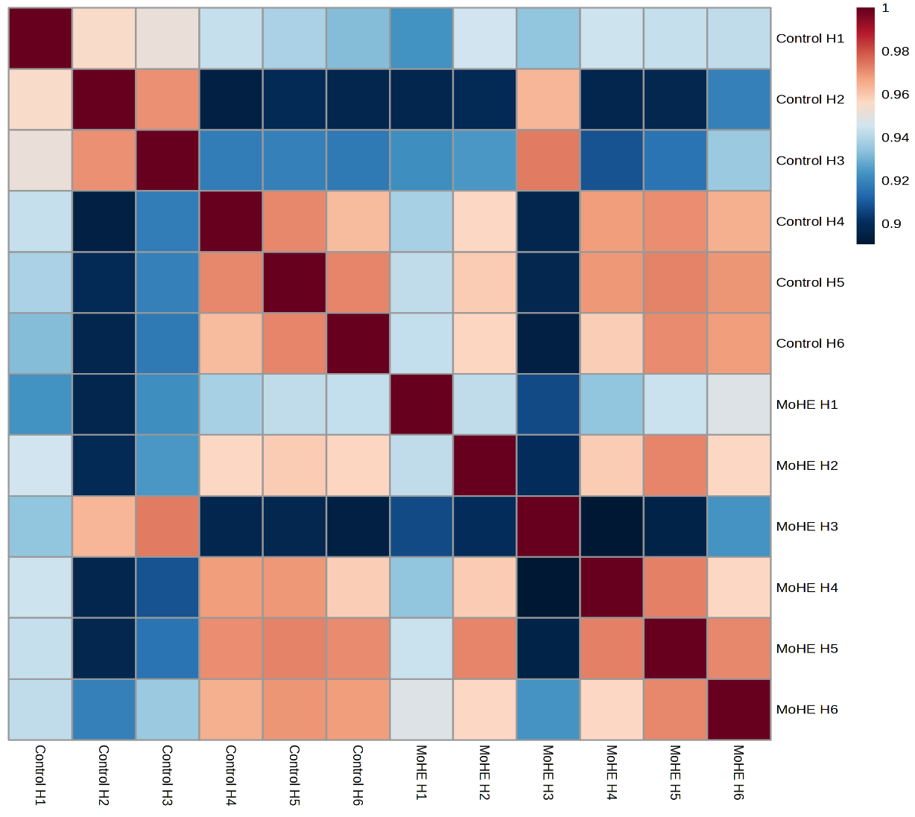
Supplementary Fig. S1 SDS-PAGE followed by Coomassie brilliant blue gel-stained photographs showing protein quality of Control and MoHE hippocampal protein samples.

Supplementary Fig. S2 showing the overall correlation heatmap.

Supplementary Table 1 (Primer details)
FAK1 | Forward primer | CTTCAAGTGTGCCCTTGGGT
FAK1 | Reverse primer | CCGCTAGGTGTGTGGGATTG
TSPAN2 | Forward primer | CCAGGCCACAAGAATTGCAT
TSPAN2 | Reverse primer | AGACCCGCAATCCCAATACC
CD9 | Forward primer | CAGCGGGAAACACTCAAAGC
CD9 | Reverse primer | CATCCGGGCAGGACTTAACC
GAPDH | Forward primer | CTGAGGAGTCCCCATCCCAA
GAPDH | Reverse primer | TGGTATTCGAGAGAAGGGAGGG

