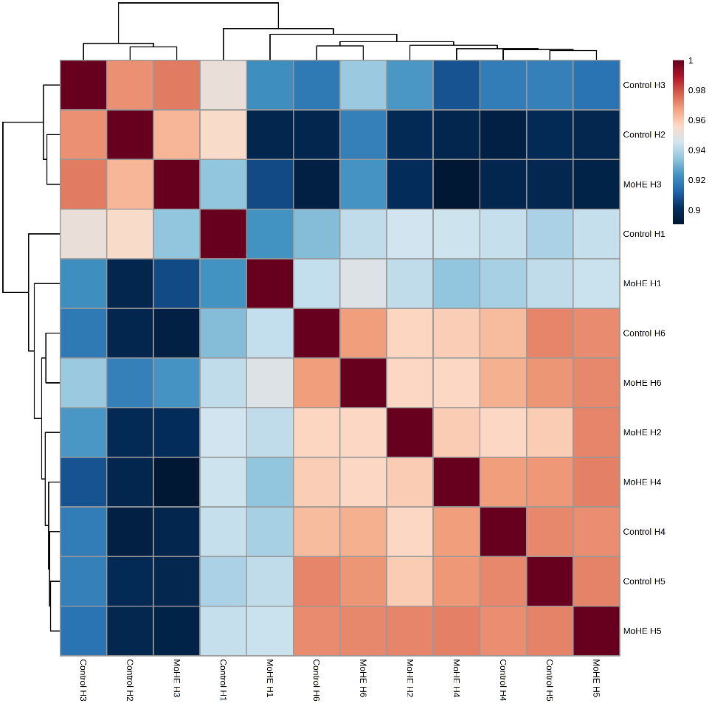
Supplementary Fig. S1 SDS-PAGE followed by Coomassie brilliant blue gel-stained photographs showing protein quality of Control and MoHE hippocampal protein samples.

Supplementary Fig. S2 showing the overall correlation heatmap.

Supplementary Fig. S3a
Supplementary Fig. S3b

Supplementary Table 1
(Primer details)
FAK1 | Forward primer | CTTCAAGTGTGCCCTTGGGT
FAK1 | Reverse primer | CCGCTAGGTGTGTGGGATTG
TSPAN2 | Forward primer | CCAGGCCACAAGAATTGCAT
TSPAN2 | Reverse primer | AGACCCGCAATCCCAATACC
CD9 antigen | Forward primer | CAGCGGGAAACACTCAAAGC
CD9 antigen | Reverse primer | CATCCGGGCAGGACTTAACC
GAPDH | Forward primer | CTGAGGAGTCCCCATCCCAA
GAPDH | Reverse primer | TGGTATTCGAGAGAAGGGAGGG

Supplementary Table 2
(List of significantly dysregulated proteins)
S.N. | Protein ID | Protein names | FC | log2(FC)
1 | O88801 | Homer protein homolog 2 | 20.344 | 4.3465
2 | Q99P39 | Cysteine desulfurase | 2.7283 | 1.448
3 | Q62764 | Y-box-binding protein 3 | 2.5184 | 1.3325
4 | Q5FWU3 | Autophagy-related protein 9A | 2.4077 | 1.2676
5 | O35346 | Focal adhesion kinase 1 | 2.4014 | 1.2639
6 | P40241 | CD9 antigen | 2.2943 | 1.198
7 | Q9JJW1 | Tetraspanin-2 | 2.2343 | 1.1598
8 | Q64566 | Calcium-transporting ATPase type 2C member 1 | 2.2249 | 1.1538
9 | P02091 | Hemoglobin subunit beta-1 | 2.2184 | 1.1495
10 | P20156 | Neurosecretory protein VGF | 1.9162 | 0.93823
11 | P24090 | Alpha-2-HS-glycoprotein | 1.898 | 0.9245
12 | Q9JKC9 | Synergin gamma | 1.898 | 0.9245
13 | Q8VHF0 | MAP/microtubule affinity-regulating kinase 3 | 1.7939 | 0.84306
14 | Q63488 | Sodium-dependent phosphate transporter 2 | 1.5882 | 0.66738
15 | P01946 | Hemoglobin subunit alpha-1/2 | 1.5752 | 0.65551
16 | Q5PQN0 | Neurocalcin-delta | 1.5433 | 0.62603
17 | P08050 | Gap junction alpha-1 protein | 1.542 | 0.62481
18 | Q75Q41 | Mitochondrial import receptor subunit TOM22 homolog | 1.5414 | 0.62426
19 | D3ZFD0 | Unconventional myosin-XVIIIa | 1.517 | 0.6012
20 | Q63327 | Myelin-associated oligodendrocyte basic protein | 1.5161 | 0.60039
21 | P04631 | Protein S100-B | 1.4937 | 0.57887
22 | Q6MFY6 | E3 ubiquitin-protein ligase PPP1R11 | 1.4817 | 0.56723
23 | Q99P82 | Claudin-11 | 1.4816 | 0.56712
24 | Q4FZT2 | Protein phosphatase methylesterase 1 | 1.4443 | 0.53038
25 | B0BNN3 | Carbonic anhydrase 1 | 1.4416 | 0.5277
26 | P60203 | Myelin proteolipid protein | 1.4343 | 0.52034
27 | Q5M7W7 | Probable proline--tRNA ligase | 1.4127 | 0.4985
28 | P97846 | Contactin-associated protein 1 | 1.394 | 0.47927
29 | Q9ESV1 | Leucine zipper protein 1 | 1.3794 | 0.46408
30 | P17475 | Alpha-1-antiproteinase | 1.3707 | 0.45486
31 | Q99376 | Transferrin receptor protein 1 | 1.3599 | 0.44346
32 | P47727 | Carbonyl reductase | 1.3533 | 0.43652
33 | P07722 | Myelin-associated glycoprotein | 1.3529 | 0.43606
34 | O70352 | CD82 antigen | 1.3453 | 0.42797
35 | Q9Z1Y3 | Cadherin-2 | 1.3361 | 0.41804
36 | Q00566 | Methyl-CpG-binding protein 2 | 1.3222 | 0.40294
37 | Q8VHW5 | Voltage-dependent calcium channel gamma-8 subunit | 1.3177 | 0.39806
38 | P04218 | OX-2 membrane glycoprotein | 1.2809 | 0.35717
39 | P30349 | Leukotriene A-4 hydrolase | 1.2747 | 0.35017
40 | P62836 | Ras-related protein Rap-1A | 1.2661 | 0.34034
41 | Q06647 | ATP synthase subunit O, mitochondrial | 1.264 | 0.33799
42 | B0K020 | CDGSH iron-sulfur domain-containing protein 1 | 1.2552 | 0.32796
43 | Q9R0J8 | Legumain | 0.60482 | -0.72541
44 | Q03626 | Murinoglobulin-1 | 0.44709 | -1.1614
45 | P42930 | Heat shock protein beta-1 | 0.42491 | -1.2348
46 | P14046 | Alpha-1-inhibitor 3 | 0.33774 | -1.566
47 | P07150 | Annexin A1 | 0.17994 | -2.4744

