Original western blots
Original western bolts of Figure 4I
p-Akt ser⁴⁷³ 60kDa
t-Akt 60kDa
β-actin 42kDa
Original western bolts of Figure 4J
p-Akt ser⁴⁷³ 60kDa
t-Akt 60kDa
β-actin 42kDa
Original western bolts of Figure 4L
p-Akt ser⁴⁷³ 60kDa
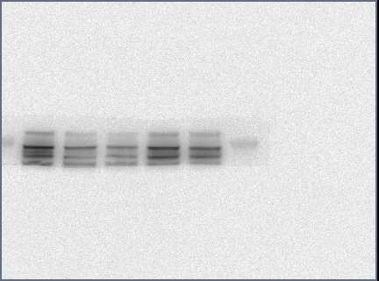
t-Akt 60kDa
β-actin 42kDa
Original western bolts of Figure 5I
p-Akt ser⁴⁷³ 60kDa
t-Akt 60kDa
β-actin 42kDa
Original western bolts of Figure 5J
p-Akt ser⁴⁷³ 60kDa
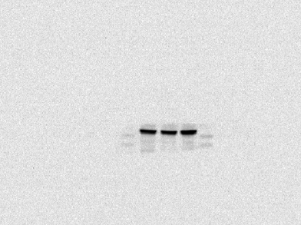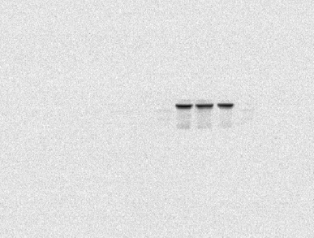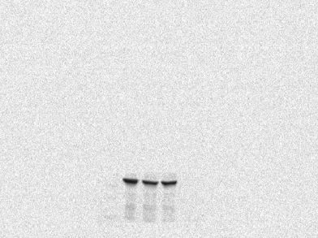
t-Akt 60kDa
β-actin 42kDa

