Graphical Abstract

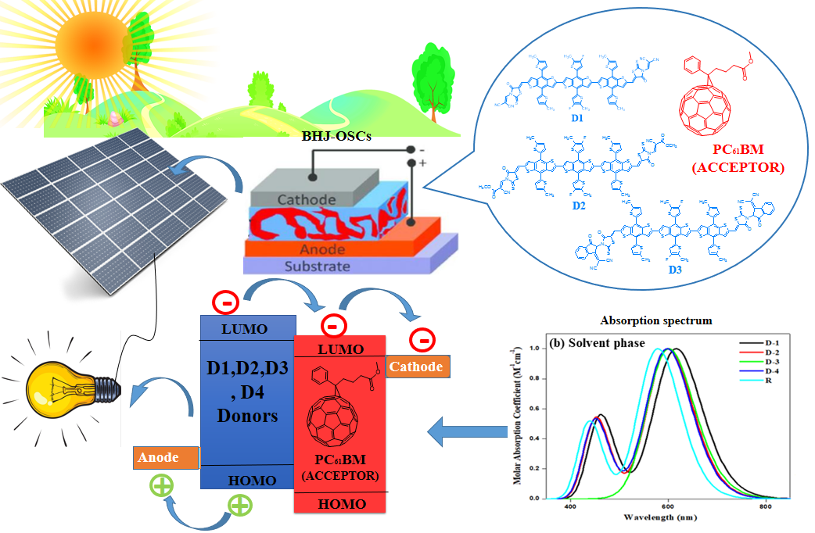

Figure. All the architecture molecules show reduced band gap and high electron transfer rate due to lowest reorganization energy (RE) of electron. The results show that there is greater contribution of acceptor and conjugated donor core towards the total absorption into visible region of the spectrum. When tailored molecules D-1, D-2, D-3 and D-4 were blended with fullerene derivative polymer (PC₆₁BM), they give high values of voltage at zero current level (V_{oc}) compared to R.

