ASAP: an automatic sequential assignment program for solid state multidimensional NMR spectra
Bo Chen
Department of Physics, University of Central Florida, Orlando, 32816 USA
Bo.chen@ucf.edu
ORCID: 0000-0001-5589-2075

Keywords Sequential assignment · NMR · multidimensional spectroscopy

Figure 1. Snapshot of the summary report by ARTIST match pairing.

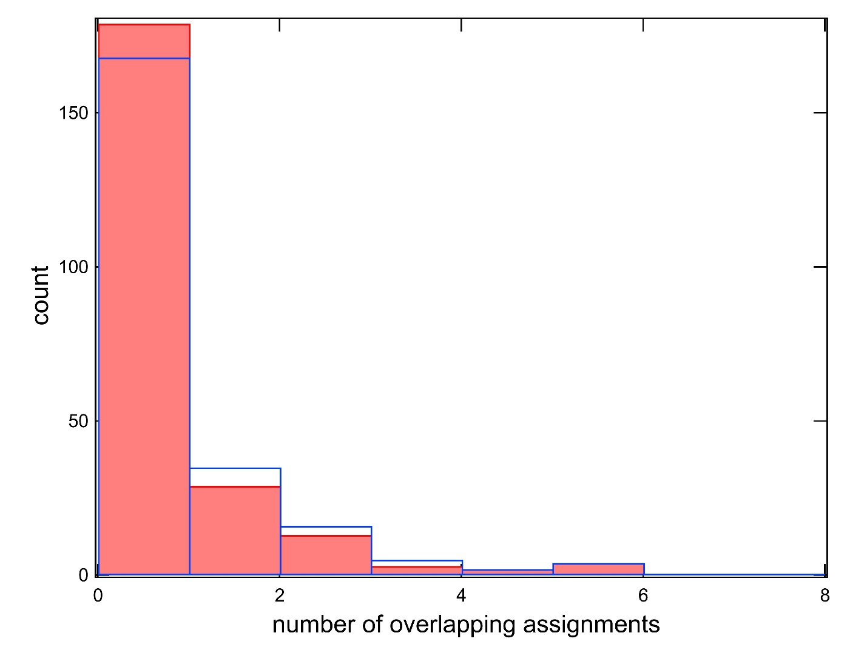
Figure S2. Histogram of the number of residue type assignment matched pairs with overlapping ¹⁵N resonances and sufficiently different secondary chemical shifts. Red filled bars: results from ncacx_1 with entirely non-ambiguous residue type assignments. Blue empty bars: results from ncacx_1 with 40 ambiguous residue type assignments for EDNQ.

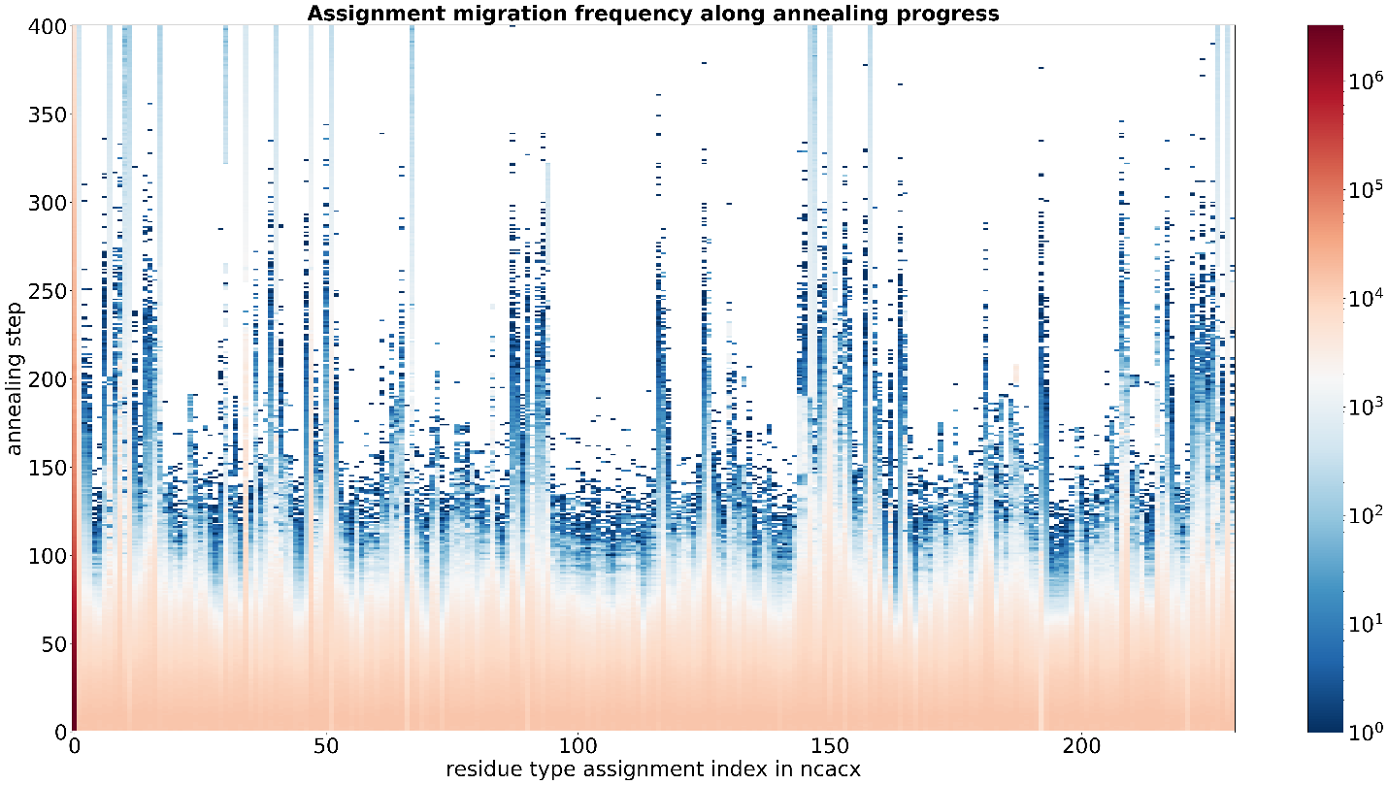
Figure S3. Re-allocation frequency of each residue type assignment in ncacx_1 as a function of annealing progress. The scale bar to the right denotes the re-allocation frequency.

Figure S4. Re-allocation frequency of each residue position at specified annealing step in A and B, and residue type assignments (asgn) seated at neighboring positions at specified annealing step in C and D. The scale bars to the right denote the re-allocation frequency.

Figure S5. Re-allocation frequency of each residue position at specified annealing steps for run 5-8 (from A to D) in Table 1.

Figure S6. Re-allocation frequency of each residue position at specified annealing steps for run 10 in Table 1 (without ambiguity in input) in (A) and run 6 in Table S1 (with ambiguity in input) in (B).

Shifted assignments sets | ¹⁵N resonance | ¹³C-alpha resonance | ¹³C-beta resonance | Allocated positions | Ambiguity in input
 | 122.6 | 54.99 | 19.04 | A72 | No
 | 122.3 | 54.51 | 18.02 | A131 | Yes
 | 119.1 | 60.5 | 38.1 | I172 | Yes
 | 119 | 66.08 | 38.63 | I35 | No
 | 134.4 | 64.9 | NAN | P63 | Yes
 | 134.8 | 65.0 | NAN | P152 | No
 | 107.7 | 44.46 | NAN | G94 | Yes
 | 107.7 | 44.5 | NAN | G30 | No
Table S1. Shifted assignments due to ambiguity in input that are not seated at the edge of a stretch of assignments with good connections.

Figure S7. Consistently allocated assignments obtained by the third iterations of ASAP run 3 in Table 3 vs those obtained by run 10 in Table 1. The y coordinates are the allocated residue positions of consistently allocated assignments in run 3 in Table 3. The x coordinates are the allocated positions of consistently allocated assignments in run 10 in Table 1. The 6 shifted assignments are either implicated with type 2 local minima, or sitting at the edge of a continuous stretch of good assignments, probably due to insufficient sampling.

