Supporting Information

Molecular Bonding Regulated Defect Passivation for Modulating Efficiency and Stability of Methylammonium Free Inverted Perovskite Solar Cells

4. Experimental Section

Materials and precursor solution:
All chemicals were purchased from commercial suppliers as mentioned and unless otherwise specified, they were used as received. Formamidinium iodide (FAI, GreatCells), 1,4-phenylenediamine dihydriodide (PEDAI, TCI, $>$98.5%), piperazine dihydriodide (PZDAI, TCI, $>$98.5%). PbI₂ (Wako Chemicals, $>$98.5%), [2-(3,6-Dimethoxy-9H-carbazol-9-yl) ethyl] phosphonic Acid (MeO-2PACz) (TCI), C₆₀ (TCI, 99%), and Bathocuproine (BCP) (Sigma Aldrich, 99% purity) were purchased and used as received. We used NiO_{x} target (purity >99.9%) from Kojundo Chemical Laboratory Co. Ltd, Japan.
Fabrication of MA-free HP; FA_{0.84}Cs_{0.12}Rb_{0.04}PbI₃:
MA-free halide perovskite: the precursor solution (1.05 M) was prepared by dissolving FAI (0.84 M), CsI (0.12 M), RbI (0.04 M), PbI₂ (1 M), and 5-AVAI (1 mM) in the mixture of dimethylformamide (DMF), and dimethyl sulfoxide (DMSO) (4:1) solvent for two hours at 60 ºC temperature. For film deposition, the precursor was spin-coated at 1000 rpm for 10 s (ramping slope 2sec) and 5000 rpm for 40 s followed by dripping 800 $μl$ of CB at 35th second of second step. Then to promote the crystallization, those as-grown films were simply placed on a hot plate at 60$℃$ for 1 min subsequent with further annealing at 100$℃$ for 45 min. For surface treatment strategy, the PEDAI or PZDAI precursor solutions of different concentration were prepared by dissolving in isopropyl alcohol (IPA) at 60 ºC for 2 h. For surface passivation, the PEDAI or PZDAI solutions were spin-coated onto the HP film at 5000 rpm for 40 s (ramping slope 3sec) and annealed at 100$℃$ for 5 min.
Perovskite solar cell Fabrication:
Solar cell devices were fabricated on pre-cleaned patterned indium tin oxide (ITO) coated glass substrates (15 Ω square^{–1}). The ITO substrates (4.5 cm $×$3.5 cm) were pre-cleaned in an ultrasonic bath with detergent, pure water, and 2-propanol, followed by an ultraviolet-ozone treatment for 5 min to remove the organic residuals. The NiO_{x} (~20 nm) film was deposited by sputtering as mentioned in our earlier reports.¹ In brief, the pre-cleaned ITO substrates were loaded in the deposition chamber and evacuated until <2$×$10⁻³ Pa then pure argon gas was introduce at the rate of 20 sccm. The NiO_{x} deposition was carried out in an argon gas pressure of 3.5 Pa and rf power supply of 150 W for 7 min at room temperature. Then substrates were transferred into a nitrogen-filled glove box (<1.0 ppm O₂ and H₂O) and the rest of the steps were carried out inside the glove box. The sputtered NiO_{x} thin film was treated with MeO-2PACz (0.1 weight% in ethanol) by spin coating at 5000 rpm for 50 s and subsequently dried at 100 $℃$ for 10 min on a hot plate. The target films were prepared with PEDAI or PZDAI treatment as described above. The C₆₀ (26-28 nm at 0.1Å/s) layer was deposited by thermal evaporation as electron transport layer (ETL). After that, the electron selective layer (ESL), BCP (5-6 nm, at 0.01 Å/s) was deposited on by evaporation at base pressure of ~2x10⁻⁴ Pa. Then, to complete the device structure, samples were then transferred into the evaporation chamber connected to the glove box for metal contact deposition. Finally, 140 nm of Ag was thermally evaporated at a pressure <10⁻⁴ Pa. Four devices in ITO substrate (4.5 cm $×$3.5 cm) with an active device area of ~1.26 x 1.26 cm² were sealed using UV-curable resins before the subsequent measurements in ambient conditions.

Materials and device Characterizations:
In NIMS Battery Research Platform facilities, X-ray diffraction (XRD) patterns of fabricated MA-free-HP films were collected using an advanced x-ray diffractometer (Rigaku SmartLab, CuK_{α} radiation, λ = 1.54050 A). X-ray photoelectron spectroscopy (XPS) spectra were obtained using a Versa Probe II (ULVAC-PHI, Japan). Perovskite film samples for XPS measurements were prepared in an N₂-filled glove box and transferred to the XPS chamber through an N₂-filled transfer vessel in order to avoid oxygen contamination. XPS with a nonmonochromatic source was measured (Al Kα; 1486.6 eV, spot size 10-300 μm) at a pass energy of 187.85 eV (1.5 eV step size) for the survey scan and pass energy 46.95 eV (0.1 eV step size) for the fine scan with spot size 100 μm. The XPS spectra were calibrated with the binding energy of 284.8 eV for C1s.
In NIMS Namiki foundry research facilities and category-3 shared facilities, the morphology of films and cross-sectional images were taken by a high-resolution scanning electron microscope (SEM) at 5 kV accelerating voltage (Hitachi, S-4800). The photoluminescence (PL) spectra were collected using micro-PL spectrometer (HORIBA, LabRamHR-PL NF(UV-NIR)) ∼532 nm laser diode (10 mWcm⁻²) as an excitation source. The carrier lifetimes were measured with a fluorescence lifetime spectrometer (Quantaurus-τ from Hamamatsu-Photonics K.K., C11367) equipped with ∼405 nm laser diode (typical peak power of 400 mW) at 200 kHz repetition rate. The absorption spectra films were measured using UV-Vis-NIR spectrometer (UV-2600i, Shimadzu). The absorption spectra and photoluminescence (PL) spectra of various films were measured using UV-Vis-NIR spectrometer (UV-2600i, Shimadzu). The band structure of the film was measured using Ultraviolet photoelectron spectroscopy (UPS, Thermo Fisher Scientific, Inc.) with a He I line (21.22 eV) from a helium discharge lamp.
The samples for transmission electron microscopy (TEM) were prepared by using a focused ion beam (FIB) technique (JEOL, JIB-4501) inside a glove box. Before the sample preparation with the FIB, we deposited a thin layer of osmium and carbon on the top of the sample (Ag layer peeled off) to protect it from damage during milling. Sample extraction was performed with an FIB accelerating voltage of 30 kV and a current of 800 pA. Once the lamella was extracted and welded on the Mo grid, it was thinned to electron transparency at 10 kV and 10 pA. The SEM accelerating voltage was kept at 5 kV for the entire process. The TEM samples were about 50–60 nm thick. The finished TEM was immediately transferred for TEM analysis to limit overall exposure to air to <2 min. STEM/EDX was carried out at room temperature (~300 K) using an analytical TEM (JEOL JEM-ARM200F for HR, a 200 kV acceleration voltage) equipped with a cold-field emission gun and a JEOL EDX detector. To minimize the damage from the electron beam, we limited the exposure time to within 5 s in every TEM observation.
Time-of-flight secondary ion mass spectrometry (ToF-SIMS) measurements were carried out using a ToF.SIMS 5 (ION-TOF GmbH) instrument equipped with a 60 keV and pA current Bi²⁺ beam for analysis and a 10 keV and nA current Ar gas cluster ion beam (Ar-GCIB) for sputtering in non-interlaced mode to have minimal interfacial mixing. The sputtered area was 700 × 700 μm² and the analysis area was 100 × 100 μm².
The current density–voltage (J–V) curves were measured at the scan rate of 0.05V/s under 1 sun with an AM1.5G spectral filter (100 mW/cm²) coupled with an MPPT system (Systemhouse Sunrise Corp.). Each device efficiency was confirmed under MPPT for two minutes tracking. The light intensity was calibrated by a silicon (Si) diode (BS-520BK). For the stability test, the encapsulated devices were measured at MPPT conditions. The devices were kept under 1-Sun intensity under MPPT conditions (elevated temperature, 60 $±$ 5 °C, relative humidity, 30–35% RH and ~35$±$ 5 °C; 60–65% RH, RT) during device stability monitoring (Bunkoukeiki Corp. BIR-50 solar cell light resistance test system, incubator type 50$×$50 mm irradiation, Systemhouse Sunrise Corp.). The external quantum efficiency (EQE) spectra were obtained using a spectrometer (SM-250IQE, Bunkokeiki, Japan).
The transient photovoltage was measured using a commercial PAIOS system (PAIOS V.4.3). A pulse intensity was used to induce a spike in photovoltage. The capacitance spectra (C-f) were taken from PAIOS v. 4.3 software, which scans from 20 Hz to 2 MHz at 30 mV AC in the dark at a bias voltage of 0 V. The C–V measurements were taken at 10 kHz with a voltage amplitude of 30 mV AC in the dark. The scan frequency is determined from the plateau region (corresponds to C_{g}) of the capacitance-frequency spectra C-f scan at zero bias. The thermal capacitance spectra (C-f-T) were measured using an LCR meter (IM3536, Hioki), voltage amplitude of 30 mV under dark conditions in the temperature range of 253 K−353 K. The temperature was varied by using the controlled chamber (SU-221) (±0.1 K).

Solar Cell certification. Device certification was obtained from The National Institute of Advanced Industrial Science and Technology (AIST), Japan. It is registered as ISO / IEC 17025 accreditation laboratory (IAJapan ASNITE 0021 Calibration) according to international mutual recognition arrangements (MRA) for ILAC and APAC.

Theoretical and computational methods.
Density functional theory (DFT) calculations have been performed using the fully constrained meta-generalized-gradient approximation (meta-GGA) SCAN² for the exchange−correlation functional and the projector-augmented wave (PAW) formalism as implemented in the Vienna ab initio simulation package (VASP).^{3,4} This approximation has previously demonstrated a remarkable accuracy for the description of lattice constants and weak interactions in a large diversity of bonded molecules and materials,^{2,5} which is especially important for the investigation of the complicated process of molecular adsorption and passivation of perovskite surfaces. The pseudo-cubic structure of the model FAPbI₃ bulk was optimized using the regular Γ-centered 6×6×6 k-point mesh for Brillouin zone sampling. The energy cutoff of 500 eV for the plane wave basis set and the convergence criterion of 10⁻⁶ eV for the self-consistent loop were employed. The optimized lattice parameters of the pseudo-cubic FAPbI₃, a = 6.4782 Å, b = 6.3080 Å, c= 6.4012 Å are in good agreement with an experimentally observed cubic unit cell of dimension ∼6.36 Å.⁶ The optimized lattice of bulk FAPbI₃ was used to construct 2x2 slab of PbI₂-terminated surface (001) with five PbI₂ layers and a vacuum region of ~25 Å. Two top PbI₂-FAI bilayers were fully relaxed, while the atoms in the bottom layers were frozen. For the Brillouin zone sampling of the slab, the Γ-centered 3×3×1 and 6×6×1 k-point meshes have been used for structural relaxations and DOS calculations, respectively.
The adsorbed PEDAI and PZDI molecules have been optimized on the perovskite surface, where all atoms in the molecules and two top PbI₂-FAI bilayers were fully relaxed until forces were <0.01 eV Å⁻¹. The binding energy of the molecule to the surface was evaluated from the change in Gibbs free energy as $E_{b}=-{(∆E}_{el}-T∆S+{∆E}_{ZPE})$. Here ${∆E}_{el}= E_{passivated surface}-\left(E_{surface}+E_{mol}\right) ,$ where $E_{passivated surface}$ is the total energy of the passivated surface, while $E_{surface}$ and $E_{mol}$ are energies of the free surface and the isolated PEDAI or PZDI molecule, as follows from DFT calculations. T is the temperature of the system taken equal to 293 K, $∆S$ is the change of entropy upon molecular adsorption, and ${∆E}_{ZPE}$ is the change in zero-point energy. To estimate the change in entropy, we have used the ideal gas approximation for the free molecules as implemented in Gaussian 09^{[15]} and considered S = 0 for the adsorbed molecules, because they are immobilized on the surface, losing the translational and rotational degrees of freedom. The zero-point energy $E_{ZPE}$ has been calculated by summation of the vibrational frequencies $ω_{ν}$ over the normal modes $ν$:
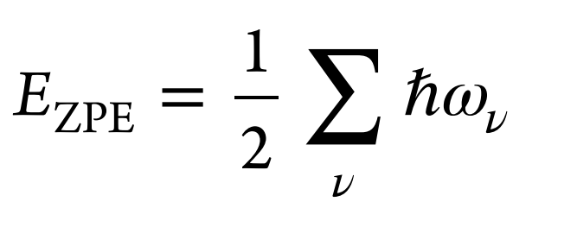
.

Table and Figures

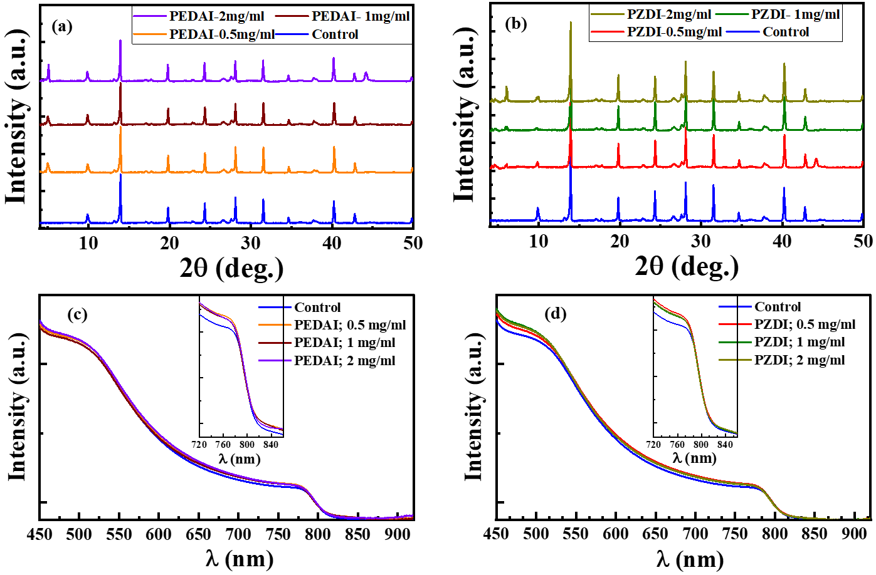
Figure S1. XRD patterns of MA-free (FA_{0.84} Rb_{0.04}Cs_{0.12}PbI₃) films without and with DIM treatments: a) PEDAI or b) PZDAI solutions in IPA; 0 (control), 0.5, 1, and 2 mg/ml. c, d) Absorption spectra of respective films.

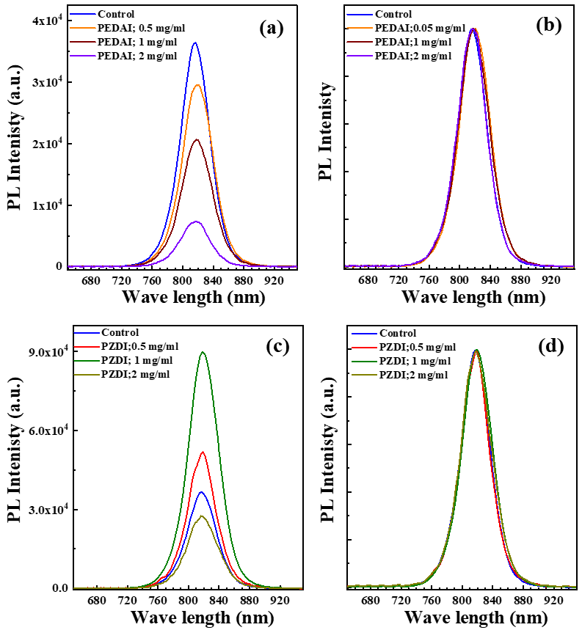
Figure S2. PL spectra of HaP films without and with DIM treatments: a) PEDAI or c) PZDI solutions in IPA; 0 (control), 0.5, 1, and 2 mg/ml. b, d) represent normalized PL spectra of respective films.

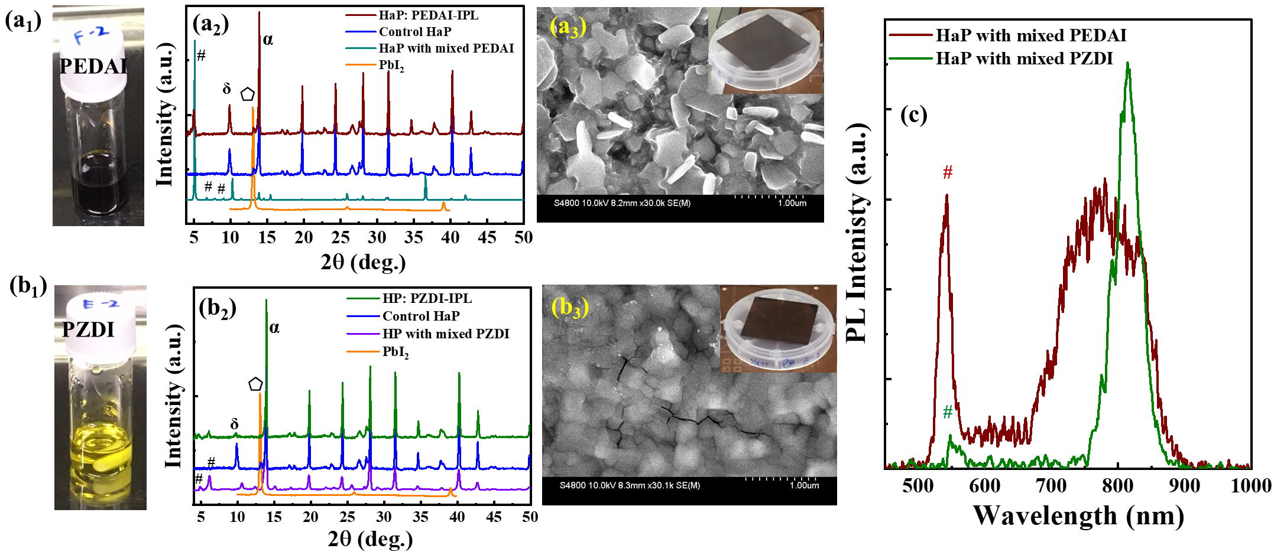
Figure S3. Photo of mixed HaP precursor [ a₁) PEDAI or b₁) PZDI and HaP/mixed precursor]. a₂, b₂) XRD patterns of PbI₂ film, control HaP film, perovskite film prepared using PEDAI or PZDI/perovskite-mixed precursor, and HaP film with DIM (dissolved 2 mg/ml in IPA) treatment. Here, # -2D phase with PEDAI or PZDI, - PbI₂ peak, 𝛿- non-photoactive perovskite phase, α- photoactive perovskite phase. a₃, b₃) SEM images of HaP film (mixed precursor: PEDAI or PZDI/perovskite-mixed precursor. c) PL spectra of the HaP film prepared using mixed precursor. The shoulder response marked with # in PL spectra stem from 2D phase formed with PEDAI or PZDI. Note that mixed precursor was prepared by mixing 0.5 M-PEDAI or PZDI + 0.5 M PbI₂ and 1M of control precursor (FA_{0.84} Rb_{0.04}Cs_{0.12}PbI₃).

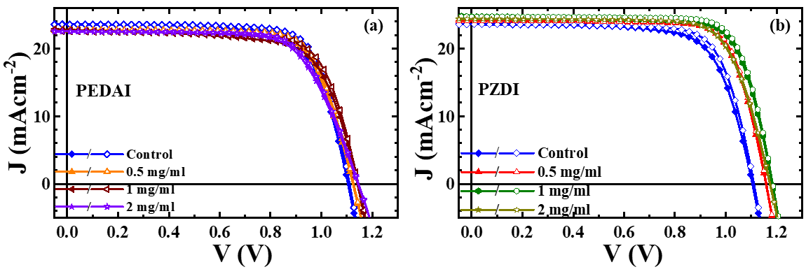
Figure S4. J-V curves of the control and DIM; a) PEDAI or b) PZDI treated HPSCs. ▼forward / reverse scan direction.

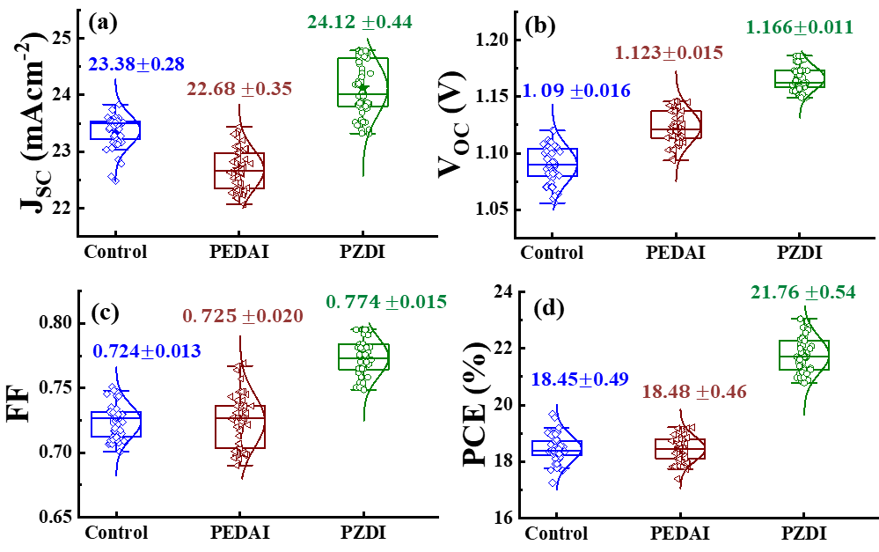
Figure S5. Statistics of PV characteristic parameters of control and IPL treated PSCs, including V_{OC}, J_{SC}, FF, and PCE. These data consist of 50 devices from 6 batches.

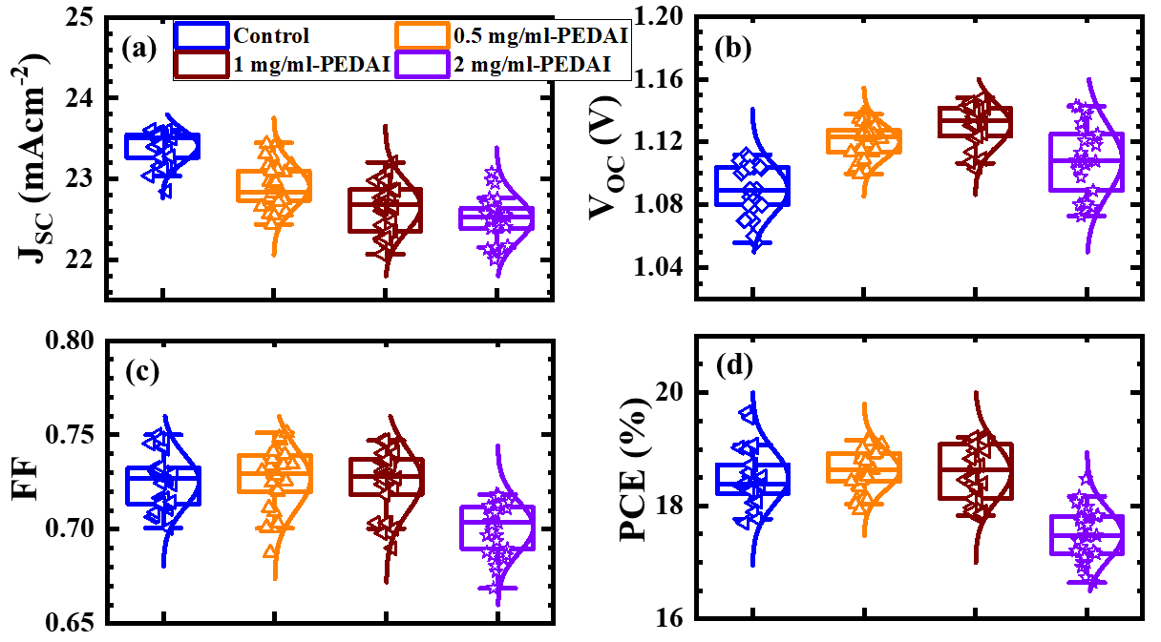
Figure S6. Statistics of PV characteristic parameters of control and PEDAI treated PSCs, including V_{OC}, J_{SC}, FF, and PCE. These data consist of 30 devices from 4 batches.

Table S1. Photovoltaic parameters of the best performing PSCs with MA-free HaP (without and with PEDAI surface treatment). The parameters given inside the parentheses represents the average values and standard deviation.
Device/parameters | Control | 0.5 mg/ml | 1 mg/ml | 2 mg/ml
J_{SC} (mAcm⁻²) | 23.56 (23.41 $±$0.21) | 22.75 (22.91$±$0.26) | 22.73 (22.66$±$0.31) | 22.67 (23.51$±$0.27)
V_{OC} (V) | 1.112 (1.089 $±$0.016) | 1.132 (1.118 ±0.014) | 1.145 (1.131 $±$0.013) | 1.142 (1.114 $±$0.022)
FF | 0.750 (0.725 $±$0.014) | 0.745 (0.726 $±$0.016) | 0.738 (0.725 $±$0.016) | 0.702 (0.701 $±$0.013)
PCE (%) | 19.64 (18.51 $±$0.48) | 19.18 (18.61 $±$0.394) | 19.22 (18.89 $±$0.48) | 18.17 (17.49 $±$0.46)

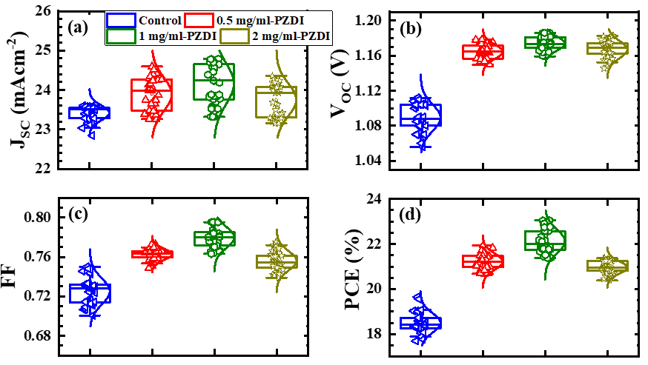
Figure S7. Statistics of PV characteristic parameters of control and PZDI treated PSCs, including V_{OC}, J_{SC}, FF, and PCE. These data consist of 30 devices from 4 batches.

Table S2. Photovoltaic parameters of the best performing PSCs with MA-free HaP (without and with PZDI surface treatment). The parameters given inside the parentheses represents the average values and standard deviation.
Device/parameters | Control | 0.5 mg/ml | 1 mg/ml | 2 mg/ml
J_{SC} (mAcm⁻²) | 23.56 (23.41 $±$0.21) | 24.63 (23.97 $±$0.42) | 24.79 (24.15 $±$0.51) | 24.54 (23.71 $±$0.43)
V_{OC} (V) | 1.112 (1.089 $±$0.016) | 1.181 (1.663 $±$0.009) | 1.186 (1.176 $±$0.008) | 1.174 (1.168 $±$0.011)
FF | 0.750 (0.725 $±$0.014) | 0.765 (0.762 $±$0.006) | 0.784 (0.775 $±$0.012) | 0.756 (0.752 $±$0.013)
PCE (%) | 19.64 (18.51 $±$0.48) | 22.25 (21.27 $±$0.39) | 23.05 (22.35 $±$0.54) | 21.78 (20.95 $±$0.49)

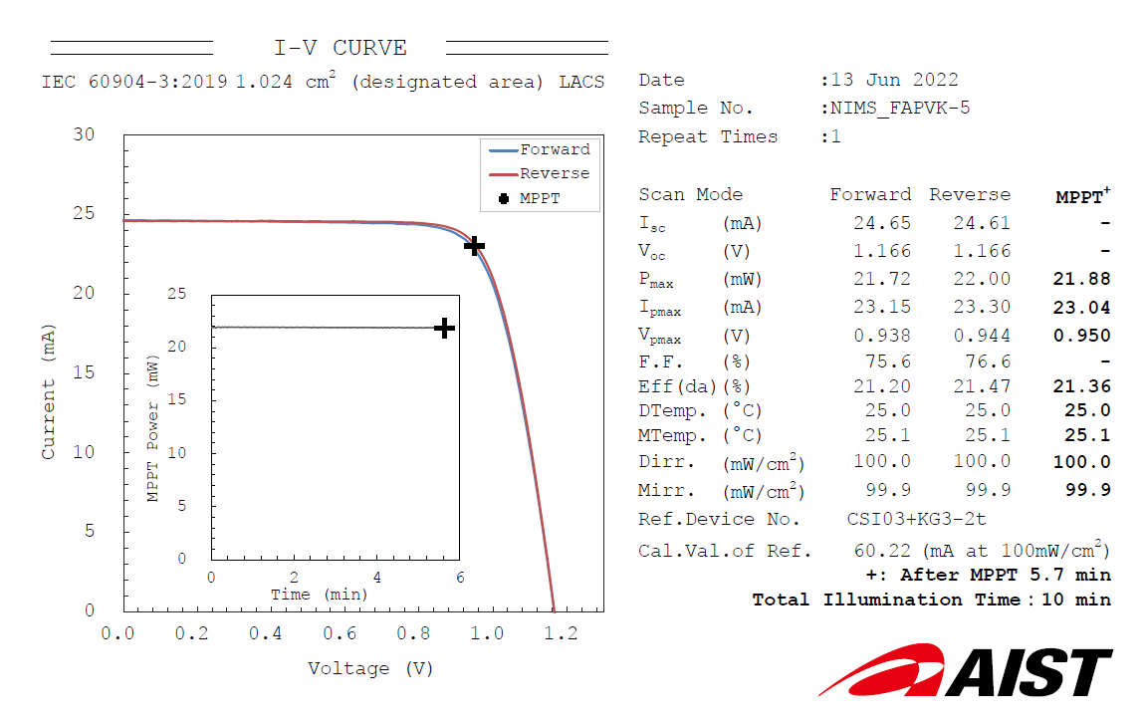

Figure S8. Certified results from an accredited photovoltaic certification laboratory (AIST, Japan). The certified PCE is 21.36% - certified aperture with the area of ~1.024 cm². The certified J-V curves with double scanning give PCE forward: 21.20% and PCE reverse: 21.47%. (HP film: Rb_{0.4}Cs_{0.12}FA_{0.84}PbI₃ with PZDI surface treatment).

Table S3. Summary of certified/record device large area (1 cm²) reports (Pb-perovskite using multiple cations, anions, functional additives, and interfacial layer).
Device Type | Device Structure | Perovskite | Additive | Area  (cm²) | PCE (%) | Reported Efficiency | date | Ref.
Regular  (n-i-p) | Glass/ITO/c-TiO₂/TiO₂ nanorods/PMMA:PCBM/ Perovskite/PMMA/Spiro-OMeTAD)/MoOx/IZO/Au | (Cs,FA,MA)Pb(I,Br)₃ | ----- | 1.0 | 21.6 | Certified | 2021 | ⁷
Regular  (n-i-p) | Glass/FTO/TiO_{x}N_{y}/meso-TiO₂/PMMA: PCBM/ perovskite/PMMA/P₃HT: CuPc/Au | (Cs,FA,MA)Pb(I,Br)₃ | 0.01 M-PbCl2, 0.01 M-MACl | 1.0 | 22.6 | Certified | 2022 | ⁸
Regular  (n-i-p) | Glass/FTO/SnO2/ perovskite/spiro-OMeTAD/EVA/Cu-Ni-Graphene | FAMAPb(I,B_{r})3 | ----- | 0.09 | 24.37 | Certified | 2022 | ⁹
 |  |  |  | 1.02 | 20.76 |  | 2022 | ⁹
Inverted  (p-i-n) | Glass/ITO/NiOx-nanoparticles/ (IL)EMDP/ Perovskite/PCBM/BCP/Au | (Cs,FA,MA₎Pb(I,B_{r)3} | ----- | 1.01 | 20.91 | Not certified | 2021 | ¹⁰
Regular  (n-i-p) | Glass/FTO/SnO₂(ALD)/PCBM/PMMA/Perovskite/PMMA/Spiro/Au | (Rb,Cs,FA)PbI₃ | ----- | 0.1024 | 20.35 | Not certified | 2018 | ¹¹
Inverted  (p-i-n) | Glass/ITO/2PACz/Perovskite/PEACl/C₆₀/BCP/Au | (Cs,FA)PbI₃ | phenethylammonium chloride | 0.123 | 22.3 | Not certified | 2021 | ¹²
Inverted  (p-i-n) | Glass/ITO/NiOx-sputtered/MeO/Perovskite/5F-PHZ/C₆₀/BCP/Ag | (Rb,Cs,FA)PbI₃ | 5F-PHZ | 1.026 | 21.01 | Certified | 2022 | ¹³
Inverted  (p-i-n) | Glass/ITO/NiOx-sputtered/MeO/Perovskite/PZDAI/C₆₀/BCP/Ag | (Rb,Cs,FA)PbI₃ | PZDAI | 1.024 | 21.47  (23.17) | Certified | *This work  (Record certify PCE for inverted device structure)

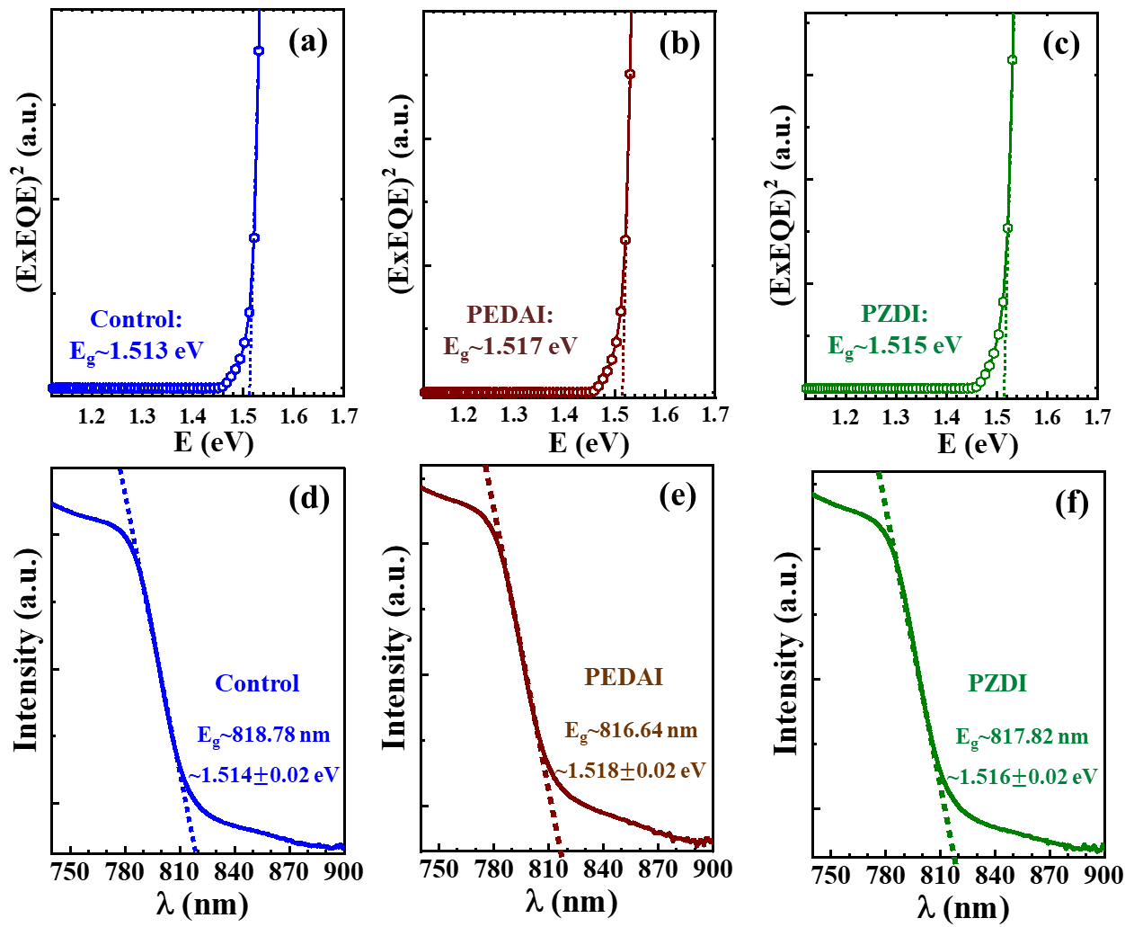
Figure S9. Estimation of bandgap energy (E_{g}) of HaP layers (control and with surface treatment (PEDAI or PZDAI)). a-c) E_{g} estimated from EQE analysis. d-f) E_{g} calculated from absorption spectra of respective films.

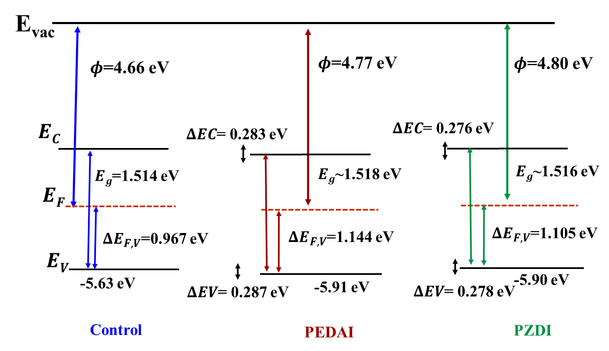
Figure S10. Energy band schematics of control and PEDAI or PZDAI treated film extracted from UPS spectra. Note that E_{g} for this schematic is calculated from absorption spectra (Fig. 9d-f).

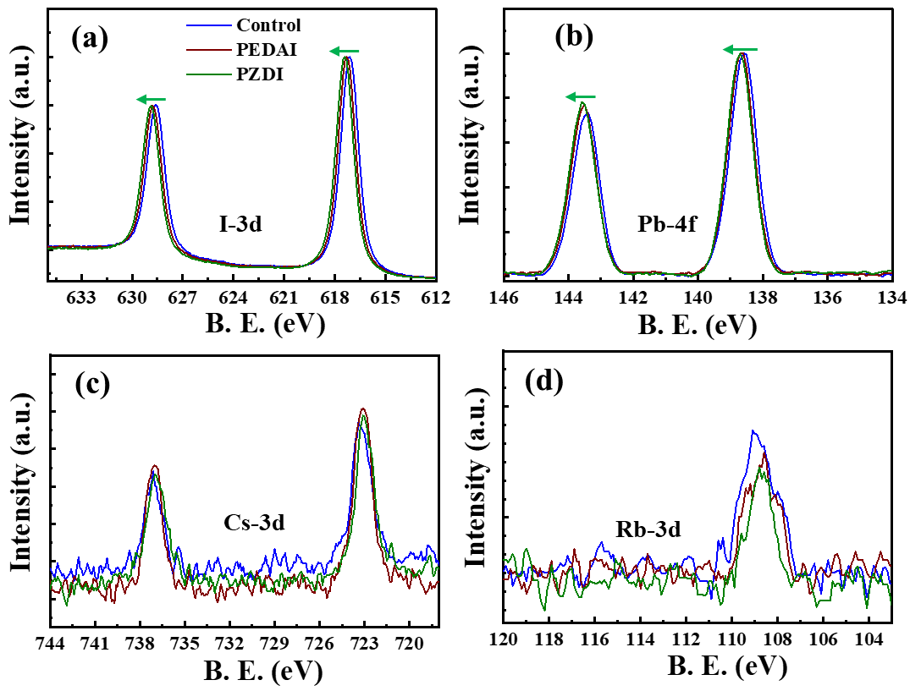
Fig. S11. XPS-spectra for the control and PEDAI or PZDI treated films; a) I-3d core, b) Pb-4f, c) Cs-3d core, and d) Rb-3d core. Arrow head indicates shifting direction of XPS characteristic peak.

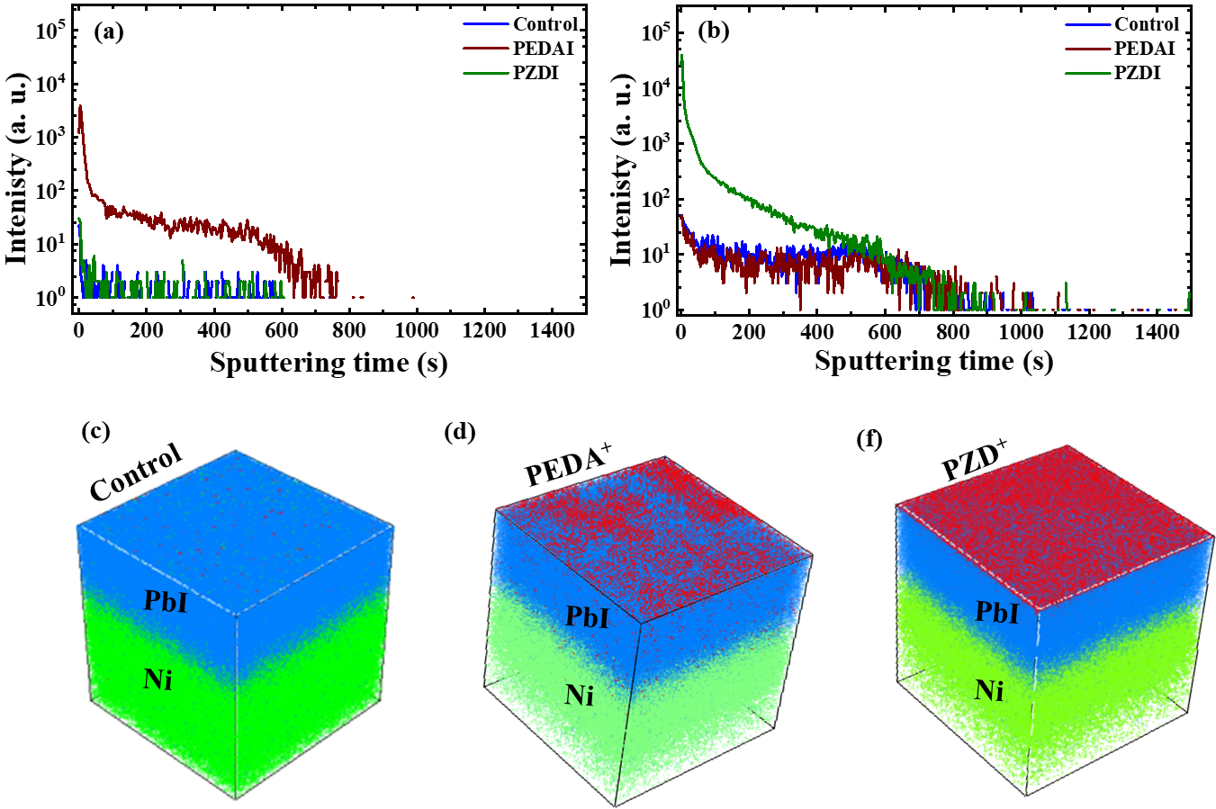
Figure S12. ToF-SIMS depth profiles of control and surface treated HaP film. a.b) control, f) PEDAI, and g) PZDI treated HaP films. Reconstructed 3D maps; h-j) the distributions of passivated molecules in HaP film.

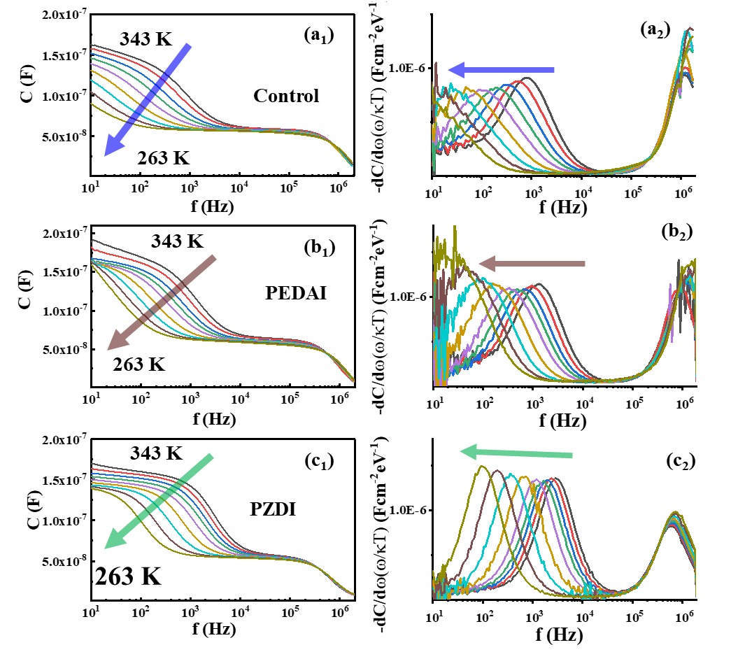

Figure S16. Thermal admittance spectra (TAS). a₁-c₁) C-f-T spectra of control and PEDAI or PZDI treated devices. a₂-c₂) differentiation of respective C-f-T spectra for determination of inflection frequencies.

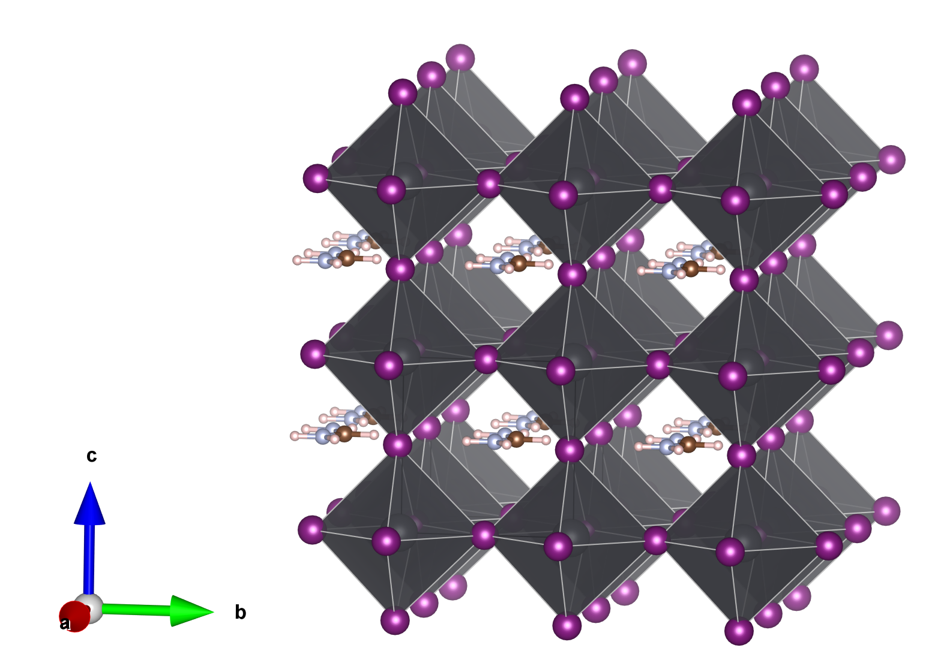

Figure S17. The optimized pseudo-cubic structure of the bulk FAPbI₃. Pb atoms are colored grey, I atoms are purple, C atoms are brown, N atoms are light grey, and H atoms are light pink. Figure was created using VESTA software.¹⁴

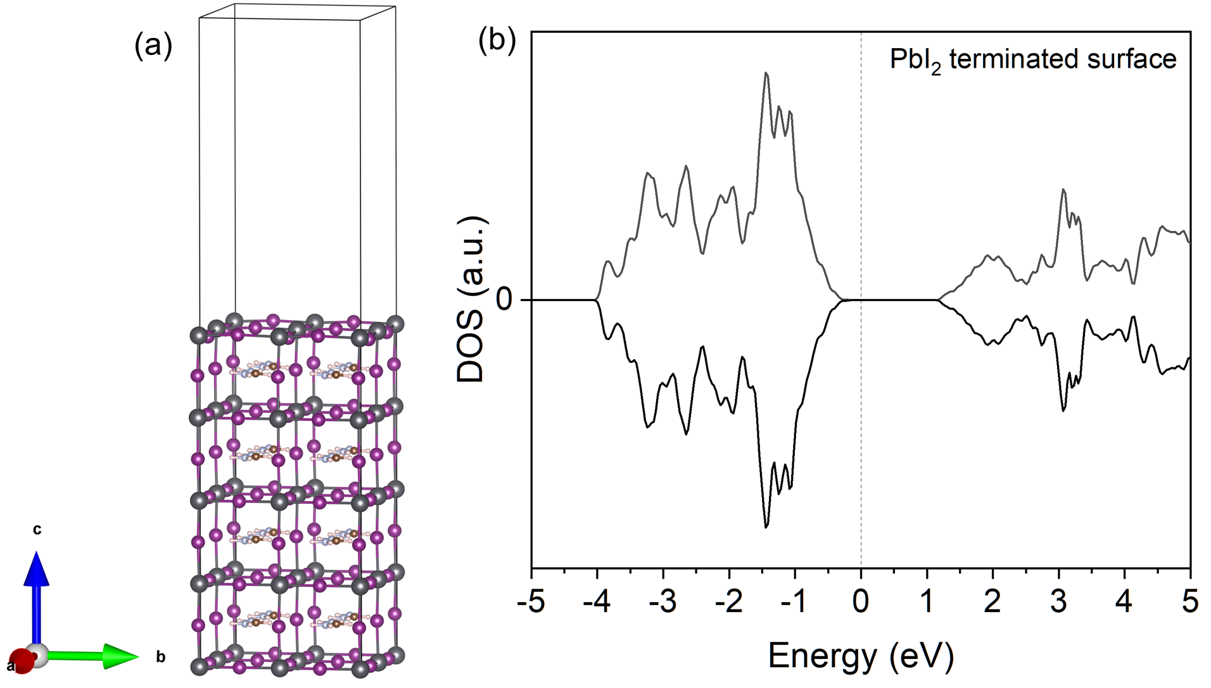

Figure S18. (a) The optimized structure of the 2x2 unit cell of PbI₂-terminated surface (001) of the pseudo-cubic FAPbI₃. (b) Total density of states calculated for the defect-free PbI₂-terminated surface of FAPbI₃. Figure in (a) was created using VESTA software.¹⁴

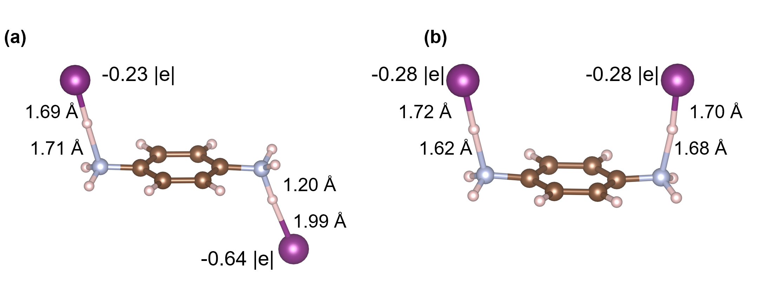

Figure S19. The optimized structures of a free 1,4-phenylenediamine dihydriodide (PEDAI), C₆H₈N₂*2HI, molecule. (a) The most stable trans-isomer structure, and (b) the low-energy cis-isomer form. Mulliken charges were calculated at the B3LYP/def2TZVP level of theory with the use of Gaussian 09.¹⁵

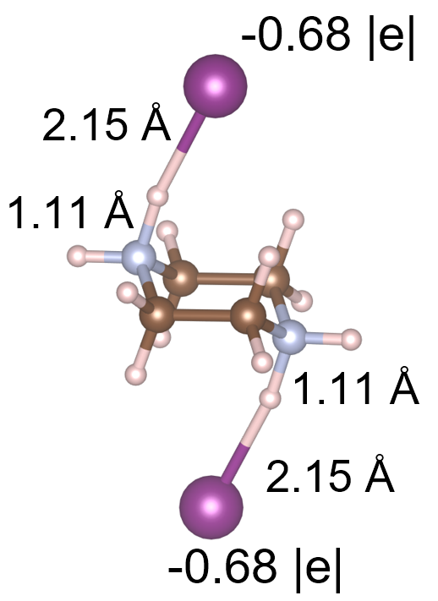

Figure S20. The optimized structure of a free piperazine dihydriodide (PZDI), C₄H₁₀N₂*2HI, molecule. Mulliken charges were calculated at the B3LYP/def2TZVP level of theory with the use of Gaussian 09.¹⁵

Free 1,4-phenylenediamine dihydriodide (PEDAI), C₆H₈N₂*2HI, molecules possess several isomeric forms depending on the position of the HI compounds. The most stable trans-isomer is shown in Figure S19a, while its cis form (Figure S19b) is only 0.086 eV less stable. When PEDAI adsorbs on the PbI₂-terminated surface of FAPbI₃ adsorption of the cis-form became energetically favorable, as it maximizes interaction of I atoms of PEDAI with the surface Pb atoms.

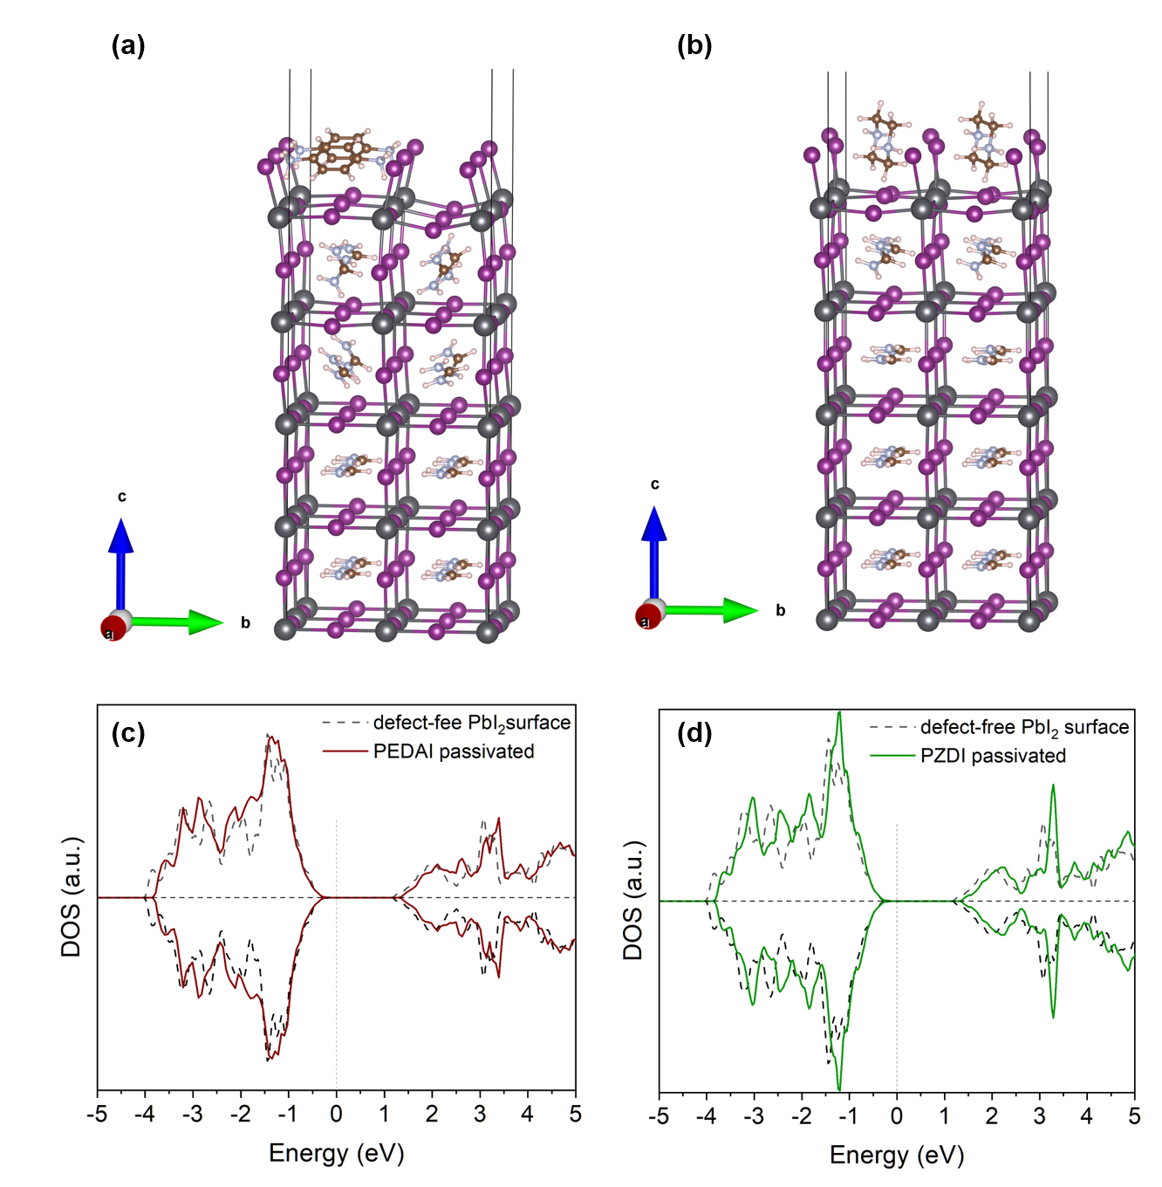

Figure 21. Optimized structures of (a) PEDAI and (b) PZDI adsorbed on the defect-free PbI₂-terminated surface of FAPbI₃. The spin-polarized total DOS calculated for the PbI₂-terminated surface of FAPbI₃ covered by (c) PEDAI and (d) PZDI. Figures in (a) and (b) were created using VESTA software.¹⁴

References
1. Khadka, D. B., Shirai, Y., Yanagida, M. & Miyano, K. Insights into Accelerated Degradation of Perovskite Solar Cells under Continuous Illumination Driven by Thermal Stress and Interfacial Junction. ACS Appl. Energy Mater. 4, 11121–11132 (2021).
2. Sun, J., Ruzsinszky, A. & Perdew, J. P. Strongly Constrained and Appropriately Normed Semilocal Density Functional. Phys. Rev. Lett. 115, 036402 (2015).
3. Kresse, G. & Furthmüller, J. Efficient iterative schemes for ab initio total-energy calculations using a plane-wave basis set. Phys. Rev. B 54, 11169–11186 (1996).
4. Kresse, G. & Joubert, D. From ultrasoft pseudopotentials to the projector augmented-wave method. Phys. Rev. B 59, 1758–1775 (1999).
5. Sun, J. et al. Accurate first-principles structures and energies of diversely bonded systems from an efficient density functional. Nat. Chem. 8, 831–836 (2016).
6. Weller, M. T., Weber, O. J., Frost, J. M. & Walsh, A. Cubic Perovskite Structure of Black Formamidinium Lead Iodide, α-[HC(NH 2 ) 2 ]PbI 3 , at 298 K. J. Phys. Chem. Lett. 6, 3209–3212 (2015).
7. Peng, J. et al. Nanoscale localized contacts for high fill factors in polymer-passivated perovskite solar cells. Science 371, 390–395 (2021).
8. Peng, J. et al. Centimetre-scale perovskite solar cells with fill factors of more than 86 per cent. Nature 601, 573–578 (2022).
9. Lin, X. et al. In situ growth of graphene on both sides of a Cu–Ni alloy electrode for perovskite solar cells with improved stability. Nat. Energy (2022) doi:10.1038/s41560-022-01038-1.
10. Zhang, S. et al. Printable and Homogeneous NiO x Hole Transport Layers Prepared by a Polymer‐Network Gel Method for Large‐Area and Flexible Perovskite Solar Cells. Adv. Funct. Mater. 31, 2106495 (2021).
11. Turren-Cruz, S.-H., Hagfeldt, A. & Saliba, M. Methylammonium-free, high-performance, and stable perovskite solar cells on a planar architecture. Science 362, 449–453 (2018).
12. Gharibzadeh, S. et al. Two birds with one stone: dual grain-boundary and interface passivation enables &gt;22% efficient inverted methylammonium-free perovskite solar cells. Energy Environ. Sci. 14, 5875–5893 (2021).
13. Khadka, D. B., Shirai, Y., Yanagida, M., Tadano, T. & Miyano, K. Interfacial Embedding for High‐Efficiency and Stable Methylammonium‐Free Perovskite Solar Cells with Fluoroarene Hydrazine. Adv. Energy Mater. 12, 2202029 (2022).
14. Momma, K. & Izumi, F. VESTA 3 for three-dimensional visualization of crystal, volumetric and morphology data. J. Appl. Crystallogr. 44, 1272–1276 (2011).
[15] Gaussian 09, Revision D.01, M. J. Frisch, G. W. Trucks, H. B. Schlegel, G. E. Scuseria, M. A. Robb, J. R. Cheeseman, G. Scalmani, V. Barone, B. Mennucci, G. A. Petersson, H. Nakatsuji, M. Caricato, X. Li, H. P. Hratchian, A. F. Izmaylov, J. Bloino, G. Zheng, J. L. Sonnenberg, M. Hada, M. Ehara, K. Toyota, R. Fukuda, J. Hasegawa, M. Ishida, T. Nakajima, Y. Honda, O. Kitao, H. Nakai, T. Vreven, J. A. Montgomery, Jr., J. E. Peralta, F. Ogliaro, M. Bearpark, J. J. Heyd, E. Brothers, K. N. Kudin, V. N. Staroverov, T. Keith, R. Kobayashi, J. Normand, K. Raghavachari, A. Rendell, J. C. Burant, S. S. Iyengar, J. Tomasi, M. Cossi, N. Rega, J. M. Millam, M. Klene, J. E. Knox, J. B. Cross, V. Bakken, C. Adamo, J. Jaramillo, R. Gomperts, R. E. Stratmann, O. Yazyev, A. J. Austin, R. Cammi, C. Pomelli, J. W. Ochterski, R. L. Martin, K. Morokuma, V. G. Zakrzewski, G. A. Voth, P. Salvador, J. J. Dannenberg, S. Dapprich, A. D. Daniels, O. Farkas, J. B. Foresman, J. V. Ortiz, J. Cioslowski, and D. J. Fox, Gaussian, Inc., Wallingford CT, 2013.

