Supplementary Material
Adaptability analysis of the ceftriaxone-resistant Neisseria gonorrhoeae FC428 clone in China
Running title: Adaptability analysis of the FC428 clone
Yamei Li^{1,2}†, Yang Yang³†, Wenling Cao⁴†, Leshan Xiu⁵, Di Wang^{1,6}, Weiming Gu³††*, Junping Peng^{1,6}††*
1. NHC Key Laboratory of Systems Biology of Pathogens, Institute of Pathogen Biology, Chinese Academy of Medical Sciences & Peking Union Medical College, Beijing, China
2. Department of Laboratory Medicine, The First Affiliated Hospital of USTC, Division of Life Sciences and Medicine, University of Science and Technology of China
3. Shanghai Skin Disease Hospital, Tongji University School of Medicine, Shanghai, China
4. Guangzhou Institute of Dermatology, Guangzhou, China
5. School of Global Health, Chinese Center for Tropical Diseases Research, Shanghai Jiao Tong University School of Medicine, Shanghai, China
6. Key Laboratory of Respiratory Disease Pathogenomics, Chinese Academy of Medical Sciences and Peking Union Medical College, Beijing, China

† These authors contributed equally to this article.
†† These authors are equal contributors.
*corresponding author: Junping Peng
Junping Peng
Tel: 86-10- 67878493
Fax: 86-10- 67878493
E-mail: pengjp@hotmail.com

Supplementary Material
Figure S1. Phylogenetic analysis of 34 previously reported FC428-like strains.
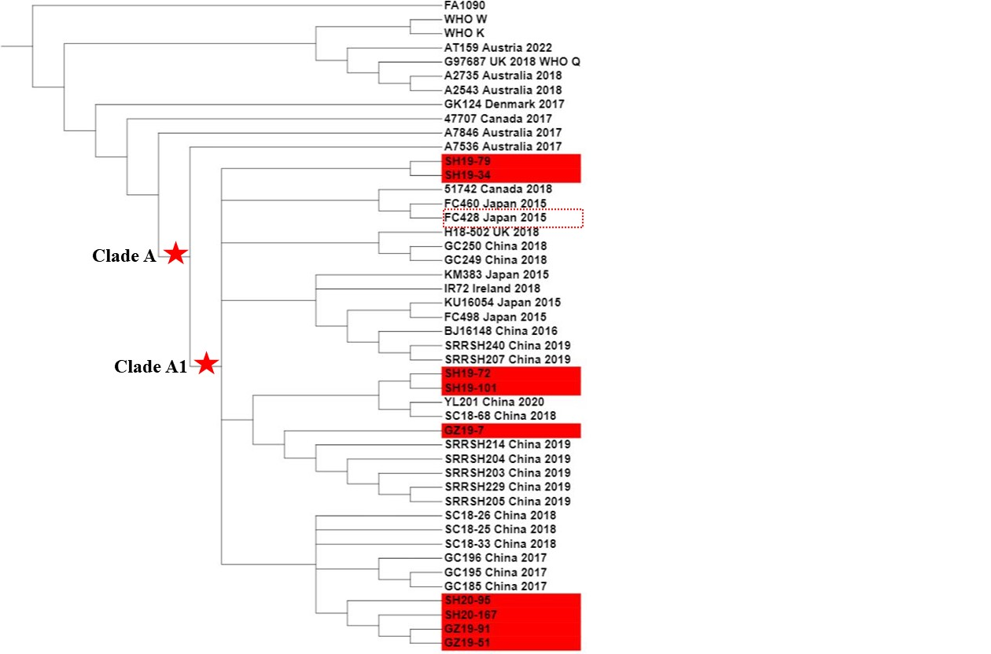Figure S1, Maximum-likelihood phylogeny of 21,715 SNPs along the whole genome. A total of 34 previously reported FC428-like strains, as well as WHO-K and WHO-F, were included in the phylogenetic analysis.

