AUTHORS PICTURE and BIOGRAPHY
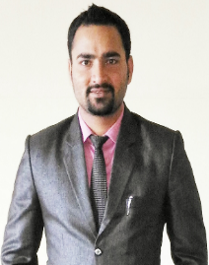

Vatan Sehrawat received the B.Tech. Degree in Computer Science and Engineering from Maharishi Dayanand University, Rohtak in 2012 and M.Tech. Degree in Computer Science and Engineering from Maharishi Dayanand University, Rohtak in 2015. He is now pursuing Ph.D. from MMEC, MMDU, Mullana, Ambala.

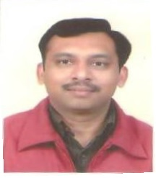

Dr.Sandip Goyal is working as Professor, Maharishi Markandeshwar Engineering college,Mullana,Ambala (Haryana) Constituent institution of Maharishi Markandeshwar University, Mullana is NAAC accredited 'A' grade deemed university & the first private engineering college of Haryana established in 1995. Total Experience: 18 years (10 years PG) + 03 years Research. He is serving in all capacity including Head of Department, Professor.

