SUPPLEMENTARY

Supplementary Figure 1. Primers and TaqMan probes used in qRT-PCR (RP: reverse primer, FP: forward primer)

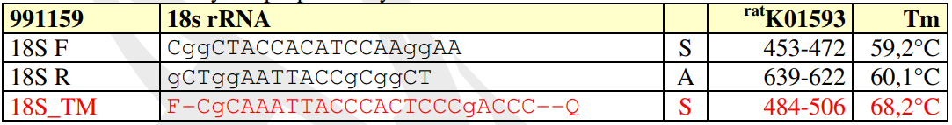
Figure 1.1. 18s rRNA primer and probe sequences

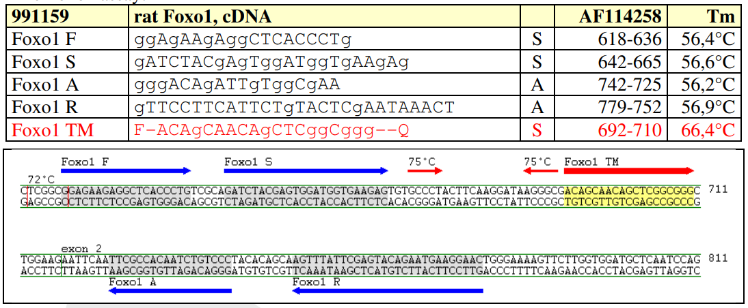
Figure 1.2. Foxo1 primer and probe sequences

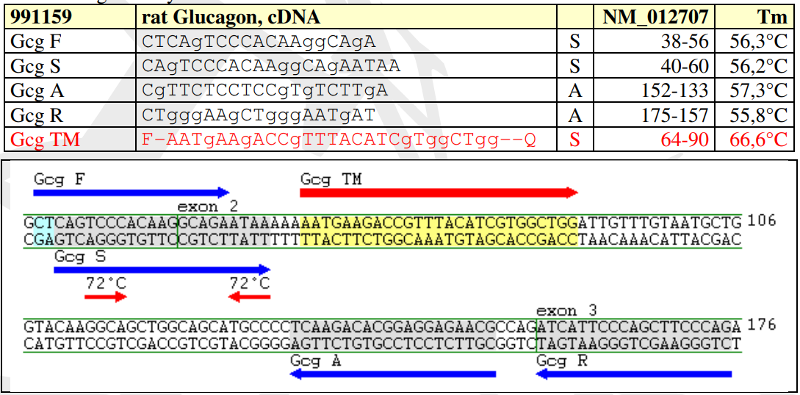
Figure 1.3. Gcg primer and probe sequences

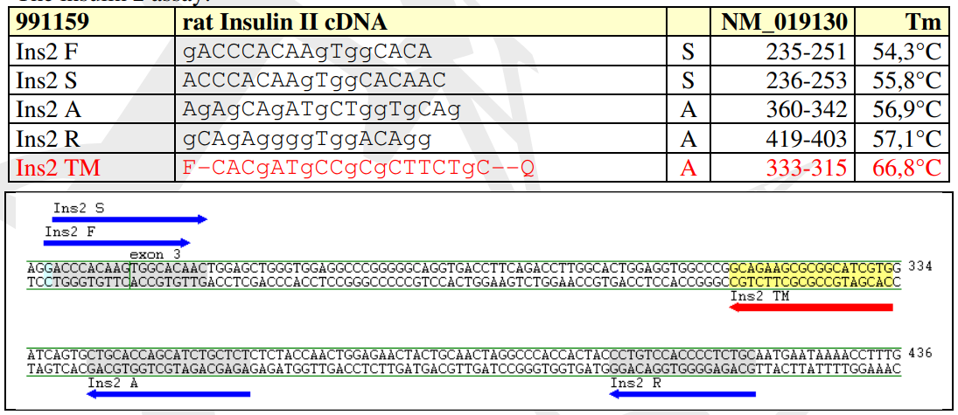
Figure 1.4. Ins2 primer and probe sequences

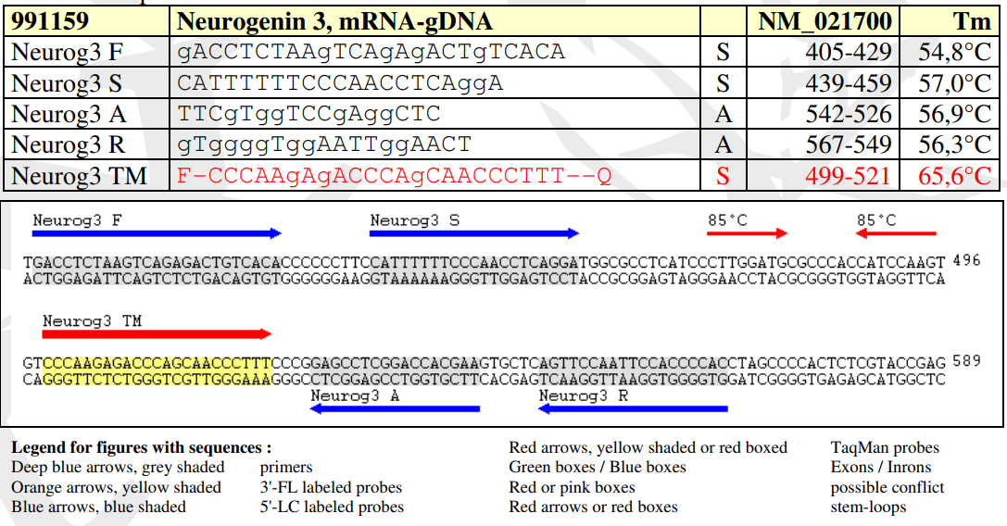
Figure 1.5. Neurog3 primer and probe sequences

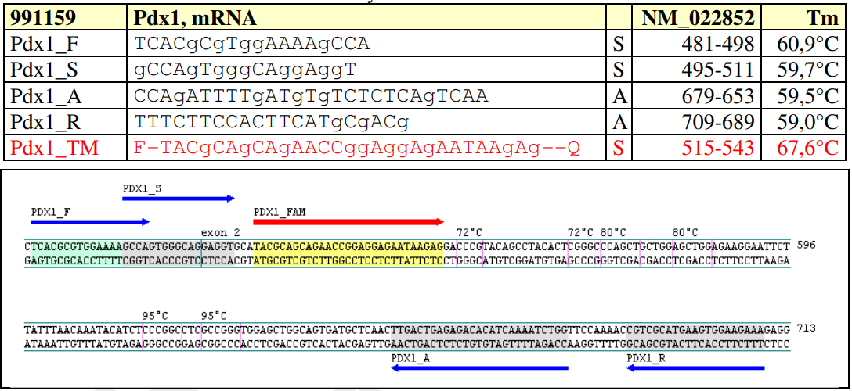
Figure 1.6. Pdx1 primer and probe sequences

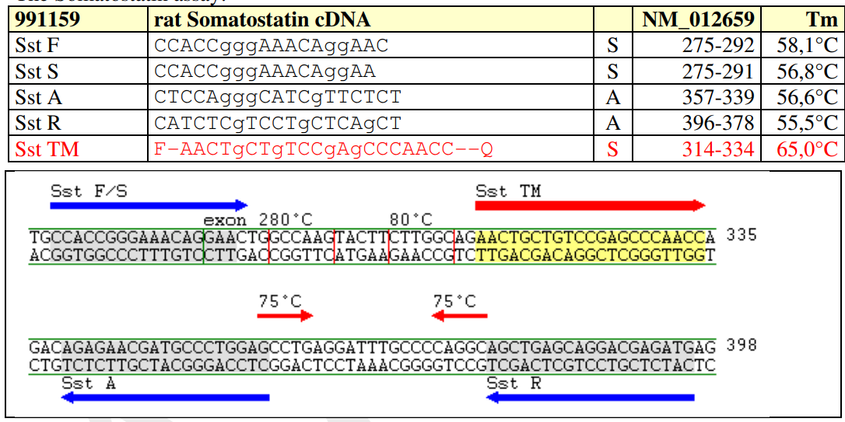
Figure 1.7. Sst primer and probe sequences

Supplementary Figure 2. Primers used in qRT-PCR (SYBR Green) (RP: reverse primer, FP: forward primer)

Gene name | Sequence | T_{m} values  (⁰C) | Product Length
ChromograninA | FP: 5′-GGAACCACAGAAGGACCCAG-3′ | 61 | 20 bp
ChromograninA | RP: 5′-CTTTTCTGGCTTGCTGCTGG-3′ | 59 | 20 bp
18S rRNA | FP: 5′-GCAATTATTCCCCATGAACG-3′ | 55 | 20 bp
18S rRNA | RP: 5′-GGCCTCACTAAACCATCCAA-3′ | 57 | 20 bp

Supplementary Inf. Relative Quantification of Target RNAs

The Tm depends on the length and composition of DNA species so that the same DNA species
can be observed as the overlapped peaks whereas different species give distinct peaks. Therefore,
performed melt curve analysis is critical for the assessment of the quality and specificity of the
amplification (Pfafll, 2006). All the RNA steps were confirmed based on MIQE guidelines in
this study (Bustin et. al., 2009).
The results obtained from the RT-qPCR reactions were analyzed by calculations of delta Ct
values and fold change ratios. First of all, efficiencies of the reactions for each gene was
determined by construction of a standard curve from different cDNA dilutions of a control
sample. Then, from the drawn change in Ct versus initial copy number curve, the reaction
efficiency was calculated as

Reaction Efficiency = - 1

When the efficiency is 100% (or 1), it means the sample doubles at each amplification cycle.
Since no absolute control was used to construct the standard curves, relative quantification was
applied. Although there are other mathematical methods of quantification (Pfaffl, 2006) owing to
the close reaction efficiencies for all genes, the calculation of fold changes was done by the
method proposed by Liwak and Schmittgen, 2001. The formulation is as follows:

ΔCt = Ct (target gene) – Ct (reference gene)
ΔΔCt = ΔCt (treatment) - ΔCt (control)
Ratio (fold change) =

Ref.
Pfaffl, M. (2006). Relative Quantfication. Published by International University Line (Editor: T.
Dorak), p 63-82.

Bustin SA, Benes V, Garson JA, Hellemans J, Huggett J, Kubista M, Mueller R, Nolan T, Pfaffl
MW, Shipley GL, Vandesompele J, Wittwer CT. The MIQE guidelines: minimum information
for publication of quantitative real-time PCR experiments. Clin Chem. 2009 Apr;55(4):611-22.
doi: 10.1373/clinchem.2008.112797.

Livak, K., and Schmittgen, T. (2001). Analysis of relative gene expression data using real time
quantitative PCR and the 2^-deltadelta Ct method. Methods, 402-408.

Supplementary Figure 3. Body weights of mother Wistar rats before pregnancy.

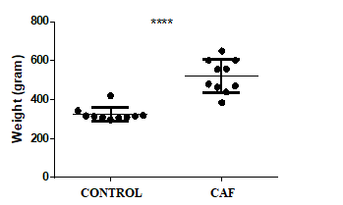

Mother rats fed with processed food statistically increased body weight (mean 570g) in the CAF group compared to the control group rats (mean 310g) which were fed with regular chow (****p <0.0001) (n = 10 rat/per group).

Supplementary Figure 4. Original Western-Blotting images

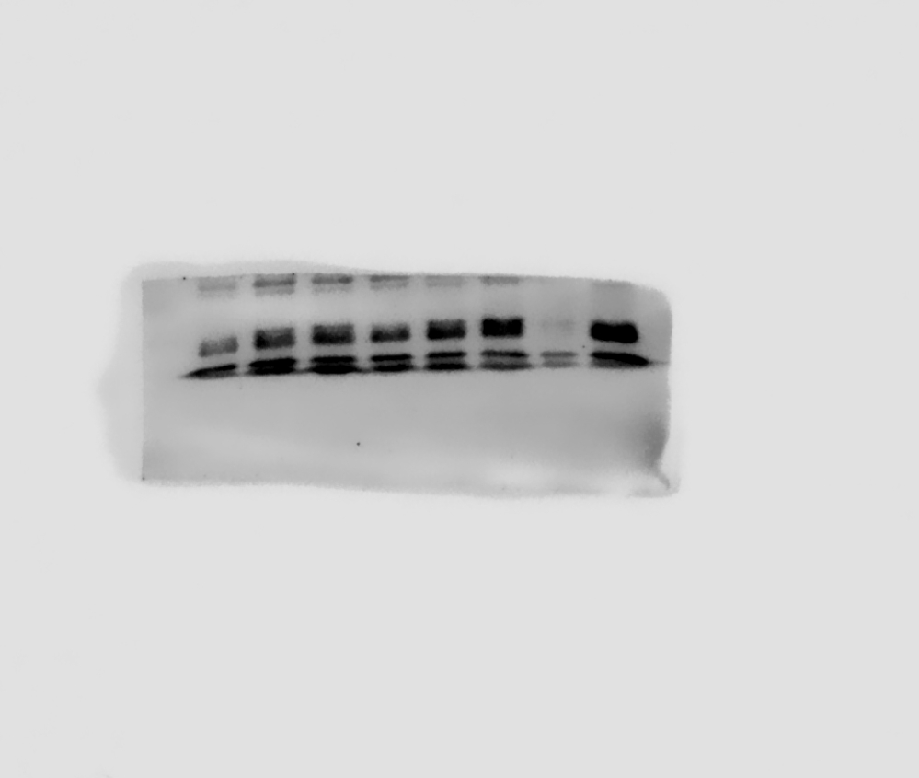
Figure 4.a. Insulin protein

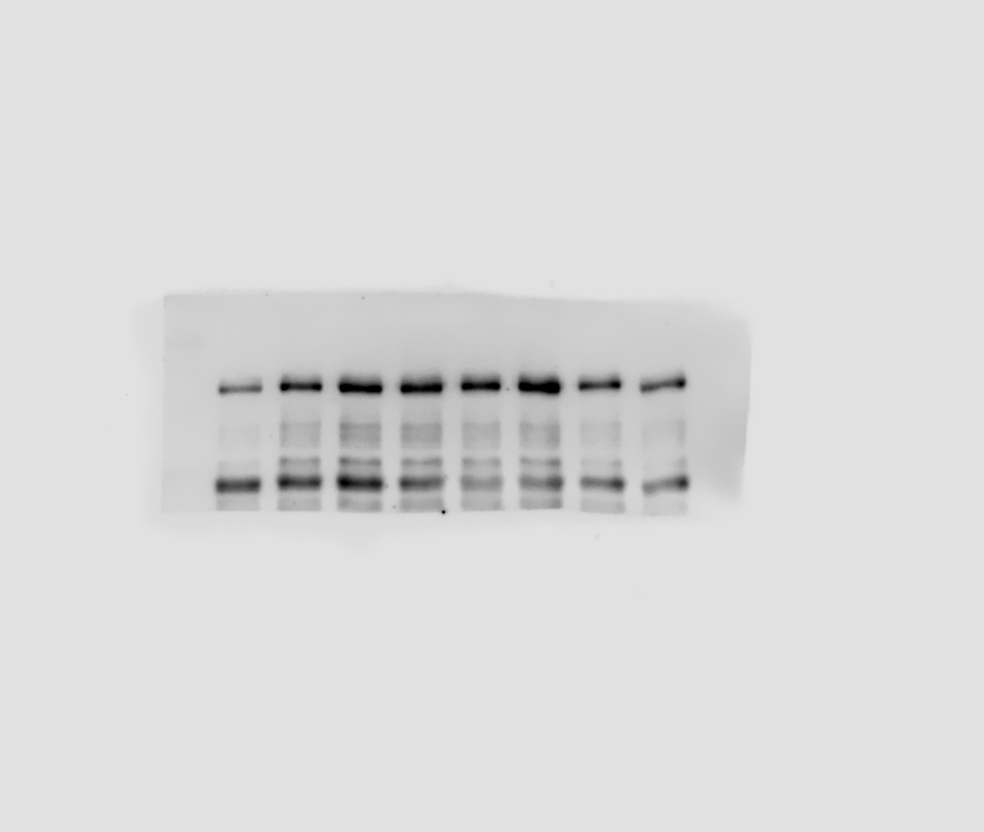
4.b. Beta-actin protein

Supplementary Table 1. Cafeteria diet (CAF) content.

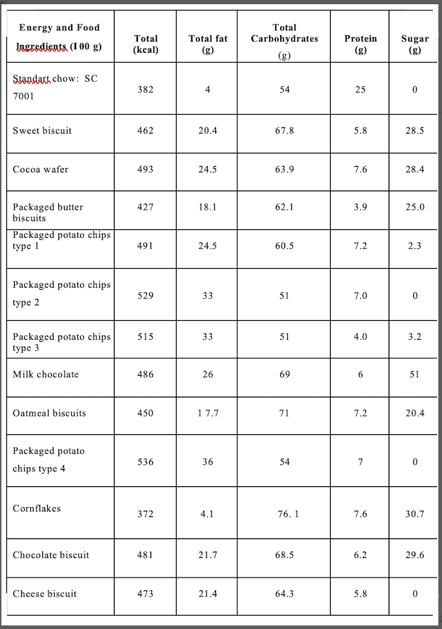

Supplementary Table 2. Standard (normal) diet composition.

