Supplementary Information for

Four-dimensional Hydrogel Dressing Adaptable to the Urethral Microenvironment for Scarless Urethral Reconstruction

Yujie Hua^{1,2,5}, Kai Wang^{3,5}, Yingying Huo^{2,5}, Yaping Zhuang⁴, Yuhui Wang¹, Wenzhuo Fang¹, Yuyan Sun², Guangdong Zhou², Qiang Fu¹*, Wenguo Cui⁴* & Kaile Zhang¹*

¹Department of Urology, Shanghai Sixth People’s Hospital Affiliated to Shanghai Jiao Tong University School of Medicine, Shanghai Jiao Tong University, Shanghai 200233, P. R. China.
²Department of Plastic and Reconstructive Surgery, Shanghai Ninth People’s Hospital Affiliated to Shanghai Jiao Tong University School of Medicine, Shanghai Key Laboratory of Tissue Engineering, Shanghai 200011, P. R. China.
³Clinical Research Center, Shanghai Chest Hospital, Shanghai Jiao Tong University School of Medicine, Shanghai 200030, P. R. China.
⁴Shanghai Institute of Traumatology and Orthopaedics, Shanghai Key Laboratory for Prevention and Treatment of Bone and Joint Diseases, Ruijin Hospital, Shanghai Jiao Tong University School of Medicine, Shanghai 200025, P. R. China.
⁵These authors contributed equally: Yujie Hua, Kai Wang, Yingying Huo.
*Corresponding author. E-mail: great_z0313@sjtu.edu.cn (K.Z.); jamesqfu@126.com (Q.F.); wgcui@sjtu.edu.cn (W.C.)

This file includes: Supplementary Fig. 1 to 10.

Supplementary Figures
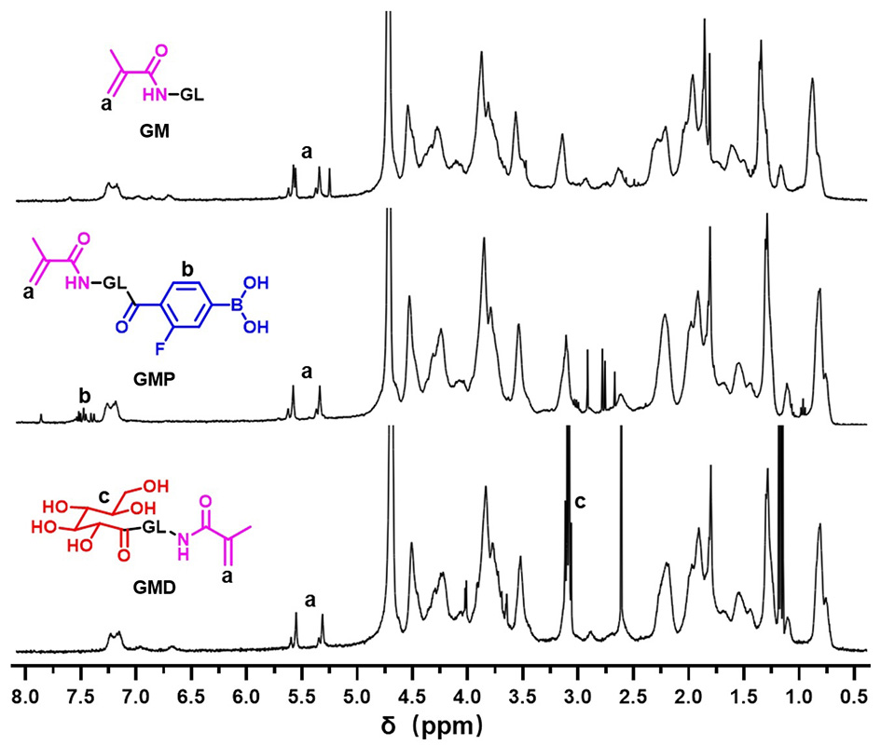
Supplementary Fig. 1. ¹H NMR spectral characterization of gelatin methacryloyl (GM), fluorophenylboronic acid (FPBA)-modified gelatin methacryloyl (GMP), and cis-diol-modified gelatin methacryloyl (GMD).

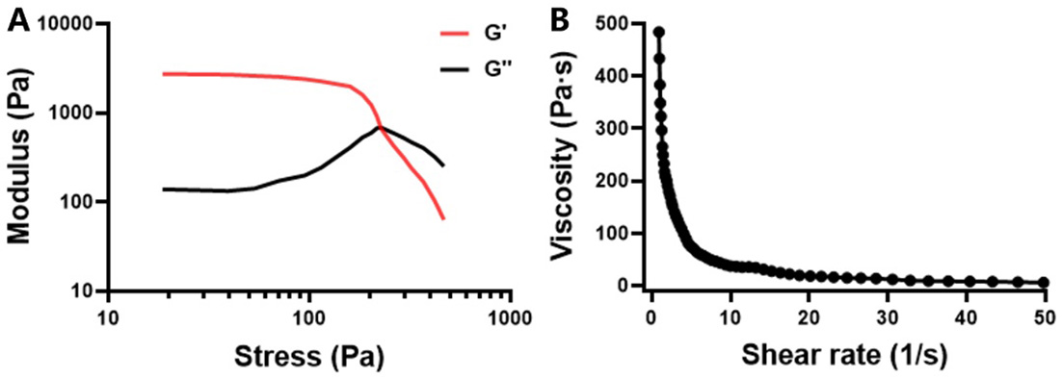
Supplementary Fig. 2. A) Representative strain sweep rheological plots of GMPD-hv hydrogels. B) Viscosity and shear-thinning behavior of GMPD-hv hydrogels.

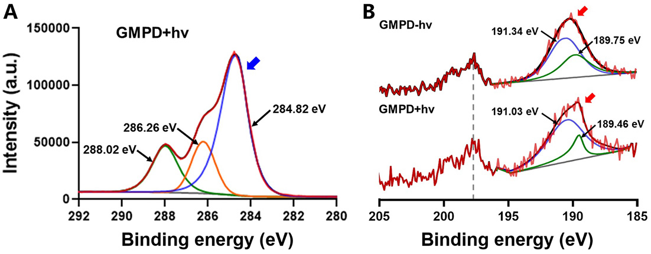
Supplementary Fig. 3. A, B) The C(1s, A) and B(1s, B) XPS regions of GMPD+hv hydrogel samples. Blue arrows represent C(1s) regions. Red arrows represent B(1s) regions.

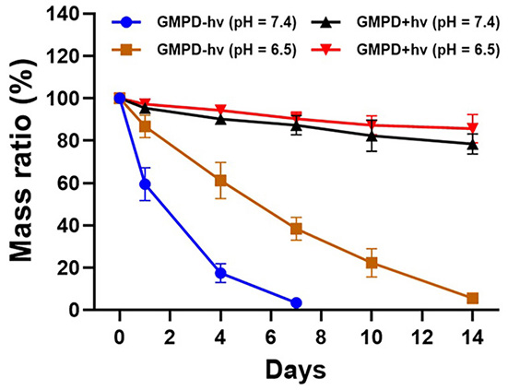
Supplementary Fig. 4. The in vitro degradation curves of GMPD-hv and GMPD+hv hydrogels in neutral (pH = 7.4) or acidic solutions (pH = 6.5).

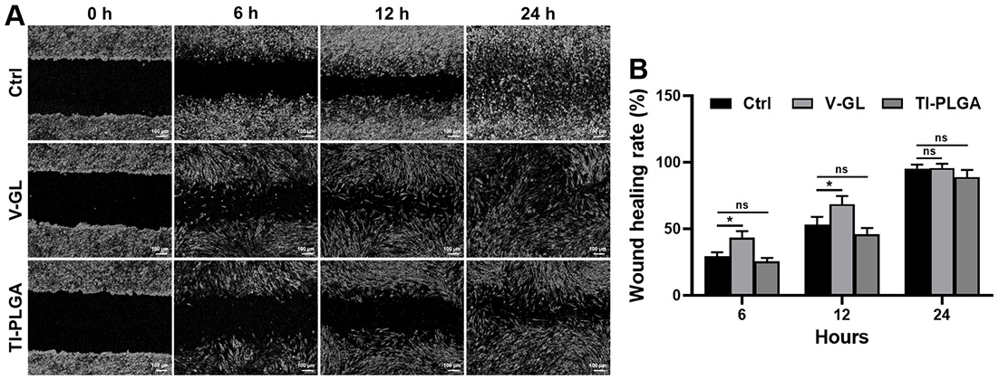
Supplementary Fig. 5. A) Observation of the endothelial cell scratch assay after 0, 6, 12, and 24 hours in the V-GM, TI-PLGA, and control (Ctrl) groups. B) Statistical analyses of the corresponding wound healing rates.
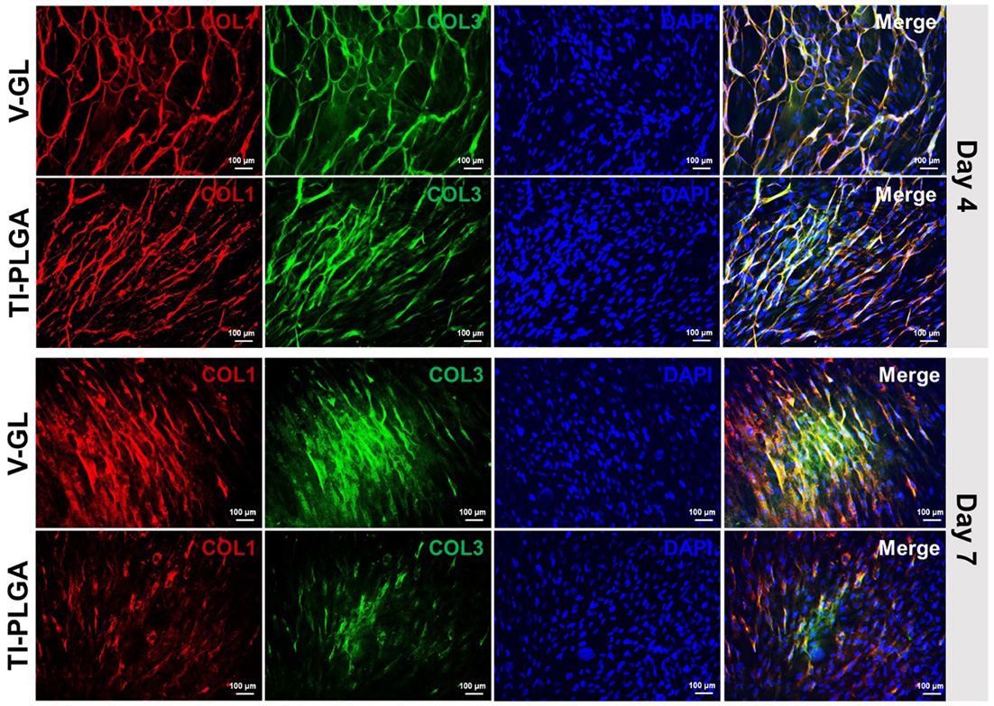
Supplementary Fig. 6. Immunofluorescence staining of COL1 (red), COL3 (green), and cell nuclei (DAPI, blue) for fibroblast marker expression after 4- and 7-days culture in the V-GM and TI-PLGA groups.

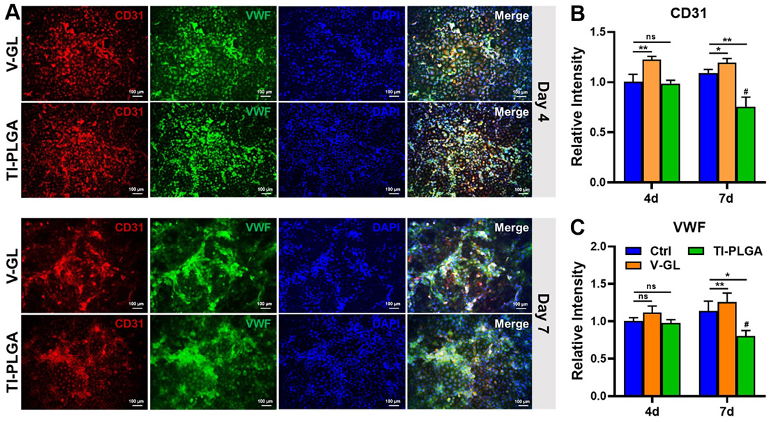
Supplementary Fig. 7. A) Immunofluorescence staining of CD31 (red), VWF (green), and cell nuclei (DAPI, blue) for endothelial cell marker expression after 4- and 7-days culture in the V-GM and TI-PLGA groups. B) Comparative endothelial cell expression levels (CD31 and VWF) after 4- and 7-days culture in the V-GM, TI-PLGA, and control (Ctrl) groups. (n = 4, *p < 0.05, **p < 0.01, #p < 0.05 compared with the corresponding group at day 4, ns = no significance)

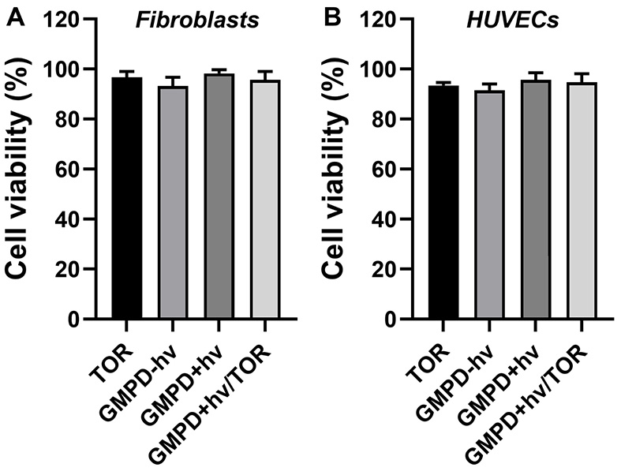
Supplementary Fig. 8. A, B) The CCK-8 data of 1% w/v extract solution of TOR microspheres, GMPD-hv, GMPD+hv, and GMPD+hv/TOR hydrogels after 24-hours culture for both fibroblasts (A) and HUVECs (B).

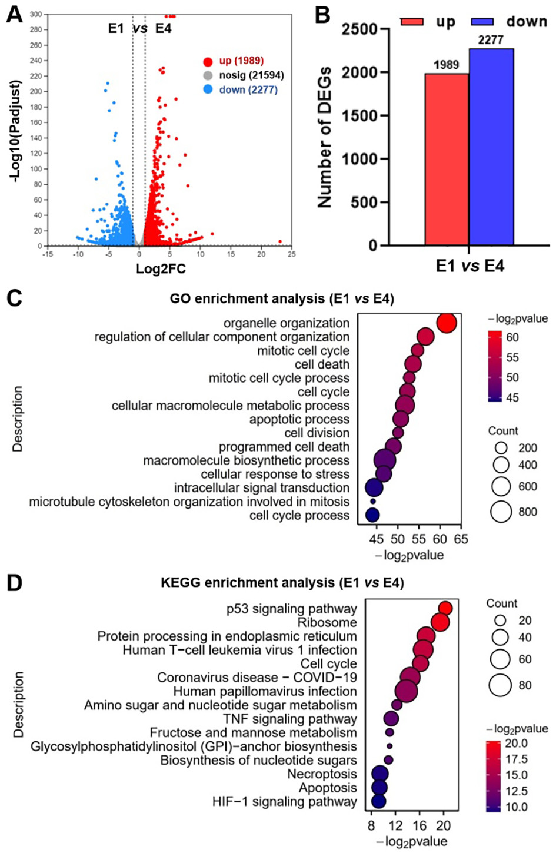
Supplementary Fig. 9. A, B) Volcano plot (A) and statistical data (B) of endothelial cell DEGs analyzed between the E1 and E4 groups. C, D) The Gene Ontology (GO, C) and Kyoto Encyclopedia of Genes and Genomes (KEGG, D) enrichment analyses of endothelial cell DEGs after mRNA sequencing in TOR-functionalized hydrogels between the E1 and E4 groups, including the top 15 representative upregulated or downregulated signaling pathways.

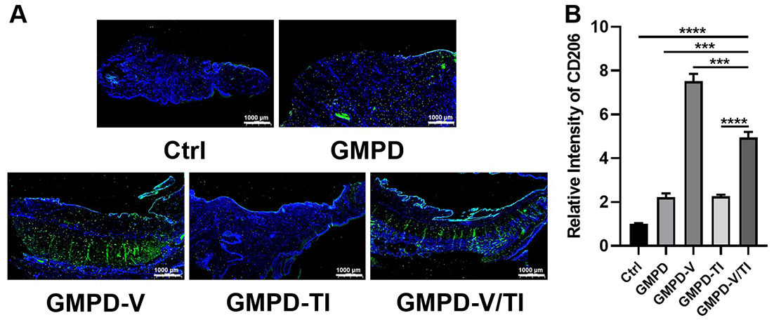
Supplementary Fig. 10. A, B) Immunofluorescence staining (A) and quantitative expression level (B) of the rabbit urethral canal for evaluating the inflammatory response (CD206) after different treatments (i.e., GMPD, GMPD-V, GMPD-TI, GMPD-V/TI, and Ctrl groups) for 8 weeks.

