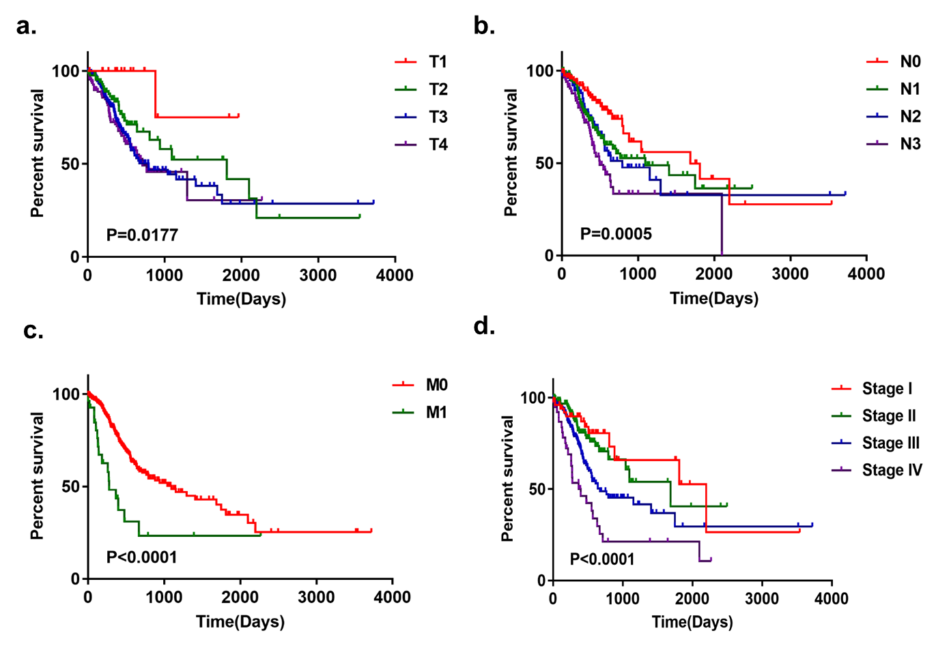
Figure. S1. Kaplan-Meier curves of the clinical factors in GC.
Survival curves of tumor (T)(a), lymph (N)(b), metastasis (M)(c), and stage (d) for GC.

Figure. S2. Genetic alteration of 8 autophagy-associated genes in the GC cohort (TCGA, Firehose Legacy dataset).

