The effects of the geometry parameters and oxidation on the localized surface plasmon resonance properties of copper nanoparticle thin film via calculation
Zhonghua Liu^{1#}, Bing Xu^{1#},Yuqing Chen², Mengting Si³, Xiangqian Chu¹, Yingcui Fang¹*, Mengtao Sun²*
¹Department of Vacuum Science and Technology, Hefei University of Technology, Hefei 230009, China
²School of Mathematics and Physics, University of Science and Technology Beijing, Beijing 100083, China.
3 School of Physics, Peking University, Beijing 100083, China.

*Corresponding author: ycfang@hfut.edu.cn, mengtaosun@ustb.edu.cn (M. T. Sun)

1. Table S1 The evolution of resonance wavelength with the diameters of the nanoparticles (D) and the interparticle distance (L/D).

D (nm) | L/D | Resonance Wavelength(nm)
D (nm) | L/D | n=1 | n=1.5 | n=2
5 | 2 | 540 | 580 | 610
5 | 1.5 | 540 | 580 | 620
5 | 1.1 | 560 | 600 | 640
5 | 1.01 | 570 | 630 | 720
10 | 2 | 540 | 580 | 610
10 | 1.5 | 540 | 580 | 620
10 | 1.1 | 560 | 600 | 650
10 | 1.01 | 570 | 630 | 730
15 | 2 | 540 | 580 | 610
15 | 1.5 | 540 | 580 | 620
15 | 1.1 | 560 | 600 | 650
15 | 1.01 | 570 | 630 | 730
50 | 2 | 550 | 590 | 640
50 | 1.5 | 540 | 600 | 650
50 | 1.1 | 560 | 620 | 740
50 | 1.01 | 580 | 660 | >800

2. The schematic diagram shown how to determine the average nanoparticle size D, the average thickness t, and the average distance L between two nanoparticles of Figure 4c.
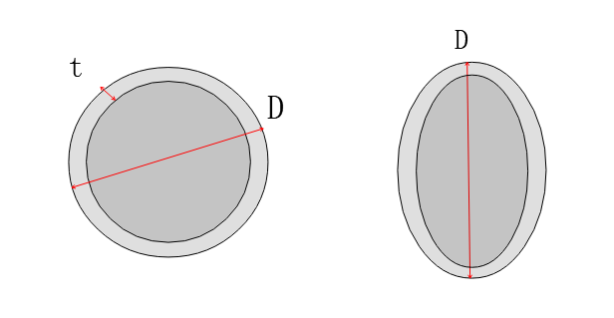
L

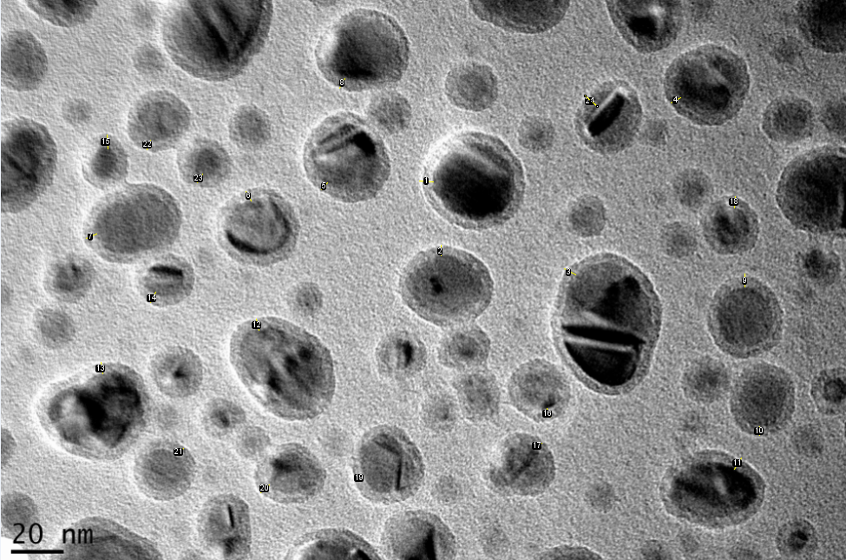
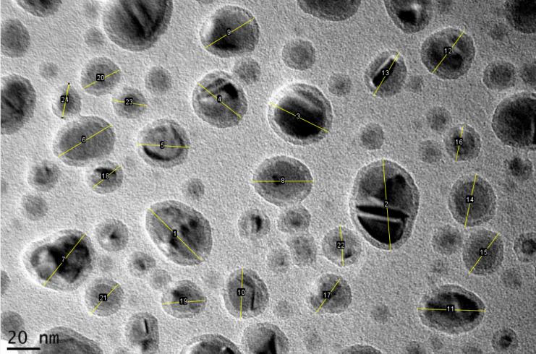
The mean t is 4.682 nm

The mean D is 35.864 nm

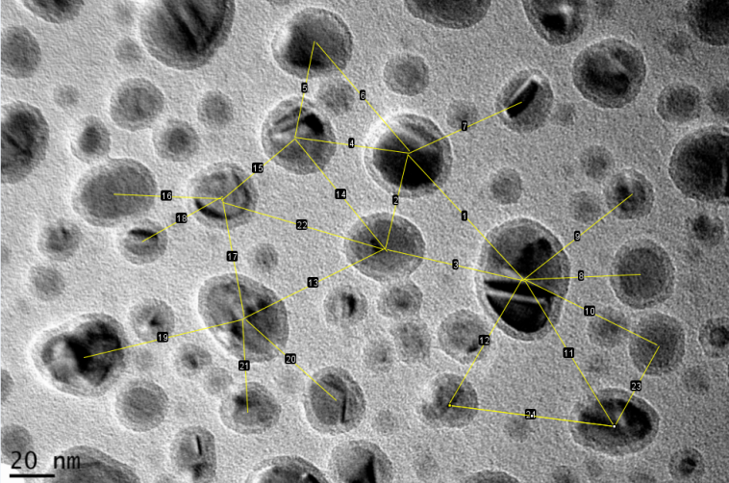
The mean L is 66.348 nm

3. Table S2. The redshift amount of the LSPR with n and t/R, when L/D decreased from 2 to 1.01.

n | Redshift(nm)
n | t/R=0.1 | 0.2 | 0.3 | 0.4 | 0.5 | 0.6
1 | 15 | 10 | 5 | 10 | 5 | 5
1.5 | 30 | 15 | 15 | 10 | 5 | 5
2 | 45 | 25 | 15 | 15 | 10 | 0

