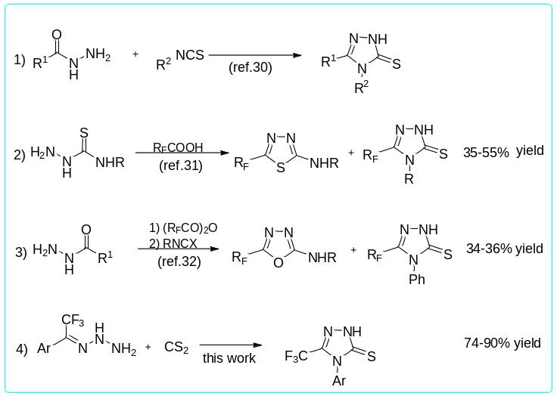
Scheme 1. Synthesis of trifluoromethyl-substituted triazolethione derivatives.

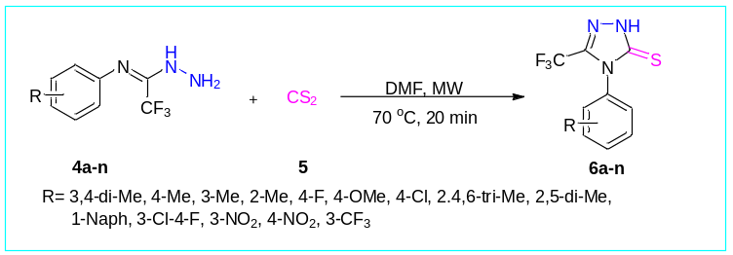
Scheme 2. Synthesis of 4-aryl-3-(trifluoromethyl)-1H-1,2,4-triazole-5(4H)-thione derivatives (6a-n).

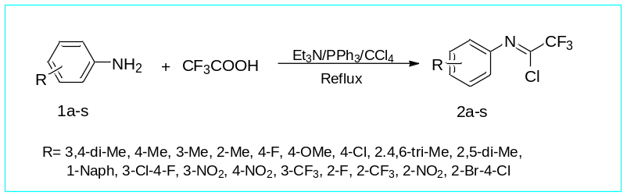
Scheme 3. Synthesis of trifluoroacetimidoyl chloride derivatives 2a-s.

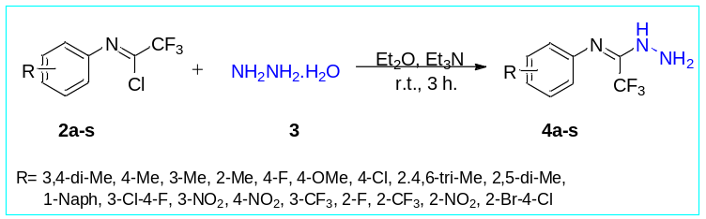
Scheme 4. Synthesis of trifluoroacetimidohydrazides derivatives 4a-s.

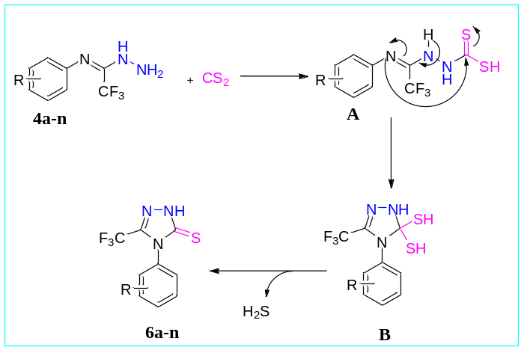
Scheme 5. A possible mechanism for the synthesis of 4-aryl-3-(trifluoromethyl)-1H-1,2,4-triazole-5(4H)-thione derivatives 6a-n.

