Table 1. Optimization of conditions reaction for synthesis of the 4-(3,4-dimethyl phenyl)-3-(trifluoromethyl)-1H-1,2,4-triazole-5(4H)-thione (6d).
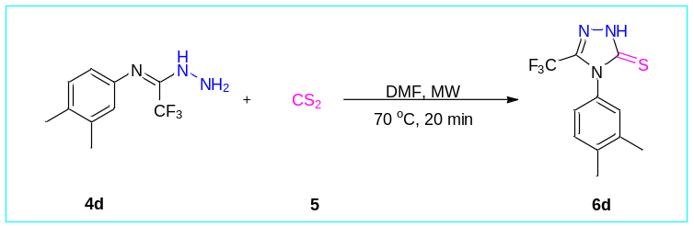
Entry | Solvent | 4:5(mmol) | Temp.(ºC) ª | Time | Yield(%)
1 | THF | 1:1 | r.t. | 24 (h) | N.R.
2 | CH₃CN | 1:1 | r.t. | 24 (h) | N.R.
3 | Toluene | 1:1 | r.t. | 24 (h) | 16
4 | DMF | 1:1 | r.t. | 24 (h) | 21
5 | DMF | 1:2 | r.t. | 24 (h) | 35
6 | DMF | 1:3 | r.t. | 24 (h) | 37
7 | DMF | 1:4 | r.t. | 24 (h) | 40
8 | DMF | 1:5 | r.t. | 24 (h) | 53
9 | THF | 1:5 | Reflux | 24 (h) | Trace
10 | CH₃CN | 1:5 | Reflux | 24 (h) | Trace
11 | Toluene | 1:5 | Reflux | 24 (h) | 23
12 | DMF | 1:5 | Reflux | 24 (h) | 26
13 | THF | 1:5 | MW(50ºC,500W)^{b} | 10(min) | Trace
14 | CH₃CN | 1:5 | MW(50ºC,500W)^{b} | 10(min) | Trace
15 | Toluene | 1:5 | MW(50ºC,500W)^{b} | 10(min) | 23
16 | DMF | 1:5 | MW(50ºC,500W)^{b} | 10(min) | 58
17 | DMF | 1:5 | MW(50ºC,500W)^{b} | 20(min) | 61
18 | DMF | 1:5 | MW(60ºC,500W)^{b} | 20(min) | 67
19 | DMF | 1:5 | MW(70ºC,500W)^{b} | 20(min) | 74
20 | DMF | 1:5 | MW(70ºC,700W)^{b} | 20(min) | 90
ªReaction conditions: solvent was 1 mL, (1.0 mmol) 4d.
^{b}Optimal thermal microwave-assisted conditions, (1.0 mmol) 4d with (5 mmol) 5, in solvent was 1 mL.

Table 2. Synthesis of 4-aryl-3-(trifluoromethyl)-1H-1,2,4-triazole-5(4H)-thione derivatives (6a-s).
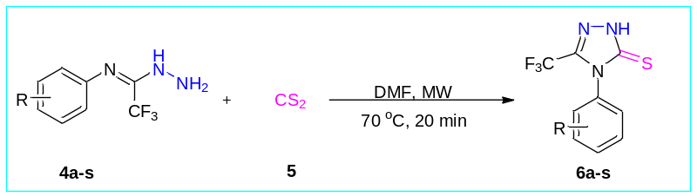
 | Product | Yield(%) | Mp(°C)
6a | 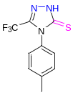 | 90 | 169-171
6b | 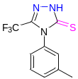 | 81 | 157-159
6c | 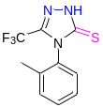 | 78 | 170-172
6d | 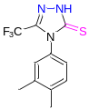 | 85 | 149-151
6e | 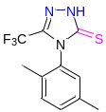 | 84 | 175-177
6f | 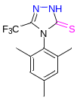 | 86 | 181-183
6g | 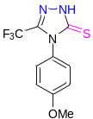 | 87 | 189-191
6h | 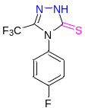 | 77 | 183-185
6i | 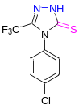 | 79 | 182-184
6j | 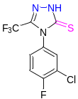 | 74 | 150-152
6k | 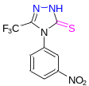 | 82 | 172-174
6l | 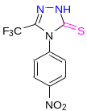 | 84 | 149-151
6m | 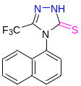 | 81 | 200-202
6n | 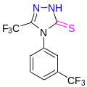 | 74 | 207-209
6o | 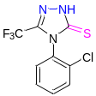 | 0 | -
6p | 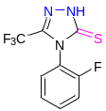 | 0 | -
6q | 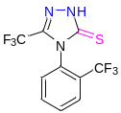 | 0 | -
6r | 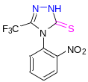 | 0 | -
6s | 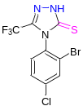 | 0 | -

