A Facile and Catalyst-Free Microwave-Promoted Method for the Synthesis of 3-Trifluoromethyl 1,2,4-triazole-5-thiones
Najmeh Zeinaliª, Ali Darehkordi*ª

Department of Chemistry, Faculty of Science, Vali-e-Asr University of Rafsanjan, Rafsanjan 77176, Iran
E-mail: darehkordi@vru.ac.ir; adarehkordi@yahoo.com

General information.
All substrates and solvents were purchased from commercial sources and used without further purification unless otherwise stated. Also all products were obtained in microwave conditions with the microwave digestion device model, Ethos 1 from Millstone Company. TLC was performed on Merck 60 F254 silica gel plates, visualization by a UV lamp (254 nm). Melting points were obtained by Barnstead Electro thermal 9200 apparatus and are uncorrected. IR spectra were recorded on a Bruker FT-IR Equinax-55 spectrophotometer in KBr with absorption in cm⁻¹. All of the NMR spectra were recorded on a Varian model UNITYInova 500 MHz spectrometer (¹H: 500 ¹³C: 125, ¹⁹F: 470.3 MHz) in DMSO using TMS as an internal standard. Chemical shifts of ¹H and ¹³C NMR are reported in parts per million (ppm) from tetramethylsilane as an internal standard and for ¹⁹F NMR in parts per million (ppm) from CFCl₃ as an internal standard, in DMSO-d₆ as a solvent; the coupling constants J are given in Hz and spectra were recorded in parts per million (ppm). Elemental analyses were performed using a Carlo Erba EA 1108 instrument.
General procedure for the synthesis of compounds 2a-s
A mixture of primary aromatic amine, trifluoroacetic acid, triphenylphosphine, and triethylamine in CCl₄ as solvent under reflux to give trifluoromethylimidoyl chlorides 2 according to the reported procedure.³³ Distillation and work-up provided the target imidoyl chlorides in good to great yields.

General procedure for the synthesis of compounds 4a-s
A mixture of N-aryl-2,2,2-trifluoroacetimidoyl chloride 2 (1 mmol), hydrazine hydrate 3 (1.25 mmol), Et₃N (1 mmol), and Et₂O (5 mL) was stirred at r.t. After completion of the reaction (3 h), as indicated by TLC (3:1 n-hexane/EtOAc), the reaction mixture was filtered. After removal of the solvent under reduced pressure, the crude product was purified by washing with n-hexane several times.³²
General procedure for the synthesis of compounds 6a-n.
To an oven-dried Schlenk tube equipped with a magnetic stirring bar, were added the appropriate 2,2,2-trifluoro-N′′-phenylacetimidohydrazide 4 (1 mmol), carbon disulfide 5 (5 mmol), and DMF (1 mL) and then was irradiated in a microwave oven at 700 W for 20 min. After completion of the reaction, as indicated by TLC (3:1 n-hexane/EtOAc), the reaction mixture was added to a 10% sodium bicarbonate solution and ice, and then filter the precipitate formed. The product was purified by washing with diethyl ether several times.

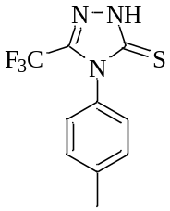
4-(P-tolyl)-3-(trifluoromethyl)-1H-1,2,4-triazole-5(4H)-thione (6a).
Yield: 0.227 g (90%); cream colored solid; mp 169-171 °C. ¹H-NMR (500 MHz, DMSO d₆) δ = 9.56 (s, 1H, NH), 7.33 (d, 2H, J= 8.2 Hz, HAr), 7.11 (d, 2H, J= 8.2 Hz, HAr), 2.27 (s, 3H, Me).¹³C-NMR (125 MHz, DMSO d₆) δ = 180.16, 160.68 (q, ²J_{CF}= 37.7 Hz), 137.33, 134.05, 129.30, 126.82 (q, ¹J_{CF}= 283.1 Hz), 124.32, 20.95 (Me). ¹⁹F-NMR (DMSO d₆, 470.33 MHz) δ = -58.32. IR KBr(ῡ_{max}, cm⁻¹): 704, 758, 810 (CF₃), 1140 (C=S), 1588 (C=N), 3150 (NH). Anal.Calcd for (C₁₀H₈F₃N₃S); C, 46.33; H, 3.11; N, 16.21%. Found: C, 46.65; H, 3.19; N, 15.97 %.

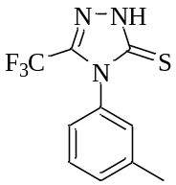
4-(m-tolyl)-3-(trifluoromethyl)-1H-1,2,4-triazole-5(4H)-thione (6b).
Yield: 0.209 g (81%); cream colored solid; mp 157-159 °C. ¹H-NMR (500 MHz, DMSO d₆) δ = 9.69 (s, 1H, NH), 7.24-7.31 (m, 2H, HAr), 7.19 (t, 1H, J= 7.8 Hz, HAr), 6.92 (d, 1H, J= 7.8 Hz, HAr) 2.27 (s, 3H, Me). ¹³C-NMR (125 MHz, DMSO d₆) δ = 179.90, 148.16 (q, ²J_{CF}= 36.1 Hz), 139.91, 138.07, 128.65, 125.52, 124.63, 121.31, 115.32 (q, ¹J_{CF}= 255.4 Hz), 21.49 (Me). ¹⁹F-NMR (DMSO d₆, 470.33 MHz) δ = -61.47. IR KBr (ῡ_{max}, cm⁻¹): 700, 748, 783 (CF₃), 1164 (C=S), 1588 (C=N), 3349 (NH). Anal.Calcd for (C₁₀H₈F₃N₃S); C, 46.33; H, 3.11; N, 16.21%. Found: C, 46.70; H, 2.97; N, 16. 37 %.
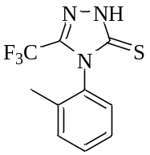
4-(o-tolyl)-3-(trifluoromethyl)-1H-1,2,4-triazole-5(4H)-thione (6c).
Yield: 0.202 g (78%); cream colored solid; mp 170-172 °C. ¹H-NMR (500 MHz, DMSO d₆) δ = 9.12 (s, 1H, NH), 7.24 (m, 2H, HAr), 7.16 (2H, HAr), 2.24 (s, 3H, Me).¹³C-NMR (125 MHz, DMSO d₆) δ = 181.70, 138.27, 135.48, 135.44 (q, ²J_{CF}= 46.4 Hz), 130.74, 129.35 (q, ¹J_{CF}= 238.7 Hz), 128.66, 126.99, 126.55, 18.23 (Me).¹⁹F-NMR (DMSO d₆, 470.33 MHz) δ = -60.81. IR KBr(ῡ_{max}, cm⁻¹): 718, 737, 756 (CF₃), 1154 (C=S), 1527 (C=N), 3336 (NH). Anal.Calcd for (C₁₀H₈F₃N₃S); C, 46.33; H, 3.11; N, 16.21%. Found: C, 46.09; H, 3.43; N,16.57 %.
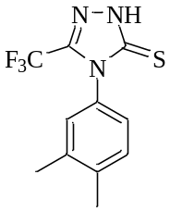
4-(3,4-dimethylphenyl)-3-(trifluoromethyl)-1H-1,2,4-triazole-5(4H)-thione (6d).
Yield: 0.232 g (85%); cream colored solid; mp 149-151 °C. ¹H-NMR (500 MHz, DMSO d₆) δ = 9.45 (s, 1H, NH), 7.18 (s, 1H, HAr), 7.14 (dd, 1H, J= 8.0 Hz, J= 2.0 Hz, HAr), 7.05 (d, 1H, J= 8.0 Hz, HAr), 2.18 (s, 3H, Me), 2.17 (s, 3H, Me).¹³C-NMR (125 MHz, DMSO d₆) δ = 180.09, 179.22 (q, ²J_{CF} = 39.8 Hz), 153.02 (q, ¹J_{CF} = 263.5 Hz), 137.49, 136.51, 132.89, 129.77, 125.63, 121.96, 19.89 (Me), 19.23 (Me).¹⁹F NMR (DMSO d₆, 470.33 MHz) δ = -58.30. IR KBr(ῡ_{max}, cm⁻¹): 680, 720, 811 (CF₃), 1024 (C=S), 1586 (C=N), 3250 (NH).Anal.Calcd for (C₁₁H₁₀F₃N₃S); C, 48.35; H, 3.69; N, 15.38%. Found: C, 48.67; H, 3.71; N, 15.42 %.
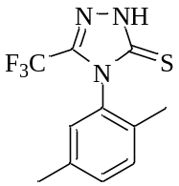
4-(2,5-dimethylphenyl)-3-(trifluoromethyl)-1H-1,2,4-triazole-5(4H)-thione (6e).
Yield: 0.229 g (84%); cream colored solid; mp 175-177 °C. ¹H-NMR (500 MHz, DMSO d₆) δ = 9.28 (s, 1H, NH), 7.08 (d, 1H, J= 7.5 Hz, HAr), 7.05 (s, 1H, HAr), 6.94 (d, 1H, J= 7.5 Hz, HAr), 2.24 (s, 3H, Me), 2.18 (s, 3H, Me).¹³C-NMR (125 MHz, DMSO d₆) δ = 181.65, 173.26 (q, ²J_{CF} = 36.1 Hz), 138.09, 135.45, 132.11, 130.47, 129.00, 127.48, 126.24 (q, ¹J_{CF} = 284.2 Hz), 20.92 (Me), 17.87 (Me).¹⁹F NMR (DMSO, 470.33 MHz) δ = -58.40.IR KBr(ῡ_{max}, cm⁻¹): 717, 780, 806 (CF₃), 1153 (C=S), 1578 (C=N), 3346 (NH). Anal.Calcd for (C₁₁H₁₀F₃N₃S); C, 48.35; H, 3.69; N, 15.38%. Found: C, 48.23; H, 3.83; N, 15.50 %.
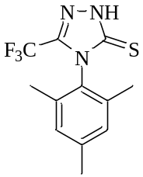
4-mesityl-3-(trifluoromethyl)-1H-1,2,4-triazole-5(4H)-thione (6f).
Yield: 0.246 g (86%); cream colored solid; mp 181-183 °C. Major isomer: ¹H-NMR (500 MHz, DMSO d₆) δ = 8.10 (s, 1H, NH), 6.99 (s, 2H, H-Ar), 2.30 (s, 3H, Me), 1.96 (s, 6H, 2Me). Minor isomer: ¹H-NMR (500 MHz, DMSO d₆) δ = 8.64 (s, 1H, NH), 6.77 (s, 2H, HAr), 2.19 (s, 3H, Me), 1.86 (s, 6H, 2Me). Major isomer: ¹³C-NMR (125 MHz, DMSO d₆) δ = 171.82, 162.83 (q, ²J_{CF} = 33.0 Hz), 155.81, 140.26, 135.94, 128.99, 109.52 (q, ¹J_{CF} = 280.0 Hz), 20.95, 17.27. Minor isomer: ¹³C-NMR (125 MHz, DMSO d₆) δ = 172.50, 164.08 (q, ²J_{CF} = 45.0 Hz), 159.44, 145.25, 136.18, 129.38, 125.63 (q, ¹J_{CF} = 290.2 Hz), 21.08, 17.92. Major isomer: ¹⁹F NMR (DMSO, 470.33 MHz) δ = -63.00. Minor isomer: ¹⁹F NMR (DMSO, 470.33 MHz) δ = -67.23. IR KBr(ῡ_{max}, cm⁻¹): 753, 851, 928 (CF₃), 1148 (C=S), 1526 (C=N), 3373 (NH). Anal.Calcd for (C₁₂H₁₂F₃N₃S); C, 50.17; H, 4.21; N, 14.63%. Found: C, 50.03; H, 4.29; N, 14.37%.
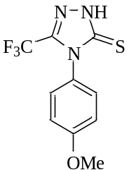
4-(4-methoxyphenyl)-3-(trifluoromethyl)-1H-1,2,4-triazole-5(4H)-thione (6g).
Yield: 0.236 g (86%); cream colored solid; mp 189-191 °C. ¹H-NMR (500 MHz, DMSO d₆) δ = 9.57 (s, 1H, NH), 7.31 (d, 2H, J= 8.9 Hz, H-Ar), 6.78 (d, 2H, J= 8.9 Hz, H-Ar), 3.72 (s, 3H, OMe). ¹³C-NMR (125 MHz, DMSO d₆) δ = 180.66, 156.89, 132.84, 126.27, 115.45 (q, ²J_{CF} = 35.8 Hz), 114.07, 109.78 (q, ¹J_{CF} = 261.8 Hz), 55.71 (OMe). ¹⁹F NMR (DMSO, 470.33 MHz) δ = 62.65. IR KBr(ῡ_{max}, cm⁻¹): 723, 756, 786 (CF₃), 1032 (C=S), 1550 (C=N), 3219 (NH). Anal.Calcd for (C₁₀H₈F₃N₃OS); C, 43.64; H, 2.93; N, 15.27%. Found: C, 43.90; H, 3.09; N,15.45 %.

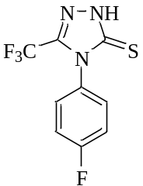
4-(4-fluorophenyl)-3-(trifluoromethyl)-1H-1,2,4-triazole-5(4H)-thione (6h).
Yield: 0.202 g (77%); cream colored solid; mp 183-185 °C. ¹H-NMR (500 MHz, DMSO d₆) δ = 9.83 (s, 1H, NH), 7.48-7.46 (m, 2H, H-Ar), 7.17-7.14 (m, 2H, H-Ar). ¹³C-NMR (125 MHz, DMSO d₆) δ =182.59 (q, ²J_{C,F} = 43.7 Hz), 180.85, 159.61 (d, ¹J_{C,F} = 239.9 Hz), 136.16, 131.73 (q, ¹J_{C,F} = 285.7 Hz), 126.58 (d, ³J_{C,F} = 8.1 Hz), 115.45 (d, ²J_{C,F} = 22.3 Hz). ¹⁹F NMR (DMSO, 470.33 MHz) δ = -60.36, -61.58. IR KBr(ῡ_{max}, cm⁻¹): 672, 720, 764 (CF₃), 1087 (C=S), 1550 (C=N), 3220 (NH). Anal.Calcd for (C₉H₅F₄N₃S); C, 41.07; H, 1.91; N, 15.96%. Found: C, 41.26; H, 2.13; N, 16.28%.

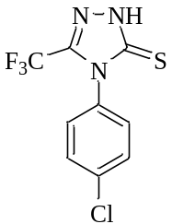
4-(4-chlorophenyl)-3-(trifluoromethyl)-1H-1,2,4-triazole-5(4H)-thione (6i).
Yield: 0.219 g (79%); cream colored solid; mp 182-184 °C. ¹H-NMR (500 MHz, DMSO d₆) δ = 10.92 (s, 1H, NH), 7.64 (d, 2H, J= 8.7 Hz, H-Ar), 7.36 (d, 2H, J= 8.7 Hz, H-Ar). ¹³C-NMR (125 MHz, DMSO d₆) δ = 179.73, 172.01 (q, ²J_{CF} = 45.6 Hz), 162.74, 142.36 (q, ¹J_{CF} = 242.5 Hz), 138.99, 128.63, 124.85. ¹⁹F NMR (DMSO, 470.33 MHz) δ = -58.39. IR KBr(ῡ_{max}, cm⁻¹): 673, 728, 804 (CF₃), 1012 (C=S), 1591 (C=N), 3211 (NH). Anal.Calcd for (C₉H₅ClF₃N₃S); C, 38.65; H, 1.80; N, 15.02%. Found: C, 38.33; H, 1.67; N, 15.19 %.
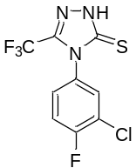
4-(3-chloro-4-fluorophenyl)-3-(trifluoromethyl)-1H-1,2,4-triazole-5(4H)-thione (6j).
Yield: 0.219 g (74%); cream colored solid; mp 150-152 °C. ¹H-NMR (500 MHz, DMSO d₆) δ = 10.94 (s, 1H, NH), 7.91 (dd, 1H, J= 8.0, 2.5 Hz, HAr), 7.47-7.50 (m, 1H, HAr), 7.38 (t, 1H, J= 8.0 Hz, HAr). ¹³C-NMR (125 MHz, DMSO d₆) δ = 180.25, 154.46 (d, ¹J_{CF} = 242.5 Hz), 137.05, 125.24, 124.14, 119.12 (d, ³J_{CF} = 18.4 Hz), 116.93 (d, ³J_{CF} = 22.0 Hz), 115.54 (q, ²J_{CF} = 28.5 Hz), 114.61 (q, ¹J_{CF} = 203.2 Hz). ¹⁹F NMR (DMSO, 470.33 MHz) δ = -58.31, -121.53. IR KBr(ῡ_{max}, cm⁻¹): 721, 773, 818 (CF₃), 1059 (C=S), 1597 (C=N), 3179 (NH). Anal.Calcd for (C₉H₄ClF₄N₃S); C, 36.32; H, 1.35; N, 14.12%. Found: C, 36.60; H, 1.39; N,14.00 %.
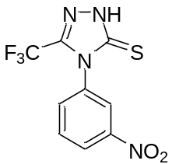
4-(3-nitrophenyl)-3-(trifluoromethyl)-1H-1,2,4-triazole-5(4H)-thione (6k).
Yield: 0.237 g (82%); yellow colored solid; mp 172-174 °C. ¹H-NMR (500 MHz, DMSO d₆) δ = 10.44 (s, 1H, NH), 8.52 (s, 1H, H-Ar), 7.93 (dd, 2H, J= 8.7 Hz, J= 4.8 Hz, H-Ar), 7.61 (t, 1H, 8.7 Hz, H-Ar). ¹³C-NMR (125 MHz, DMSO d₆) δ = 180.54, 155.95 (q, ²J_{CF} = 33.7 Hz), 140.05, 140.92, 130.23, 130.21, 119.51, 119.18 (q, ¹J_{CF} = 296.6 Hz), 118.29. ¹⁹F NMR (DMSO, 470.33 MHz) δ = -61.55. IR KBr(ῡ_{max}, cm⁻¹): 680, 735, 799 (CF₃), 1090 (C=S), 1599 (C=N), 3338 (NH). Anal.Calcd for (C₉H₅F₃N₄O₂S); C, 37.25; H, 1.74; N, 19.30%. Found: C, 37.38; H, 1.80; N,19.57 %.
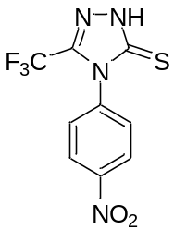
4-(4-nitrophenyl)-3-(trifluoromethyl)-1H-1,2,4-triazole-5(4H)-thione (6l).
Yield: 0.243 g (84%); yellow colored solid; mp 149-151 °C. ¹H-NMR (500 MHz, DMSO d₆) δ = 7.92 (d, 2H, J= 9.1 Hz, HAr), 6.67 (s, 1H, NH), 6.58 (d, 2H, 9.1 Hz, HAr). ¹³C-NMR (125 MHz, DMSO d₆) δ = 186.11, 163.66 (q, ²J_{CF} = 46.8 Hz), 156.11, 136.18, 126.77, 112.83, 107.43 (q, ¹J_{CF} = 275.1 Hz). ¹⁹F NMR (DMSO, 470.33 MHz) δ = -61.32. IR KBr(ῡ_{max}, cm⁻¹): 631, 697, 752 (CF₃), 1112 (C=S), 1631 (C=N), 3481 (NH). Anal.Calcd for (C₉H₅F₃N₄O₂S); C, 37.25; H, 1.74; N, 19.30%. Found: C, 37.03; H, 1.88; N,19.18 %.

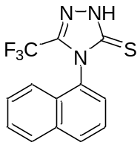
4-(naphthalen-1-yl)-3-(trifluoromethyl)-1H-1,2,4-triazole-5(4H)-thione (6m).
Yield: 0.238 g (81%); cream colored solid; mp 200-202 °C. ¹H-NMR (500 MHz, DMSO d₆) δ = 10.02 (s, 1H, NH), 8.06 (d, 1H, J= 8.0 Hz, HAr), 7.95 (d, 1H, J= 8.0 Hz, HAr), 7.84 (d, 1H, J= 8.0 Hz, HAr), 7.47-7.65 (m, 4H, HAr). ¹³C-NMR (125 MHz, DMSO d₆) δ = 183.40, 174.07 (q, ²J_{CF} = 28.9 Hz), 135.80, 134.36, 130.62, 128.53, 127.15, 126.56, 126.50, 126.14, 126.04, 123.65. ¹⁹F NMR (DMSO, 470.33 MHz) δ = -60.21. IR KBr(ῡ_{max}, cm⁻¹): 601, 638, 660 (CF₃), 1157 (C=S), 1626 (C=N), 3338 (NH). Anal.Calcd for (C₁₃H₈F₃N₃S); C, 52.88; H, 2.73; N, 14.23%. Found: C, 53.09.; H, 2.65; N, 14.49 %.
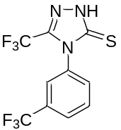
3-(trifluoromethyl)-4-(3-(trifluoromethyl)phenyl)-1H-1,2,4-triazole-5(4H)-thione (6n).
Yield: 0.231 g (74%); cream colored solid; mp 207-209 °C. ¹H-NMR (500 MHz, DMSO d₆) δ = 10.45 (s, 1H, NH), 7.94-7.98 (m, 1H, HAr), 7.76-7.77 (m, 1H, HAr), 7.56-7.59 (m, 1H, HAr), 7.46-7.49 (m, 1H, HAr). ¹⁹F NMR (DMSO, 470.33 MHz) δ = -58.28, 61.21. IR KBr(ῡ_{max}, cm⁻¹): 730, 810, 883 (CF3), 1115 (C=S), 1579 (C=N), 3359 (NH). Anal.Calcd for (C₁₀H₅F₆N₃S); C, 38.35; H, 1.61; N, 13.42%. Found: C, 38.19; H, 1.75; N,13.18 %

4-(P-tolyl)-3-(trifluoromethyl)-1H-1,2,4-triazole-5(4H)-thione (6a)

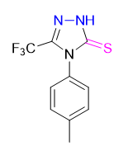
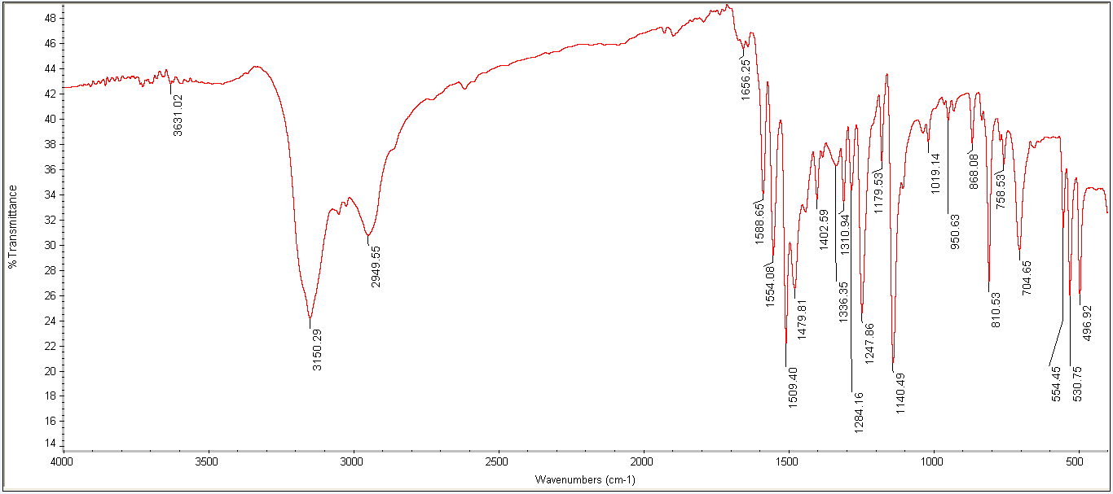
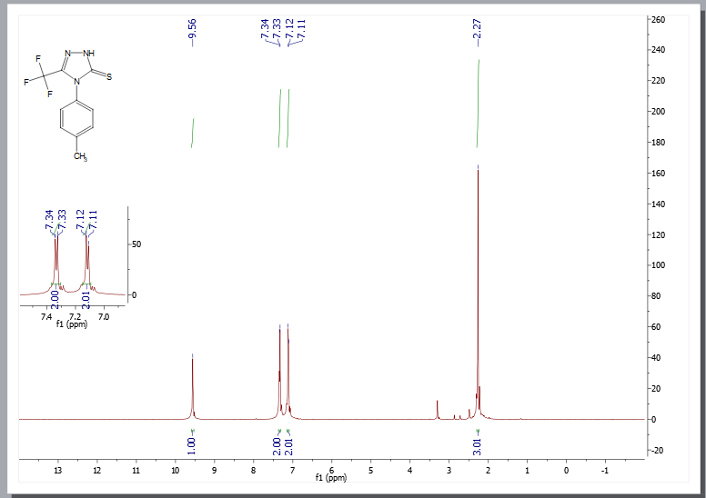

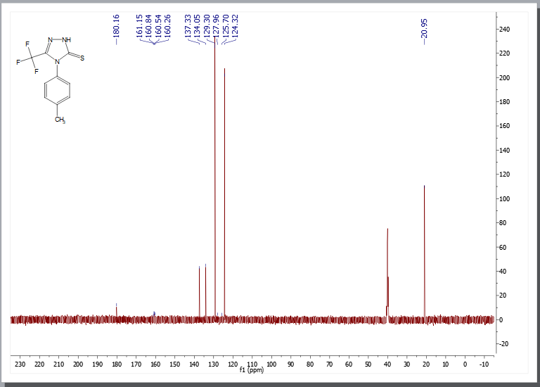
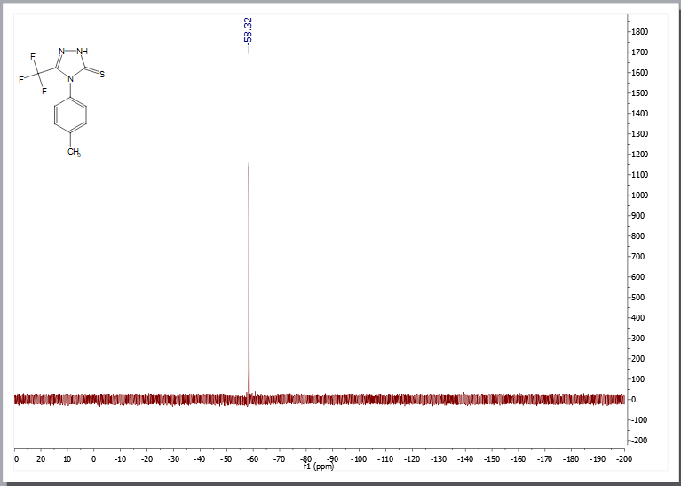

4-(m-tolyl)-3-(trifluoromethyl)-1H-1,2,4-triazole-5(4H)-thione (6b)

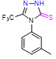
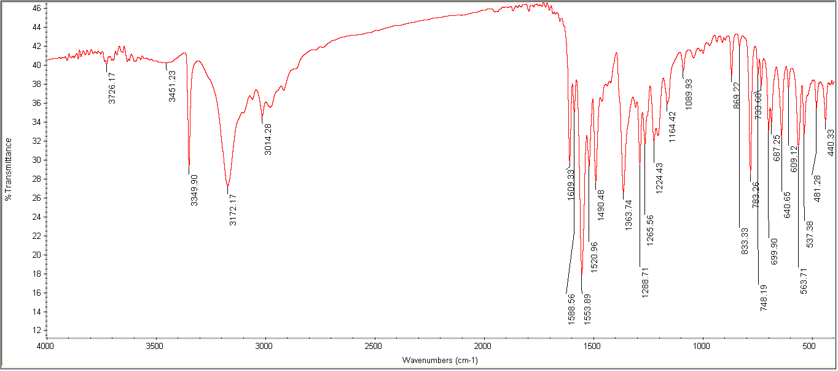
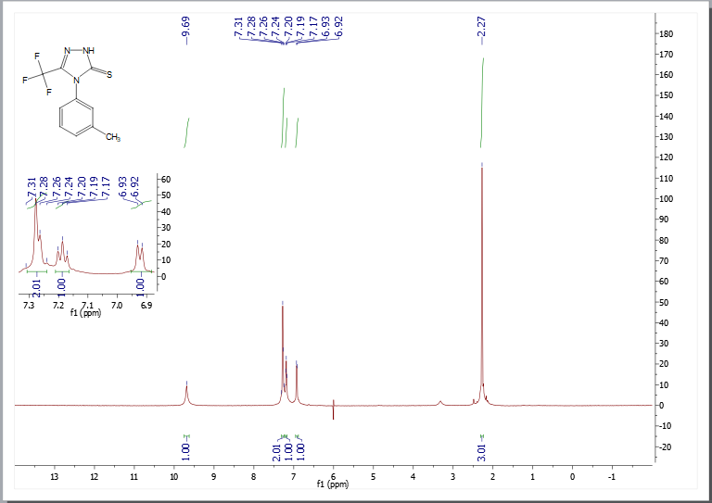
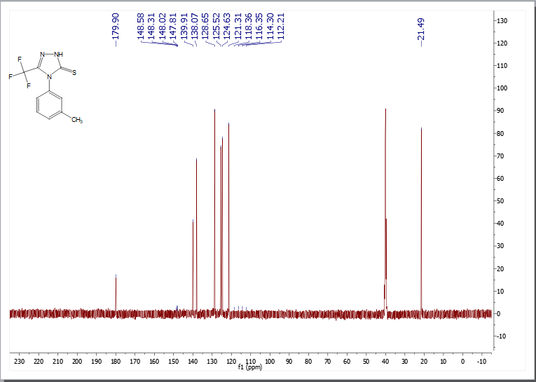
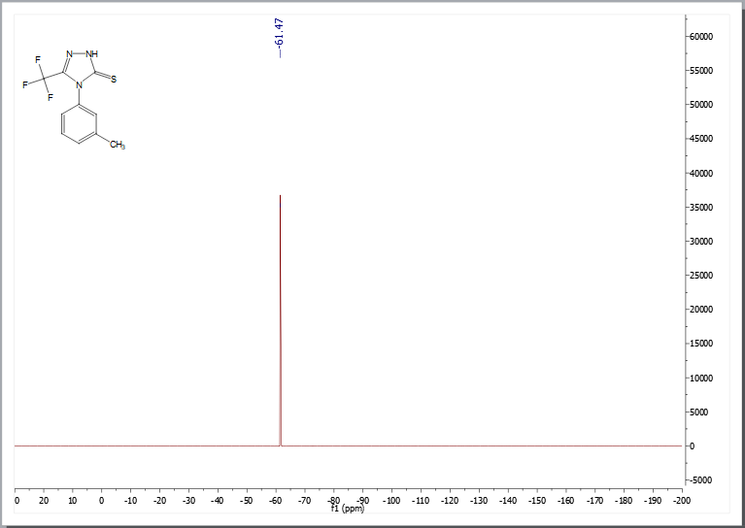

4-(o-tolyl)-3-(trifluoromethyl)-1H-1,2,4-triazole-5(4H)-thione (6c)
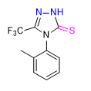
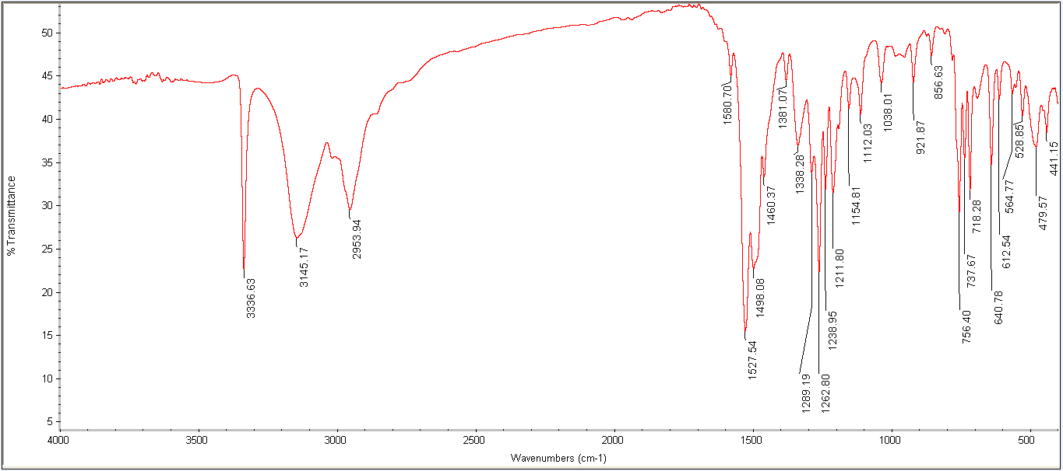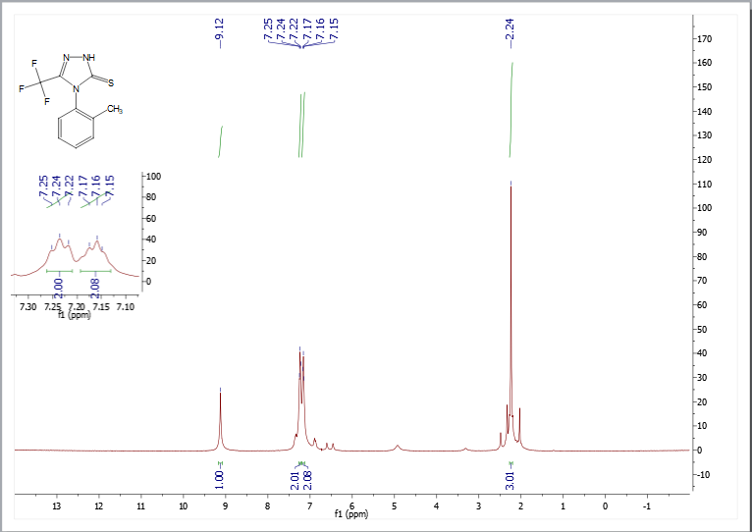
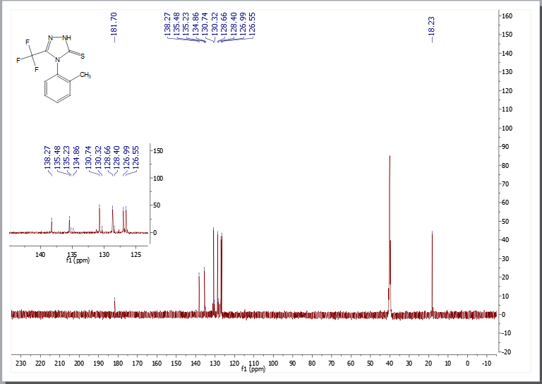
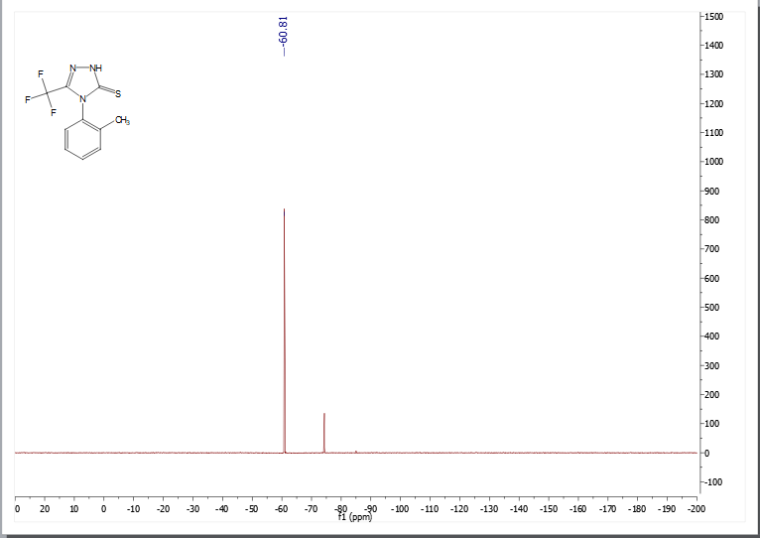

4-(3,4-dimethylphenyl)-3-(trifluoromethyl)-1H-1,2,4-triazole-5(4H)-thione (6d)
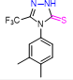
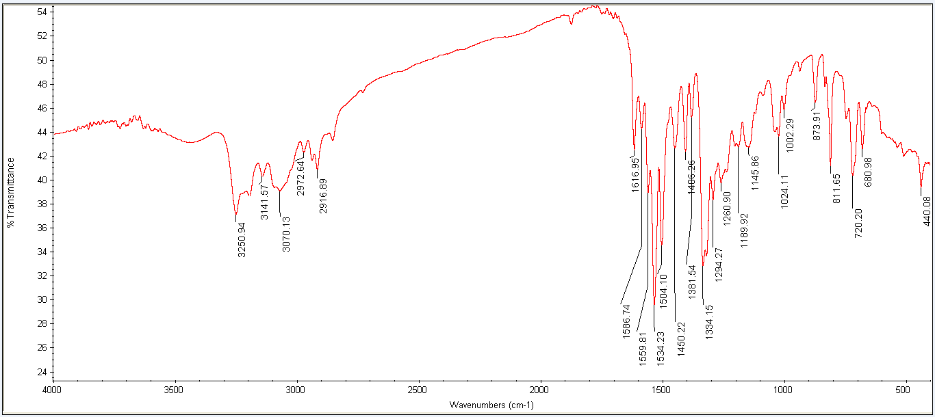
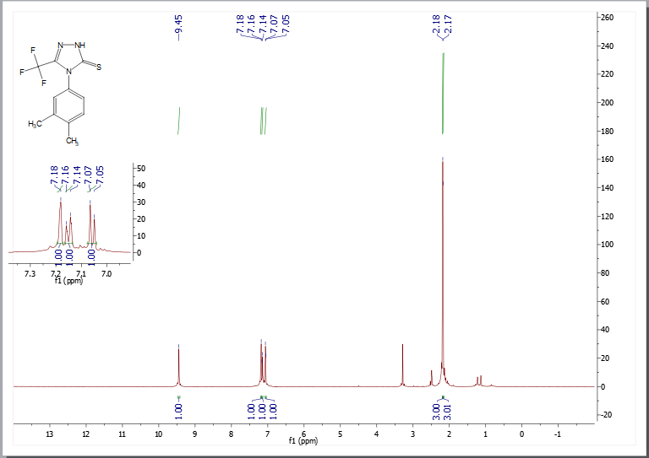
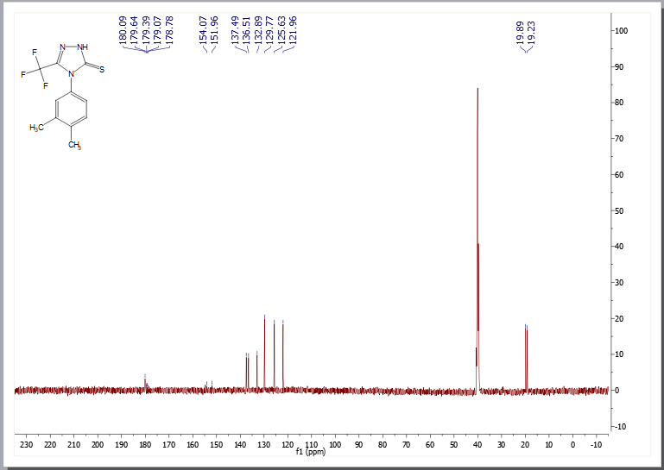
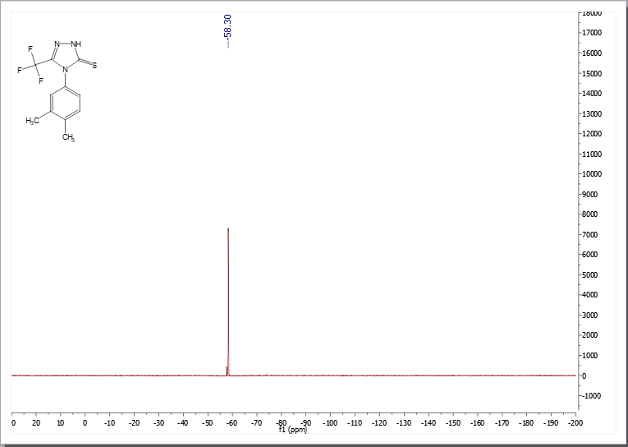

4-(2,5-dimethylphenyl)-3-(trifluoromethyl)-1H-1,2,4-triazole-5(4H)-thione (6e)
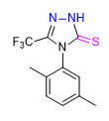
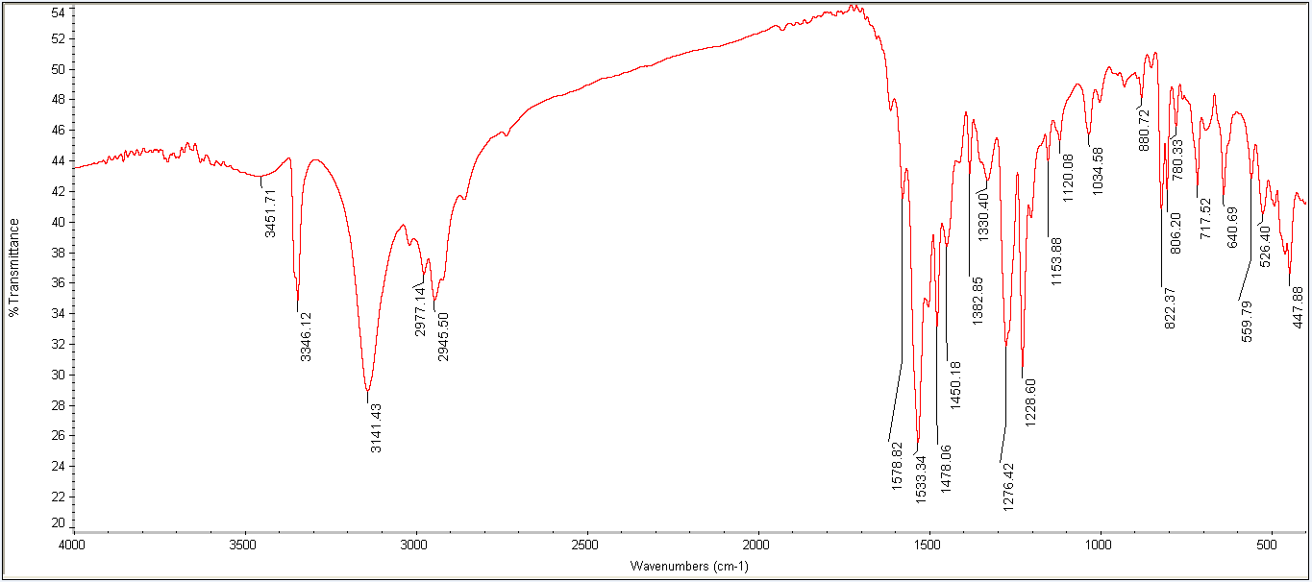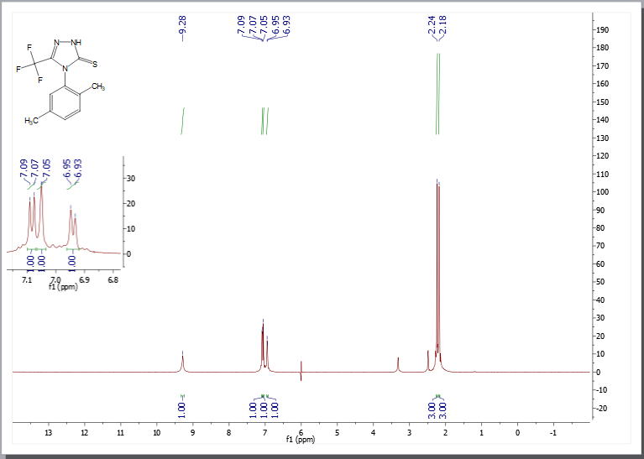
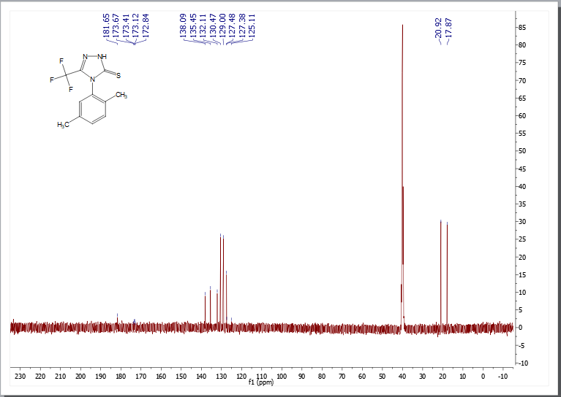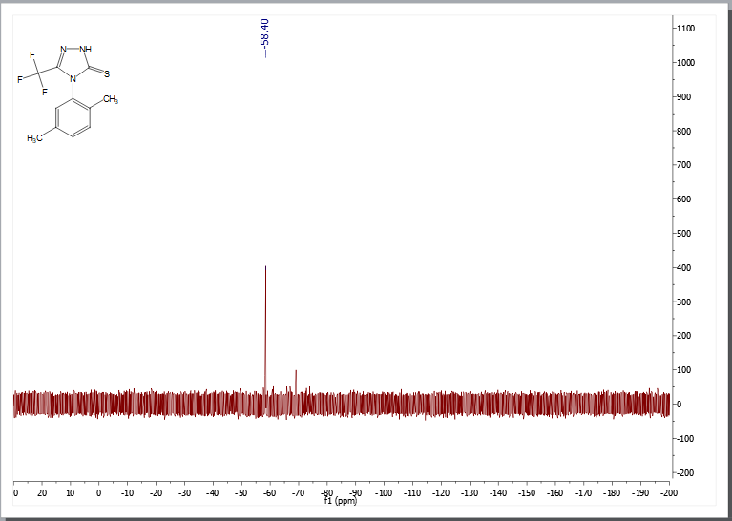

4-mesityl-3-(trifluoromethyl)-1H-1,2,4-triazole-5(4H)-thione (6f)
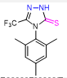
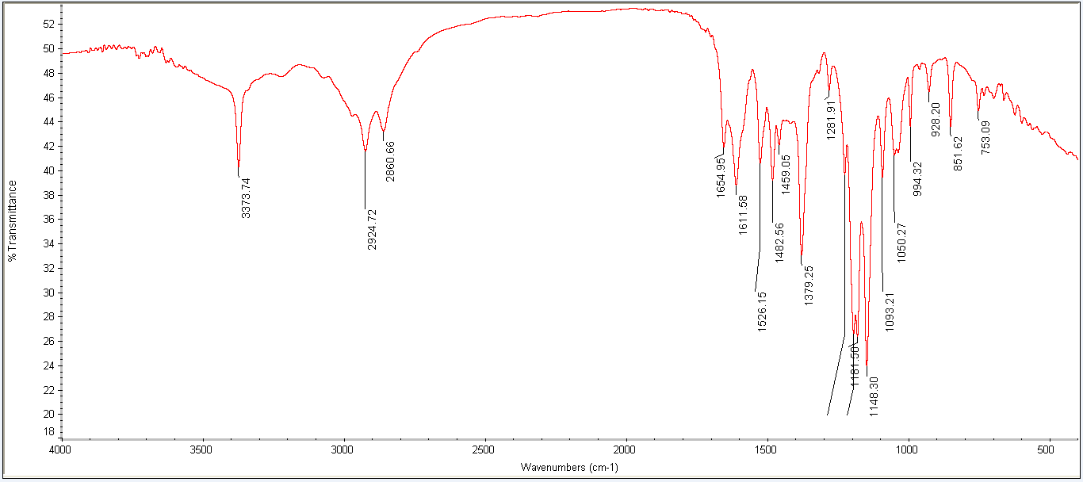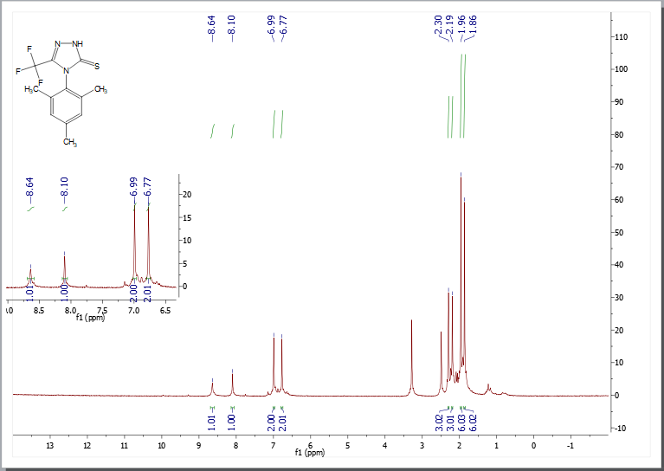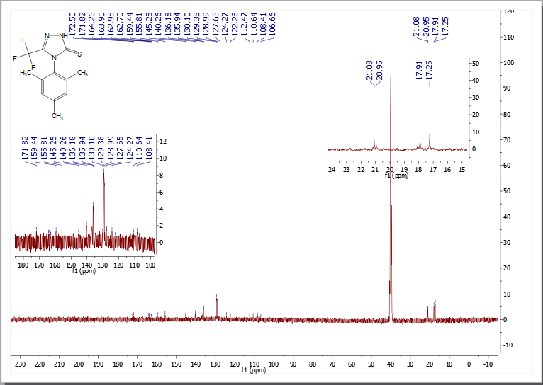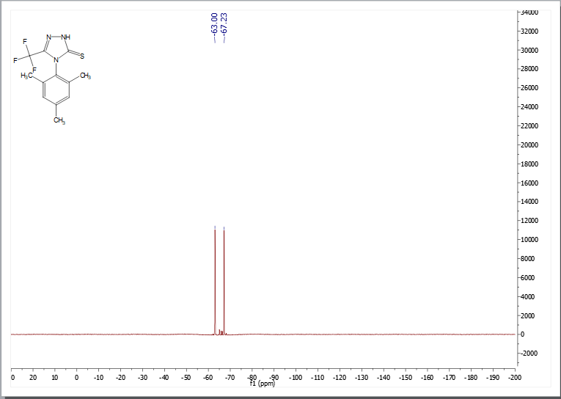

4-(4-methoxyphenyl)-3-(trifluoromethyl)-1H-1,2,4-triazole-5(4H)-thione (6g)
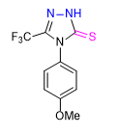
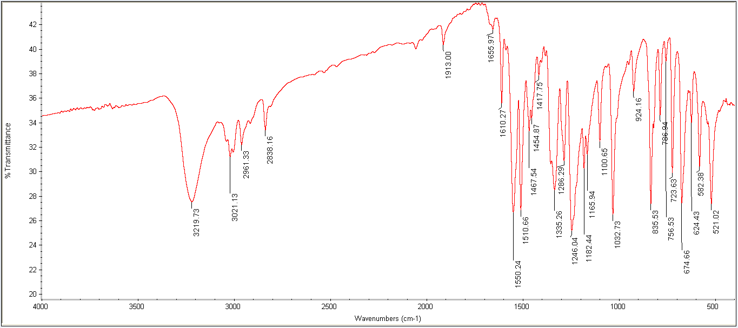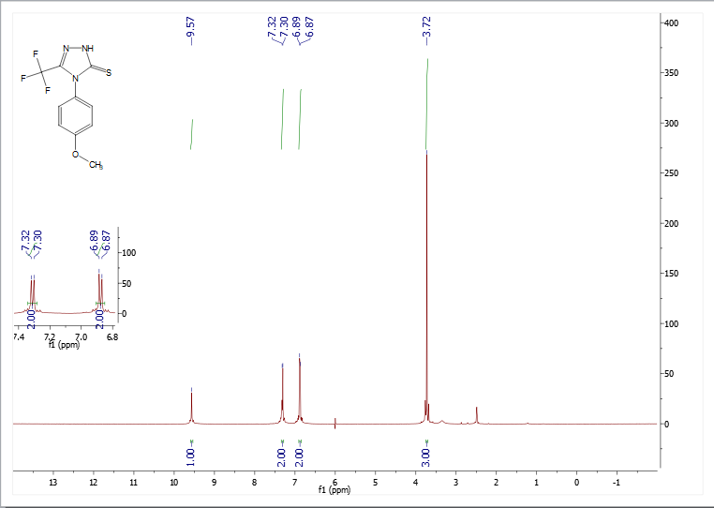
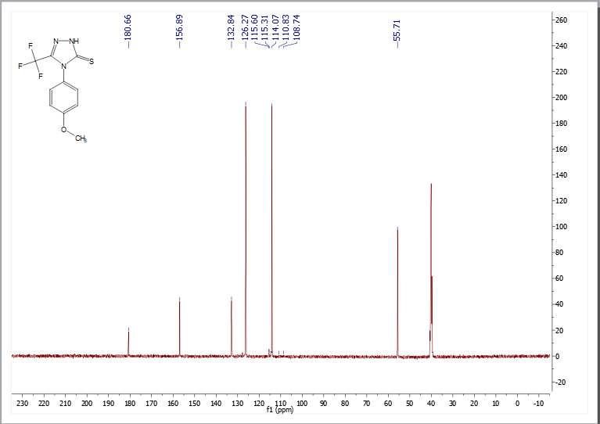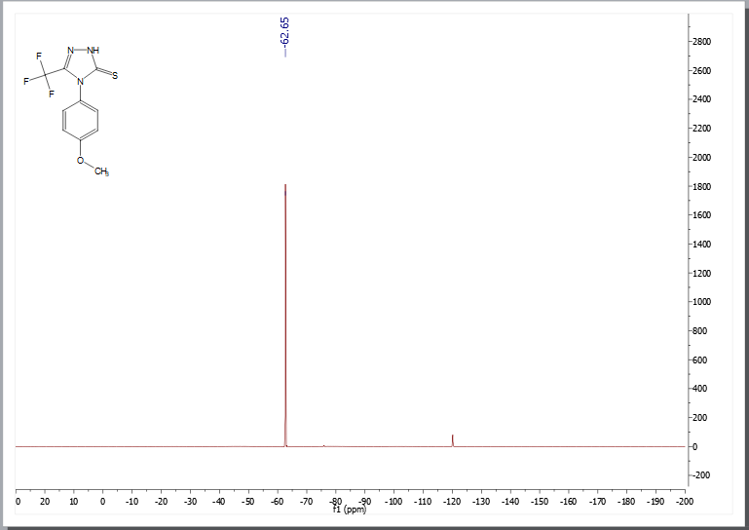

4-(4-fluorophenyl)-3-(trifluoromethyl)-1H-1,2,4-triazole-5(4H)-thione (6h)
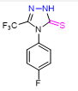
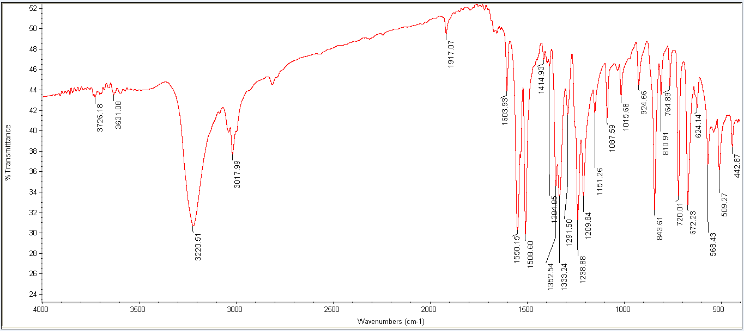
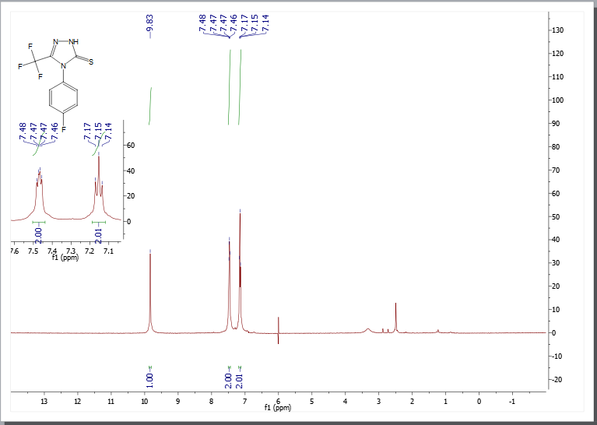
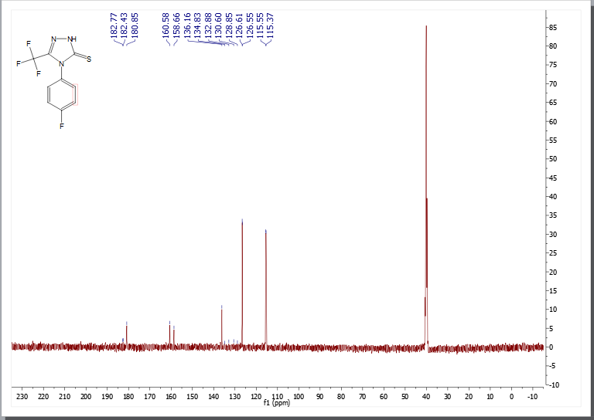
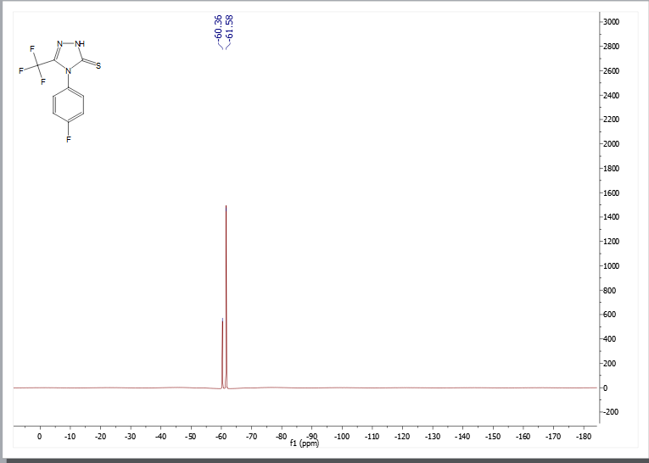

4-(4-chlorophenyl)-3-(trifluoromethyl)-1H-1,2,4-triazole-5(4H)-thione (6i)
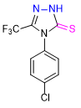
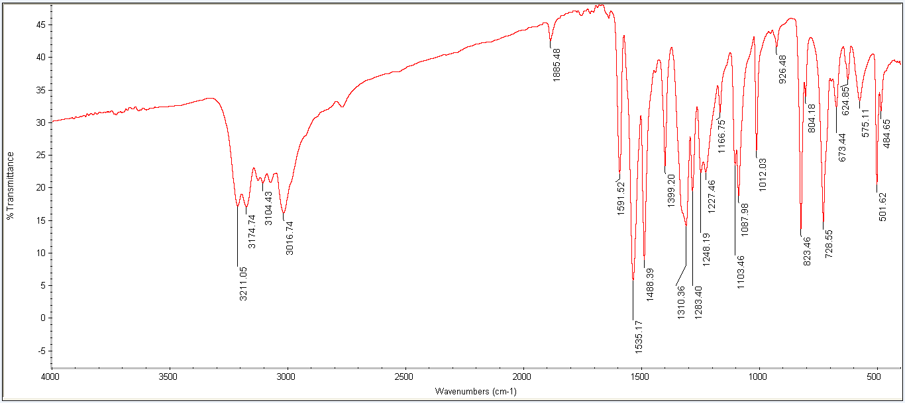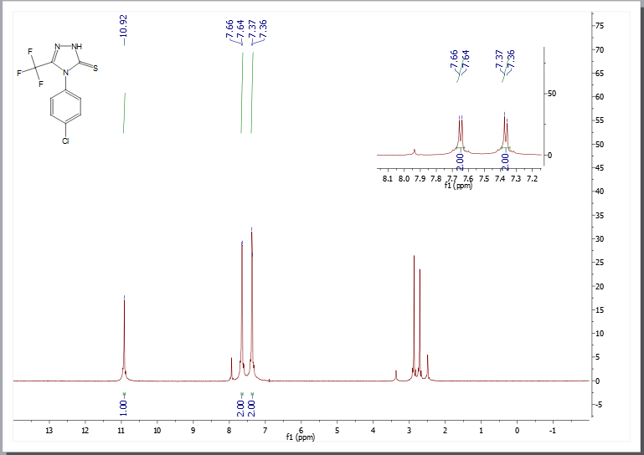
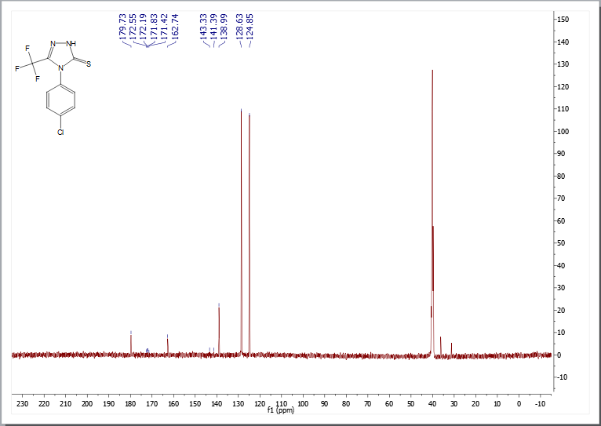
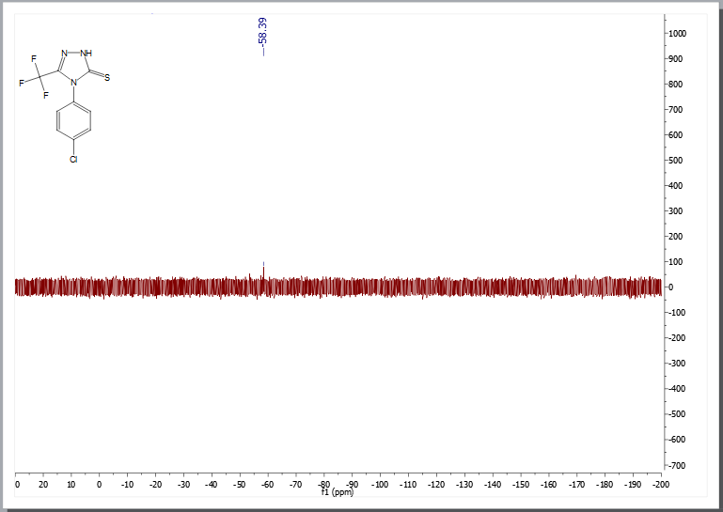

4-(3-chloro-4-fluorophenyl)-3-(trifluoromethyl)-1H-1,2,4-triazole-5(4H)-thione (6j)
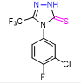
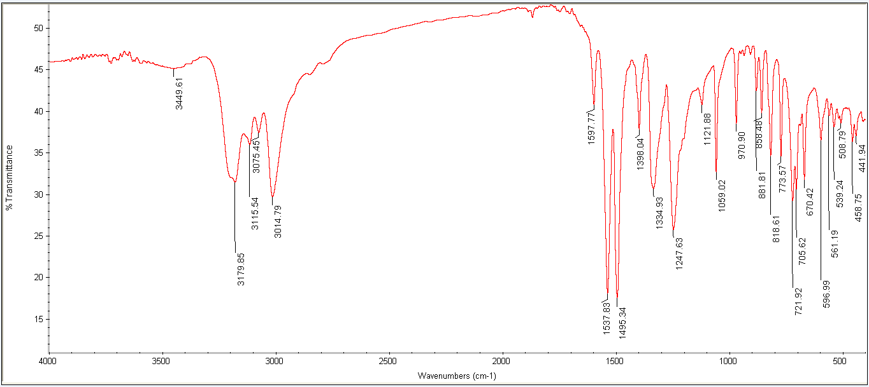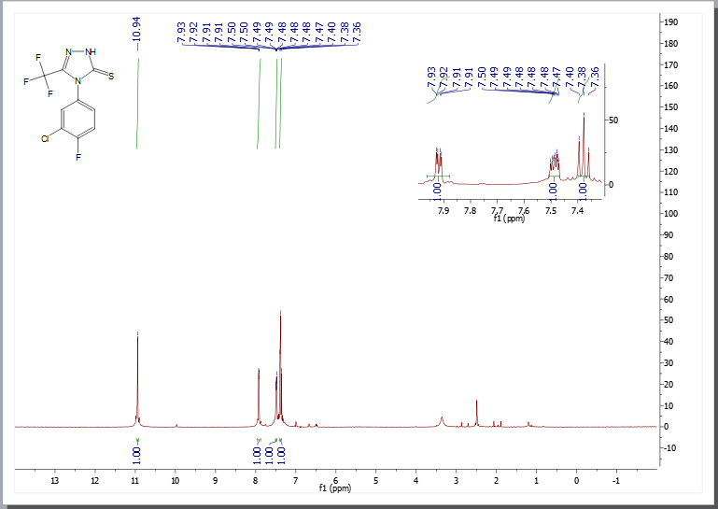

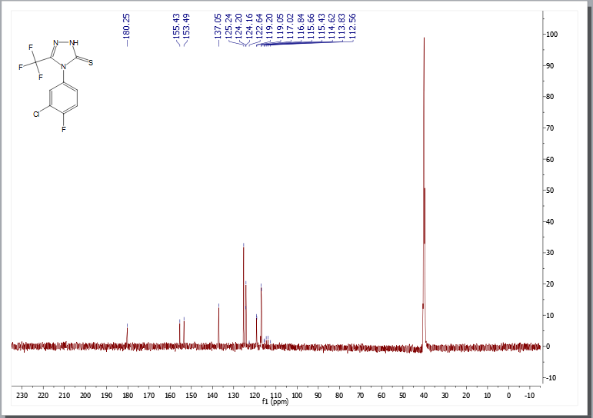
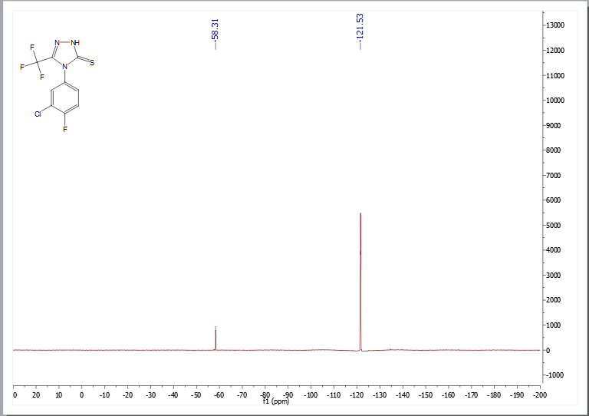

4-(3-nitrophenyl)-3-(trifluoromethyl)-1H-1,2,4-triazole-5(4H)-thione (6k)
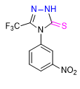
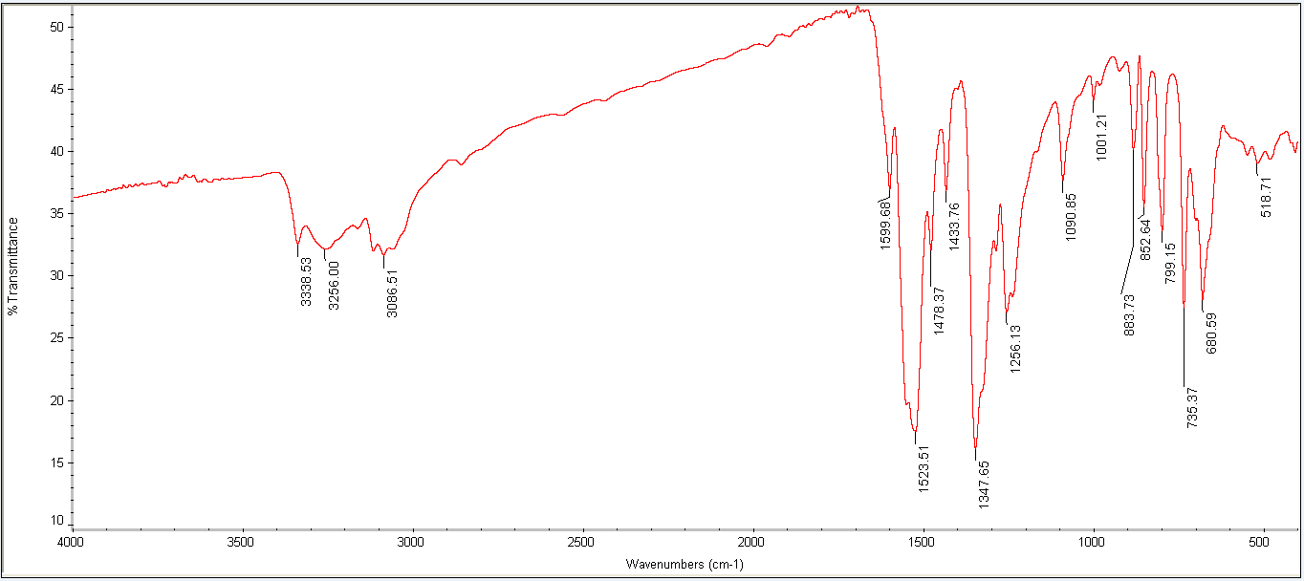
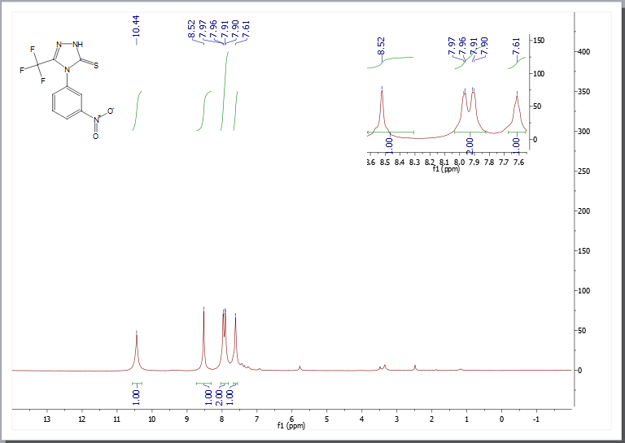
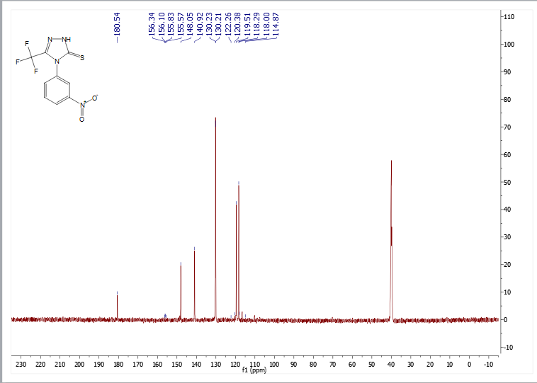
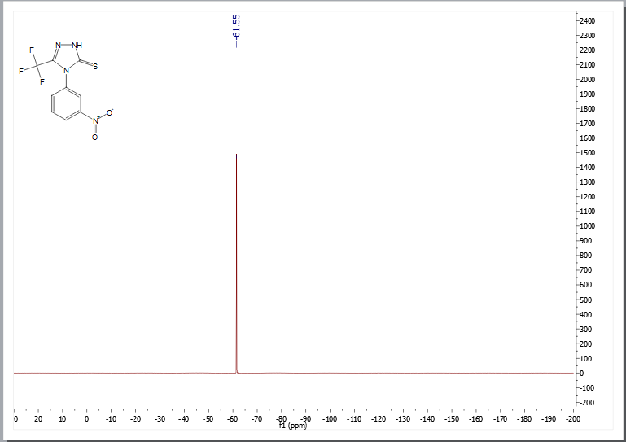

4-(4-nitrophenyl)-3-(trifluoromethyl)-1H-1,2,4-triazole-5(4H)-thione (6l)
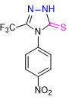
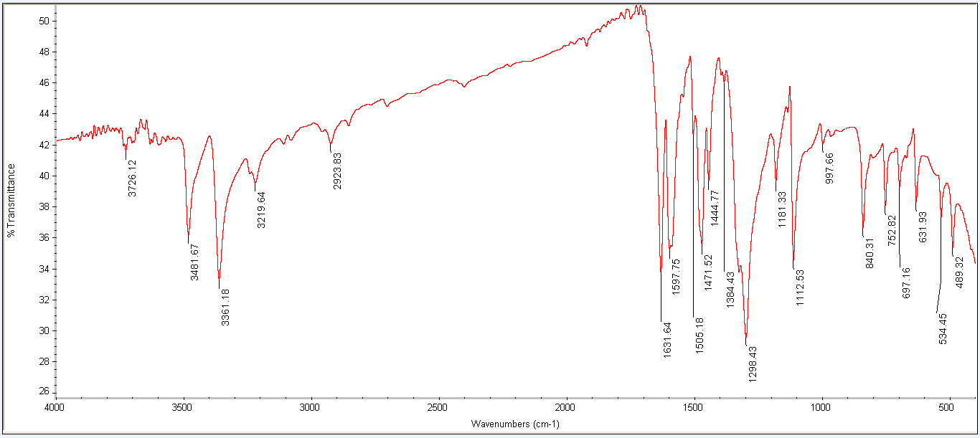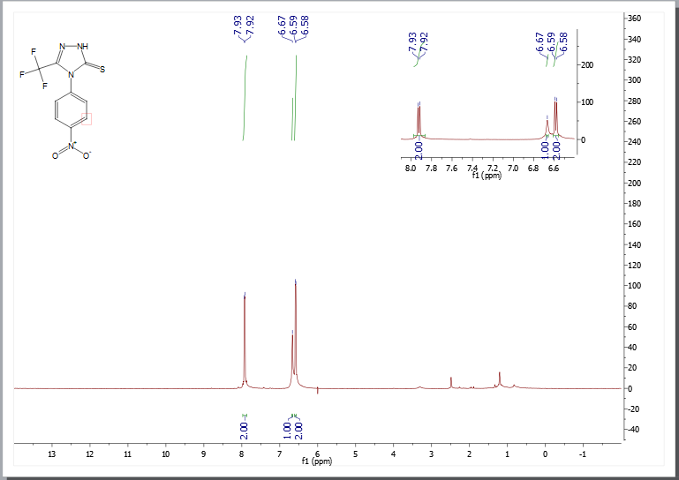

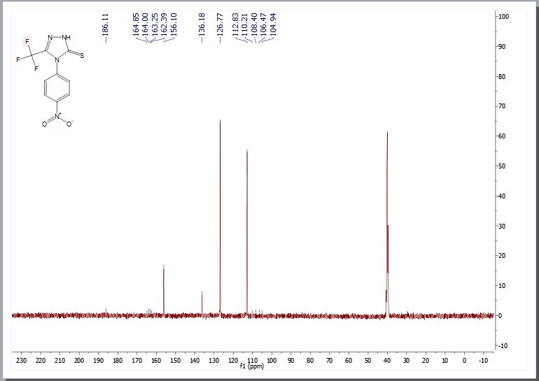
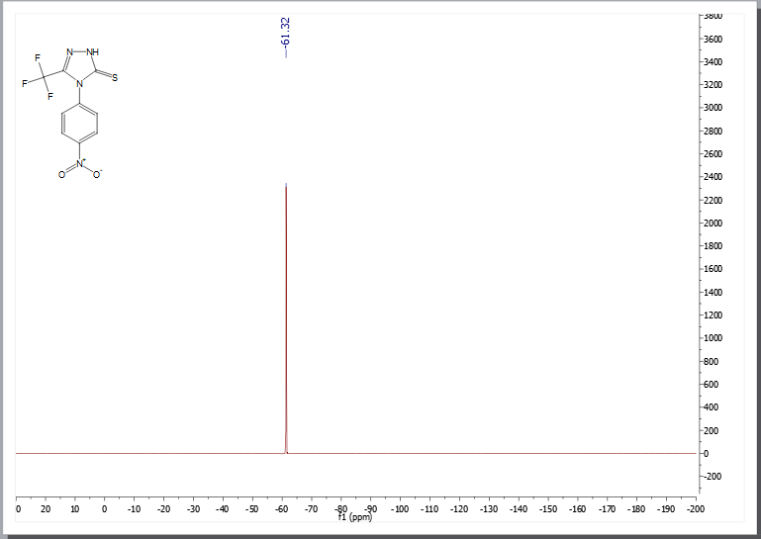

4-(naphthalen-1-yl)-3-(trifluoromethyl)-1H-1,2,4-triazole-5(4H)-thione (6m).
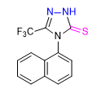
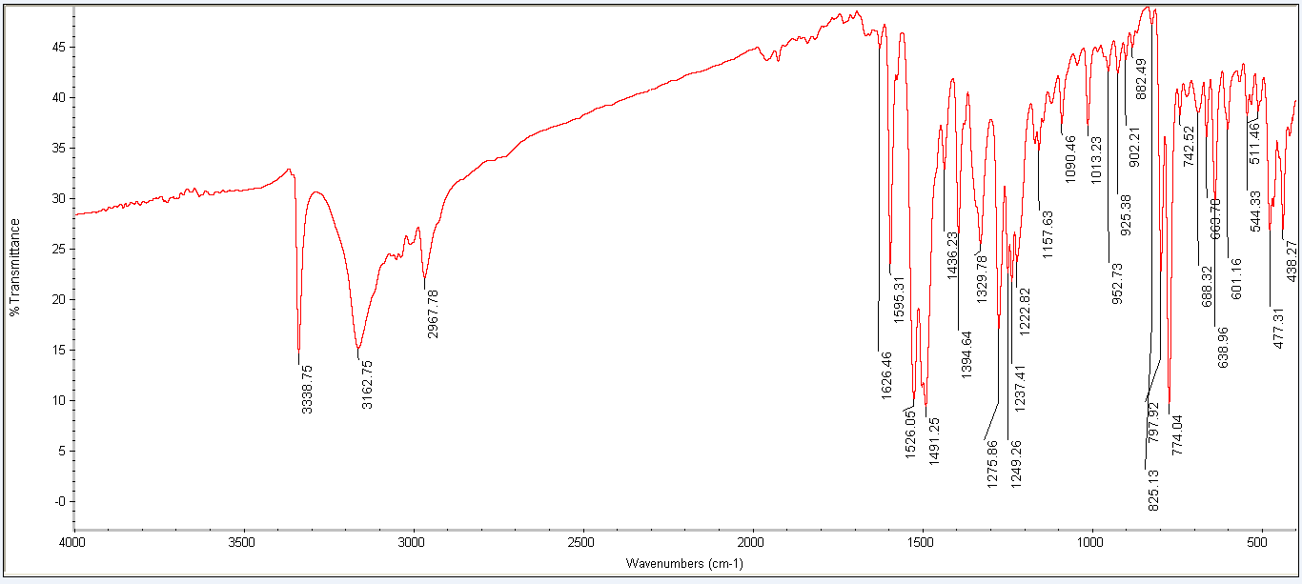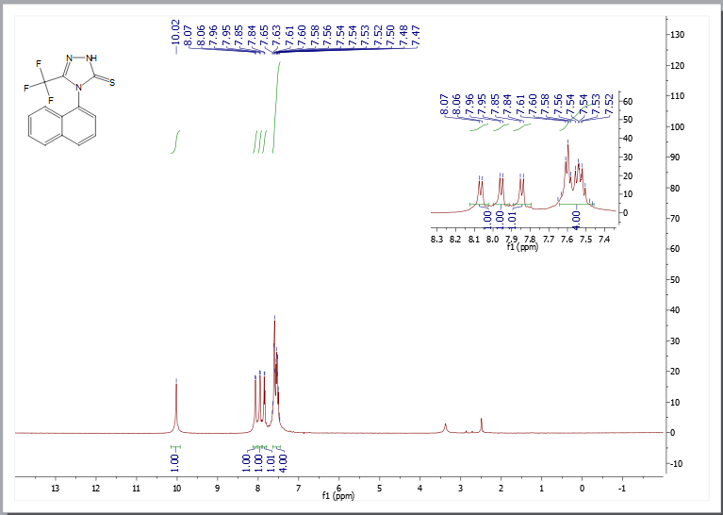
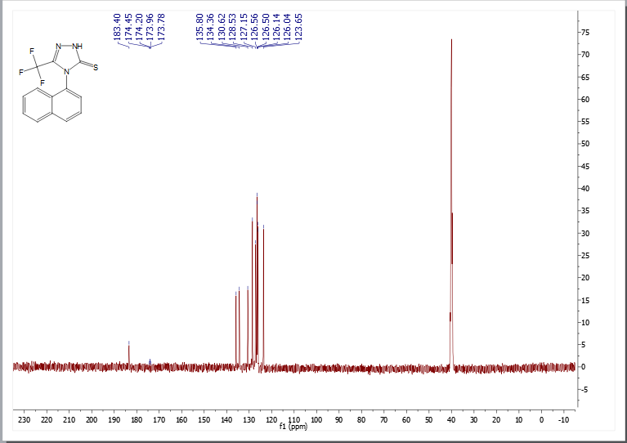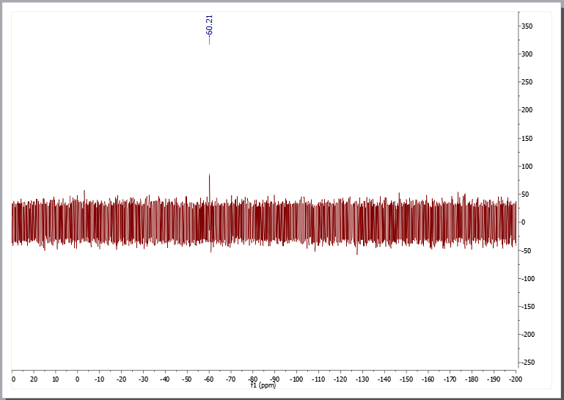

3-(trifluoromethyl)-4-(3-(trifluoromethyl)phenyl)-1H-1,2,4-triazole-5(4H)-thione (6n)
