Electronic supporting information

Rh-Catalyzed cyclization of carbamates – synthesis of a new heterocyclic system: tetrahydro-3H-4-oxa-2-thia-2b-azacyclopropa[cd]pentalen-3-one 2,2-dioxide

Kateryna V. Dil¹, Yevhenii K. Kozyriev^{1,2}, Vitalii A. Palchykov¹*

¹Oles Honchar Dnipro National University, Research Institute of Chemistry and Geology, Gagarina Av. 72, Dnipro, 49010, Ukraine
²Enamine Ltd. (www.enamine.net), Chervonotkatska Str. 78, Kyiv, 02094, Ukraine
*Corresponding author email: palchikoff82@gmail.com (web: https://palchykovchem.vercel.app)

Contents:
¹H and ¹³C NMR spectra for 1,1-dioxidotetrahydrothiophen-3-yl carbamate (5a)
¹H and ¹³C NMR spectra for 1,1-dioxidotetrahydro-2H-thiopyran-3-yl carbamate (5b)
¹H and ¹³C NMR spectra for tetrahydro-2H-thiopyran-3-yl carbamate (5c)
¹H and ¹³C NMR spectra for 1,1-dioxido-2,3-dihydrothiophen-3-yl carbamate (5d)
¹H and ¹³C NMR spectra for tetrahydro-3H-4-oxa-2-thia-2b-azacyclopropa[cd]pentalen-3-one 2,2-dioxide (6d)
2D NMR spectra for tetrahydro-3H-4-oxa-2-thia-2b-azacyclopropa[cd]pentalen-3-one 2,2-dioxide (6d)
HRMS spectrum for tetrahydro-3H-4-oxa-2-thia-2b-azacyclopropa[cd]pentalen-3-one 2,2-dioxide (6d)
In silico pharmacological profile of aziridine 6d

¹H and ¹³C NMR spectra for 1,1-dioxidotetrahydrothiophen-3-yl carbamate (5a)

¹H and ¹³C NMR spectra for 1,1-dioxidotetrahydro-2H-thiopyran-3-yl carbamate (5b)

¹H and ¹³C NMR spectra for tetrahydro-2H-thiopyran-3-yl carbamate (5c)

¹H and ¹³C NMR spectra for 1,1-dioxido-2,3-dihydrothiophen-3-yl carbamate (5d)

¹H and ¹³C NMR spectra for tetrahydro-3H-4-oxa-2-thia-2b-azacyclopropa[cd]pentalen-3-one 2,2-dioxide (6d)

APT spectrum for tetrahydro-3H-4-oxa-2-thia-2b-azacyclopropa[cd]pentalen-3-one 2,2-dioxide (6d)
HMBC spectrum for tetrahydro-3H-4-oxa-2-thia-2b-azacyclopropa[cd]pentalen-3-one 2,2-dioxide (6d)
HSQC spectrum for tetrahydro-3H-4-oxa-2-thia-2b-azacyclopropa[cd]pentalen-3-one 2,2-dioxide (6d)
COSY spectrum for tetrahydro-3H-4-oxa-2-thia-2b-azacyclopropa[cd]pentalen-3-one 2,2-dioxide (6d)
NOESY spectrum for tetrahydro-3H-4-oxa-2-thia-2b-azacyclopropa[cd]pentalen-3-one 2,2-dioxide (6d)
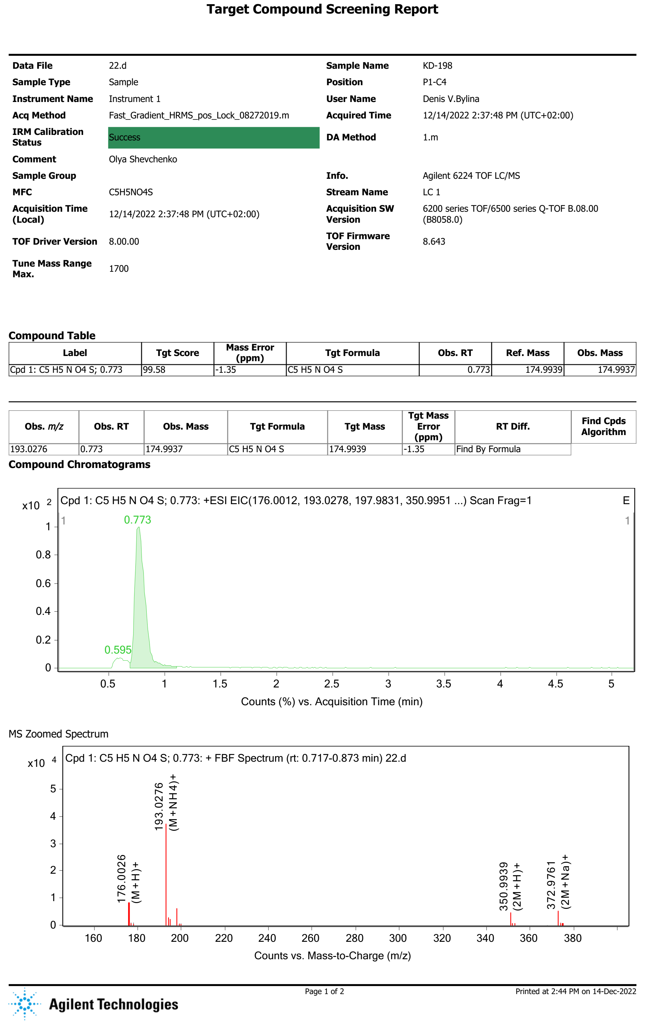
HRMS spectrum for tetrahydro-3H-4-oxa-2-thia-2b-azacyclopropa[cd]pentalen-3-one 2,2-dioxide (6d)
In silico pharmacological profile of aziridine 6d was performed to determine classic and modern MedChem descriptors using SwissADME tool (http://www.swissadme.ch)
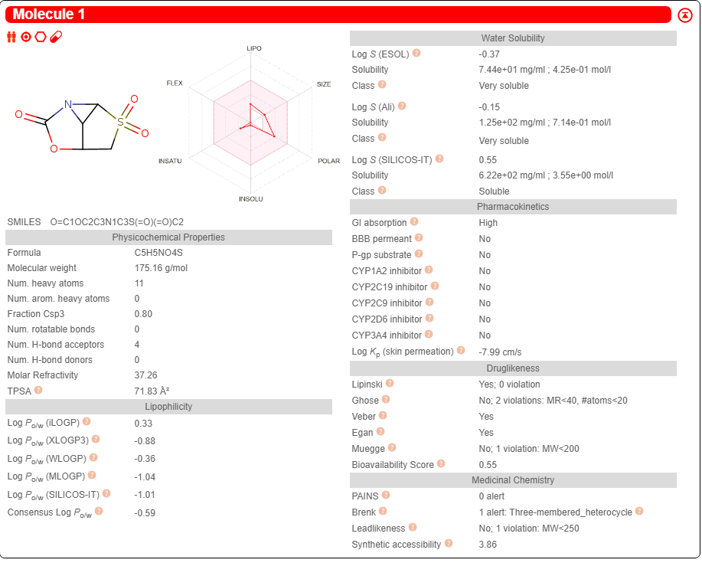
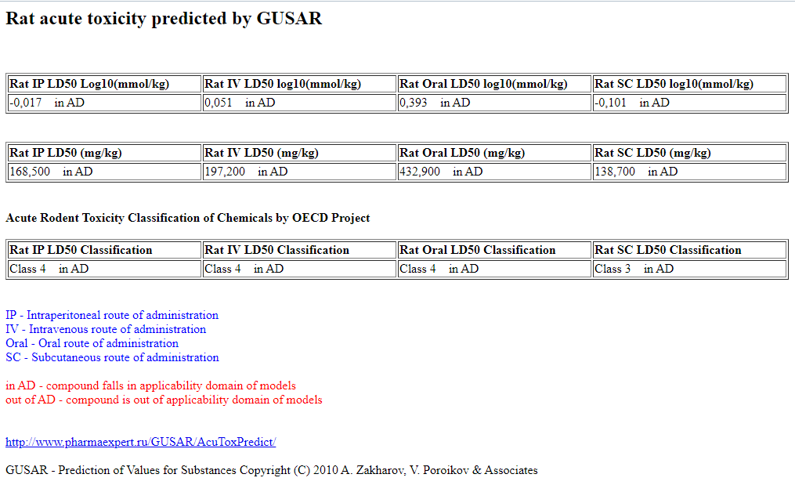
http://www.way2drug.com/gusar/acutoxpredict.html
Lagunin A., Zakharov A., Filimonov D., Poroikov V. QSAR Modelling of Rat Acute Toxicity on the Basis of PASS Prediction. Mol. Informatics, 2011, 30(2-3), 241–250
******************************************************************
CLC-Pred (Cell Line Cytotoxicity Predictor) is a web-service for in silico prediction of cytotoxic effect of chemical compounds in non-transformed and cancer cell lines based on structural formula. CLC-Pred provides a prediction of the cytotoxicity of a chemical compound to assess the relevance of the substance's inclusion in experimental screening. Prediction is based on PASS (Prediction of Activity Spectra for Substances) technology (http://www.way2drug.com/PASSonline) and the training set created on the basis of data on cytotoxicity retrieved from ChEMBLdb (version 23) (https://www.ebi.ac.uk/chembldb/).
http://way2drug.com/Cell-line/index.php
Lagunin A.A., Dubovskaja V.I., Rudik A.V., Pogodin P.V., Druzhilovskiy D.S., Gloriozova T.A., Filimonov D.A., Sastry G.N., Poroikov V.V. CLC-Pred: a freely available web-service for in silico prediction of human cell line cytotoxicity for drug-like compounds. PLOS One, 2018, 13 (1), e0191838. DOI: 10.1371/journal.pone.0191838
