Supplementary
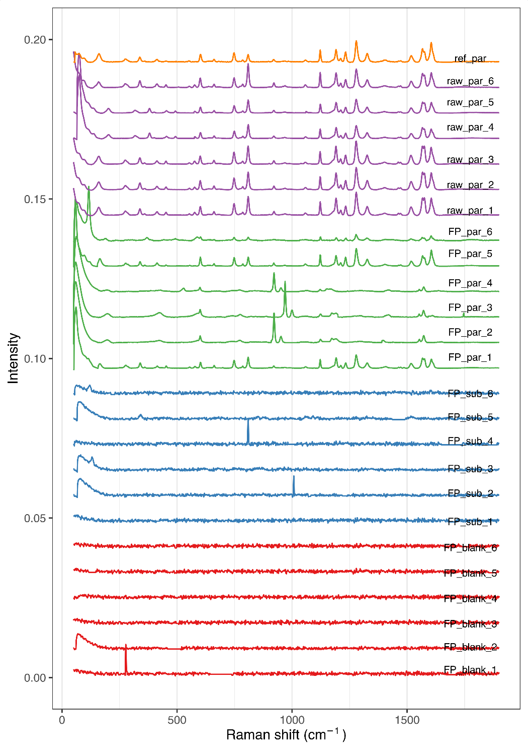
Supplementary figure S1. Normalized, baseline corrected, and shifted Raman spectra.

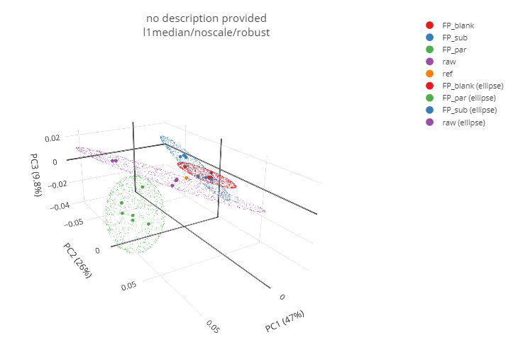
Supplementary figure S2. Score plot of the first three principal components (PC1, PC2, PC3).

