The tyrosine kinase inhibitor Dasatinib reduces cardiac steatosis and fibrosis in obese, type 2 diabetic mice

SUPPLEMENTARY MATERIAL

Supplementary Figure 1: Protocol of the short-duration study in diabetic mice.
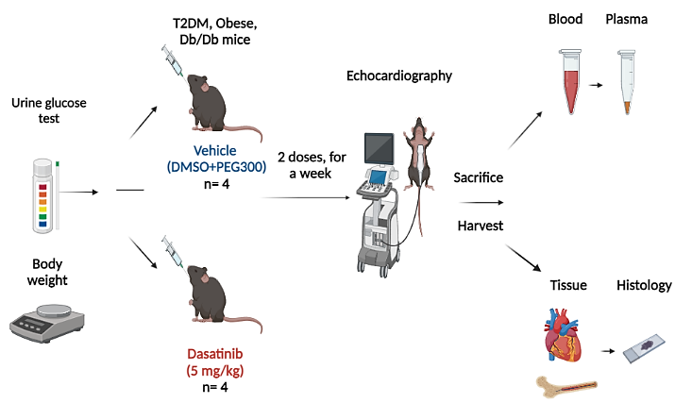

Supplementary Figure 2: Protocol of the long-duration study in diabetic mice.
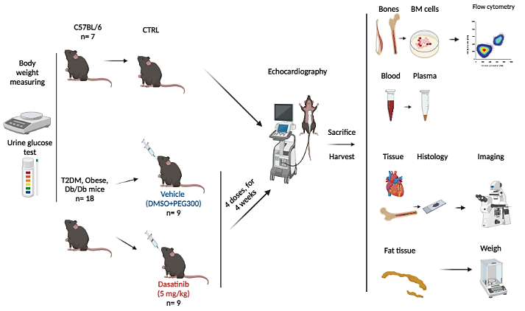

Supplementary Figure 3: Control staining for mouse heart and bone marrow p16 immunohistochemistry study.

Supplementary Table 1. Primary and secondary antibodies used in immunohistochemistry studies.
Antigen | Host | Reactivity | Dilution | Supplier & CAT# | 2nd Abs
P16 | Mouse | Mouse | 1:50 | Santa Cruz,  SC-1661 | Invitrogen, Alexa568 goat anti-mouse

Supplementary Table 2: List of antibodies used in flow cytometry analyses on mouse BM cells.

Antibody | Reactivity | Dilution | Fluorophores | Supplier
CD36 | Mouse | 1:30 | Super Bright 600 | eBioscience
DPP-4 | Mouse | 1:20 | PE | Biolegend
CD29 | Mouse | 1:10 | APC-Vio 770 | Miltenyi Biotec
CD45 | Mouse | 1:160 | Brilliant Violet 785 | Biolegend
CD73 | Mouse | 1:80 | Super Bright 702 | eBioscience
Sca-1 | Mouse | 1:40 | Brilliant Violet 421 | Biolegend
CD11b | Mouse | 1:100 | APC-Vio® 770, REAfinity™ | Miltenyi Biotec
CD140a | Mouse | 1:40 | PE/Dazzle™ 594 | Biolegend

Supplementary Table 3: Clinical characteristics of patients recruited to the study.
Sample NO. | Patient ID code | Gender | Age | Diabetic | Flow cytometry | ICC Phenotype | Dasatinib+ Differentiation
BM1 | 23/16062021/CP | Male | 63 | No | √ | √ | √
BM2 | 22/29062021/DP | Male | 48 | No | √ | √ | √
BM3 | 22/29062021/RP | Female | 67 | No | √ | √ | √
BM4 | 22/28012022/LP | Male | 72 | No | √ | √ | √

Supplementary table 4: TaqMan probes used in qPCR assays.
Gene | Species | Assay ID
PPARɣ | Human | Hs01115513_m1
FABP4 | Human | Hs01086177_m1
ADIPOQ | Human | Hs00977214_m1
UBC | Human | Hs00824723_m1

Supplementary Table 5: List of antibodies used for Western blot analyses.

Antibody | Reactivity | MW (kDa) | Source | Dilution | CAT# | Supplier
PPARɣ | Human | 53, 57 | Rabbit | 1:1000 | 2435 | Cell Signalling
GAPDH | Human | 37 | Mouse | 1:1000 | 97166 | Cell Signalling

