Author's Picture & Biography

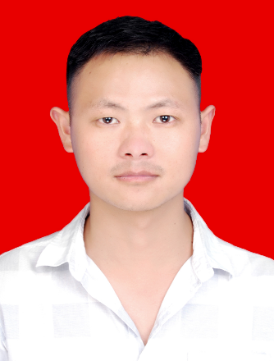
Jia Li received the master's degree from Lanzhou University of Technology, Chain, Lanzhou, in 2019. He is currently an engineer in Sichuan Academy of Medical Sciences & Sichuan Provincial People's Hospital in The Medical Equipment Department. His interests research is areas of Network communication and control, the stability of Neural network.

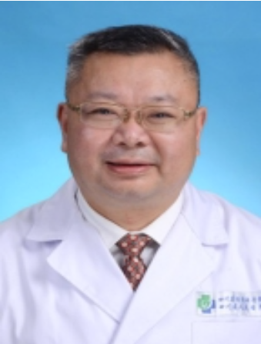
Yugang Gu Working as a professor in Sichuan Academy of Medical Sciences & Sichuan Provincial People's Hospital, Chain, Chengdu. He has done his Bachelor's degree in Chongqing Medical University. His fields of interest are Intelligent hospital, bioinformatics and Surgical acute abdomen.

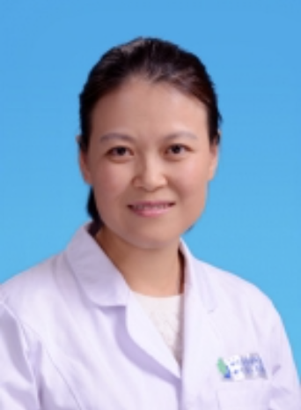
Yi Liang received her master's degree in neurology from Luzhou Medical College in 2008. She is Working as an Associate professor in Sichuan Academy of Medical Sciences & Sichuan Provincial People's Hospital, Chain, Chengdu. Her research interests include the neurobiology, Neurological diseases of adults.

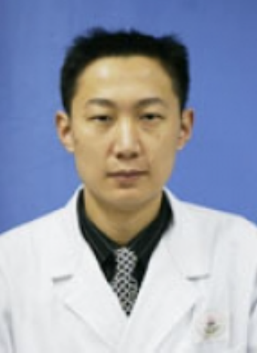
Gang Li is a postgraduate supervisor at the University of Electronic Science and Technology of China and Working as a professor in Sichuan Academy of Medical Sciences & Sichuan Provincial People's Hospital, Chain, Chengdu. His fields of interest are neuropharmacy and modern hospital management.

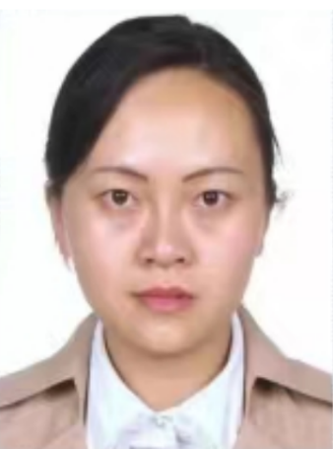
Yuchun Yang is a senior engineer in Sichuan Academy of Medical Sciences & Sichuan Provincial People's Hospital. Currently She is a part-time editor at Metrology & Measurement Technique. Yuchun Yang research area included Measurement & control, Secure communication, Medical engineering.

Affiliations
Jia Li¹, Yugang Gu²，Yi Liang³， Gang Li¹, Yuchun Yang¹

Jia Li
1575764629@qq.com

Yugang Gu
1175147995@qq.com
Liang Yi
Liangyi3377@163.com

Gang Li
ligang7498@126.com

Yuchun Yang
18793181672@163.com

¹ The Medical Equipment Department, Sichuan Academy of Medical Sciences & Sichuan Provincial People's Hospital, Chengdu,610031,China.
² The General Surgery, Sichuan Academy of Medical Sciences & Sichuan Provincial People's Hospital, Chengdu,610031,China.
³ The Neurology Department, Sichuan Academy of Medical Sciences & Sichuan Provincial People's Hospital,Chengdu,610031,China.

