Table 4

Sample Data Illustrating Coding Decisions

Dimension | Code (competency) | Context | Image | Verbatim transcription
Operational | Finding information  Video and/or oral evidence of applying technology or technical skills or knowledge to find potentially relevant online information.  Skills:  • correctly using apps and browsers  • using search keywords and/or strings  • using tabs for navigation  • using synonyms | Students L&O had selected the Safari browser and were entering a search string made up of sample key words created during the introduction to a lesson. These had been recorded on the class whiteboard. | 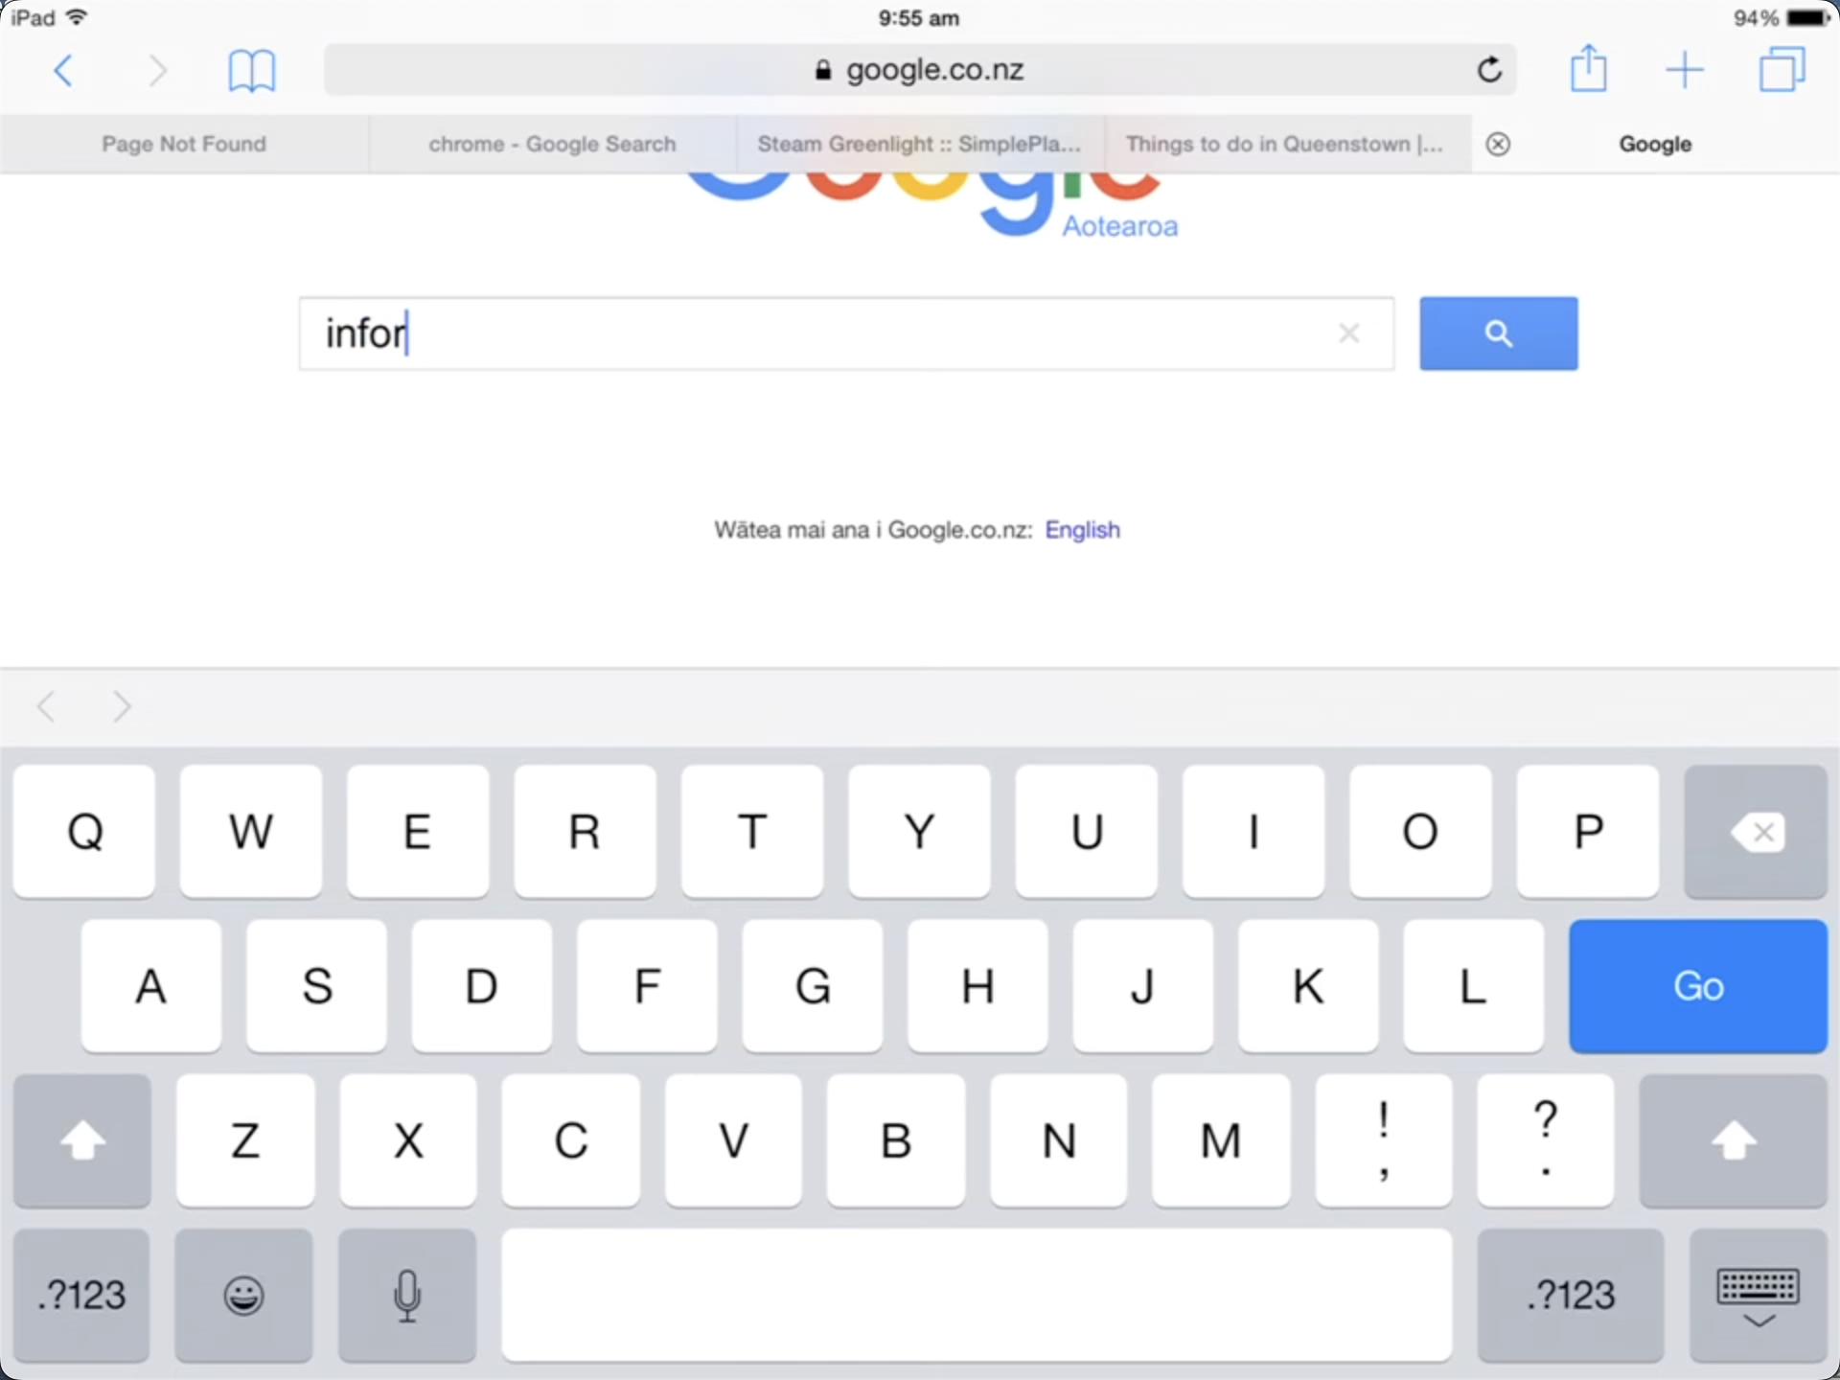 | O: We need to do some searching… [pause]… to find in-for-ma-tion [sounding]…. information… that’s it!! [begins to type… verbalising, ‘i-n-f-o-r’…].  L: What else d’we need to put? [pause]…  O: We need to tell it what… [pause]…what we need information about… ? [pause]…  L: Alright… put ‘Matariki’… [pause]…  O: … about Matariki… that’ll do… [pause]…  L: … but don’t we want to find out about the Seven Sisters?  O: Yeah… ah… we can do that next… [pause]… let’s see if this works first… [completes string and presses ‘search’ icon]… then we can put in other words… if we have to…
 | Using device functions or tools  Video and/or oral evidence of using device functions (e.g., text-to-speech, autocorrect, spell check) to access and make sense of information, or work with information within or between apps (e.g., copy and paste, text or image editing tools).  Skills:  • using automated or manual device functions  • using conventional text management procedures (e.g., copy & paste) | Students A&D had searched using the string ‘what is matariki about’ using sample keywords. The search had returned the Encyclopaedia of New Zealand website, and they were using the iPad’s text-to-speech function to make sense of page description. | 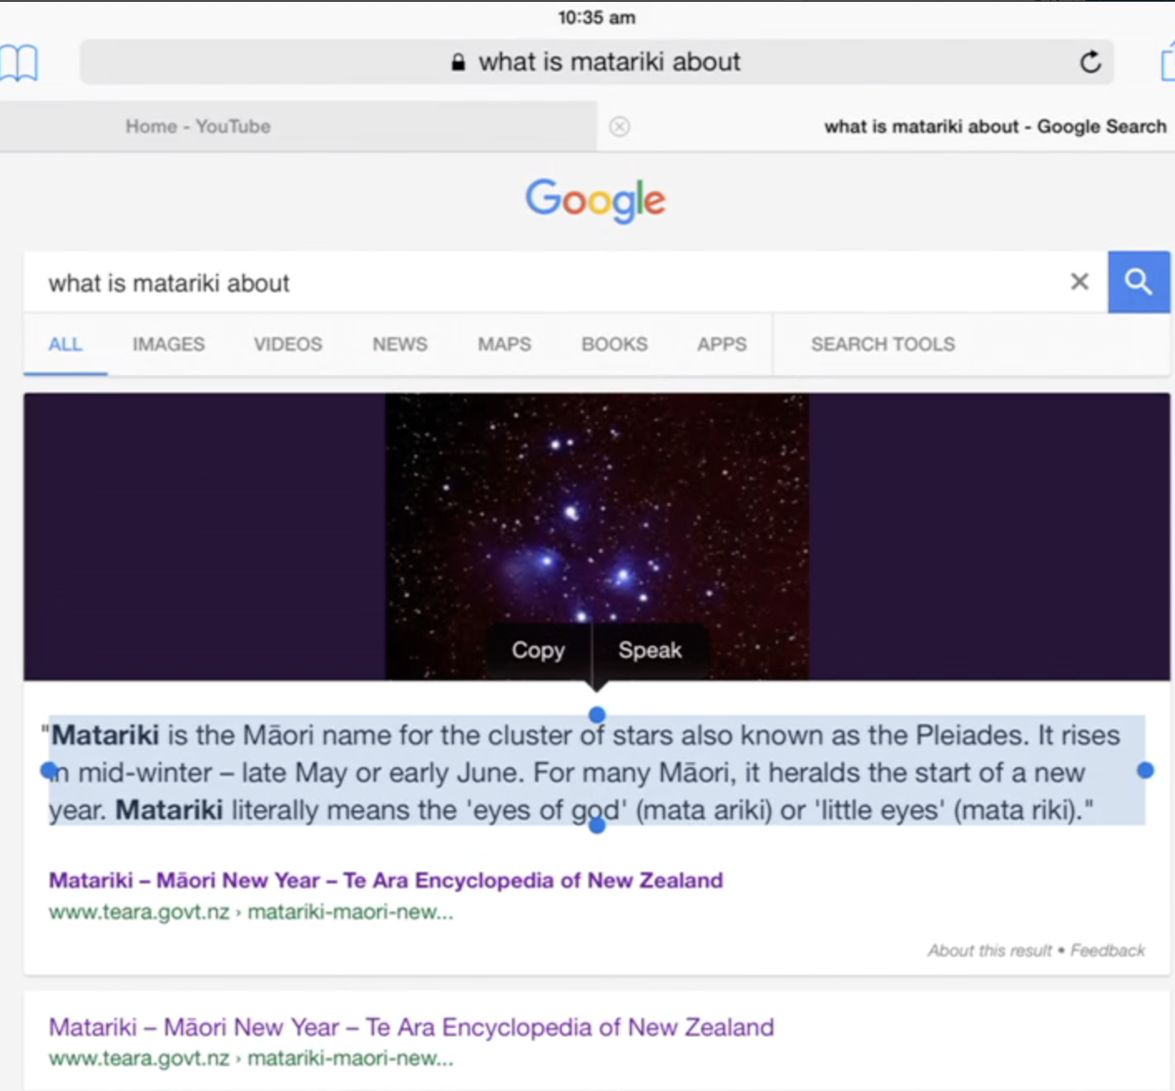 | A: This might be good… ‘Matariki is the Maori name for the… cl…a’ [attempts to read ‘cluster’, pause]. Ummm… what’s that word? [pause]… ‘cl…ass…’  D: I know… it can tell us... remember… Mrs. [teacher name] showed us how to do it… [pause]…  A: Oh yeah… that’s right… [pause]… what d’ya do again?  D: You hold your finger on the words… then drag the lolly pops over the bit you want… [D selects text]…. see… ‘Copy or Speak’… [pause]…  A: We want ‘Speak’, don’t we A…  D: OK… [touches ‘Speak’, pause while reading]… ‘the stars come out in June…’  A: What does ‘heralds’ mean? [pause]…  D: Don’t know… I’ll ask the teacher… [pause]…
Knowledge-building | Evaluating  Oral and video evidence of students questioning, evaluating, verifying or checking text information or images, before, during or after accessing.  Skills:  • questioning or clarifying  • verifying  • comparing and contrasting  • reviewing descriptors | Students A&E were sourcing an image to supplement the text in their PicCollage artefact on the legend of the Six Daughters of Matariki (seven sisters). The stars appearing in the sky represented Matariki and her 6 daughters, and signalled the beginning of the new year. A&E had entered the search string: Seven Sisters of Matariki and had navigated to ‘Images’. | 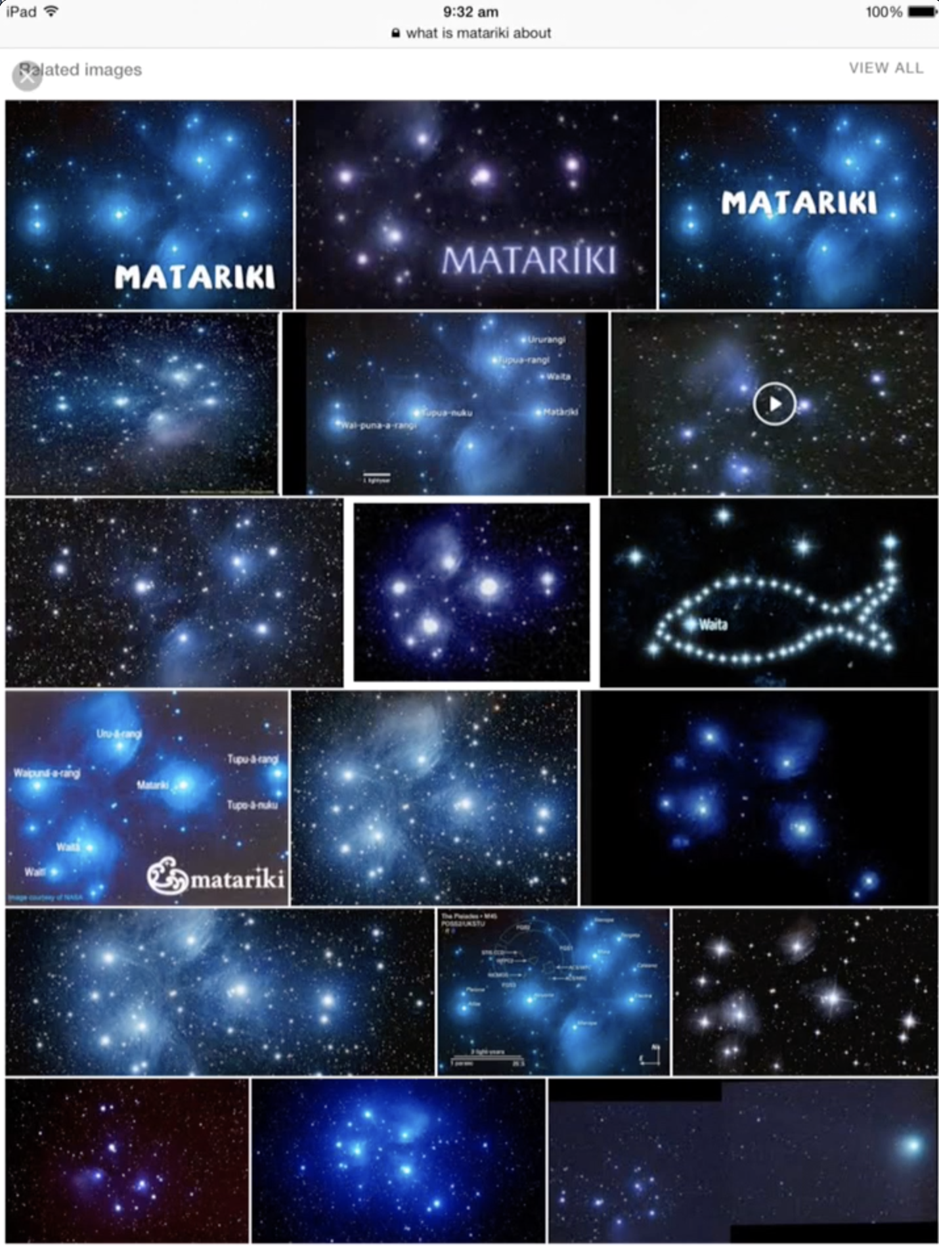 | A: OK, here we go… right… [pause]…  E: Which one d’you think we should use?  A: It needs to be clear… [pause]…  E: How about this one? [indicating middle image in bottom row]…  A: No… the stars… [pause]… they’re a bit fuzzy….  E: And blue…  A: What about this… here? [selecting centre image, as shown]… it’s pretty clear… [pause]…  E: But does it have them all in?  A: How d’ya mean?  E: Is there seven stars? [pause]… it’s got to be right… [counting]… 1,2,3,4,5…6… there’s only 6…  A: No. This one over here… [touching small star beneath main cluster]…  E: That must be the little sister… [laughing]…  A: Shall we use this one? [pause]…  E: OK…
 | Reading, selecting and using information  Oral and video evidence of students reading (with or without assistive functions), selecting and using information (e.g., taking notes, summarising, synthesising).  Skills:  • reading text, image captions etc.  • selecting bodies of text for later use  • synthesising  • summarising | Students B&L had located information on a previous site about the legend of Matariki explaining that the brightness of the Seven Sisters cluster was an indication of how successful the upcoming harvest will be. They were verifying the information by checking on a second site. Finding agreement, they were selecting the text for editing in Pages. | 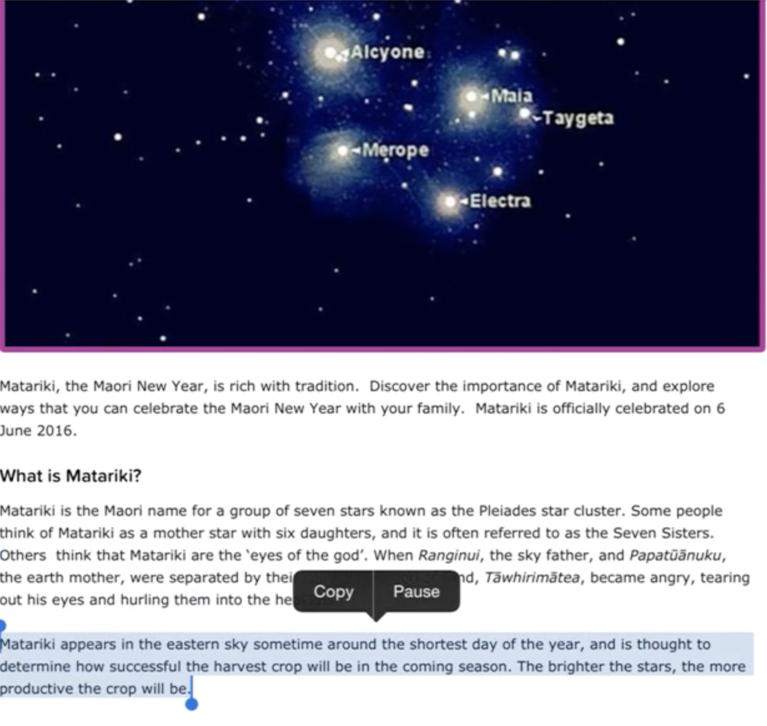 | L: It’s about how bright the stars are… [pause]… like before… [referring to previous website]…  B: Yeah… [pause]…  L: Do you think we should use it? [the information]…  B: …[pause]… I wonder if it’s true… [pause]… I mean … how bright the stars are… does it make the harvest grow?  L: It’s only a story… [pause]… Maori people made it up to… you know… it’s not true… [pause]…  B: It might be…!  L: OK… [pause]… but anyway… we’ve found it 2 times so we can use it… [dragging across text to select]… there… copy... [pause]…  B: Now… go to Pages and put it in there… [pause]… we can use it later…
Cultural-Critical | Information and knowledge  Oral evidence indicating awareness of the web as an open environment and/or demonstrating concern for the accuracy of sourced information.  Skills:  • recognising different perspectives present in information  • recognising that not all online information is true. | Students L&B had accessed the Christchurch City Library site and were using text-to-speech to read the ‘Discover Matariki Stories’ section. They then discussed the information contained in the excerpt about the legend of Matariki and her daughters. | 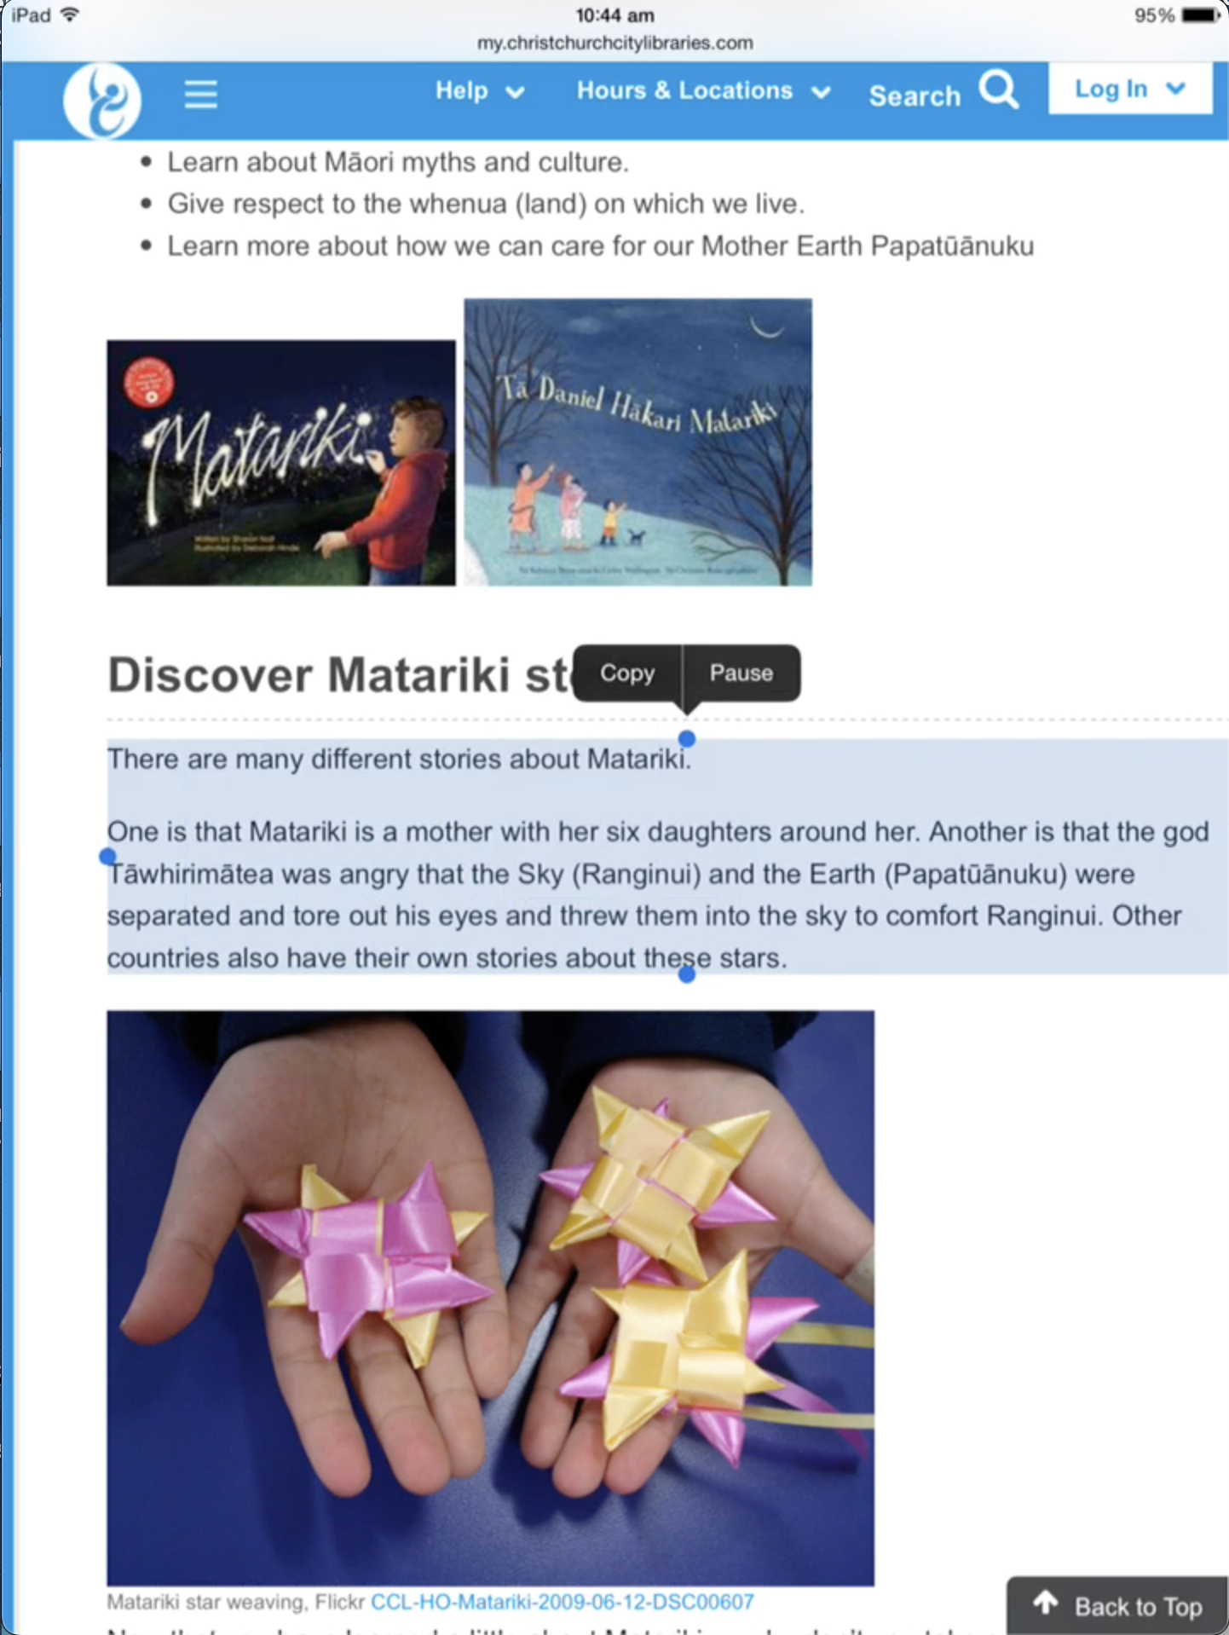 | L: Ah… so the stars are the sisters… [pause]…  B: It’s just a story… it’s made up… [pause]…  L: Ha… it’s ‘Fake News’ [laughing, pause]…  B: Yeah… see… [pause]… but it says that they’re the eyes of God… [pause]…  L: Where?  [O replays the text-to-speech]  B: It says the God was angry and tore out his eyes and threw them into the sky… and that’s the stars… [pause]…  L: That must have hurt… [laughing]…  B: … and that other places make up other stories about them…  L: …it’s confusing… [pause]…  B: It’s just a legend… it’s not real… [pause]…  L: … like a story… made up…[pause]…  B: Mmm… people can put what they want here… [pause]… it’s only what they think happened…
 | Purpose and audience  Oral and video evidence indicating consideration of purpose and audience when creating digital artefacts. This included design considerations such as impact, visibility, colour choice and layout.  Skills:  • consideration of purpose and audience for information  • consideration of artefact design and layout appropriate for audience and purpose. | Students P&F had summarised their 3 Matariki facts from Pages and had chosen PicCollage as their artefact authoring application. They had selected a suitable image for the background and added stars representing the Matariki sisters. They had recorded their facts in red text boxes. | 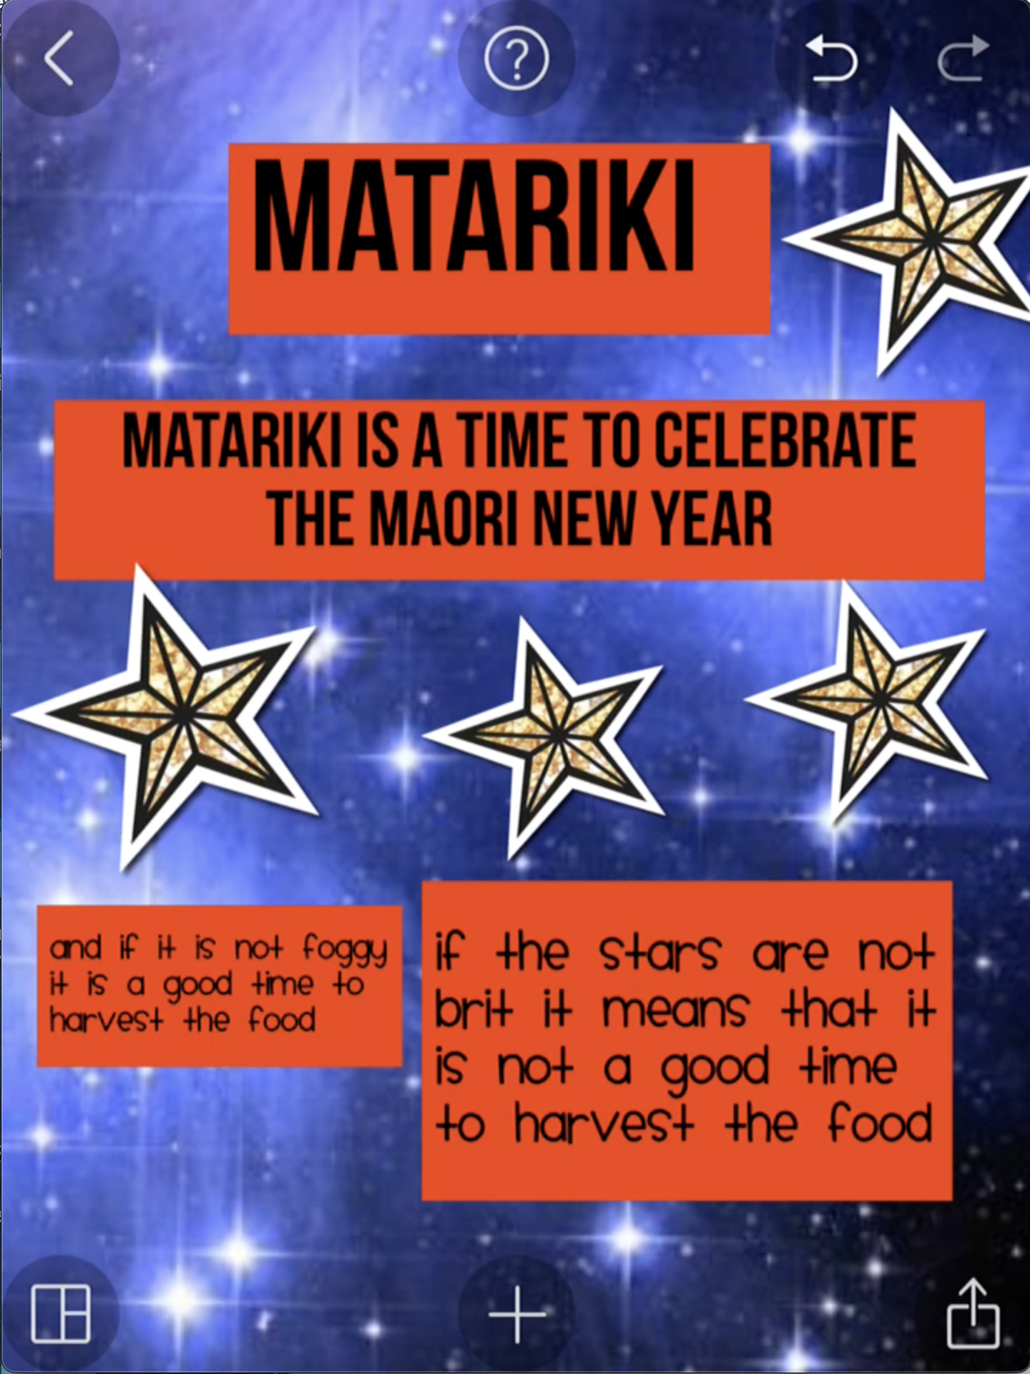 | P: … it needs to be big enough so they can read it from the back [referring to other students]… ‘cos we have to do it for room 10, don’t forget… [pause]…  F: OK… [pause]… I think this is fine [headers]… but we should make this a bit bigger [text in lower left box]…  P: It’s too small… [pause]… but it won’t fit in the gap if we make it bigger… [pause]…  F: Move the other one… [pause]…  [J drags adjacent text box to right and higher, and resizes it slightly]  P: That should do it… [pause]…  F: Now, make the other one bigger…. [pause]…  [J repositions left box and increases its size]  P: That’s better… [reading]… ‘and if it is not foggy it is a good time to harvest the food’… [pause]… you can see that better now… [pause]… and the colours stand out…  F: Anything else we should change…?

