Scalable manufacturing of cellulose nanofibrils to enhance melt-processed poly(vinyl alcohol) composites
Chuansong Yu ª, Huanhui Zhu ^{b}, Hongkai Deng ^{b}, Peng Zhou ^{c}, Xinxing Zhang ^{b, c*}, Zhenming Chen ^{a, b *}
ª School of Materials Science and Engineering, Guilin University Of Electronic Technology, Guilin City, 541004 China
^{b} Guangxi Key Laboratory of Calcium Carbonate Resources Comprehensive Utilization, College of Materials and Chemical Engineering, Hezhou University, Hezhou City, 542899, China
^{c} State Key Laboratory of Polymer Materials Engineering, Polymer Research Institute, Sichuan University, Chengdu City, 610065, China
1. FTIR spectrum
Figure S1. The FTIR spectrum of OSWs, CNFs, and BBP.
2. Preparation of PVA/CNF/AMWs composites
Figure S2 Schematic diagram of composite material design

Table S1 Composition of composite materials
Components phr | PVA | CNF | OSWs | Formamide | Water
PVA | 100 | - | - | 50 | 50
PVA-CNF5% | 100 | 5 | - | 50 | 50
PVA-CNF10% | 100 | 10 | - | 50 | 50
PVA-FCNF5% | 100 | 5 | 5 | 50 | 50
PVA-FCNF10% | 100 | 10 | 10 | 50 | 50

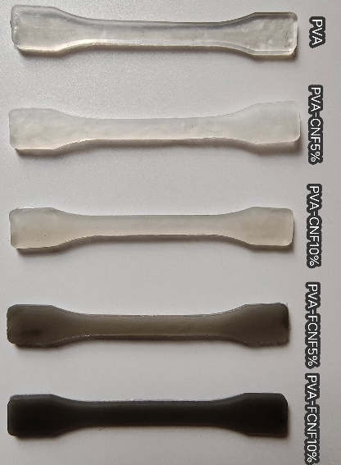
Figure S3 Composite injection finished product diagram

2. Characterization
2.1 SEM
CNF, OSWs, and composite microscopic morphology were investigated using a Japanese JSM-7610F SEM at an accelerating voltage of 5 kV. Before testing, all samples were subjected to gold spraying.
2.2 FTIR
FTIR spectra of the composites at ambient temperature were recorded using a Spectrum Two model infrared spectrometer from Perkin Elmer Co. 20 scans were performed at the same conditions as the background with a resolution of 2 cm⁻¹ and a range of 500-4000 cm⁻¹. The samples were analyzed using attenuated total reflection (ATR) mode measurements.
2. 3 XRD
XRD spectra were recorded using an Ultima IV instrument (Rigaku, Japan) with an acceleration voltage of 40 kV and a current of 40 mA. These samples were measured at 10-40° with a measurement of 0.02°/s. The nanocellulose crystallinity index (CrI) was calculated as follows(Huang et al, 2020):
CrI=(I₂₀₀-I_{am})/I₂₀₀
where I₂₀₀ is the maximum intensity of diffraction from the peak (200) and I_{am} is the minimum intensity of diffraction between 110 and 200 peaks(Segal et al, 1959).
The grain size of the composite was calculated using the Scherrer equation:
D=$\frac{Kλ}{β_{1/2}cosθ}$
where D represents the microcrystal size, β1/2 represents the full peak width at half height (FWHM), and K is a constant equal to 0.94(Wu et al, 2021).
2. 4 TGA
Thermogravimetric analysis was performed using a TGA 4000 (Perkin Elmer Co., USA) with a termination temperature of 600°C and a heating rate of 10°C/min under nitrogen protection.
2.5 DSC
Differential scanning calorimetry (DSC) was performed using a Q200 DSC instrument (TA, USA) under nitrogen protection with initial heating to 150°C to eliminate the thermal history, followed by characterization in the temperature range 50-250°C with a ramp rate of 10°C/min. To avoid plasticizer vaporization, the tests were performed in a sealed crucible. The crystallinity of the PVA/ OSWs composites was characterized using the following equation:
X_{C}=$\frac{ΔH_{m}}{wΔH_{m}^{o}}$
where w is the mass fraction of PVA matrix in PVA/ OSWs composites, ${ΔH}_{m}$ is the heat of melting, and ${ΔH}_{m}^{o}$ is the heat of melting of 100% pure PVA, which is equal to 161 J/g(Kochkina et al, 2022).
2.6 Tensile test
Data for tensile strength, modulus, and elongation at break were obtained by operating an INSTRON 3367 universal testing machine (USA) with a crosshead speed of 50 mm/min following ASTM D 412-80 specifications.

References
Huang X, Guo, Q, Zhou, P, Lu C, Yuan G, Chen Z, Zhang X (2020) Poly(vinyl alcohol)/organic stone wastes composites with improved melt processability and mechanical properties. Compos B Eng 182:107628.
Segal L, Creely JJ, Martin AE, Conrad CM (1959) An empirical method for estimating the degree of crystallinity of native cellulose using the X-ray diffractometer. Text Res J 29(10):786-794.
Wu M, Liao K, Liao C, Yu G, Rahmaninia M, Li H, Li B (2021) Integrated and sustainable preparation of functional nanocellulose via formic acid/choline chloride solvents pretreatment. Cellulose 28(15):9689-9703.
Kochkina NE, Butikova OA (2019) Effect of fibrous TiO 2 filler on the structural, mechanical, barrier and optical characteristics of biodegradable maize starch/PVA composite films. Int J Biol Macromol 139:431-439.

