Supporting Information
A simple AuNPs-based colorimetric aptasensor for
chlorpyrifos detection
Yuan Liu,ª Taotao Li,^{b} Gaojian Yang,ª Yan Deng,*^{c} Xianbo Mou^{d} and Nongyue He*^{a,c}
ª State Key Laboratory of Bioelectronics, School of Biological Science and Medical Engineering, Southeast University, Nanjing 210096, Jiangsu, PR China
^{b} Hunan Provincial Key Lab of Dark Tea and Jin-Hua, School of Materials and Chemical Engineering, Hunan City University, Yiyang 413000, Hunan, PR China
^{c} Hunan Key Laboratory of Biomedical Nanomaterials and Devices, Hunan University of Technology, Zhuzhou 412007, Hunan, PR China
^{d} Medical School of Ningbo University, Ningbo 315211, Zhejiang, PR China
* Corresponding authors: Yan Deng, hndengyan@126.com; Nongyue He, nyhe1958@163.com. Phone and fax: 86-25-83790885

1. Experimental part

1.1. Materials and chemicals
Chlorpyrifos (Chl) was purchased from Aladdin (Shanghai, China). DNA denaturing PAGE kit, emulsion polymerase chain reaction (ePCR) microdroplet generation oil, and 2×TBE-urea loading buffer were purchased from Anhui Aptamy Biotechnology Co., Ltd. (Hefei, China), Dynabeads™ MyOne™ Streptavidin C1 were purchased from Thermo Fisher Scientific Ltd. (Shanghai, China). DNA Marker and TBE buffer were purchased from Sangon Biotechnology (Shanghai, China), and all of the oligonucleotides, including the initial ssDNA library, the forward primer P1, the reverse primer P2, the binding primer P3, the FAM labelled P1, the poly A labelled P2, the selected aptamer (Table S1) were synthesized and HPLC-purified by Sangon Biotechnology (Shanghai, China). Polymerase chain reaction (PCR) mix and quantitative real-time polymerase chain reaction (Q-PCR) mix were purchased from Nanjing Vazyme Biotechnology Co., Ltd. (China). Other reagents were obtained from Sinopharm Chemical Reagent Co., Ltd. (Shanghai, China). All reagents were of analytical grade and were used without further purification. Solutions were prepared with doubly distilled (DI) water (18 MΩ cm).
1.2. Aptamers selection protocol
Briefly, each round of Chl selection including the procedure of ssDNA library immobilization, Chl incubation and separation of specific ssDNA, asymmetric emulsion polymerase chain reaction (ePCR) amplification of ssDNA, polyacrylamide gel electrophoresis and ssDNA recovery.
The initial ssDNA library with 1300 pmol was hybridized with the biotin labelled strand P3 with the molar ration of 1:2 in binding buffer (DPBS, pH 7.4). The mixture annealed under following procedure: 95℃ for 10 min, 60℃ for 1 min, and 25℃ for 10 min. The streptavidin magnetic beads (SA-MNPs) were washed 4 times with DPBS binding buffer, then incubated with the above the mixture for 45 min. Later the ssDNA coated SA-MNPs were washed 5 times with DPBS binding buffer to remove the unbound and weakly bound DNAs, each eluent was collected and marked as W_{n} (n means washing time, n=1, 2, 3, 4, 5) respectively. The trapped beads then incubated with 100 μM Chl (containing 2% methyl alcohol) in 100 μL DPBS binding buffer for 50 min. After incubation, the elution containing Chl-bound sequences was collected through magnetic separation. All of the detailed experimental conditions were listed in Table S2. The negative selection was added by incubating with 100 μL DPBS binding buffer (including 2% n-butyl alcohol) before incubated with target to improve the selectivity of aptamers to Chl. All the incubated condition was at room temperature.
To monitor the screening efficiency, the collected eluents were Q-PCR-amplified to calculate the retention rate.¹ 20 μL Q-PCR mixture contained 2 μL template, 0.4 μL P1 (10 μM), 0.4 μL P2 (10 μM), 10 μL qPCR-mix, 7.2 μL ultrapure water. Then the Q-PCR reaction was carried out as follows: it was denatured at 95℃ for 3 min, followed by 35 cycles of denaturation at 95 ℃ for 10 s, annealing at 60 ℃ for 30 s, and extension at 72 ℃ for 30 s, then was extended at 72 ℃ for 5 min and cooled at 4 ℃. The Ct value was analyzed.
The rest of the ssDNA elution was ePCR-amplified to obtain secondary ssDNA library. The ePCR mixture contained 90 μL template, 1 mL 2×PCR mix, 10 μL P1-FAM (100 μM), 10 μL P2-polyA (100 μM), with ultrapure water added to make a ﬁnal volume of 2 mL, then 8 mL of ePCR microdroplet generation oil was added. The mixture was vertical vibrated for 5 min to make sure the mixture was emulsified thoroughly. The ePCR was performed under following procedure: 95℃ for 3 min, followed by 25 cycles of 95 ℃ for 60 s, 60 ℃ for 60 s, 72 ℃ for 60 s, then extended at 72 ℃ for 5 min. The ePCR product was collected and concentrated with n-butyl alcohol to reduce the volume to 100 µL and further mixed with equal volume of 2×TBE-urea loading buffer. 8% PAGE was carried out after the mixture was boiled for 10 min. The separated ssDAN library with fluorescence was cut off, further concentrated and purified. The concentration of purified ssDAN library was quantified by OneDrop OD-1000 spectrophotometer for the next selection round.
1.3 Sequencing and analysis of sequences
After eight rounds of selection, the enriched ssDNA library was PCR amplified under the same condition described above except using unlabeled primers. High-throughput sequencing was performed by Sangon Biotechnology (Shanghai, China). The secondary structure of the most enrichment aptamer was performed using M-fold software (http://unafold.rna.albany.edu/?q=mfold/DNA-Folding-Form).
1.4 Dissociation constant K_{d} measurement
The dissociation constant K_{d} of Chl-aptamer was measured by monitoring the concentration of eluted ssDNA after binding with certain Chl. Firstly, 100 μM of Chl was incubated with various concentrations of the FAM-Chl-aptamer (25, 50, 100, 200, 300, 400, 500 nM) in 100 μL binding buffer at room temperature for 50 min, respectively. The fluorescence emission intensity at 519 nm was recorded, then the concentration of eluted ssDNA was calculated, further the concentration of eluted ssDNA was plotted against the FAM-Chl-aptamer concentration. The K_{d} can be determined by fitting the binding curve using the following equation: Y=P•$x$ /(K_{d} +$x$). Where Y is the concentration of eluted ssDNA after incubated with Chl, $x$ is the concentration of FAM-Chl-aptamer, and the K_{d} was obtained by nonlinear fitting using the Origin v8.0. Fluorescence spectra were obtained at room temperature by a LabSolutions RF-6000 fluorescence spectrometer (Shimadzu, Japan).

References
- Luo, Z.; He, L.; Wang, J.; Fang, X.; Zhang, L. Developing a combined strategy for monitoring the progress of aptamer selection. Analyst 2017, 142, 3136−3139.

Captions
Table S1 DNA sequences used in this study
Table S2 The conditions for Chl aptamer selection
Fig. S1 The retention rate for each round of selection.
Fig. S2 The secondary structures of the Chl-aptamer
Fig. S3 The K_{d} curve of the Chl-aptamer.

Retention rate= $\frac{C1×V1}{C2×V2×η}×100\%$
$C1$: Concentration of eluted ssDNA library by Chl of each round selection;
$V1$: Volume of the eluted solution by Chl;
$C2$: Concentration of initial ssDNA library of each round selection;
$V2$: Volume of the initial ssDNA library of each round selection;
$η$: The binding efficiency of magnetic beads of each round selection, which is given by testing initial ssDNA library and suspension solution after incubated with P1.
The C_{t} value from Q-PCR were used to calculate the concentration of eluted ssDNA library.
Table S1 DNA sequences used in this study
Name | Sequence (5'- 3'） | Description
Pool | TCCAGCACTCCACGCATAAC-N40- GTTATGCGTGCGGCAGTGAA | Initial ssDNA library used in SELEX
P1 | TCCAGCACTCCACGCATAAC | Forward primer in PCR/Q-PCR
P2 | TTCACTGCCGCACGCATAAC | Reverse primer in PCR/ Q-PCR
P3 | GTTATGCGTGGAGTGCTGGA-biotin | Binding primer
P1-FAM | FAM- TCCAGCACTCCACGCATAAC | Forward primer in ePCR
P2-polyA | AAAAAAAAAAAAAAAAAAAAAAAAA-Spacer 18- TTCACTGC CGCACGCATAAC | Reverse primer in ePCR
Chl-aptamer | TCCAGCACTCCACGCATAACCGGTGAGAGCTACGGCCCCCCTAGTCGTTGGGTCTCTTAGGTTATGCGTGCGGCAGTGAA | Aptamer
FAM-Chl-aptamer | FAM-TCCAGCACTCCACGCATAACCGGTG  AGAGCTACGGCCCCCCTAGTCGTTGGGTCTCTTAGGTTATGCGTGCGGCAGTGAA | FAM labelled aptamer

Table S2 The conditions for Chl aptamer selection
Selection round | ssDNA (pmol) | Biotin-P1  (pmol) | Magntic beads (μL) | The binding efficiency | Washing times of SELEX buffer | Concentration of Chl (μM) | Incubation time of negative selection (min) | Incubation time of positive selection (min)
1 | 1300 | 2600 | 1000 | 89.79% | 5 | 100 | 10 | 50
2 | 80 | 160 | 80 | 90.45% | 5 | 100 | 20 | 50
3 | 80 | 160 | 80 | 93.25% | 5 | 50 | 20 | 40
4 | 60 | 120 | 60 | 93.68% | 5 | 50 | 30 | 40
5 | 60 | 120 | 60 | 94.65% | 5 | 50 | 30 | 30
6 | 60 | 120 | 60 | 93.13% | 5 | 50 | 40 | 30
7 | 40 | 80 | 40 | 93.41% | 5 | 50 | 40 | 30
8 | 40 | 80 | 40 | 94.88% | 5 | 50 | 50 | 20

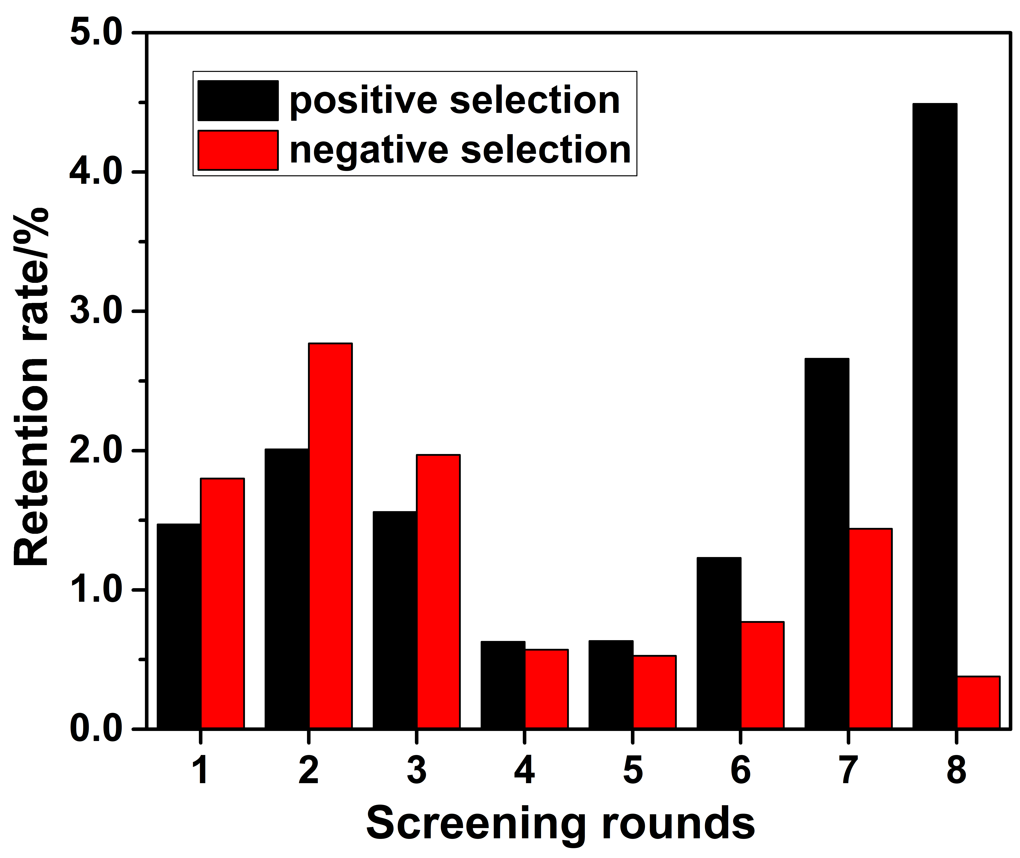
Fig. S1 The retention rate for each round of selection.

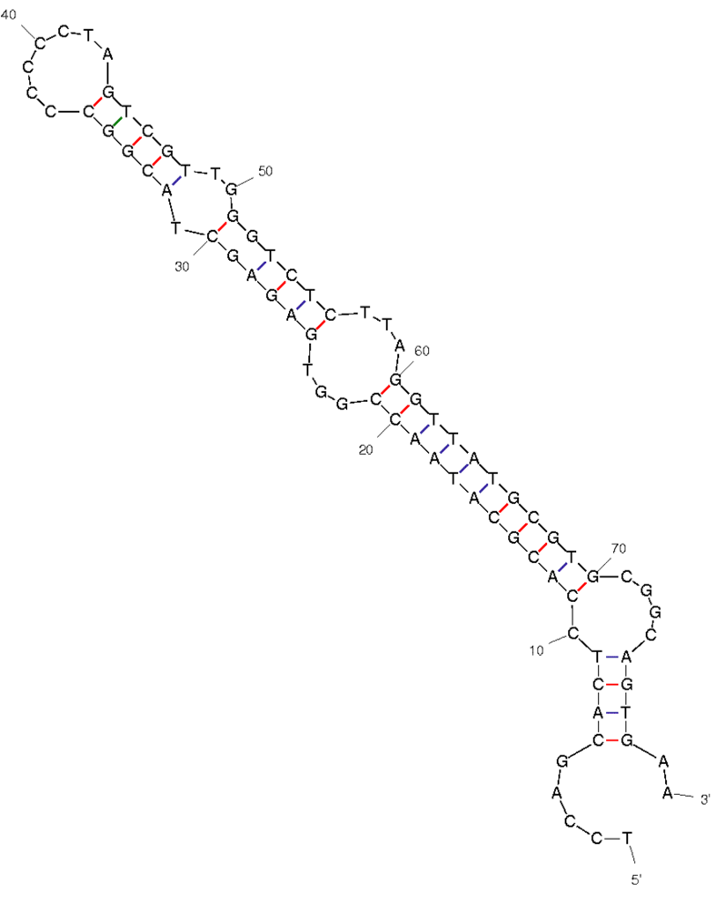
Fig. S2 The secondary structures of the Chl-aptamer

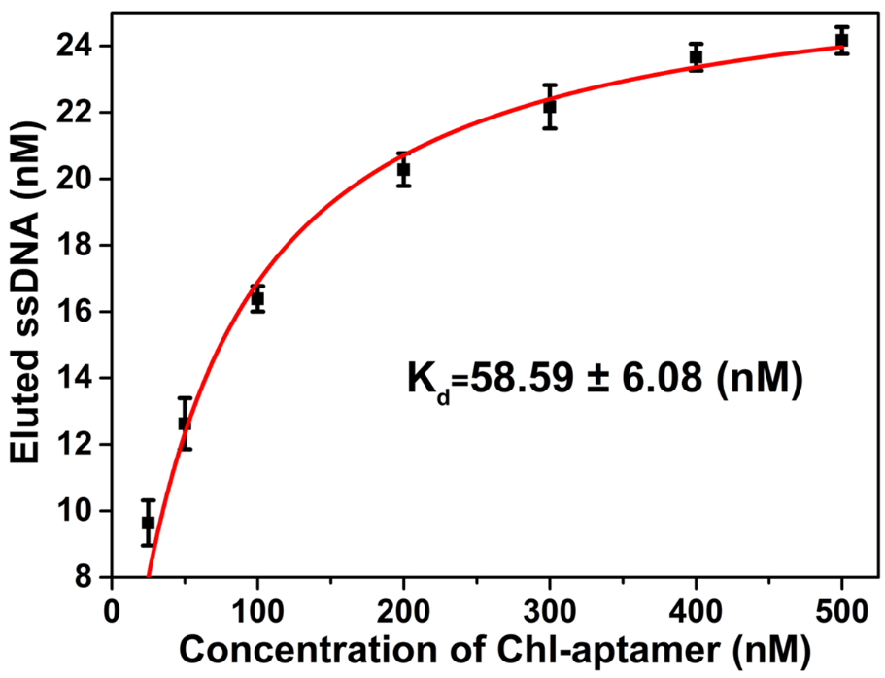
Fig. S3 The K_{d} curve of the Chl-aptamer.

