Extended Data Figure 1 Relationship between the response index of the abundance of novel functional plants and fungal pathogen relative abundance on plants in high (orange circles) and low (blue triangles) diversity plant communities. The solid line represents a statistically significant relationship (P < 0.05) and the dotted line represents a non-significant relationship based on unary linear regression with a random effect for plant community.

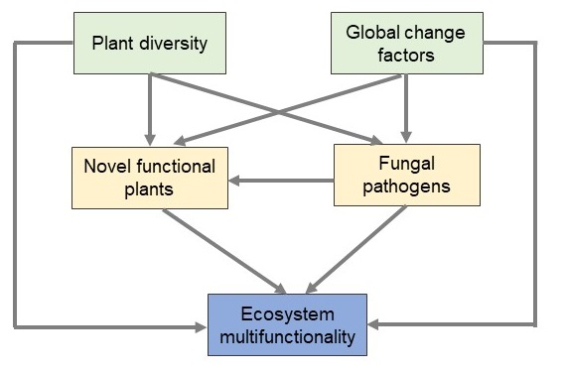
Extended Data Figure 2 Hypothesized Structural Equation Model (SEM) relating plant diversity, global change factors and ecosystem multifunctionality. Green boxes represent experimental treatments (global change factors, plant diversity), blue boxes represent response variables (ecosystem multifunctionality), and yellow boxes represent observed explanatory variables (relative abundance of fungal plant pathogens, abundance of novel functional plants).

Extended Data Figure 3 Mean (± S.E.) ecosystem multifunctionality in high (orange circles) and low (blue triangles) diversity plant communities, subjected or not (control) to the average (overall) or individual effects of global change factors.

