Supplementary Figure 1. Flowchart of how the analytical cohort was derived in the single time point analysis.

Number of patients with blood or saliva specimens
n=7,303
Number of unselected specimens
n=4,939
Number of unique patients used in methylation experiment
n=2,364
Exclusion (total n=109)
Negative (n=50)
Specificity I (n=13)
Staining (n=6)
Greedycut (n=5)
Bisulfite conversion I (n=3)
Sample type unknown (n=32)
Number of unique patients that passed quality check
n=2,255
Exclusion (total n=101)
LUMP<0.9 in blood specimens (n=3)
Unknown chemotherapy status (n=98)
Number of patients in analytical data
n=2,154

Supplementary Figure 2. Probes and promoters significant after Bonferroni correction across the three datasets (paired samples, SGBCC blood specimens, and SGBCC saliva specimens).

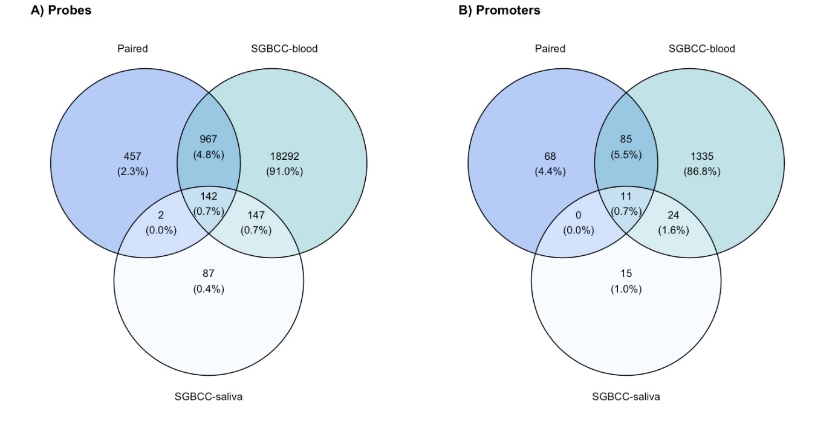

Supplementary Figure 3. Scatterplots comparing strength of associations from the single time point analysis (beta values from the linear model of the association between DNAm [588,798 probes] and chemotherapy) by time since start of chemotherapy. The slopes and standard errors [SE] corresponding to each time comparison are shown in the bottom right of each panel.

Supplementary Figure 4. Scatterplots comparing strength of associations from the single time point analysis (beta values from the linear model of the association between DNAm [41,222 promoters] and chemotherapy) by time since start of chemotherapy. The slopes and standard errors [SE] corresponding to each time comparison are shown in the bottom right of each panel.

Supplementary Figure 5. Olfactory transduction pathway (enriched KEGG pathways) in SGBCC dataset, by sample type (blood or saliva). Adjustments: (1) blood – age at diagnosis, cell types, LUMP, ethnicity, and year of diagnosis; (2) saliva – age at diagnosis, LUMP, ethnicity, and year of diagnosis; (3) blood – age at diagnosis, cell types, LUMP, and ethnicity; (4) saliva – age at diagnosis, LUMP, and ethnicity.

