Table S1. General Characteristics of the Countries (N=72)
Categorization |  | Minimum | Maximum | Mean | SD
Tobacco Industry Interference Index (2021)
 | All countries (N=72) | 30.0 | 96.0 | 59.2 | 14.8
 | State-Owned Tobacco Companies (N=7) | 39.0 | 76.0 | 55.9 | 13.4
 | Non-SOTCs (N=65) | 30.0 | 96.0 | 59.6 | 14.9
 | SOTCs + Lebanon & Japan (N=9) | 39.0 | 88.0 | 61.2 | 16.3
 | Non-SOTCs (N=63) | 20.0 | 96.0 | 59.0 | 14.7
MPOWER Scores (2021)
 | All countries (N=72) | 11.0 | 28.0 | 20.8 | 3.6
 | State-Owned Tobacco Companies (N=7) | 16.0 | 26.0 | 21.6 | 3.3
 | Non-SOTCs (N=65) | 11.0 | 28.0 | 20.7 | 3.7
 | SOTCs + Lebanon & Japan (N=9) | 16.0 | 26.0 | 21.2 | 3.1
 | Non-SOTCs (N=63) | 11.0 | 28.0 | 20.7 | 3.7
Adult Daily Smoking Prevalence (2019) published by WHO 2021 Report
 | All countries (N=72) | 2.0 | 37.0 | 15.2 | 8.2
 | State-Owned Tobacco Companies (N=7) | 9.0 | 23.0 | 17.1 | 4.8
 | Non-SOTCs (N=65) | 2.0 | 37.0 | 15.0 | 8.4
 | SOTCs + Lebanon & Japan (N=9) | 9.0 | 24.0 | 17.9 | 4.8
 | Non-SOTCs (N=63) | 2.0 | 37.0 | 14.8 | 8.5

Table S2. Impact of the Tobacco Industry Interference (TIII) on MPOWER scores and adult daily smoking prevalence rate in 72 countries (Stratification by the State-Owned Tobacco Companies, SOTCs)
Variables | MPOWE(R) Scores |  | Adult daily smoking prevalence
Variables | β | P-value | β | P-value
Tobacco Industry Interference Index
All countries (N=72) ^{a b} | -0.083* | 0.004 | 0.162* | 0.008
State-Owned Tobacco Companies (N=7)^{c} | -0.048 | 0.678 | 0.292 | 0.028
Non-SOTCs (N=65) | -0.065 | 0.035 | 0.141 | 0.045
SOTCs + Lebanon & Japan (N=9) ^{d} | -0.037 | 0.617 | 0.182 | 0.075
Non-SOTCs (N=63) | -0.070 | 0.030 | 0.138 | 0.060
Note: ª Adjusted adult daily smoking prevalence. ^{b} Adjusted MPOWER scores. P<0.05* ^{c} State-Owned Tobacco Companies (SOTCs) are Botswana, China, Egypt, Iran, Iraq, Thailand, and Viet Nam. ^{d} State-Owned Tobacco Companies (SOTCs) are Botswana, China, Egypt, Iran, Iraq, Thailand, and Viet Nam + Lebanon & Japan

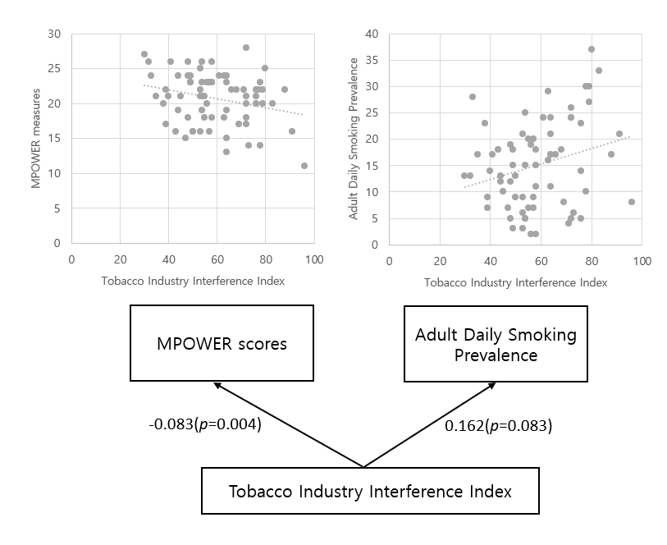
Note: Adjusted adult daily smoking prevalence or MPOWER scores. P<0.05*

Figure S1. Association between Tobacco Industry Interference Index (TIII) and MPOWER scores and adult daily smoking prevalence in 72 countries

Table S3. Impact of the subcomponents of the Tobacco Industry Interference (TIII) on MPOWER scores in 72 countries
Variable | MPOWER Scores
Variable | β | P-value
Tobacco Industry Interference Index
Participation in Policy Development | -0.117 | 0.206
Tobacco-related CSR Activities | 0.233 | 0.404
Benefits to the Tobacco Industry | -0.400* | 0.047
Forms of Unnecessary Interaction | -0.084 | 0.425
Conflict of Interest | -0.227 | 0.219
Transparency | -0.116 | 0.394
Preventive Measures | -0.231* | 0.010
Note: P<0.05*

Table S4. Impact of the Subcomponents of the TIII on Subcomponents of the MPOWER package in 72 countries
Variable | M |  |  | P |  |  | O |  |  | W(1) |  |  | W(2) |  | E |  |  | R
Variable | β | P-value | β |  | P-value | β |  | P-value | β |  | P-value | β |  | P-value | β | P-value | β |  | P-value
Tobacco Industry Interference Index | -0.001 | 0.919 | -0.007 |  | 0.501 | -0.003 |  | 0.544 | -0.018* |  | 0.028 | -0.011 |  | 0.275 | -0.020* | 0.004 | -0.004 |  | 0.530
Participation in Policy Development | 0.005 | 0.832 | -0.019 |  | 0.544 | 0.006 |  | 0.751 | -0.045 |  | 0.083 | -0.011 |  | 0.725 | -0.051* | 0.026 | -0.002 |  | 0.916
Tobacco-related CSR Activities | 0.015 | 0.835 | -0.038 |  | 0.690 | 0.086 |  | 0.109 | 0.041 |  | 0.597 | 0.113 |  | 0.234 | -0.066 | 0.339 | 0.083 |  | 0.210
Benefits to the Tobacco Industry | 0.004 | 0.946 | -0.091 |  | 0.189 | 0.000 |  | 1.000 | -0.109 |  | 0.052 | -0.050 |  | 0.471 | -0.096 | 0.055 | -0.054 |  | 0.261
Forms of Unnecessary Interaction | -0.019 | 0.498 | 0.023 |  | 0.528 | -0.021 |  | 0.297 | -0.007 |  | 0.801 | -0.044 |  | 0.217 | -0.023 | 0.372 | 0.007 |  | 0.788
Conflict of Interest | -0.004 | 0.938 | 0.004 |  | 0.950 | -0.005 |  | 0.888 | -0.087 |  | 0.087 | -0.082 |  | 0.190 | -0.004 | 0.932 | -0.050 |  | 0.255
Transparency | 0.020 | 0.579 | -0.016 |  | 0.738 | -0.005 |  | 0.836 | -0.030 |  | 0.424 | -0.041 |  | 0.381 | -0.073* | 0.027 | 0.030 |  | 0.362
Preventive Measures | -0.007 | 0.778 | -0.021 |  | 0.502 | -0.032 |  | 0.072 | -0.062* |  | 0.013 | -0.018 |  | 0.556 | -0.048* | 0.033 | -0.042* |  | 0.050
Note: P<0.05*. M contains monitoring tobacco use and preventive measures and five attainment levels for each other components. P means protecting the population from cigarette smoke, such as designing non-smoking areas in public places. O indicates help to quit tobacco use, such as smoking cessation clinics or cessation call centers. W consists of packaging a health warning about the dangers of tobacco (W1) and implementing a non-smoking campaign for cigarette risk (W2). E summarizes advertising on tobacco ban, promotion and sponsorship. R means raising taxes on tobacco.

Table S5. Impact of the Subcomponents of the TIII on Adult Daily Smoking Prevalence by Gender in 72 countries
Variable | Adult daily smoking prevalence
Variable | Both Sexes |  | Male |  |  | Female
Variable | β | P-value | β | P-value |  | β |  | P-value
Tobacco Industry Interference Index | 0.118 | 0.053 | 0.206* | 0.040 |  | 0.014 |  | 0.792
Participation in Policy Development | 0.281 | 0.146 | 0.533 | 0.090 |  | 0.000 |  | 0.999
Tobacco-related CSR Activities | 0.853 | 0.141 | 1.601 | 0.090 |  | 0.501 |  | 0.324
Benefits to the Tobacco Industry | 0.889* | 0.035 | 1.498* | 0.029 |  | 0.238 |  | 0.523
Forms of Unnecessary Interaction | 0.286 | 0.192 | 0.478 | 0.180 |  | -0.044 |  | 0.817
Conflict of Interest | 0.594 | 0.122 | 1.363 | 0.028 |  | -0.269 |  | 0.425
Transparency | 0.184 | 0.519 | 0.263 | 0.572 |  | 0.015 |  | 0.952
Preventive Measures | 0.119 | 0.537 | 0.066 | 0.835 |  | 0.122 |  | 0.465
Note: P<0.05*

