Table 2: Overview of the silhouette in human identificaiton studies: stimuli, task, findings.
 | Stimuli | Experimental Stimuli | Experimental Result
Allyson Rice et al 2013 | Image pairs |  | Eye movement patterns
Noa Simhi et al 2015 | Moving  Faces and People |  | Similarity detection
Emma L. Axelsson et al 2019 | Headless inverted |  | Body inversion effects
Afzal A. Godil et al 2003 | Body Shape |  | Human identification
Robert T. Collins et al 2002 | Motion sequences |  | Gait recognition
Sue Fletcher et al 2006 | Person-present and person-absent scenes were randomly | 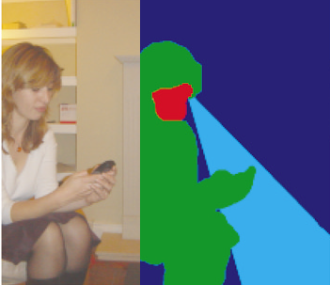 | Eye movement patterns
N K A K M Rasheed et al 2013 | Body Shape |  | Body feature Classification
Xiaoli Zhou et al 2006 | Motion sequences |  | Human Gait recognition
Minh-Tuan Nguyen et al 2016 | Video sequences |  | Human identification
Leonid Pishchulin et al 2016 | 3D human shape and pose |  | human body reconstruction
Seung-Yeob Baek et al 2012 | Body shapes |  | human body shape modeling
Sungmin Kim et al 2004 | Body cross section |  | Body model for garment drape simulation
Zhanfeng Yue et al 2008 | Body Shape | 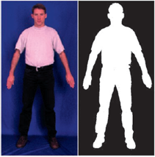 | silhouette extraction
Celia Foster et al 2021 | neural representation of face and body |  | Identiy Learning

