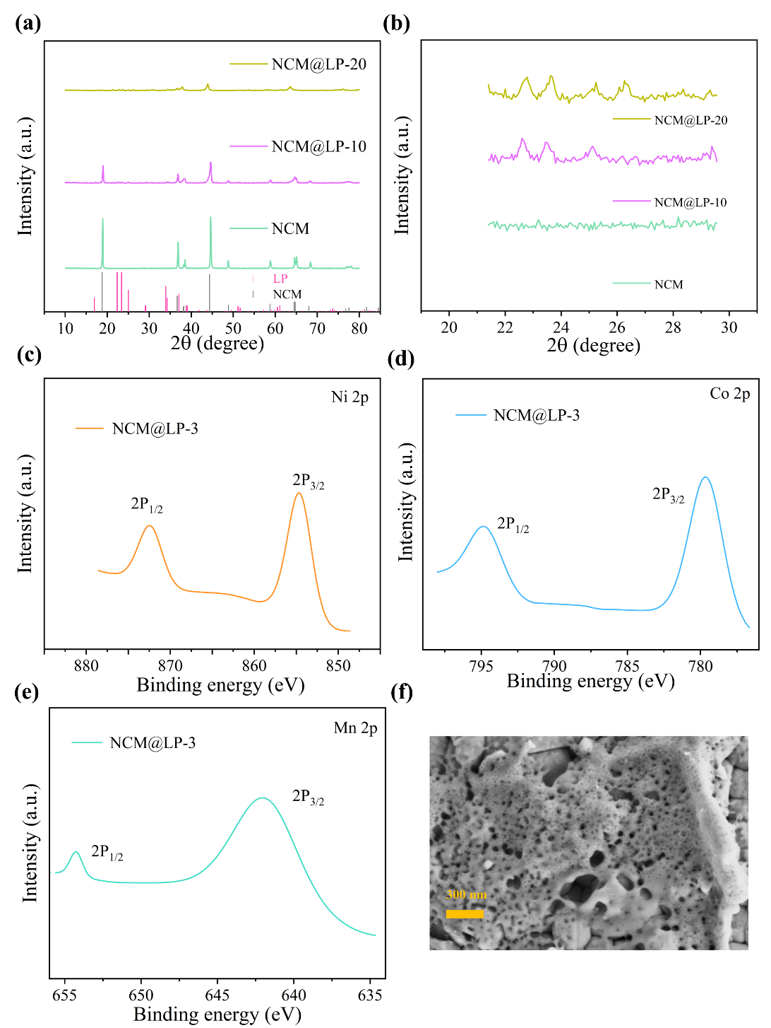
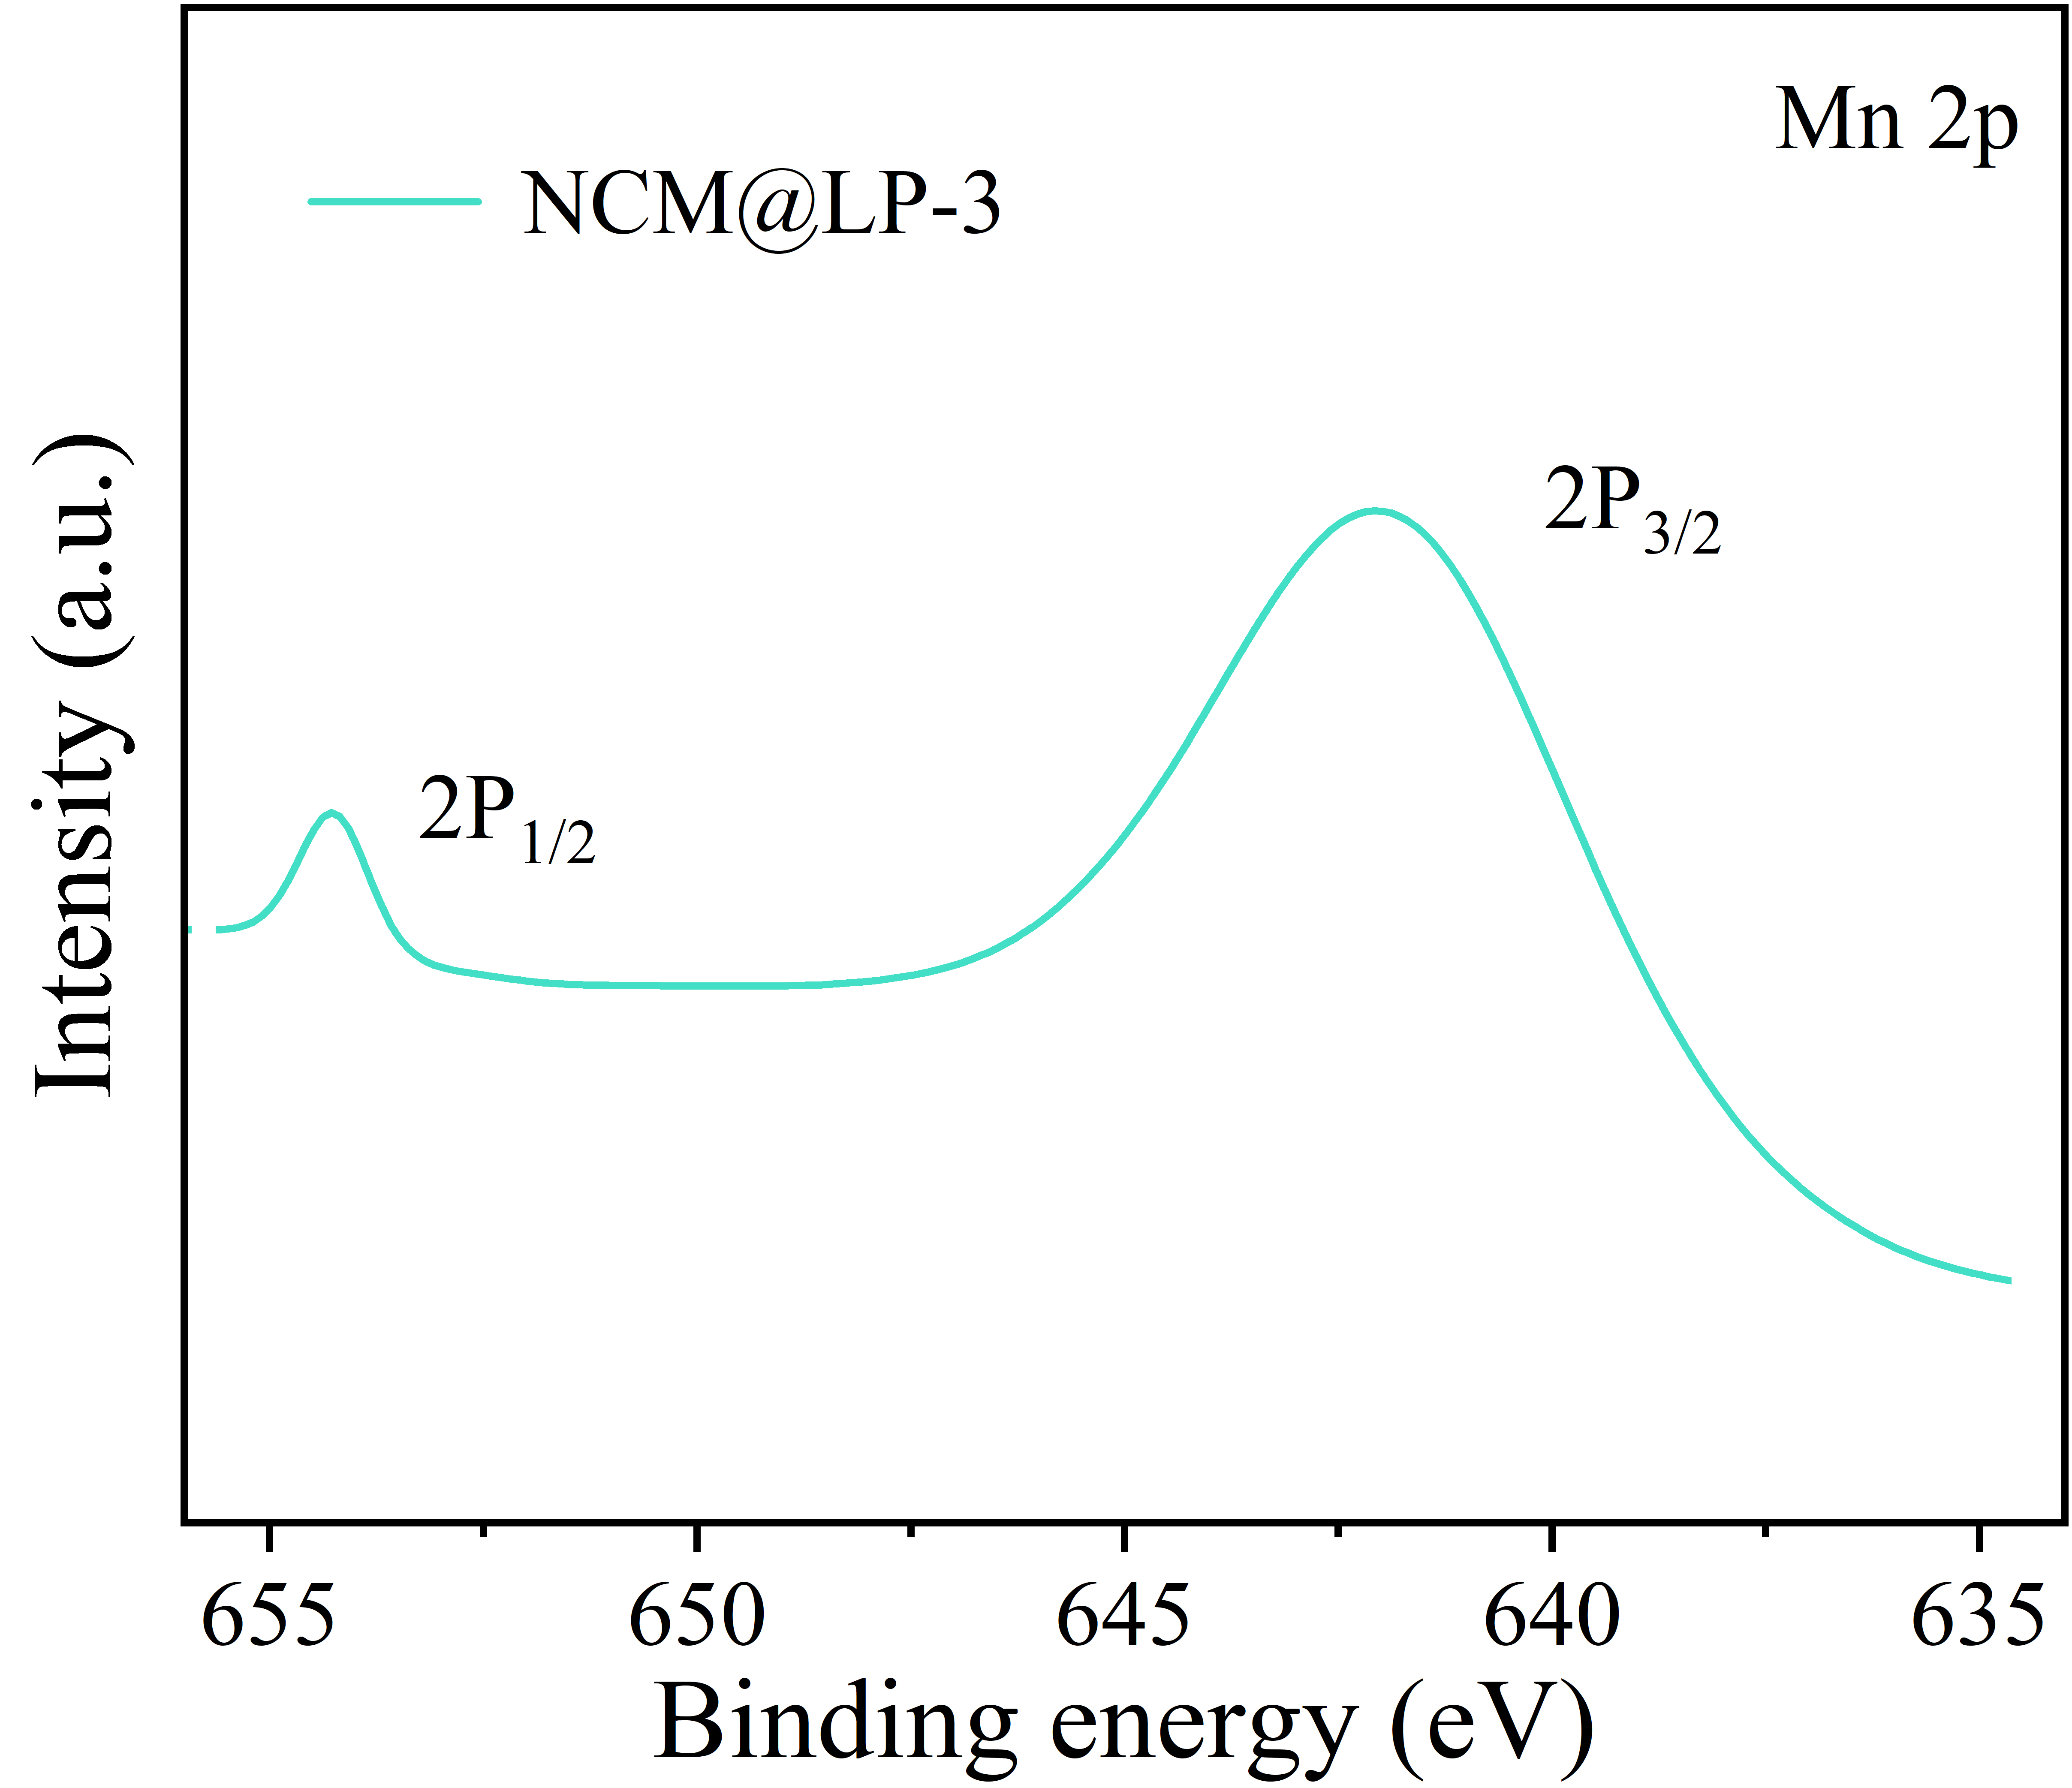
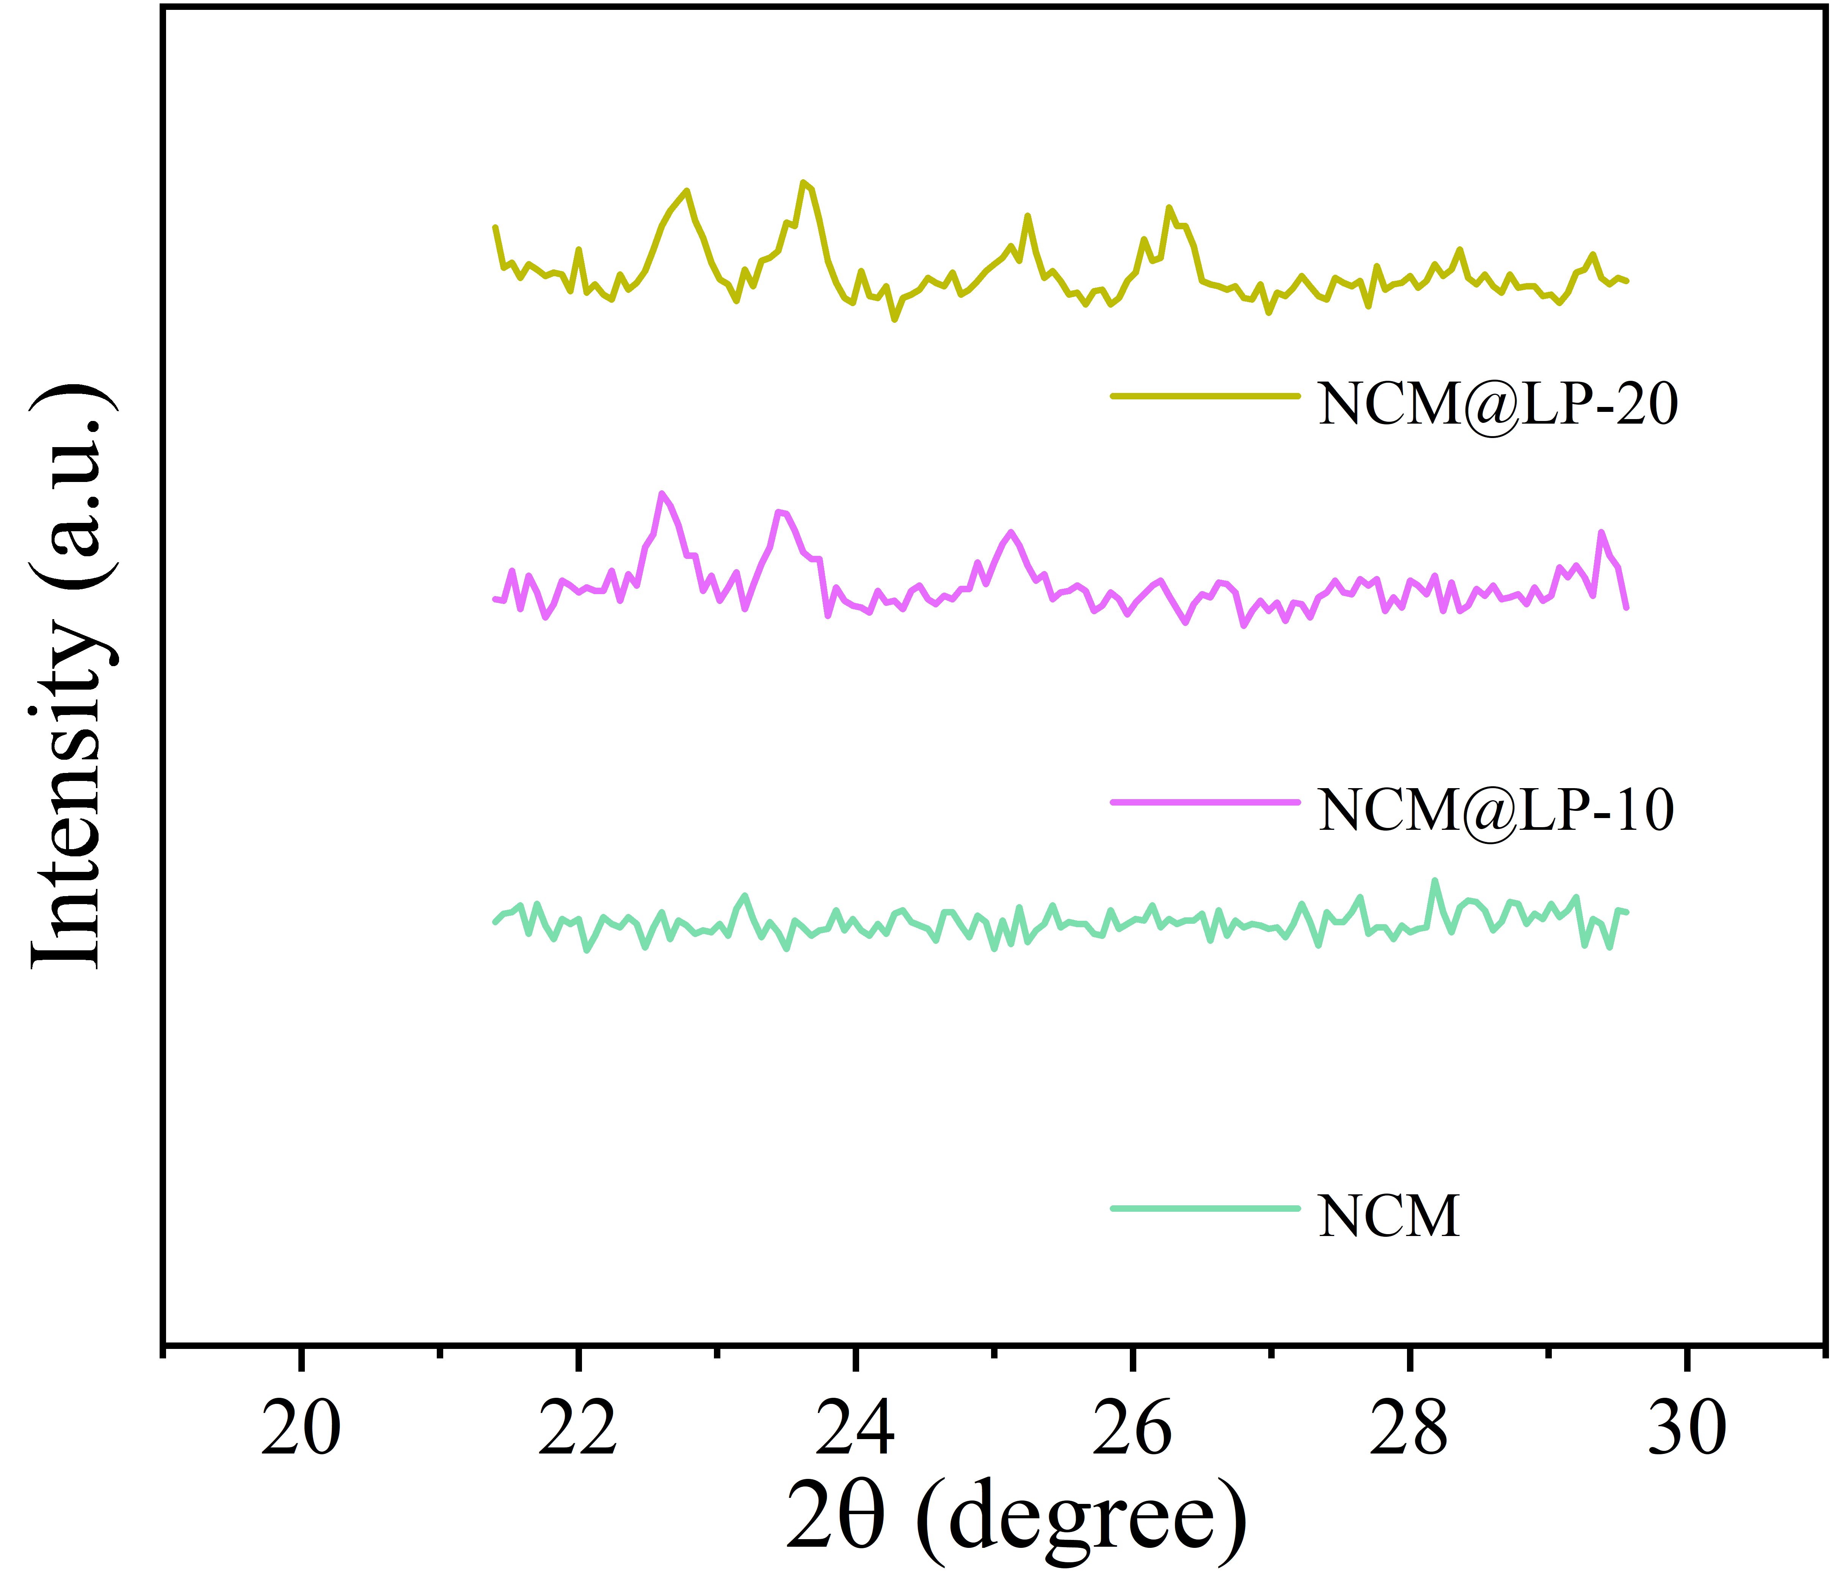
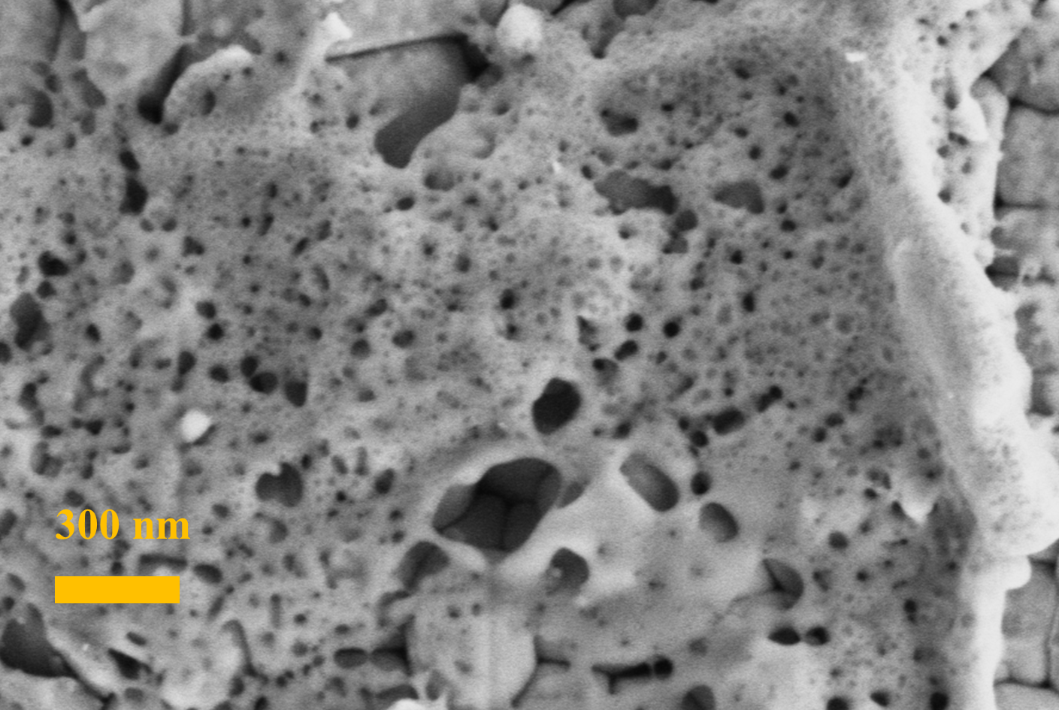
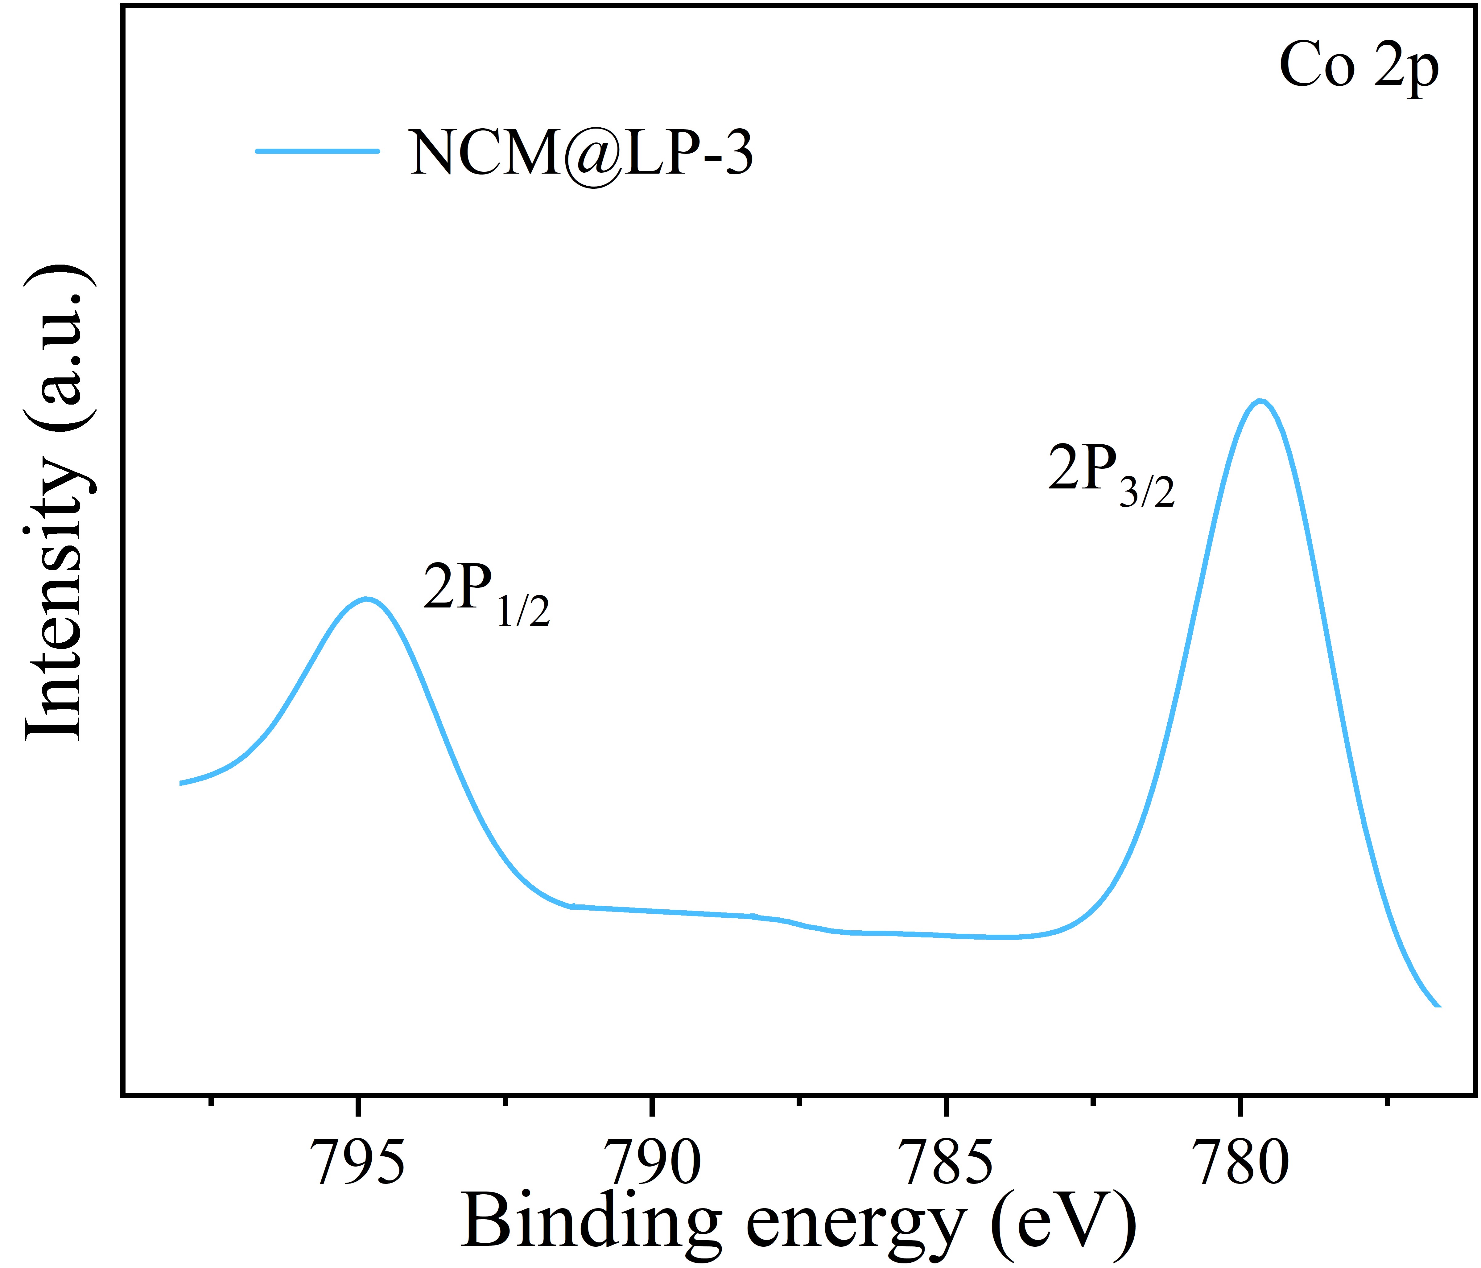
Fig. S1 a XRD patterns of NCM, NCM@LP-10, and NCM@LP-20, b Magnified view of NCM, NCM@LP-10, and NCM@LP-20, c XPS spectra of Ni of NCM@LP-3, d Co, e Mn, f SEM image of NCM@LP-3-A
(b)
(d)
(e)
(f)
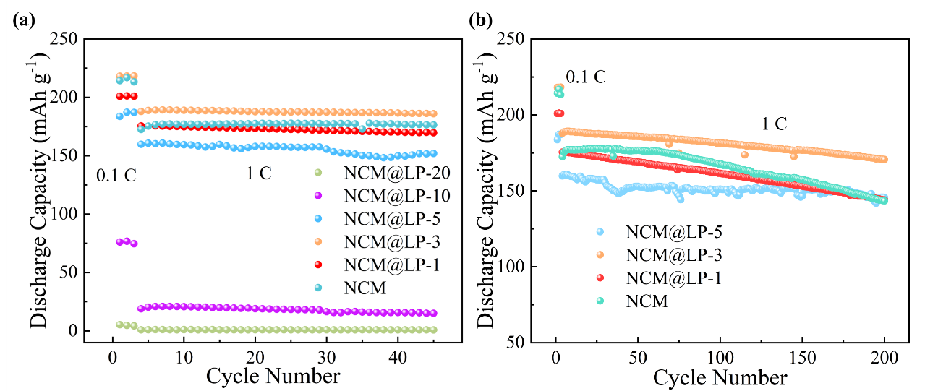
Fig. S2 a cycling performance of NCM, NCM@LP-1, NCM@LP-3, NCM@LP-5, NCM@LP-10, NCM@LP-20 at 1 C for 45 cycles, b of NCM, NCM@LP-1, NCM@LP-3, NCM@LP-5 at 1 C for 200 cycles

