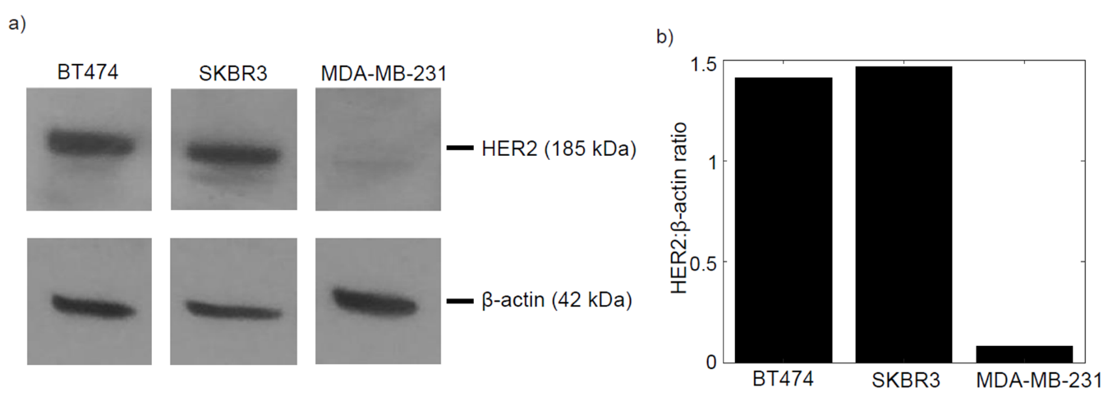
Supp. Fig. 1: HER2 quantification in BT474, SKBR3 and MDA-MB-231 cells. a) Expression of HER2 protein (185 kDa) in each cell line. β-actin (42 kDa) was used as an internal control. Visible protein bands are seen in the BT474 and SKBR3 HER2+ cell lines while MDA-MB-231 shows little to no expression. B) HER2:β-actin ratio in each cell line. BT474 and SKBR3 cells have ratios of 1.41 and 1.46, respectively. MDA-MB-231 has a ratio of 0.08, confirming no HER2 amplification.
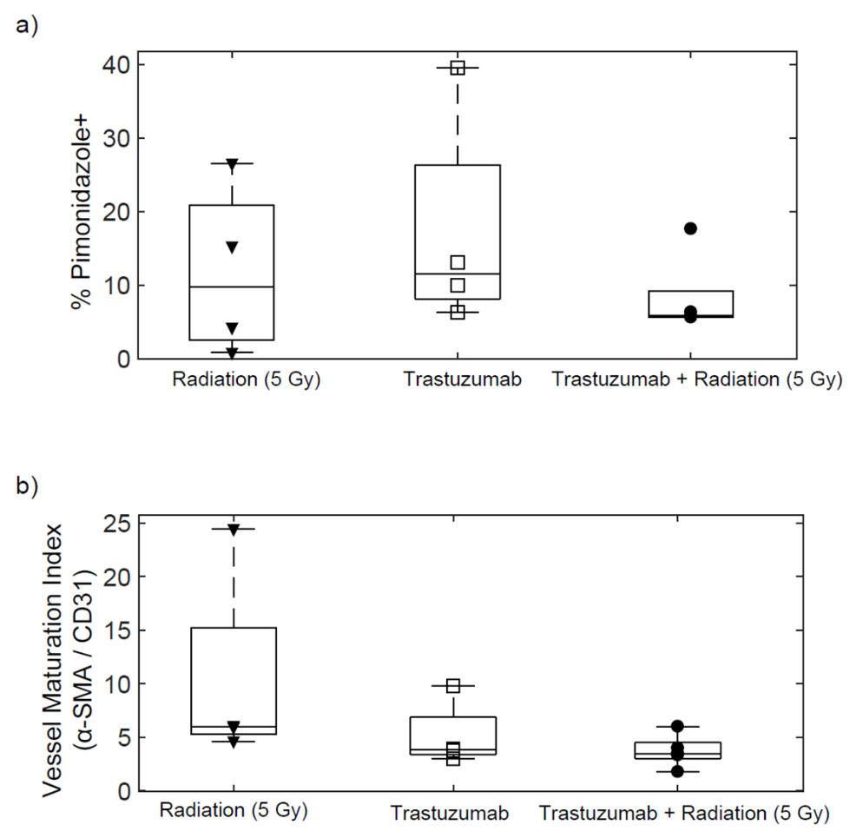
Supp. Fig. 2: Hypoxia and vascular staining in single agent radiation, trastuzumab and combination treated tumors. All radiation single agent and combination groups were treated with 5 Gy of radiation on Day 0. All trastuzumab single agent and combination groups were treated with 10 mg/kg of trastuzumab on Days 0 and 3. a) Percent pimonidazole staining revealing no significant differences between treatment groups (P > 0.05). B) Vascular maturation index revealing no significant differences between treatment groups (P > 0.05).

