Figure 4
GAPDH

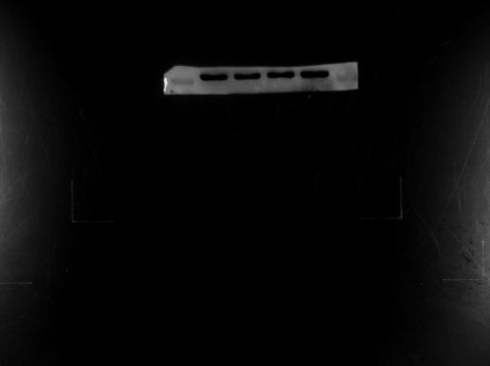
35 kDa

Bcl-2
35 kDa

25 kDa

25 kDa

35 kDa

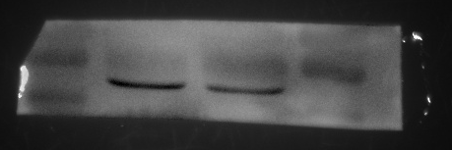

Bax
25 kDa
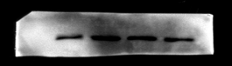
15 kDa

Cleaved caspase 3

15 kDa

Figure 5
Fscn2
55 kDa
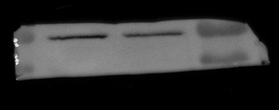
35 kDa
55 kDa
35 kDa
GAPDH
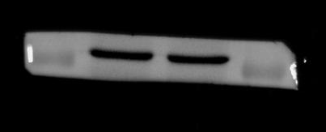
35 kDa
35 kDa

Figure 6
GAPDH

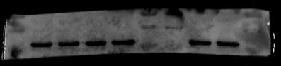
35 kDa

Bax

25 kDa
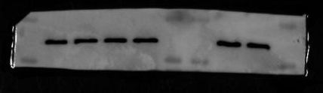
15 kDa

Bcl-2

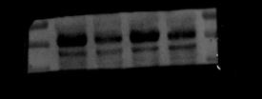
15 kDa
25 kDa
35 kDa

Cleaved caspase3

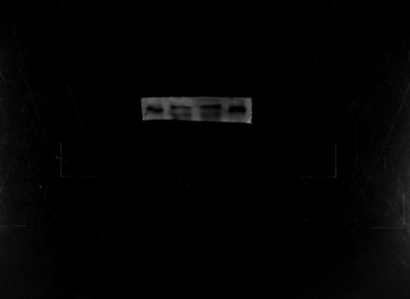
15 kDa
Figure S1

