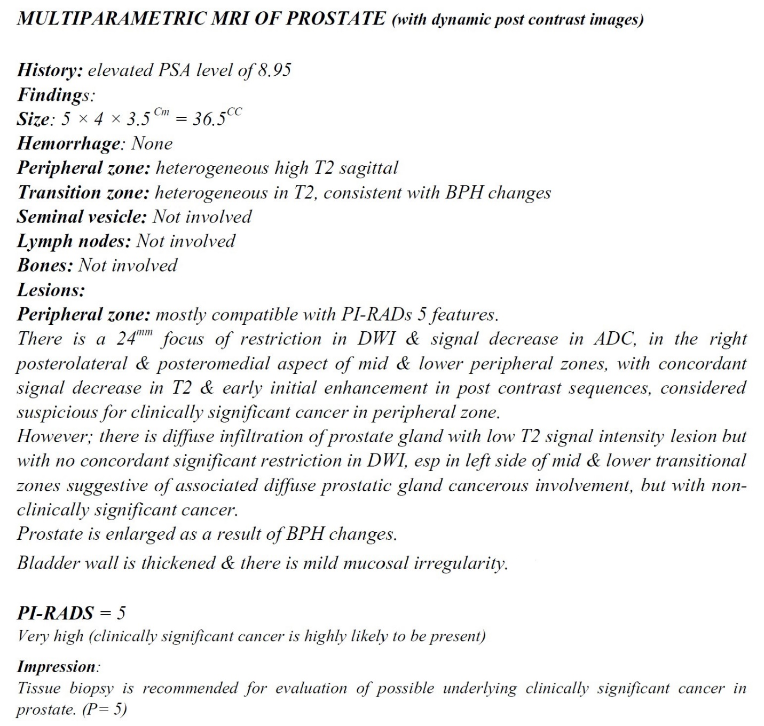
Supplementary Figure S 1. Multiparametric magnetic resonance imaging report according to the PI-RADS 2.1 outlined standard reporting format.
PSA, prostate-specific antigen; BPH, benign prostatic hyperplasia; DWI, diffusion-weighted imaging; ADC, Apparent diffusion coefficient; EPE, extraprostatic extension, PI-RADS, Prostate Imaging Reporting and Data System.

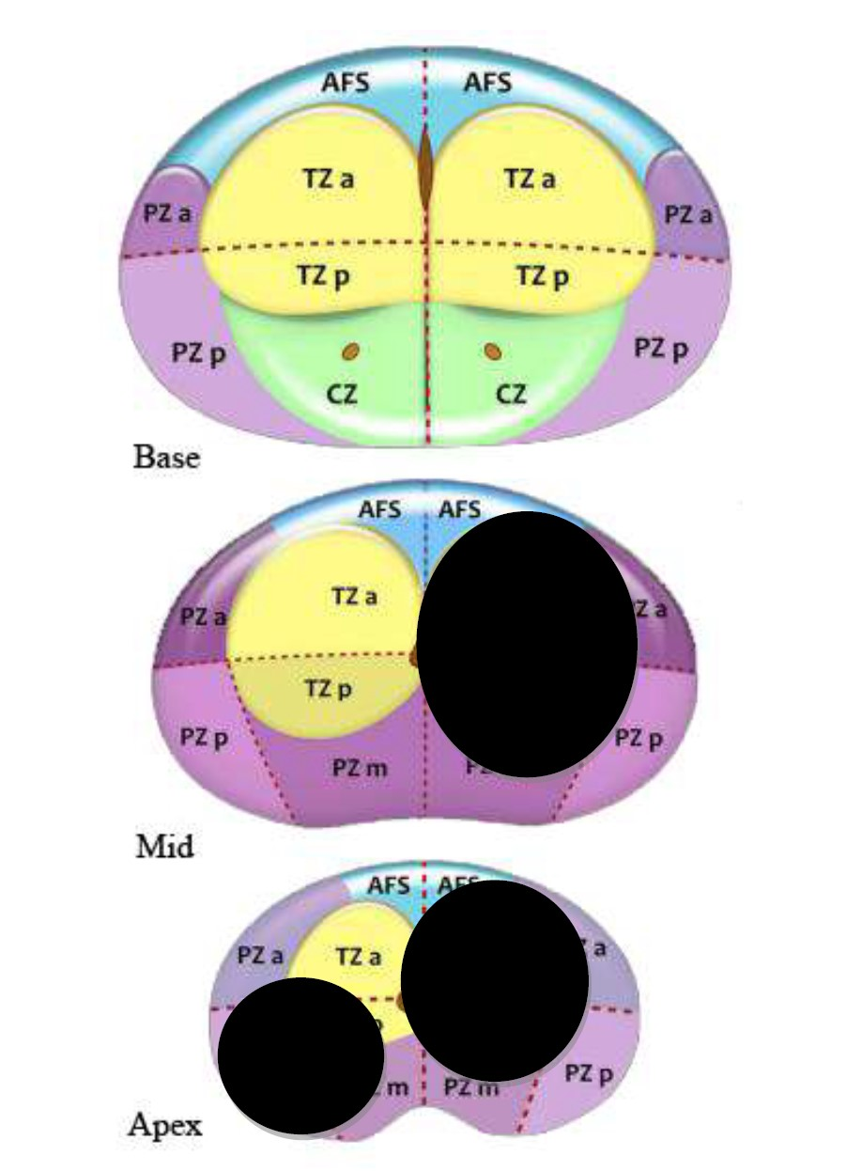
Supplementary Figure S 2. Topographic map of the prostate according to PI-RADS v2.1 sector map diagram
PZ, peripheral zone; TZ, transition zone; CZ, central zone; AFS, anterior fibromuscular stroma; a, anterior; p, posterior, PI-RADS v2.1, Prostate Imaging Reporting and Data System version 2.1.

Supplementary Table S1. The prostate mp-MRI sequence specifications
 | TR (ms) | TE (ms) | Slice thickness (mm) | FOV (cm) | Matrix | b value (s/mm²)
Sequences
Axial T2WI | 4200 | 100 | 3 | 15 | 352×352 | -
Coronal T2WI | 3600 | 100 | 3 | 15 | 352×352 | -
Axial DWI (zoom DWI) | 2100 | 100 | 4 | 15 | 96×96 | 0,800,1400
Axial post contrast T1 classic | 660 | 10 | 5 | 35 | - | -
Axial DCE T1 VIBE (Mdixon) including precontrast | 4.8 | 0 | 3 | 15 | 320×320 | -
mp-MRI, multiparametric magnetic resonance imaging; TR, repetition time, TE, echo time; FOV, field of view; T2WI, T2 weighted image; DWI, diffusion-weighted imaging; VIBE, volumetric interpolated breath-hold examination; DCE, dynamic contrast enhancement.

Supplementary Table S2. Baseline characteristics of the study population according to PIRADS categories
 | PI-RADS v2.1 |  | p-value
 | PI-RADS 4  (n = 35) | PI-RADS 5  (n = 41) | p-value
Characteristics
Age (years) | 66.83 (8.32) | 70.37 (9.03) | 0.082
PSA† (ng/ml) | 7.50 (5.32-12.36) | 16.10 (7.52-30.72) | <0.001
Prostate volume (ml) | 45.00 (35.00-69.00) | 46.00 (35.50-81.00) | 0.393
The number of lesions per patient | 1 (1-2) | 1 (1-2) | 0.628
Single lesion | 19 (54.30%) | 25 (61.00%) | 0.643
Multiple lesions | 16 (45.70%) | 16 (39.0%) | 0.643
The calculated mean of lesions diameter per patient (mm) | 13.00 (11.50-14.00) | 20.00 (17.50-32.50) | <0.001
Anatomical location of the lesion
Transitional zone | 20 (57.10%) | 15 (36.60%) | 0.106
Peripheral zone | 18 (51.40%) | 33 (80.50%) | 0.013
Number of additional cognitive cores per patient | 2 (1-3) | 2 (1-3) | 0.857
The total biopsy cores length (mm) | 231.71 (41.79) | 222.07 (38.95) | 0.302
Values are expressed as mean (standard deviation) or median (interquartile range) for continuous variables and n (%) for categorical variables.
csPCa, clinically significant prostate cancer; PSA, prostate-specific antigen; mp-MRI, multiparametric magnetic resonance imaging; PI-RADS, Prostate Imaging Reporting and Data System.
† There was one missing data for PSA among the study population.

Supplementary Table S3. Characteristics PI-RADS v2.1 studies among Middle East population
Authors  (references)  Year  Country | Method  Duration | Patient number  Lesion number  Anatomical location  (Lesions number) | Age (mean/median)  (year) | PSA level  (mean/median)  (ng/dl) | PI-RADS version  (Patients/lesions number) | MRI | PI-RADS categories  (Patients/ lesions number) | Prior biopsy status  (Patients number) | Biopsy technique | csPCa definition | csPCa detection rate  (Percent)
Coskun et al. [1]  2021  Turkey | Retrospective  Patient-based  2 years | 154  138  Peripheral = 119  Transitional = 19 | 66 | 7.8 | v2.1 | 1.5 T | PI-RADS 1 = 34  PI-RADS 2 = 6  PI-RADS 3 = 11  PI-RADS 4 = 38  PI-RADS 5 = 65 | NR | 12 quadrants systematic biopsy  Additional cognitive fusion biopsy among 19 patients with TZ lesion | GS ≥ 3+4 | PI-RADS 1 = 0 %  PI-RADS 2 = 18 %  PI-RADS 3 = 34 %  PI-RADS 4 = 80 %  PI-RADS 5 = 82%
Vural et al. [2]  2021  Turkey | Retrospective  Single-center  Lesion-based  8 years | 246  277  Peripheral = 227  Transitional = 46  Central = 4 | 65.7 | 7.75 | v1 = 39  v2 = 201  v2.1 = 37 | 3 T | PI-RADS 4 = 165  PI-RADS 5 = 112 | Biopsy naïve = 200  Prior negative biopsy = 46 | In-bore  In addition, 81 patients underwent radical prostatectomy. | GP ≥ 4 | Overall = 63 %  Among biopsy naïve patients = 66%  PI-RADS score of 4 = 49.7%  PI-RADS score of 5 = 75 %
Koparal et al.  [3]  2021  Turkey | Retrospective  Prostate cancer and prostate biopsy database analysis (Turkish Urooncology Association)  Patient-based  4 years | 1143  1500 | 63 | 6.6 | v2  v2.1 | NR | PI-RADS 2 = 24  PI-RADS 3 = 318  PI-RADS 4 = 545  PI-RADS 5 = 256 | Biopsy naïve (NR)  Prior negative systematic biopsy | Software-guided transperineal/transrectal MRI/TURS fusion biopsy followed by 12 quadrants transperineal/transrectal systematic biopsy | ISUP GG ≥ 2 | Transrectal target biopsy = 19.5%  Transrectal systematic biopsy = 16.3%  Transrectal target biopsy plus systematic biopsy = 24.6%  Transperineal target biopsy = 27.5%  Transperineal systematic biopsy = 24.6%  Transperineal target biopsy plus systematic biopsy = 35.5%
PI-RADS v2.1, Prostate Imaging Reporting and Data System version 2.1; PSA, prostate-specific antigen; MRI, magnetic resonance imaging; csPCa, clinically significant prostate cancer; v1, v2, v2.1, version; T, tesla; NR, not reported; TZ, transitional zone; GS, Gleason score; GP, Gleason pattern; TRUS, transrectal ultrasound; ISUP GG, International Society of Urological Pathology Grade Group.

1. Coşkun M, Dönmez EMH, Akın Y, Öcal İ, Gümüş C, Uluç ME: Predictors of Clinically Significant Prostate Cancer: A Comparative Study of PSA, PSA Density, and MRI Parameters. Istanbul Medical Journal 2021, 22(1).
2. Vural M, Coskun B, Kilic M, Durmaz S, Gumus T, Cengiz D, Onay A, Saglican Y, Colakoglu B, Akpek S: In-bore MRI-guided prostate biopsy in a patient group with PI-RADS 4 and 5 targets: A single center experience. European Journal of Radiology 2021, 141:109785.
3. Koparal MY, Sözen TS, Karşıyakalı N, Aslan G, Akdoğan B, Şahin B, Türkeri L, Association MoTU: Comparison of transperineal and transrectal targeted prostate biopsy using Mahalanobis distance matching within propensity score caliper method: A multicenter study of Turkish Urooncology Association. The Prostate 2022, 82(4):425-432.

