Supplementary Materials
S1 Odds ratios in univariate and multivariate logistic regression analyses of the CT model
The odds ratios in univariate and multivariate logistic regression analyses of the CT model are shown in Table S1.
Table S1 Odds ratios in univariate and multivariate logistic regression analyses of the CT model
Variables | Univariable regression |  |  | Multivariable regression
 | OR (95% CI) | P value |  | OR (95% CI) | P value
Perforation | 1.000(0.116~8.595) | 1.000
Abscess | 1.000(0.116~8.595) | 1.000
Appendiceal Intraluminal Gas | 1.728×10⁷(0~NA) | 0.988
Pneumoperitoneum | 5.984×10⁶(0~NA) | 0.988
Appendix Wall Thickening | 1.270(0.581~2.798) | 0.550
Peritonitis | 1.646(0.619~4.584) | 0.323
Ileocecal Lymph Node | 1.641(0.74~3.701) | 0.226
Fecal Retention | 1.828(0.81~4.226) | 0.150
Thickness Of Appendix | 3.434(1.065~12.879) | 0.050
Surrounding Strand | 4.836(1.605~18.041) | 0.009 |  | 3.125(0.956,12.336) | 0.074
Cecum Wall Thickening | 3.366(1.512~7.78) | 0.004 |  | 2.486(1.052,6.059) | 0.040

S2 Parameters in the LASSO regression process
The trend of the lambda and mean squared error during the fivefold cross validation of the LASSO regression is shown in Figure S1. The coefficients of the arguments with different L1 norm values during LASSO regression are shown in Figure S2. The coefficients of the arguments with different lambda values during LASSO regression are shown in Figure S3. The fraction deviance explained with different L1 norm values during LASSO regression is shown in Figure S4.
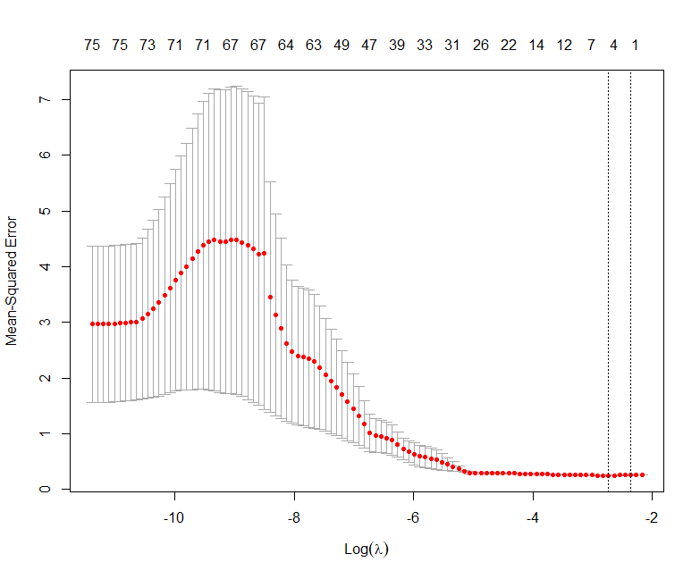
Figure S1. Trend of the lambda and m ean squared error during the fivefold cross validation of the LASSO regression
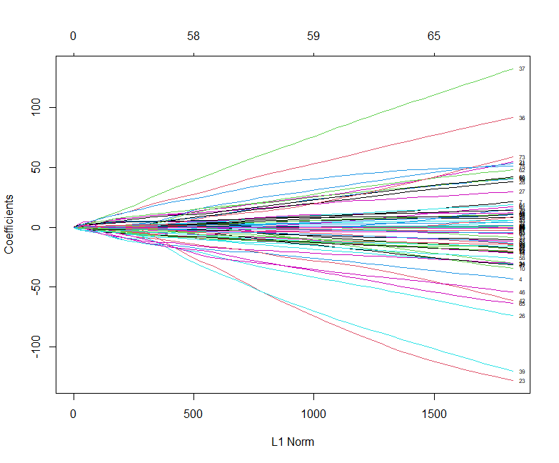
Figure S2. Coefficients of the arguments with different L1 norm values during LASSO regression

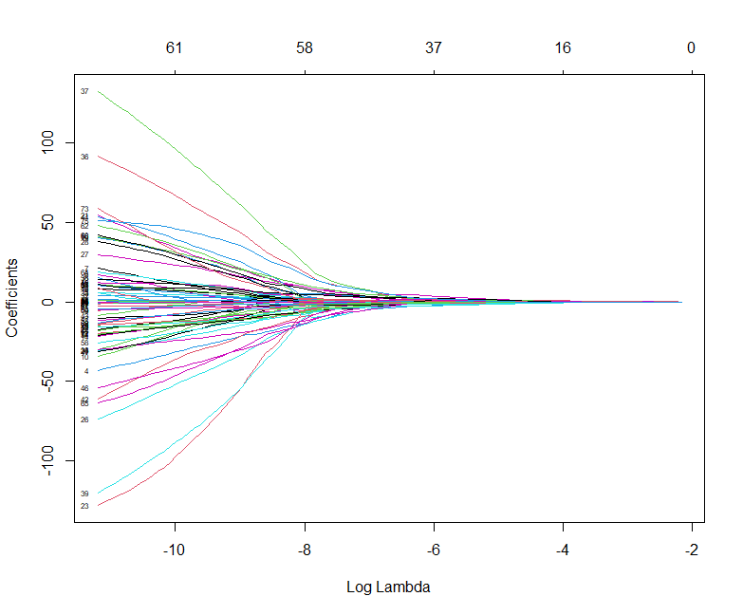
Figure S3. The coefficients of the arguments with different lambda values during LASSO regression

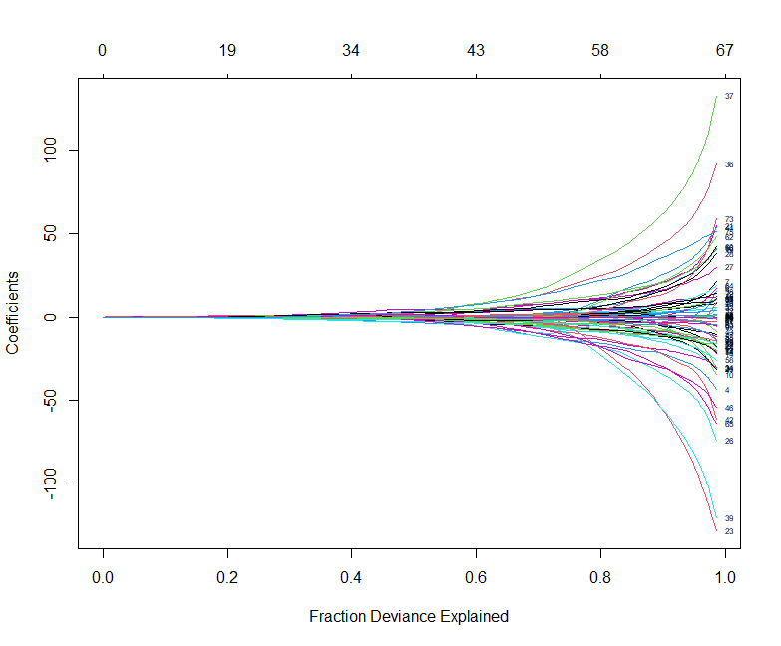
Figure S4. Fraction deviance explained with different L1 norm values during LASSO regression

...

S3 Arguments in the LASSO regression model
The arguments in the LASSO regression model are shown in Table S2.
Table S2 Arguments in the LASSO regression model
 | Feature Type | Name | Value
Lambda |  |  | 0.065
Intercept |  |  | 0.007
Arguments | GLDM | Dependence Variance | -0.204
 | GLSZM | Large Area Emphasis | 0.243
 | Shaped-based | Maximum 2D Diameter Column | 0.017
 | Shaped-based | Minor Axis Length | 0.026
 | Shaped-based | Surface Volume Ratio | <0.001

S4 Precision-recall curve and the calibration curve
After the best model was determined, the precision-recall curve and the calibration curve were plotted for further evaluation of the best model. For the calibration plot, bootstrapping using 1,000 repetitions was used to obtain bias-corrected predictive accuracy measures of the models.
The PR curve of the combined model in the test cohort is shown in Figure S5, with an AUC of 0.974. The calibration curve is shown in Figure S6. Calculation using 1,000 bootstrap replicates showed that the mean absolute error of the calibration test was 0.015, the mean squared error was < 0.001, and the 90% quantile of the absolute error was 0.023.
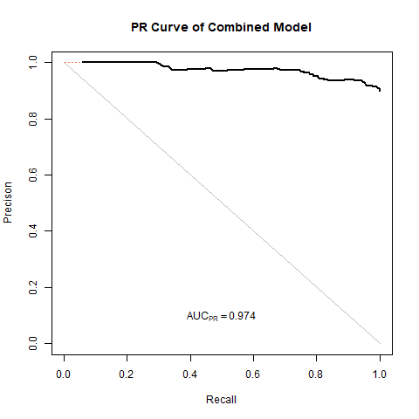
Figure S5. Precision-recall curve of the combined model in the test cohort, with an AUC of 0.974
Figure S6. Calibration curve of the combined model with 1,000 bootstrap replicates in the test cohort. Calculation using 1,000 bootstrap replicates showed that the mean absolute error of the calibration test was 0.015, the mean squared error was < 0.001, and the 90% quantile of the absolute error was 0.023.
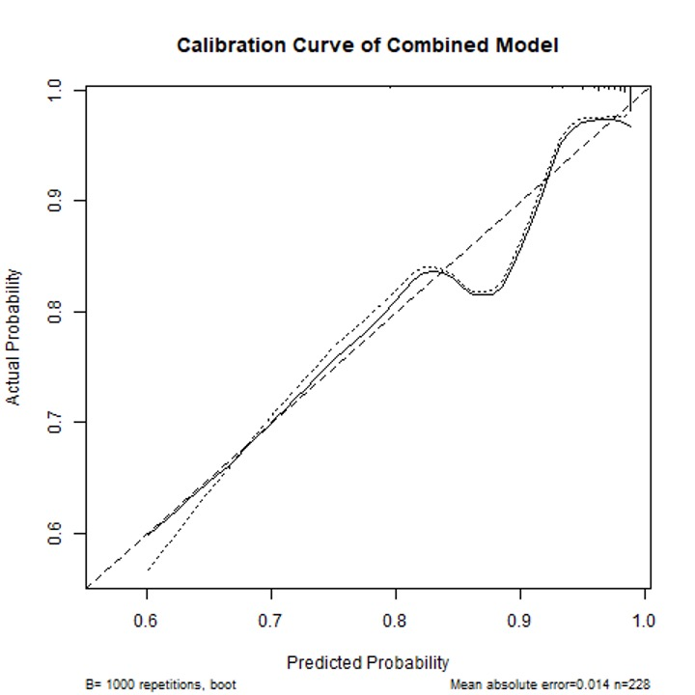

S5 Points of the nomogram of the combined model
The points of age, body temperature, neutrophil percentage, and Rad-score in the nomogram of the combined model are shown in Tables S3-S6. The total points vs the possibility of non-simple appendicitis are shown in Table S7.

Table S3 Points of age in the nomogram of the combined model
Age | Xbeta | points
15 | 0.752655 | 0
20 | 1.00354 | 3.230525
25 | 1.254425 | 6.46105
30 | 1.50531 | 9.691575
35 | 1.756195 | 12.9221
40 | 2.007081 | 16.15263
45 | 2.257966 | 19.38315
50 | 2.508851 | 22.61368
55 | 2.759736 | 25.8442
60 | 3.010621 | 29.07473
65 | 3.261506 | 32.30525
70 | 3.512391 | 35.53578
75 | 3.763276 | 38.7663
80 | 4.014161 | 41.99683

Table S4 Points of body temperature in the nomogram of the combined model
Body Temperature | Xbeta | points
36 | 71.94032 | 0
36.2 | 72.33999 | 5.146337
36.4 | 72.73966 | 10.29267
36.6 | 73.13933 | 15.43901
36.8 | 73.539 | 20.58535
37 | 73.93867 | 25.73168
37.2 | 74.33834 | 30.87802
37.4 | 74.738 | 36.02436
37.6 | 75.13767 | 41.17069
37.8 | 75.53734 | 46.31703
38 | 75.93701 | 51.46337
38.2 | 76.33668 | 56.6097
38.4 | 76.73635 | 61.75604
38.6 | 77.13601 | 66.90237

Table S5 Points of neutrophil percentage in the nomogram of the combined model
Neutrophil percentage | Xbeta | points
50 | 2.247318 | 0
55 | 2.47205 | 2.893763
60 | 2.696782 | 5.787525
65 | 2.921514 | 8.681288
70 | 3.146246 | 11.57505
75 | 3.370978 | 14.46881
80 | 3.595709 | 17.36258
85 | 3.820441 | 20.25634
90 | 4.045173 | 23.1501
95 | 4.269905 | 26.04386
100 | 4.494637 | 28.93763

Table S6 Points of the Rad-score predicted by LASSO in the nomogram of the combined model
Rad-score | Xbeta | points
0.25 | 2.986953 | 0
0.3 | 3.584343 | 7.692308
0.35 | 4.181734 | 15.38462
0.4 | 4.779124 | 23.07692
0.45 | 5.376515 | 30.76923
0.5 | 5.973906 | 38.46154
0.55 | 6.571296 | 46.15385
0.6 | 7.168687 | 53.84615
0.65 | 7.766077 | 61.53846
0.7 | 8.363468 | 69.23077
0.75 | 8.960858 | 76.92308
0.8 | 9.558249 | 84.61538
0.85 | 10.15564 | 92.30769
0.9 | 10.75303 | 100

Table S7 Total points vs possibility of non-simple appendicitis in the nomogram of the combined model
Total points | Possibility
74.58187 | 0.1
85.02392 | 0.2
91.96434 | 0.3
97.65367 | 0.4
102.8747 | 0.5
108.0957 | 0.6
113.7851 | 0.7
120.7254 | 0.8
131.1673 | 0.9

