Fig. S1. The dandelions in the wild area (nature reserves) have longer flower stalks and seed head stalks. (A) The flower stalks of the dandelions in the pristine nature reserves or wastelands (“wild”) are significantly longer than those observed in the lawns of the suburbs (n=25). (B) The seed head stalks of the dandelions in wild area are significantly longer than those observed in the lawns (n=50) (****P<0.0001, as determined by one-way ANOVA). Each dot represents the value of a single plant in the individual value plot. Values are compared between plots. All results are expressed as Mean ± SD.
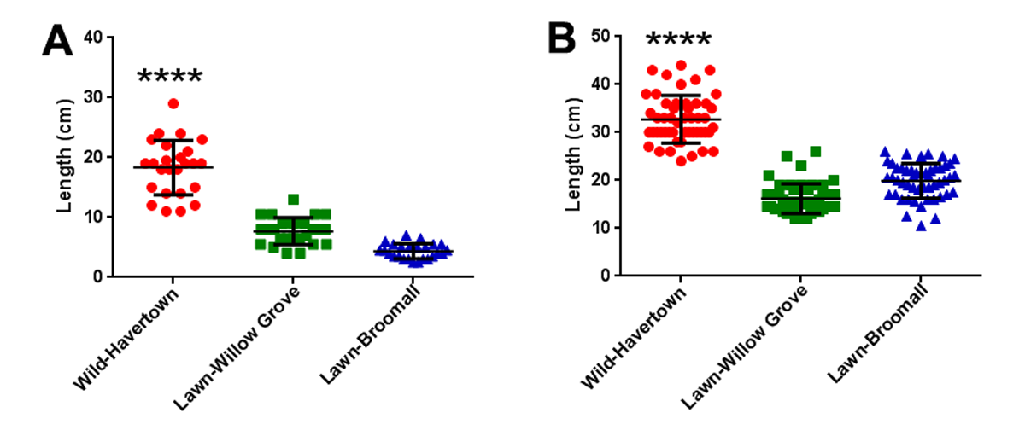

Fig. S2. The seed head stalks of the dandelions are longer than flower stalks. Dandelions have significantly longer seed head stalks than flower stalks (****P<0.0001, as determined by one-way ANOVA). The seed head stalks are longer than flower stalks in dandelions in the wild area or the suburban lawns. Each dot represents the value of a single plant in the individual value plot. Values are compared between plots. The results are expressed as Mean ± SD; (n = 25 samples per group).

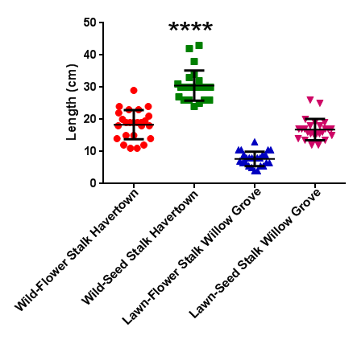

Fig. S3. The angle of seed head stalks of dandelion is 90º. The flower stalks of the dandelions in the wild area (nature reserves) had significantly larger angles compared to the counterparts in the suburban lawns. The seed head stalks of the dandelions in the wild area and suburban lawns had an angle of 90º (****P<0.0001, as determined by one-way ANOVA). Each dot represents the value of a single plant in the individual value plot. Values are compared between plots. All results are expressed as Mean ± SD; (n = 25 samples per group).

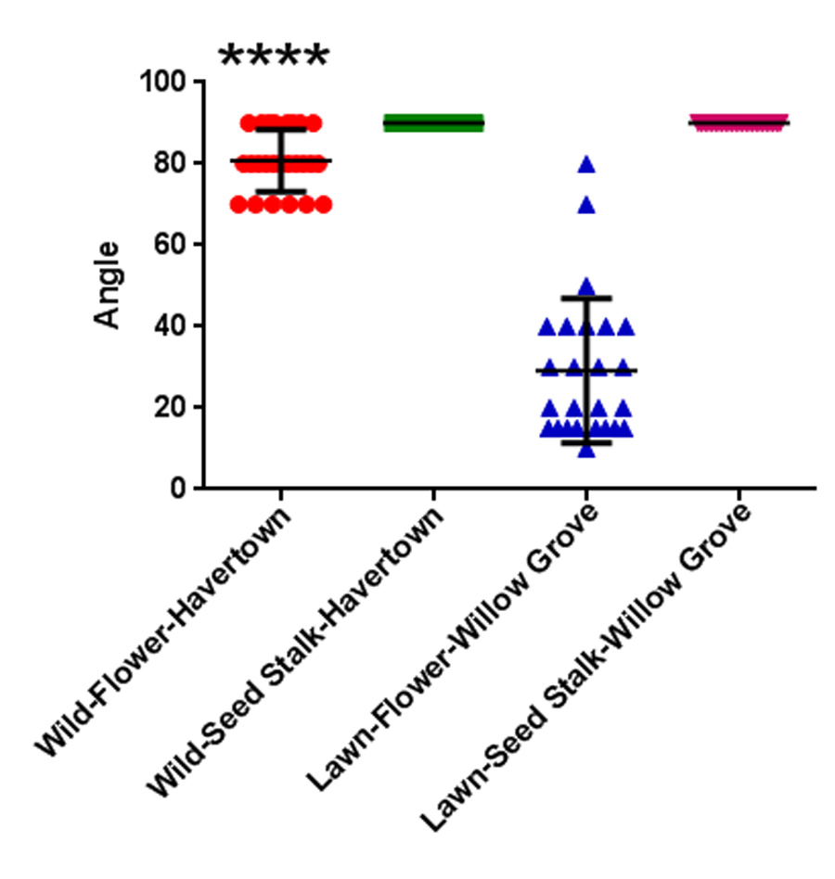

Fig. S4. The flower diameters of the dandelions in the suburban lawns are significantly smaller compared to the dandelions in the wild areas (nature reserves). The flower diameters of dandelions are significantly smaller in the suburban lawns compared to the diameters of dandelion flowers in the wild area (***P<0.001, as determined by Students t-test). All results are expressed as Mean ± SD; (n = 25 samples per group).

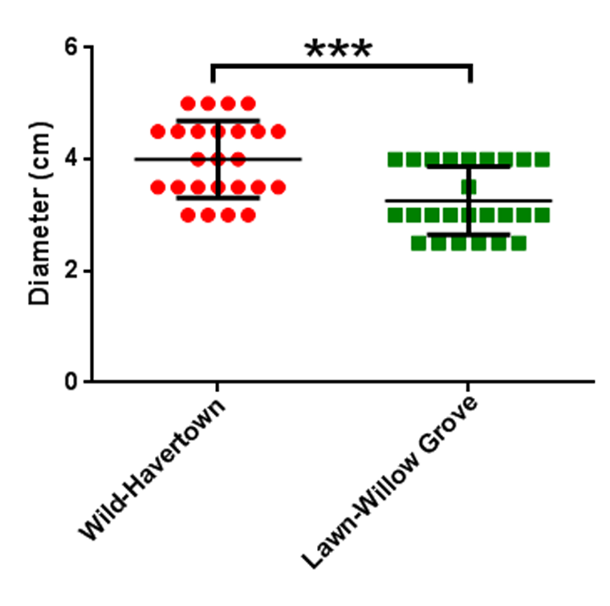

Fig. S5. The flower stalk and leaf size of dandelions at the uncut periphery of the playground (Coopertown/Bryn Mawr) was significantly longer compared to the plants in the playground. The flower stalk and leaf size of dandelions in the playground are significantly smaller compared to the dandelions in the uncut periphery of the playground (****P<0.0001, as determined by Students t-test). All results are expressed as Mean ± SD; (n = 25 samples per group in playground and n = 10 in the periphery).

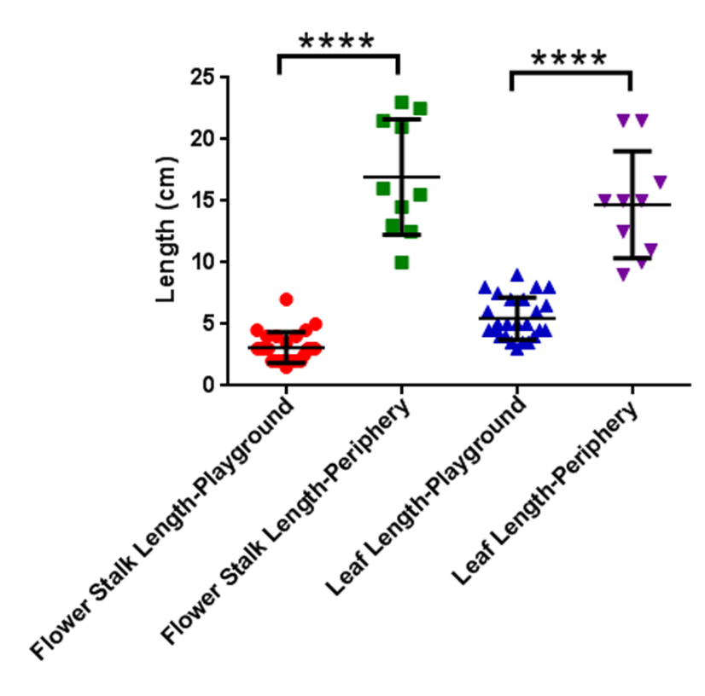

Fig. S6. Five days after lawn mowing, seed head stalks sprouted upwards, exhibiting vertical growth, and growing taller than the lawn grass to aid seed dispersal. The average length of the dandelion seed head stalk is 22±3.7cm (n=20) in a lawn of height 4.5 cm.
