Supplemental online appendix

Impact of a theory-informed and user-centered stroke information campaign on the public’s behaviors, attitudes, and knowledge when facing acute stroke - Haesebaert J et al

Appendix 1: Campaign resources

1a. Campaign posters (3 visuals)

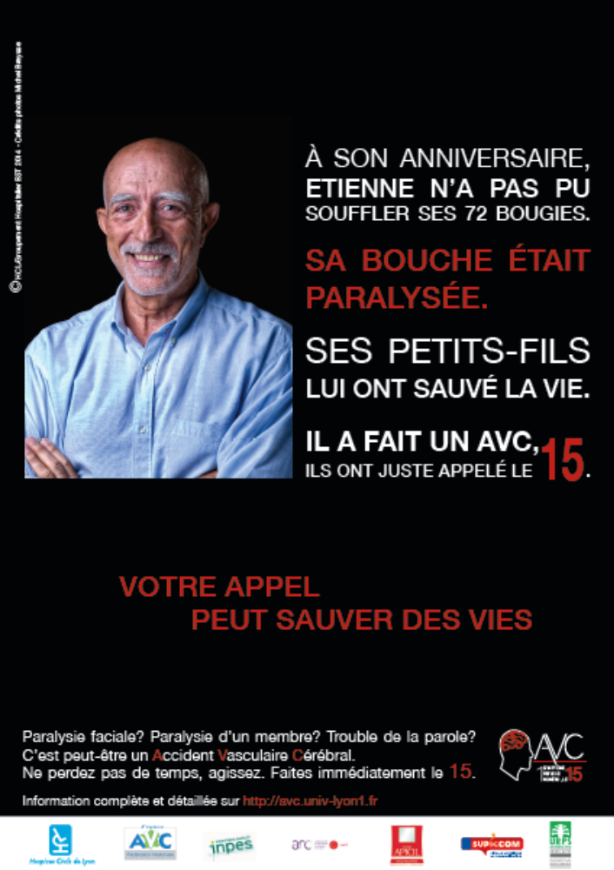

All individuals on campaigns materials provided in appendix of this publication have given their written consent for their likeness to be displayed in these images.

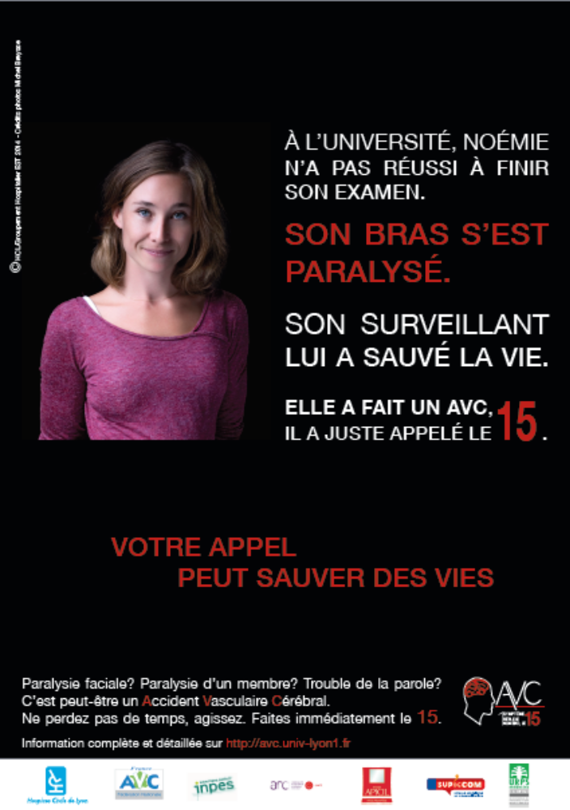

All individuals on campaigns materials provided in appendix of this publication have given their written consent for their likeness to be displayed in these images.

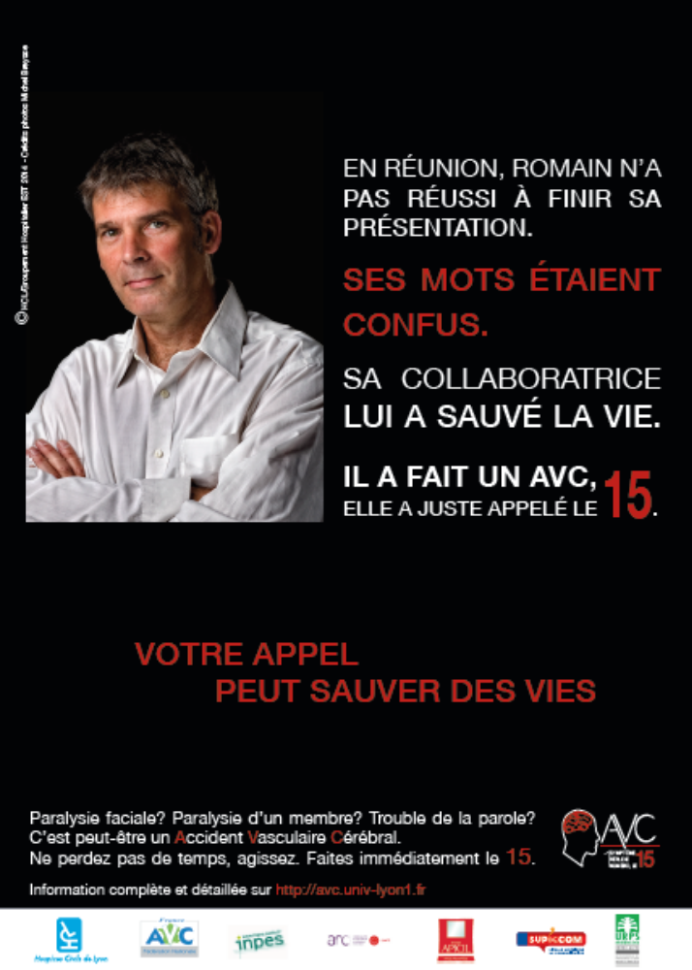

All individuals on campaigns materials provided in appendix of this publication have given their written consent for their likeness to be displayed in these images.

1b. Information leaflet

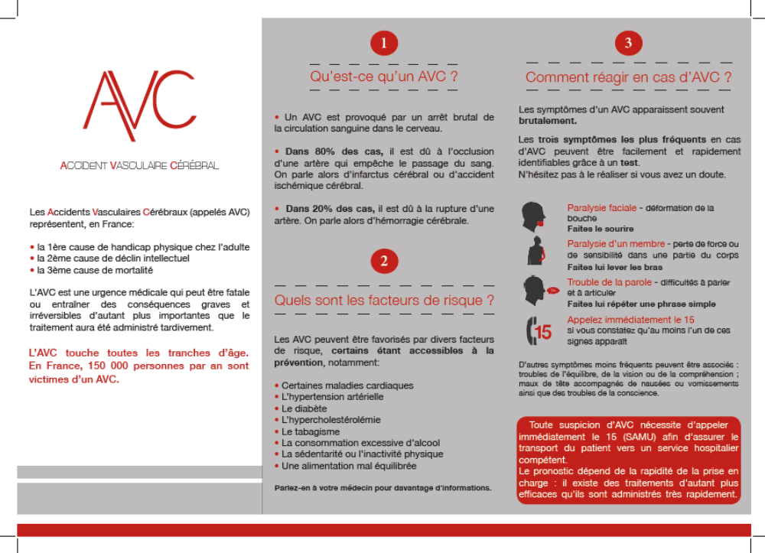

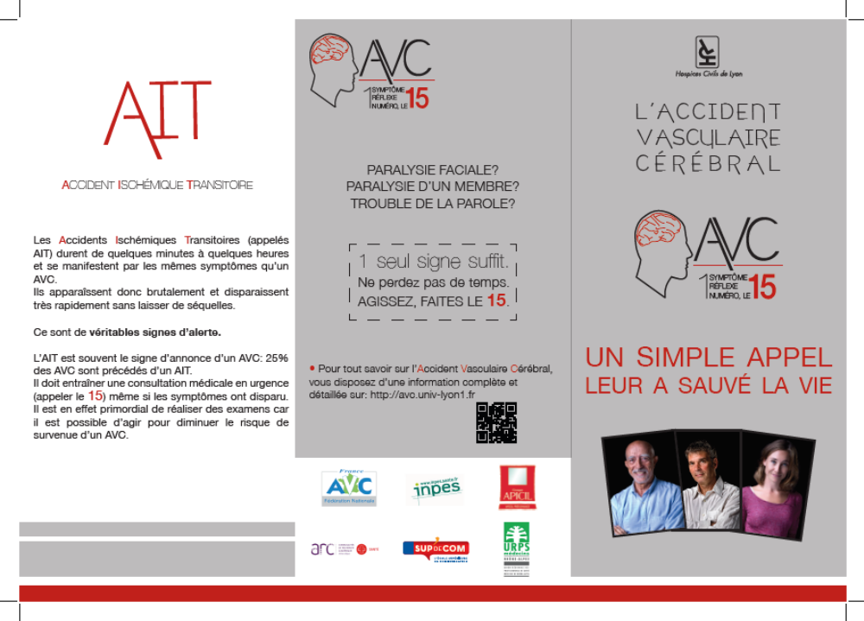
All individuals on campaigns materials provided in appendix of this publication have given their written consent for their likeness to be displayed in these images.

1c. Website
- url http://avc.univ-lyon1.fr/

- screen shot
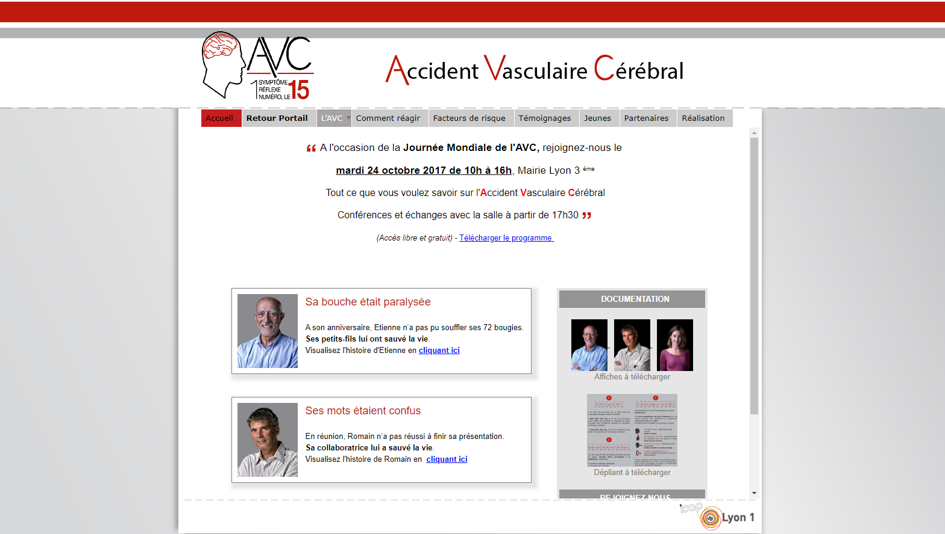
All individuals on campaigns materials provided in appendix of this publication have given their written consent for their likeness to be displayed in these images.

217,476 EMS calls  1,404 EMS calls with stroke symptoms  707 included EMS calls  T0: 214  T1: 234  T2: 259  197 duplicates  37 aged under 18 yo  463 other direct etiology  No stroke symptoms 216,072 | 74,526 EMS calls  527 EMS calls with  stroke symptoms  - included EMS calls  T0: 186  T1: 174  T2: 159  6 duplicates  2 aged under 18 yo  No stroke symptoms 73,999
1a: Flow-chart for the Rhône county | 1b Flow chart for the Isère county
Appendix 2: Flow chart for inclusion of EMS calls

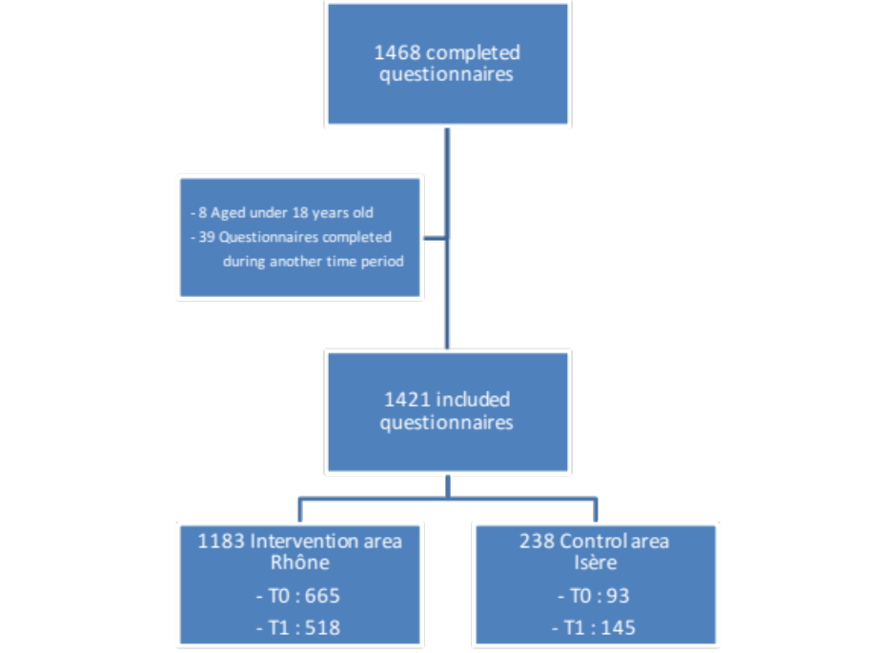

Appendix 3: Flow chart for inclusion of questionnaires on stroke knowledge and attitudes

Appendix 4: Multivariate logistic regression analysis for changes in stroke knowledge and attitudes between T0 and T1 (N=1421)

 | ≥2 FAST warning signs |  | EMS call in case of stroke |  | Emergency situation
 | OR [95%CI] | p-value | OR [95%CI] | p-value | OR [95%CI] | p-value
Gender
Male | 1 |  | 1 |  | 1
Female | 1.49 [1.15-1.93] | 0.002 | 0.85 [0.62-1.17] | 0.327 | 1.49 [0.56-4.01] | 0.425
Age class
18-44 years old | 1 | 0.310 | 1 | 0.293 | 1 | 0.642
45-64 years old | 1.14 [0.87-1.50] |  | 1.25 [0.89-1.77] |  | 0.99 [0.26-3.88]
≥65 years old | 0.87 [0.61-1.24] |  | 1.35 [0.87-2.10] |  | 0.57 [0.15-5.53]
Educational level
Low | 1 | <0.001 | 1 | 0.029 | 1 | 0.318
Middle | 1.79 [1.24-2.58] |  | 1.42 [0.94-2.16] |  | 2.80 [0.52-7.40]
High | 3.03 [2.13-4.31] |  | 1.73 [1.50-2.60] |  | 2.12 [0.73-10.75]
Stroke survivor or relative of a stroke survivor | 1.57 [1.24-2.58] | 0.002 | 0.86 [0.64-1.16] | 0.317 | 2.12 [0.81-5.53] | 0.124
Campaign (time*area) | 1.23 [0.90-1.67] | 0.160 | 0.94 [0.65-1.36] | 0.821 | 0.98 [0.55-2.73] | 0.157

Analysis was conducted using the GLIMMIX procedure (SAS software). We modeled the impact of the campaign (interaction between area and time) on knowing at least 2 symptoms of the FAST message (yes/no), knowledge concerning the emergency of the situation (yes/no), and knowledge concerning the need to call EMS (yes/no)

