Appendix to Haesebaert et al. Impact of a theory-informed and user-centered stroke information campaign on the public’s behaviors, attitudes, and knowledge when facing acute stroke: a controlled before-and-after study. Cover title: Impact of the ReACT stroke campaign

Campaign resources

1. Campaign posters (3 visuals)

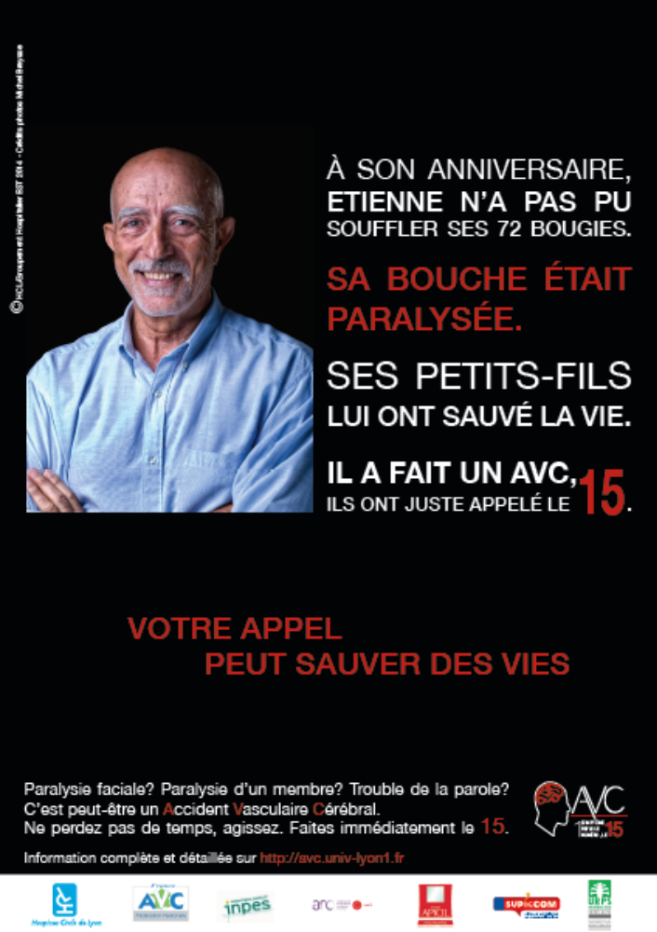

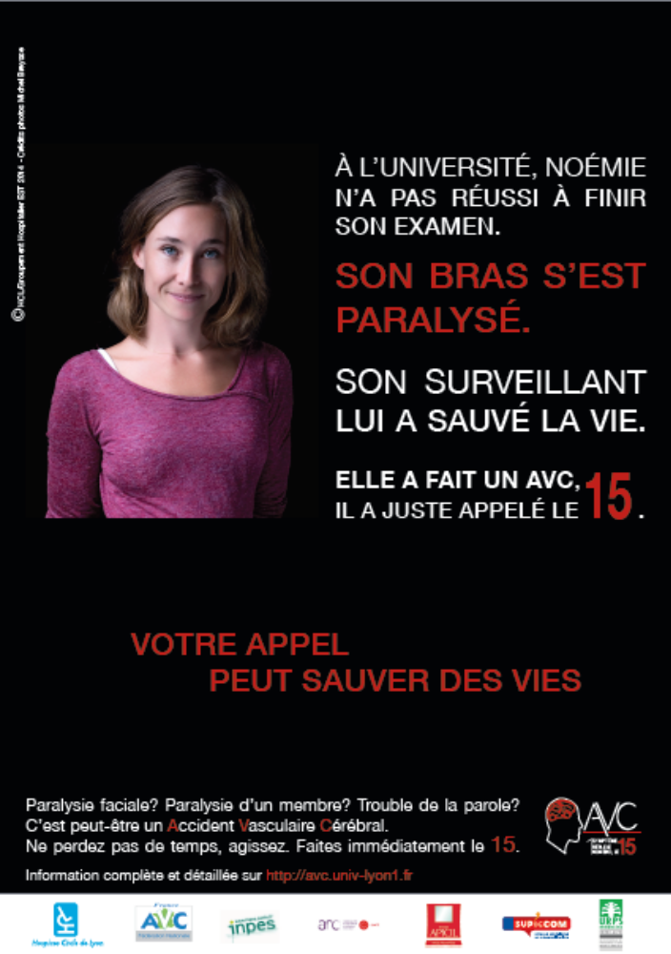

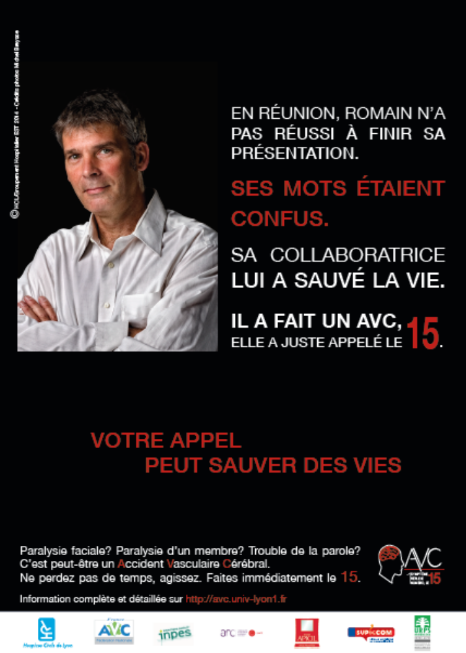

2. Information leaflet

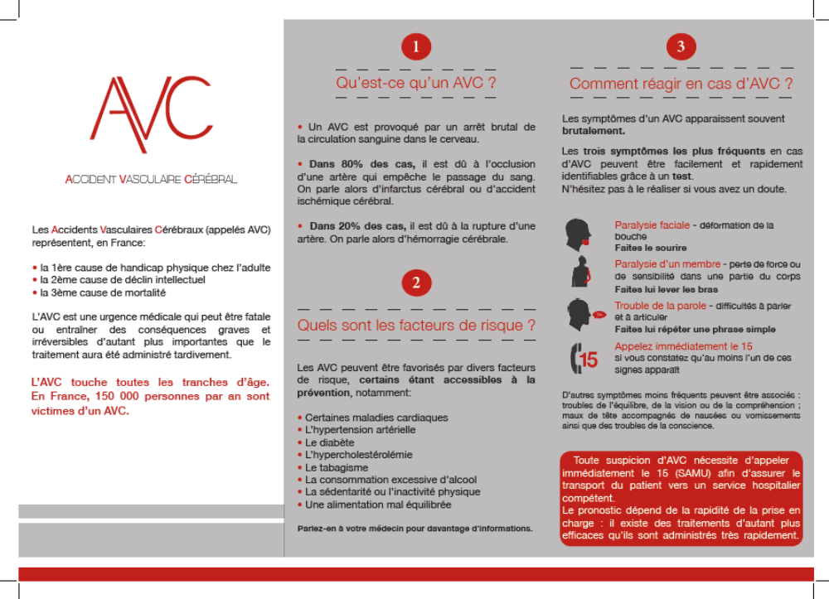

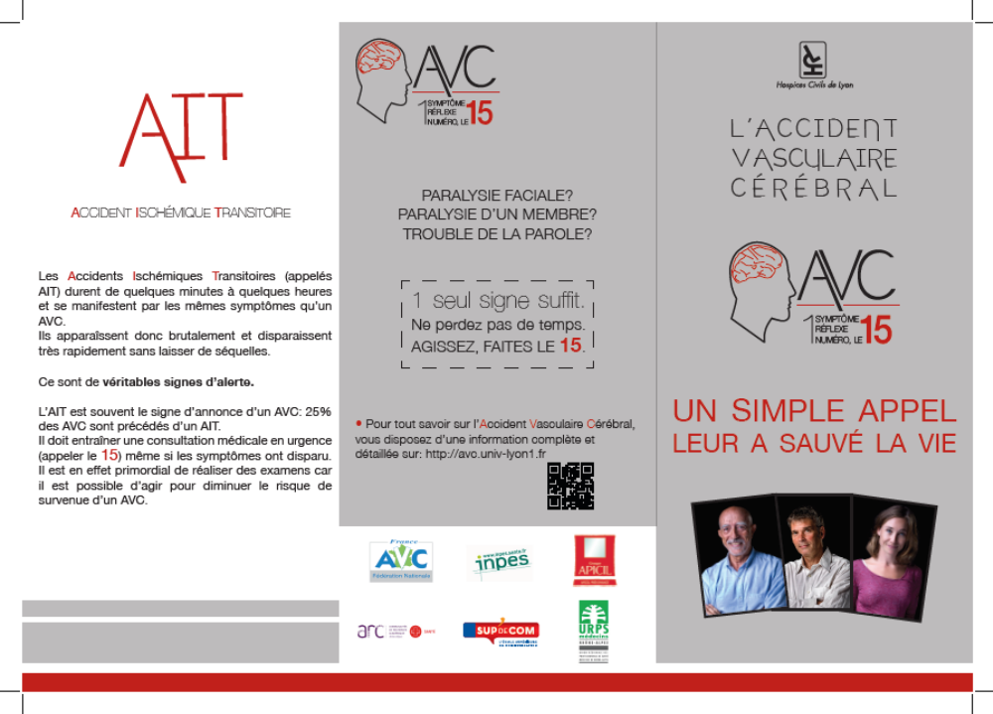

3. Website
- url http://avc.univ-lyon1.fr/

- screen shot
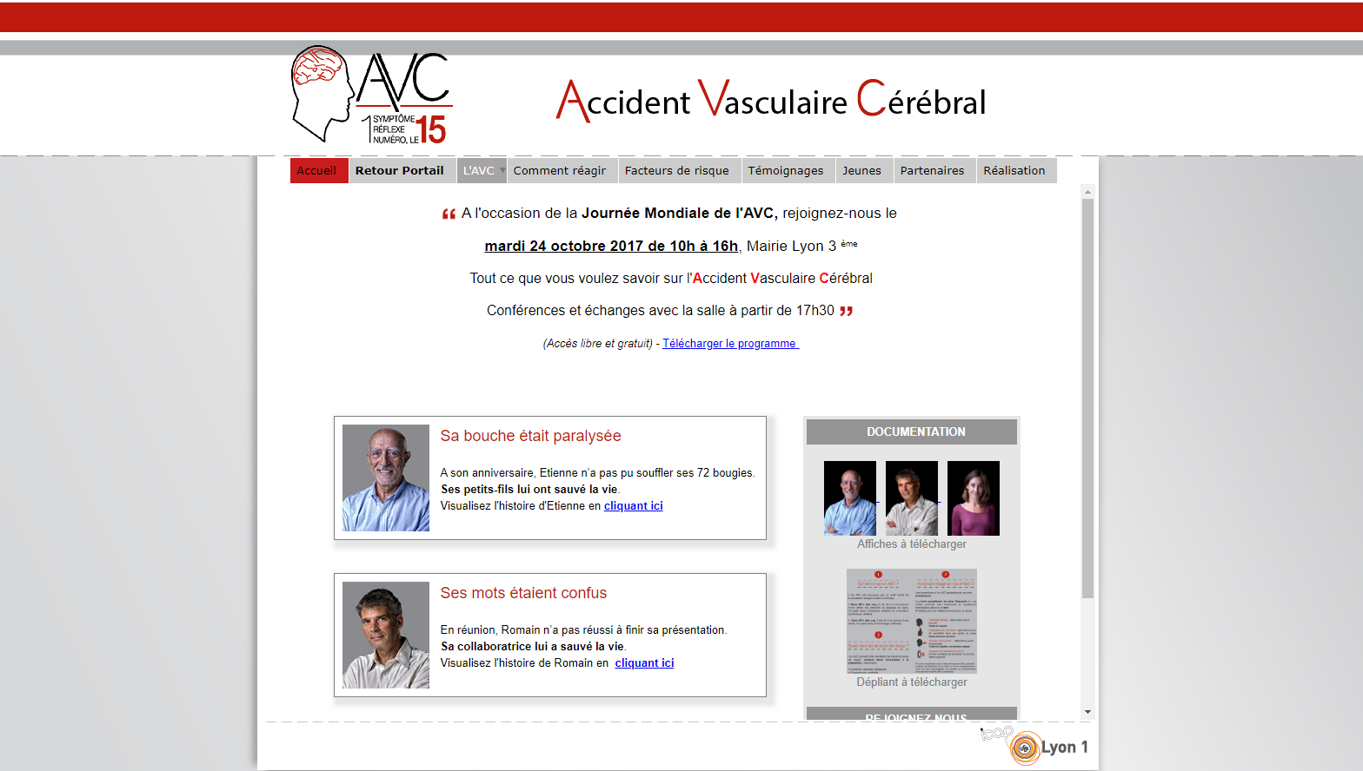

4. World stroke day event in Lyon Oct 29th, 2014.
