Supplementary Figure 1. Flowchart of participant selection

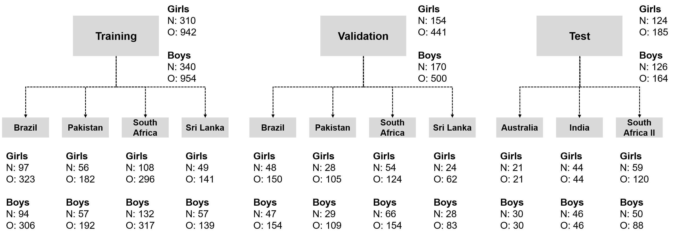
N: Number of participants, O: Number of total observations from all participants; We excluded one record each in males and females due to unavailability of subscapular skinfold thickness in the pooled dataset for training and validation. In the test dataset, excluded 5 observations in males and 6 observations in females due to unavailability of one of triceps skinfold and subscapular skinfold thickness.

