Supplementary Figure 2. Body composition in training data by age at visit

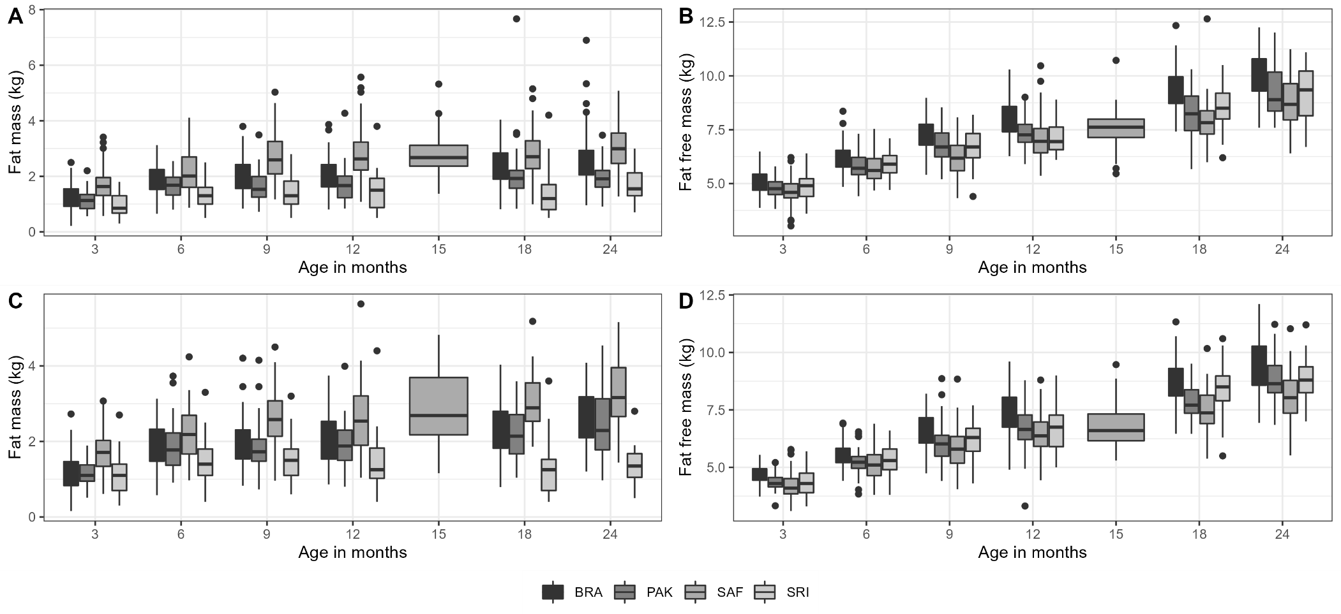
A: Male fat mass, B: Male fat free mass, C: Female fat mass, D: Female fat free mass

