Supplementary Figure 5. Bivariate distribution of anthropometric indicators in females

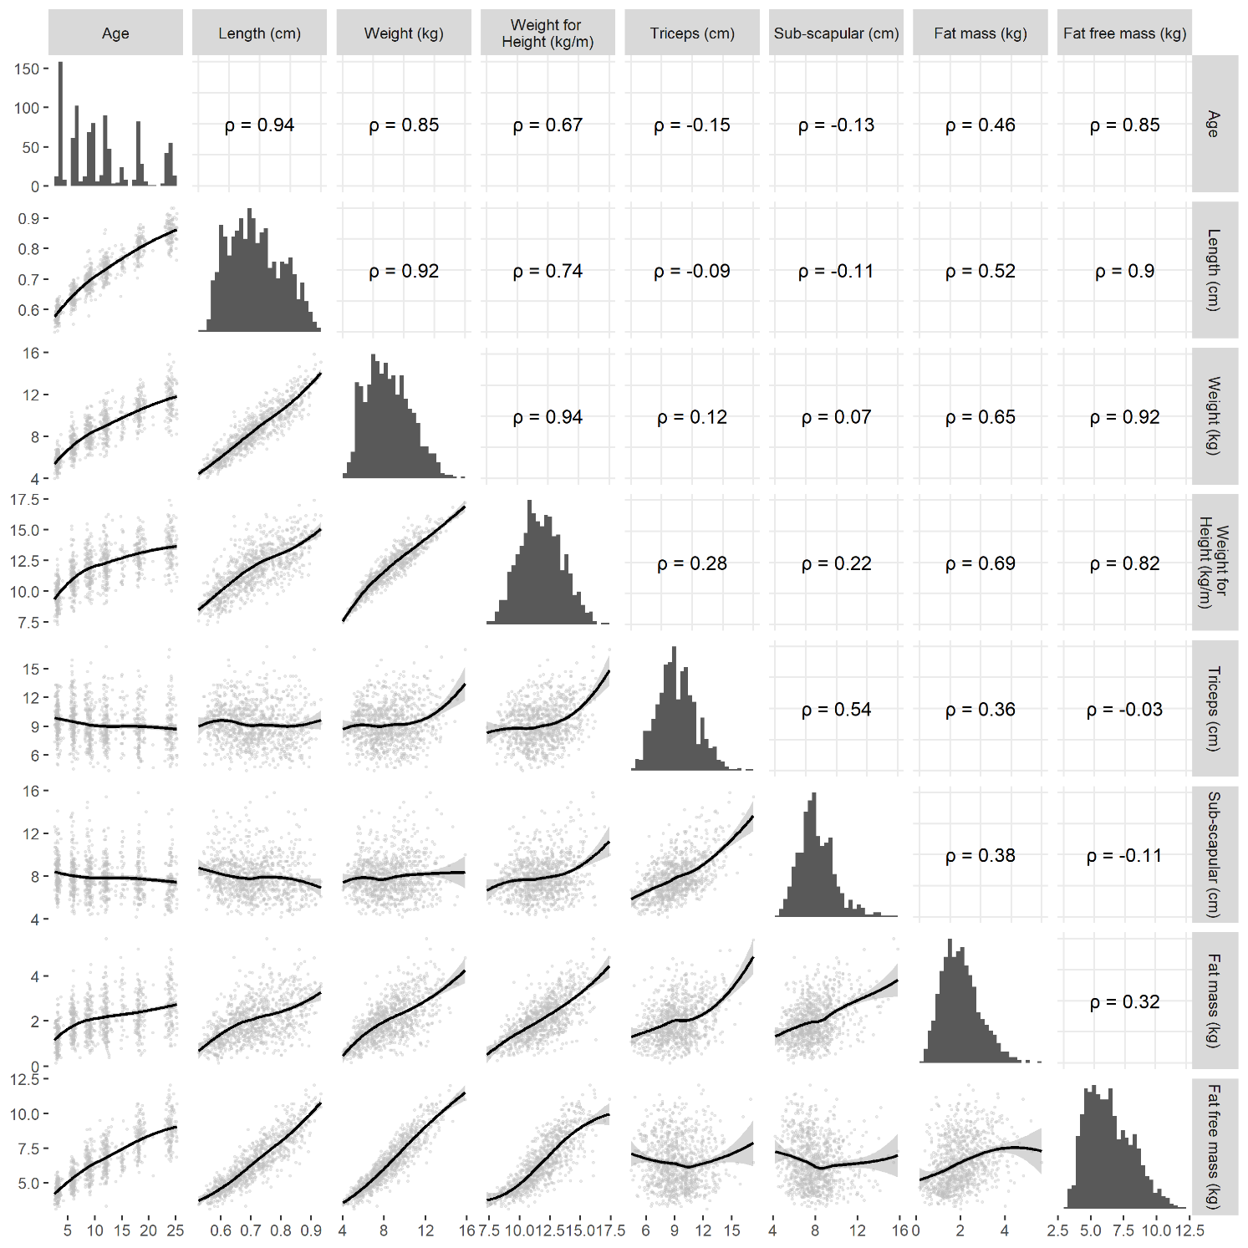
All values are in the pooled training set for females consisting of all observations from Brazil, Pakistan, South Africa and Sri Lanka. The black regression line in the scatterplot is the loess fit.

