Supplementary Figure 3. Body composition in test data by age at visit

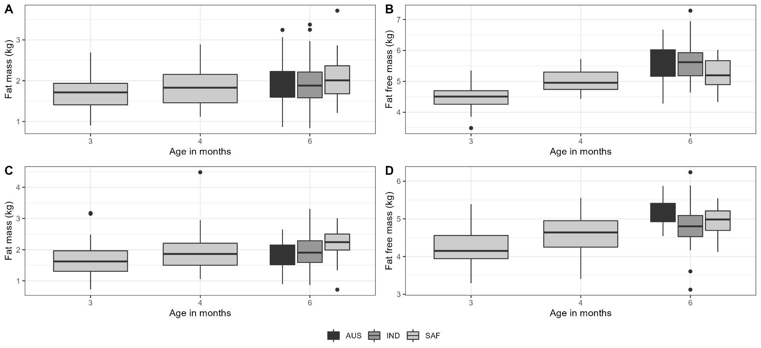
A: Male fat mass, B: Male fat free mass, C: Female fat mass, D: Female fat free mass

