Supplementary Figure 4. Bivariate distribution of anthropometric indicators in males

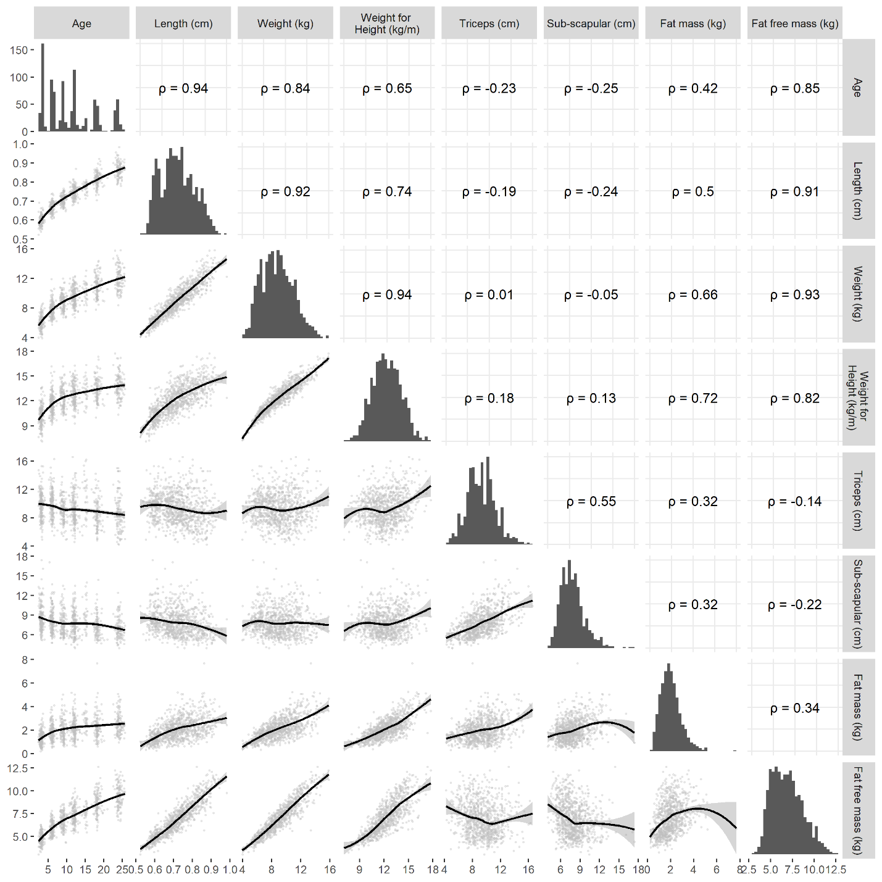
All values are in the pooled training set for males consisting of all observations from Brazil, Pakistan, South Africa and Sri Lanka. The black regression line in the scatterplot is the loess fit.

