Supplementary Material
to
Regionally adjusted stochastic earthquake ground motion models, associated variabilities and epistemic uncertainties
by
Jaleena Sunny, Marco de Angelis and Benjamin Edwards

This Supplement contains:

By using the Cholesky decomposition to develop correlated variables, this study obtained simulation parameters for Peak Ground Acceleration (PGA), 0.1, 0.5 and 1s spectral periods. The final 14 parameter-sets, applicable across this period range, are listed in Table S2. The application of correlated variables has led to a sevenfold increase in the number of parameters that fit inside the empirical data confidence bands, relative to the prior analysis (i.e. as opposed to the 2 uncorrelated parameter combinations that previously fit inside the 95% confidence band). Figure S1 illustrates the parameters that fall within the 95% confidence band of the PGA data when using correlated random samples as the prior. The use of correlated samples resulted in a significant increase in the percentage of samples that fit inside the confidence band, rising from 4.1% to 66% when compared to the use of uncorrelated samples.

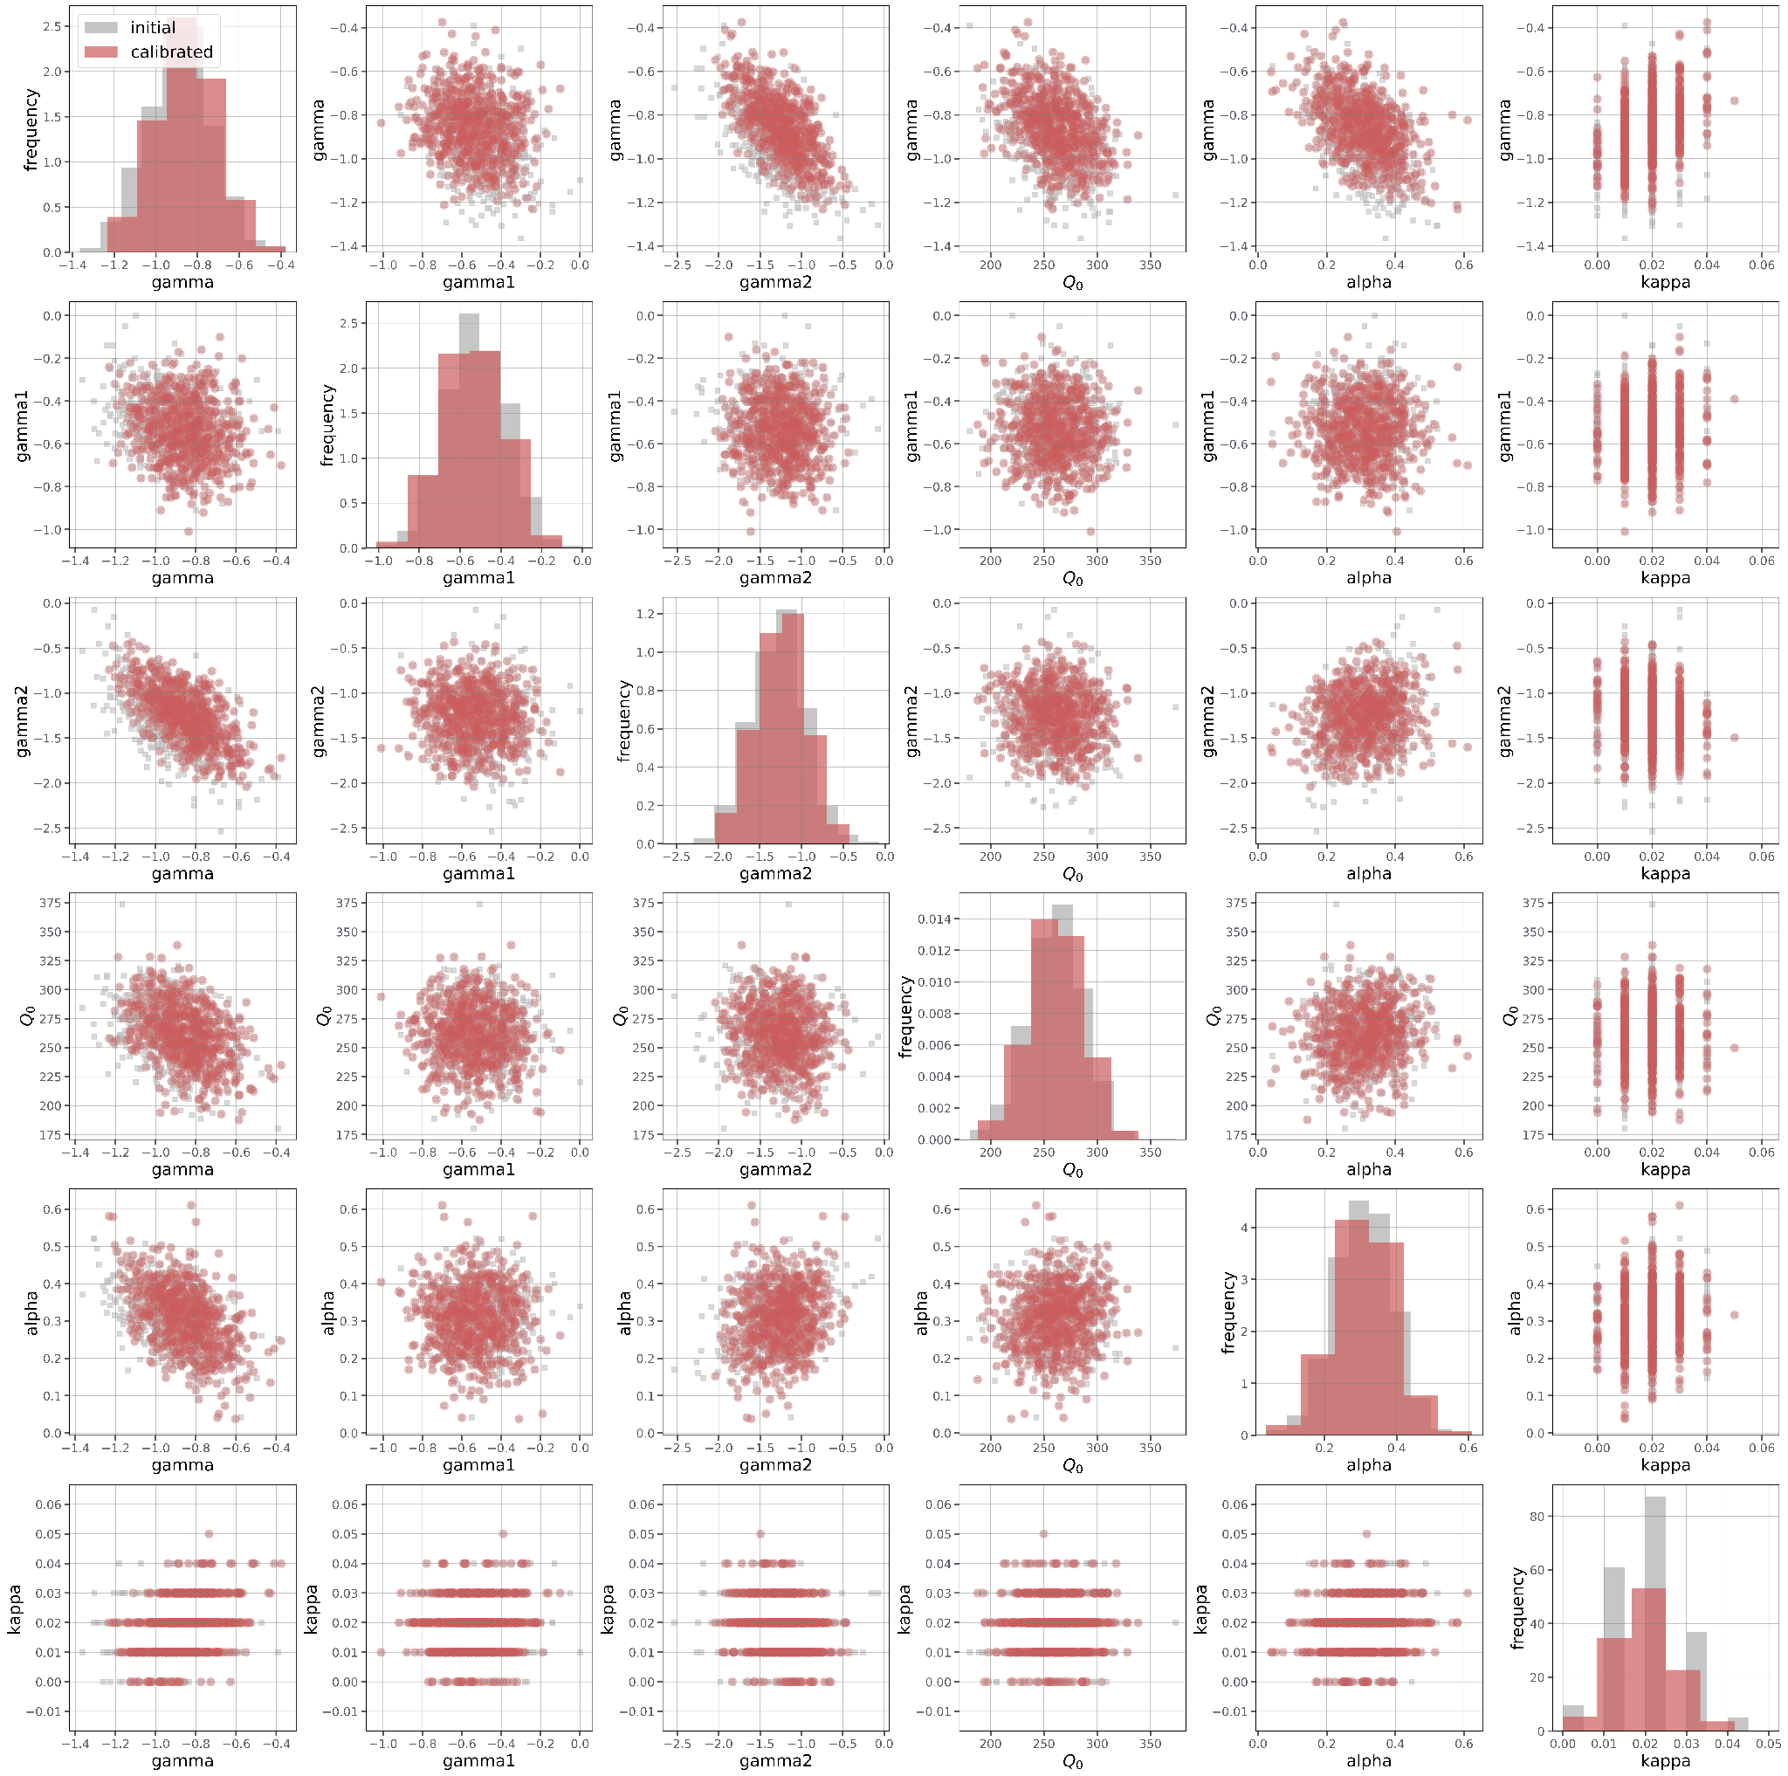
Figure S1. Pair-wise comparison showing the dependencies between various parameters. The parameters being examined here are Q_0, gamma, gamma_1, gamma_2, alpha, and kappa_0. Within the plot, red circles indicate the number of parameters that fall within the confidence band of the PGA data, while grey circles represent the initial sample of correlated initial parameters, while red circles indicate the number of those parameters that fall within the confidence band of the PGA data.

Table S1. The final set of parameters that can be used across the period ranges from PGA to 1s. Each row corresponds to a parameter combination that fits within the 95% confidence bands of the PGA, 0.1, 0.5 and 1s simultaneously.

gamma | gamma1 | gamma2 | Q0 | alpha | kappa
-0.6557 | -0.69 | -1.1630 | 264.09 | 0.0729 | 0.012
-0.6114 | -0.81 | -1.2040 | 264.90 | 0.2036 | 0.026
-0.6904 | -0.50 | -1.0680 | 251.40 | 0.1823 | 0.023
-0.6070 | -0.35 | -1.4038 | 221.08 | 0.2790 | 0.028
-0.5944 | -0.52 | -1.4324 | 253.66 | 0.3115 | 0.031
-0.6639 | -0.65 | -1.1093 | 258.54 | 0.1689 | 0.023
-0.6362 | -0.53 | -1.3934 | 247.12 | 0.2056 | 0.018
-0.6843 | -0.77 | -0.8858 | 237.76 | 0.2290 | 0.025
-0.6020 | -0.64 | -1.3403 | 241.81 | 0.3052 | 0.033
-0.7283 | -0.57 | -0.8958 | 225.70 | 0.2688 | 0.016
-0.6444 | -0.66 | -1.4715 | 287.73 | 0.2685 | 0.023
-0.7038 | -0.60 | -1.0529 | 230.78 | 0.2712 | 0.019
-0.6901 | -0.68 | -1.0279 | 225.72 | 0.2174 | 0.012
-0.7587 | -0.66 | -0.9629 | 273.66 | 0.1665 | 0.021

