 | Healthy | SCM | CM
1 | 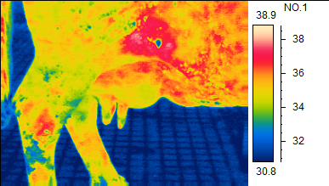  33.84ºC | 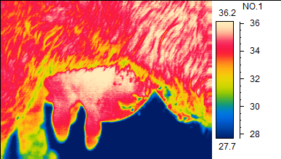  36.01ºC | 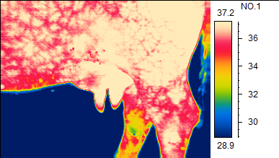  36.95ºC
2 | 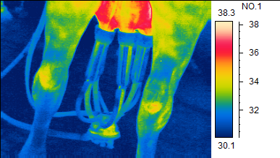  31.21ºC | 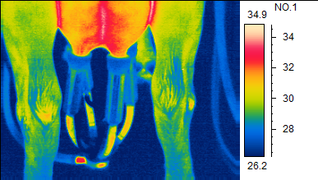  33.40ºC | 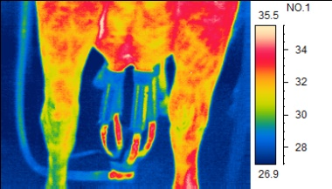  34.93ºC
3 | 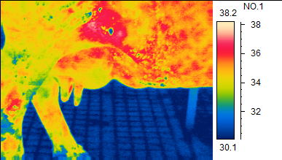  34.13ºC | 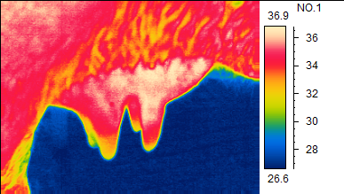  35.79ºC | 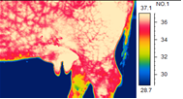  36.58ºC
4 | 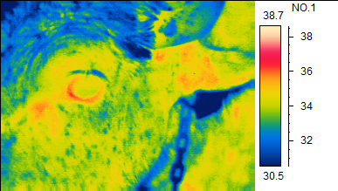  35.31ºC | 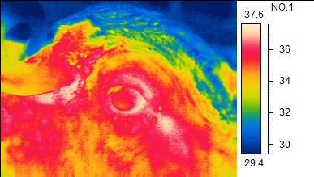  37.12ºC | 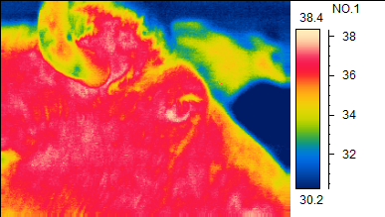  37.83ºC
1. Pre-milking udder skin surface temperature
2. Short-milking -tube surface temperature
3. post-milking udder skin surface temperature
4. Eyeball surface temperature

Plate 1 Mean values of thermographic parameters of healthy quarters, subclinical and clinical mastitis quarters in Murrah buffaloes

