 | Supplementary Table S1: Features used in predictions
 | Description |  | Unit
 | Corpuscular hemoglobin concentration mean |  | g/dL
 | Eosinophils (%) |  | %
 | Hemoglobin concentration distribution width |  | g/dL
 | Lymphocytes (%) |  | %
 | Mean corpuscular volume |  | fL
 | Mean corpuscular hemoglobin |  | pg
 | Mean corpuscular hemoglobin concentration |  | g/dL
 | Mean platelet volume |  | fL
 | Platelets |  | 10E3/μL
 | Red blood cell counts |  | 10E6/μL
 | Red blood cell distribution width |  | %
 | White blood cell counts |  | 10E3/μL
 | Number of circulating neutrophils |  | 10E3/μL
 | Number of circulating eosinophils |  | 10E3/μL
 | Fasting blood glucose |  | mg/dL
 | Body weight |  | g

Supplementary Figure S2: Analysis of variability between strains

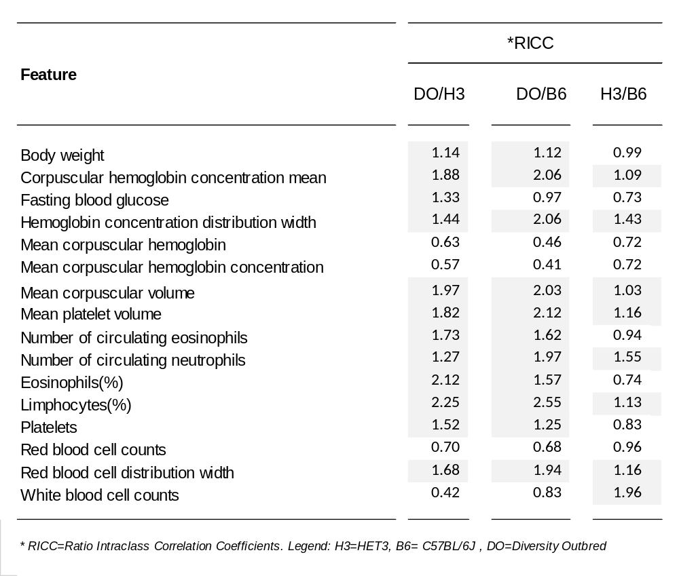

Supplementary Figure S3: Feature importance stratified by sex and strain.
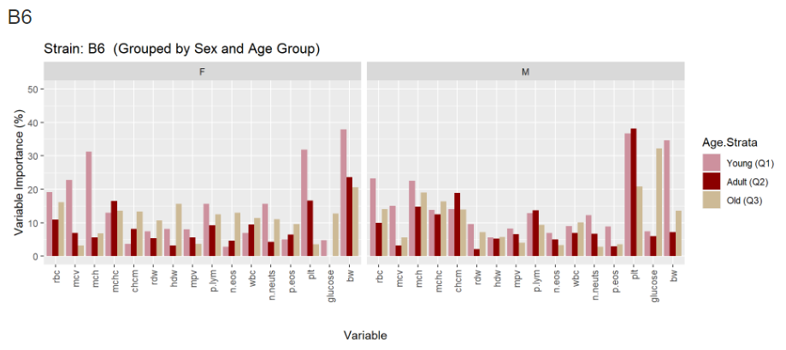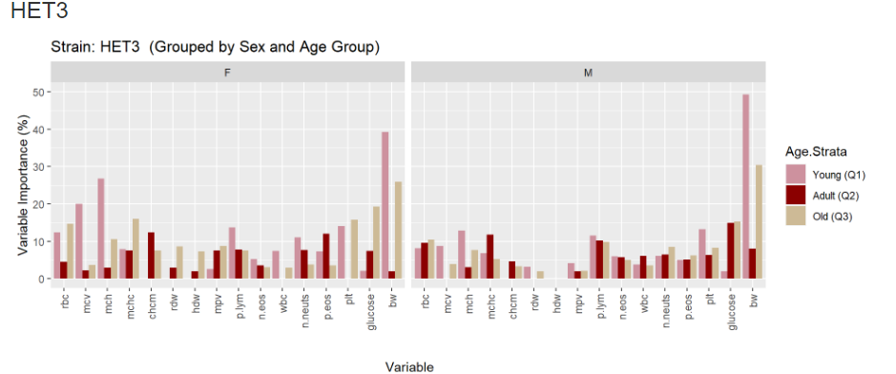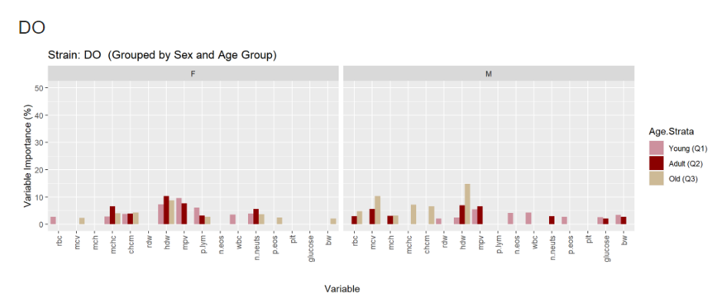

Supplementary Table S4: Percentage of the variance explained by the variable cohort for each feature
Feature |  | Variance cohort (% of total variance)
 |  | Before harmonization | After harmonization
 | Mean corpuscular volume (Reticulocytes) | 13.6120 | 0.00000
 | Mean corpuscular hemoglobin concentration | 11.6294 | 0.00000
 | Corpuscular hemoglobin concentration mean (Reticulocytes) | 9.8342 | 0.00000
 | Number of circulating neutrophils | 9.7949 | 0.00000
 | Mean platelet volume | 9.7394 | 0.00090
 | Hemoglobin | 9.6057 | 0.00000
 | Corpuscular hemoglobin concentration mean | 8.6387 | 0.00000
 | Eosinophils | 8.4917 | 0.00000
 | Mean corpuscular volume | 7.9977 | 0.00080
 | Fasting blood glucose | 7.7985 | 0.00100
 | Mean corpuscular hemoglobin | 7.6230 | 0.00000
 | Body weight | 7.5998 | 0.00000
 | White blood cell counts | 7.1771 | 0.00000
 | Red blood cell distribution width | 6.9786 | 0.00000
 | Neutrophils (%) | 6.1614 | 0.00000
 | Reticulocytes | 5.8816 | 0.00000
 | Lymphocytes | 5.8405 | 0.00000
 | Red blood cell counts | 5.2873 | 0.00000
 | Lymphocytes (%) | 5.2678 | 0.00000
 | Eosinophils (%) | 4.3555 | 0.00000
 | Hemoglobin concentration distribution width | 4.2744 | 0.00000
 | Platelets | 3.5083 | 0.00000

Supplementary Table S5: Null hypothesis testing. Prediction results by the hematological clock using blood parameters as features and a permuted version of age as outcome (50 iterations)
