Assessing driving factors for variability in soybean yield in Northern Ghana: Coupling on farms trials and machine learning approaches

Alfred Balenor Buernor ¹, Muhammad Rabiu Kabiru^{1,5}, Michael Asante², Edwin K. Akley², Anas Raklami¹, Francis B. T. Silatsa^{1,} Sara Dahhani ³, Anis Bouraqqadi ³, Mohamed Hafidi⁴, Jibrin Mohammed Jibrin⁵, and Martin Jemo ^{1, *}

Figure S1: Monthly precipitation and average temperature of the study area in Northern Ghana. Temperature max; maximum average temperature, Tmin; minimum average temperature, Prec; precipitation.
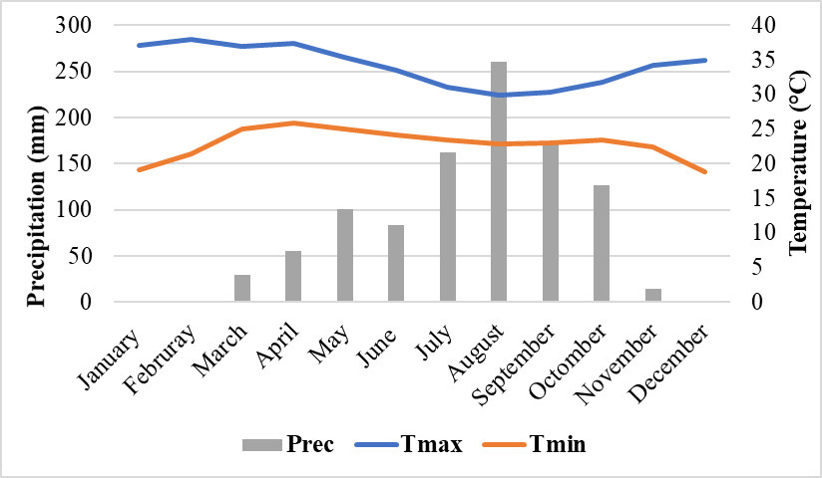
Figure S2. Shoot dry biomass of soybean plants under no-P and P application (a), P sources (b) and rhizobia strains inoculation (c) from all trials, on-farm, and on-station in Northern Ghana. Means ± s.e followed by different lowercase letters are significantly different at P < 0.05
