Supplementary data
Supplementary Figure 1: Cytokines concentration (pg/mL) in plasma of healthy donors (n=4) and patients after myocardial infarction (H0-H48: n= 16 to 20; D3: n=2 to 5; M6-M12: n=7 to 10 for IL-2, IL-1β, IFN-γ, IL-12 ; healthy donors : n=2; H0-H48: n= 2; D3: n=2 ; M6-M12: n=1 for TGF-β1). (A) IL-2, (B)IL-1β, (C) IL-17, (D) IFN-γ, (E) IL-12, (F) TGF-β1. Error bars correspond to interquartile range. Kruskall-Wallis test was used to compare the 4 groups.
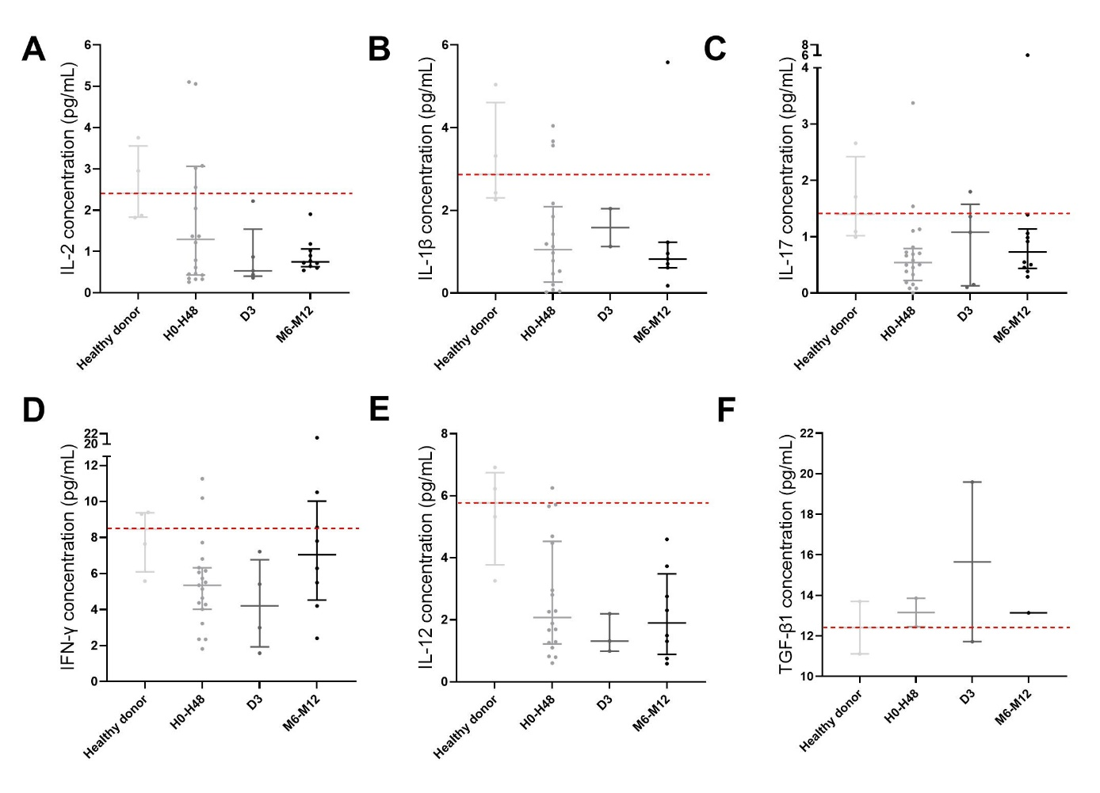

Supplementary Figure 2: Characterization of P2Y11 receptor expression in cardiac fibroblasts after coculture with PBMC from collected at H0, H24, H48, M1 after myocardial infarction by RT-qPCR and flow cytometry. n=2 to 4 samples in healthy donors, n=2 to 3 samples in H0, H48 and M1 groups, n=3 to 4 samples in H24 group.
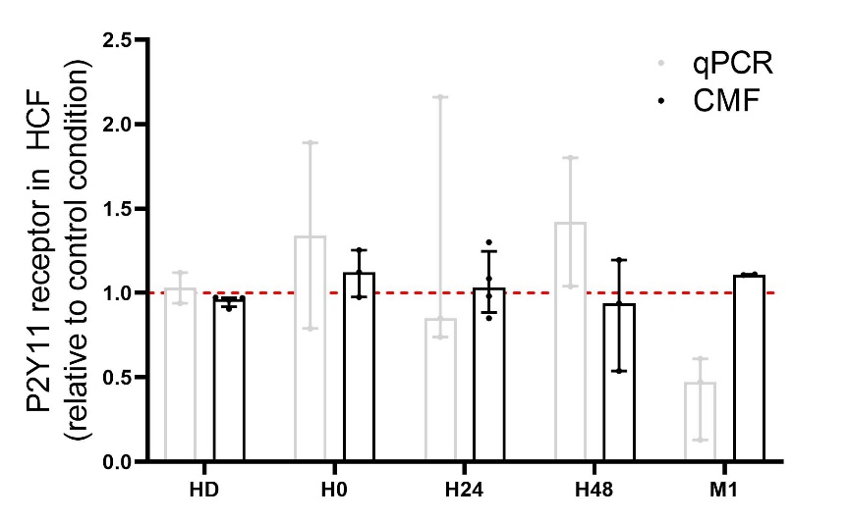

Supplementary Figure 3: F-actin (red, phalloidin staining) and α-SMA (green) staining of cardiac fibroblasts (DAPI stains the nuclei in blue) after 24hrs of culture with conditioned supernatants. Supernatants were obtained from PBMC after normoxia (A) or hypoxia/reoxygenation (B) condition. Scale: 50μM. X60.
