Supplementary Material
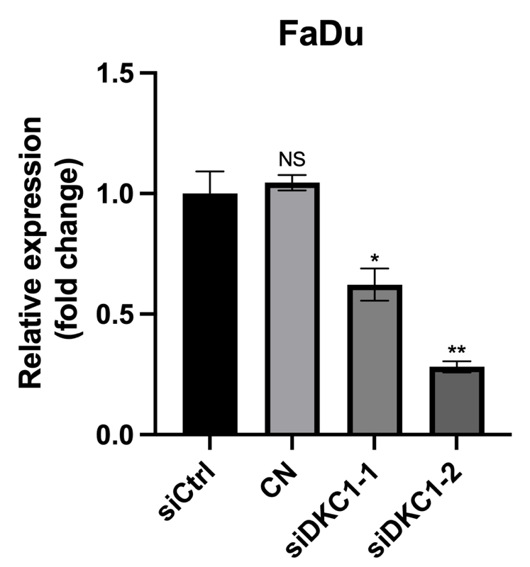
Supplementary Figure 1. Expression of siDKC1 after transfection in FaDu cells.
* P<0.05,** P<0.005

Supplementary Material
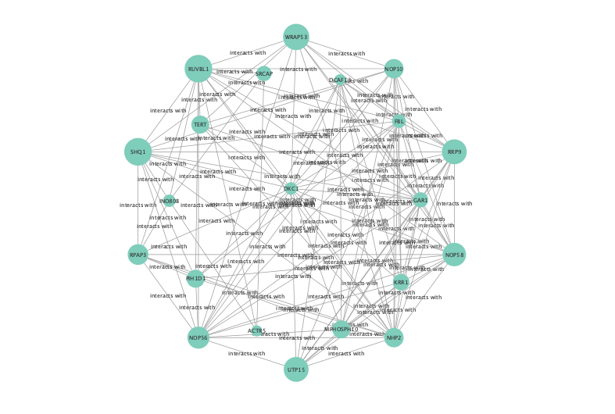
Supplementary Figure 2. Protein-protein interaction network of DKC1-related DEGs and top 10 hub genes.

Supplementary Material
Supplementary Figure 3. Progress Free Interval for patients with HNSCC.

