Supplementary Figures

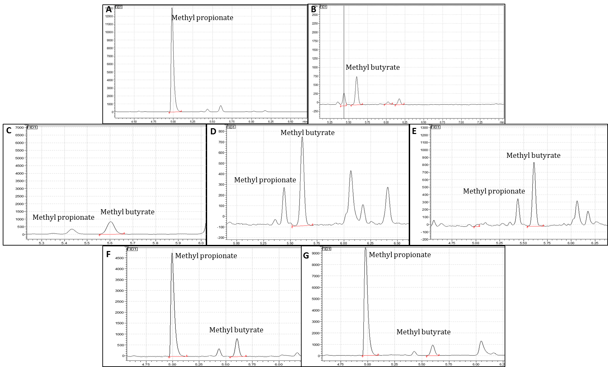
Fig S1: (a) GC chromatogram of SCFA- Methyl propionate standard peak (Retention time- 4.9 min) (b) GC chromatogram of SCFA- Methyl butyrate standard peak (Retention time- 5.6 min) (c) GC- Chromatogram of SCFA (methyl butyrate: R.T- 5.6 min; methyl propionate: R.T- 4.9 min) in unfermented soymilk (control) (d) GC- Chromatograms of SCFA in synbiotic soymilk fermented with mixed cultures of 1% (v/v) Lactobacillus rhamnosus and Weissella confusa 30082b supplemented with 2% FOS after 24 h of fermentation (e) GC- Chromatograms of SCFA in synbiotic soymilk supplemented with 3% FOS after 24 h of fermentation (f) GC- Chromatograms of SCFA in synbiotic soymilk supplemented with 2% RFOs after 24 h of fermentation (g) GC- Chromatograms of SCFA in synbiotic soymilk supplemented with 3% RFOs after 24 h of fermentation.

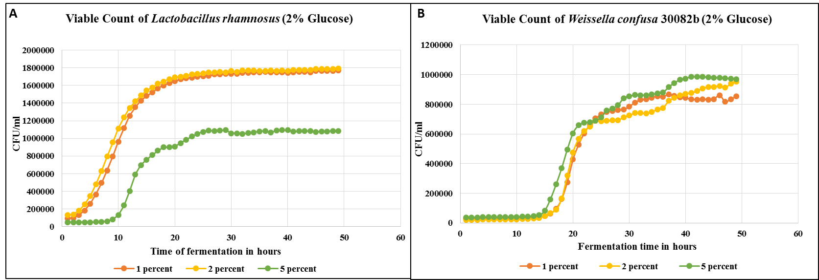
Fig S2: Standardization of inoculum (a) Kinetics of growth of pure cultures of 1, 2 and 5% (v/v) Lactobacillus rhamnosus in MRS broth supplemented with 2% glucose (b) Kinetics of growth of pure cultures of 1, 2 and 5% (v/v) Weissella confusa 30082b supplemented with 2% glucose

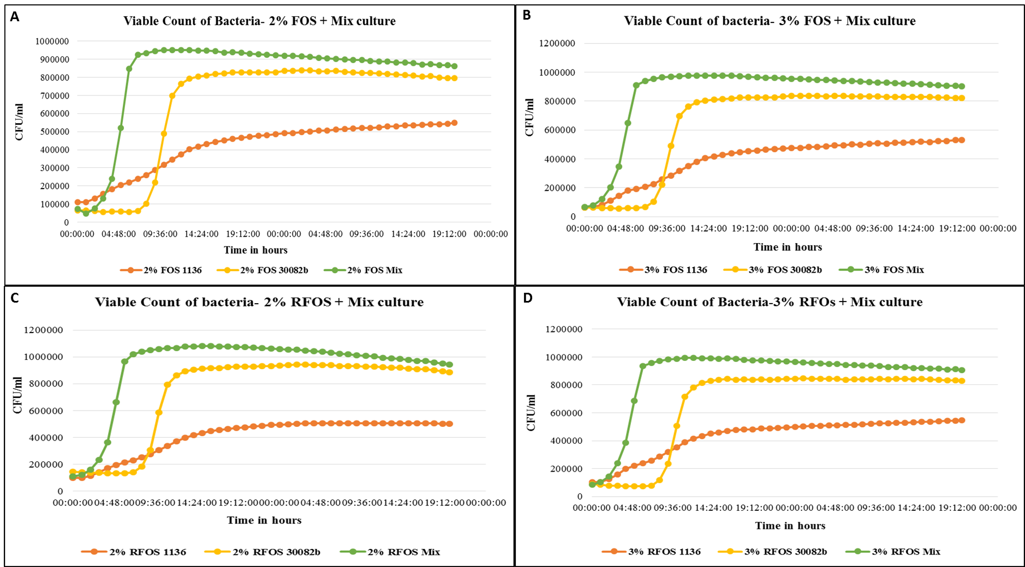
Fig S3: (a) Kinetics of growth of pure and mixed cultures of 1% (v/v) Lactobacillus rhamnosus and Weissella confusa 30082b in MRS broth supplemented with 2% FOS upto 48 hours (b) Kinetics of growth of pure and mixed cultures of 1% (v/v) Lactobacillus rhamnosus and Weissella confusa 30082b in MRS broth supplemented with 3% FOS upto 48 hours. (c) Kinetics of growth curve of pure and mixed cultures of 1% (v/v) Lactobacillus rhamnosus and Weissella confusa 30082b in MRS broth supplemented with 2% RFOs upto 48 hours. (d) Kinetics of growth curve of pure and mixed cultures of 1% (v/v) Lactobacillus rhamnosus and Weissella confusa 30082b in MRS broth supplemented with 3% RFOs upto 48 hours.

Sr. No. | Sample | Growth Rate Constant (µ) (mins) | Doubling Time (Td) (mins)
1 | 2% FOS + L. rhamnosus | 20.16 ± 0.45 | 123.6 ± 1.15
2 | 2% FOS + W. confusa 30082b | 28.67 ± 0.65 | 87.5 ± 0.58
3 | 2% FOS + Mix culture | 39.48 ± 0.89 | 63.2 ± 0.57
4 | 3% FOS + L. rhamnosus | 37.12 ± 0.67 | 67.2 ± 0.34
5 | 3% FOS + W. confusa 30082b | 38.85 ± 0.32 | 64.2 ± 0.78
6 | 3% FOS + Mix culture | 47.52 ± 0.38 | 52.5 ± 0.67
7 | 2% RFOs + L. rhamnosus | 22.1 ± 0.15 | 112.9 ± 0.56
8 | 2% RFOs + W. confusa 30082b | 51.58 ± 0.37 | 48.4 ± 0.32
9 | 2% RFOs + Mix culture | 63.48 ± 0.72 | 39.3 ± 0.45
10 | 3% RFOs + L. rhamnosus | 45.39 ± 0.89 | 55 ± 0.53
11 | 3% RFOs + W. confusa 30082b | 44.23 ± 0.54 | 56.4 ± 0.75
12 | 3% RFOs + Mix culture | 60.26 ± 0.98 | 41.4 ± 0.43
Table S1: Doubling time and specific growth rates of 1% (v/v) pure and mixed cultures of L. rhamnosus and W. confusa 30082 in MRS broth supplemented with 2, 3% FOS and 2,3 % RFOs (w/v).

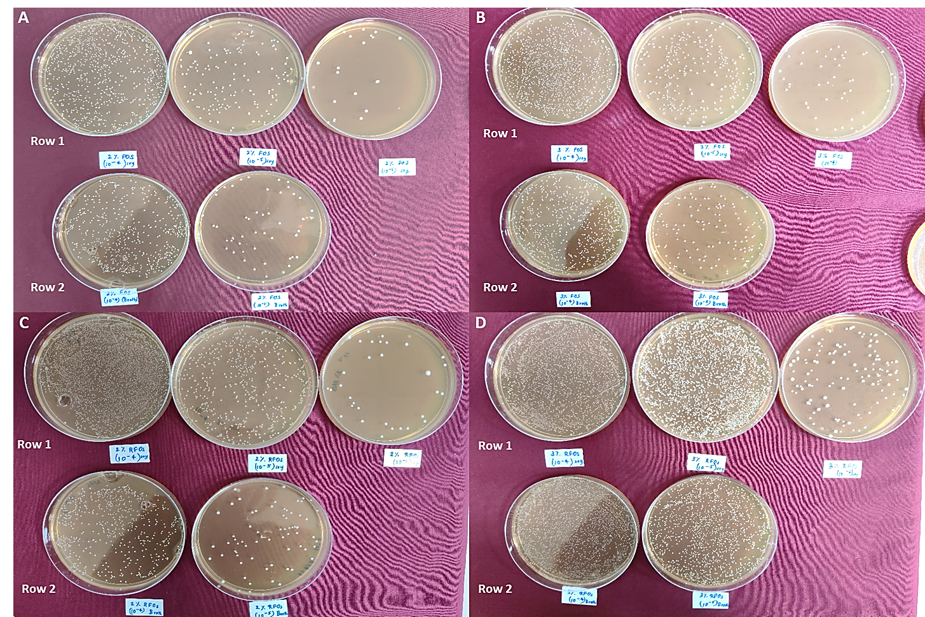
Fig S4: (a) Growth of 1% (v/v) mixed cultures of L. rhamnosus and W. confusa 30082 in synbiotic soymilk supplemented with 2% FOS (w/v) (Row A1) and in MRS broth supplemented with 2% FOS (w/v) (Row A2) (b) Growth of 1% (v/v) mixed cultures of L. rhamnosus and W. confusa 30082 in synbiotic soymilk supplemented with 3% FOS (w/v) (Row B1) and in MRS broth supplemented with 3% FOS (w/v) (Row B2) (c) Growth of 1% (v/v) mixed cultures of L. rhamnosus and W. confusa 30082 in synbiotic soymilk supplemented with 2% RFOs (w/v) (Row C1) and in MRS broth supplemented with 2% RFOs (w/v) (Row C2) (d) Growth of 1% (v/v) mixed cultures of L. rhamnosus and W. confusa 30082 in synbiotic soymilk supplemented with 3% RFOs (w/v) (Row D1) and in MRS broth supplemented with 3% RFOs (w/v) (Row D2)

