- Results
Table 1. Amino acid composition of the collagen peptides
Amino acid | Weight (%)
Glycine | 22.2
Proline | 12.7
Hydroxyproline | 11.9
Glutamic acid | 10.2
Alanine | 8.6
Arginine | 7.3
Aspartic acid | 5.8
Serine | 3.2
Leucine | 2.7
Valine | 2.4
Phenylalanine | 2.1
Threonine | 1.8
Hydroxylysine | 1.6
Isoleucine | 1.4
Histidine | 1.0
Methionine | 0.9
Tyrosine | 0.8

Table 2. Baseline characteristics of the participants
Variable | Placebo (n=37) | Collagen (n=37) | p-value¹⁾
Age (year) | 60.5±6.1 | 62.2±6.5 | 0.243
50-64 | 30(81) | 27(73) | 1.000
≥65 | 7(19) | 10(27) | 1.000
Sex (M/F) | 8(22)/29(78) | 8(22)/29(78) | 0.407
Body Weight (kg) | 65.1±8.1 | 64.3±8.1 | 0.647  0.767
BMI (kg/m²⁾ | 25.7±2.3 | 25.9±2.0 | 0.647  0.767
WHR | 0.91±0.05 | 0.92±0.04 | 0.313
Education level
≤ middle school | 3(8) | 8(22) | 0.263
high school | 22(59) | 19(51) | 0.263
≥ university | 12(32) | 10(27) | 0.263
Marital status, n(%)
Married | 37(100) | 36(97) | 0.314
Single | 0(0) | 1(3) | 0.314
Smoker, n(%) | 3(8) | 3(8) | 0.898
Energy intake (kcal/day) | 1568.7±398.0 | 1655.5±399.0 | 0.352
IPAQ (METs)²⁾ | 2828.9±2001.7 | 3086.6±2809.1 | 0.651
Menopausal women, n(%) | 27(93) | 28(97) | 0.839
Abbreviations: BMI, body mass index; F, female; IPAQ, international physical activity questionnaires; M, male; MET, metabolic equivalent task; n, number of subjects; WHR, waist-hip-ratio.
·Date are presented as mean ± standard deviation or number (%).
·The participants take a collagen peptide supplementation (15g/day) or placebo product once daily during the 12-week intervention period.
·No statistically significant differences in age, sex, body weight, BMI, WHR, educational level, marital status, smoker, energy intake, physical activity and menopausal status between Placebo and Collagen groups were determined at study baseline.
¹⁾ p-value obtained by chi-square test or student's t-test.
²⁾ The score is calculated using the IPAQ with a higher score indicating greater physical activity.

Table 3. Changes of body composition measured by bioelectrical impedance analysis system
Variable | Placebo (n=37) |  |  |  | Collagen (n=37)
Variable | Baseline | 12 week | Changes | p-value ¹⁾ | Baseline | 12 week | Changes | p-value ¹⁾ | p-value ²⁾
Weight (kg) | 65.1±8.1 | 65.0±8.5 | -0.1±1.5 | 0.739 | 64.3±8.1 | 63.8±8.0 | -0.5±1.4 | 0.048* | 0.260
BMI (kg/m²) | 25.7±2.3 | 25.7±2.3 | -0.1±0.6 | 0.647 | 25.9±2.0 | 25.6±2.0 | -0.2±0.6 | 0.022* | 0.204
WHR | 0.91±0.05 | 0.90±0.04 | -0.00±0.02 | 0.170 | 0.92±0.04 | 0.91±0.04 | -0.01±0.02 | 0.002** | 0.146
Visceral fat area (m²) | 110.5±29.3 | 108.1±27.6 | -2.4±8.3 | 0.084 | 116.3±32.3 | 110.6±29.2 | -5.7±8.7 | 0.000*** | 0.106
Fat free mass (kg) | 42.5±7.0 | 42.7±7.1 | 0.2±0.9 | 0.246 | 41.2±7.0 | 41.4±6.9 | 0.2±1.95 | 0.131 | 0.753
Skeletal muscle mass (kg) | 23.2±4.2 | 23.3±4.3 | 0.1±0.5 | 0.350 | 22.4±4.3 | 22.6±4.2 | 0.1±0.6 | 0.147 | 0.643
Fat mass
Whole body
Body fat mass (kg) | 22.5±4.6 | 22.5±4.5 | -0.0±1.2 | 0.881 | 23.1±4.9 | 22.4±4.5 | -0.7±1.2 | 0.002** | 0.021*
Percent body fat (%) | 34.8±5.6 | 34.4±5.2 | -0.3±1.3 | 0.121 | 36.0±5.9 | 35.2±5.6 | -0.8±1.5 | 0.002** | 0.148
Trunk
Body fat mass (kg) | 11.6±2.4 | 11.4±2.3 | -0.2±0.7 | 0.159 | 11.9±2.3 | 11.4±2.1 | -0.4±0.7 | 0.001** | 0.100
Percent body fat (%) | 249.9±52.9 | 247.2±53.3 | -2.7±15.2 | 0.285 | 260.9±47.2 | 251.6±44.5 | -9.3±14.7 | 0.000*** | 0.064
Abbreviations: BMI, body mass index; WHR, waist-hip-ratio
·Date are presented as mean ± standard deviation
·The participants take a collagen peptide supplementation (15g/day) or placebo product once daily during the 12-week intervention period.
¹⁾ Significance as determined by Paired t-test, p-value less than p<0.05. *p<0.05, **p<0.01, ***p<0.001
²⁾ Significance as determined by Independent t-test, p-value less than p<0.05. *p<0.05, **p<0.01, ***p<0.001

Table 4 Changes of biochemical parameters and physical activity level
Variable | Placebo (n=37) |  |  |  | Collagen (n=37)
Variable | Baseline | 12 week | Changes | p-value¹⁾ | Baseline | 12 week | Changes | p-value¹⁾ | p-value²⁾
Biochemical parameters
Total cholesterol (mg/dL) | 200.4±40.6 | 200.9±42.5 | 0.5±22.0 | 0.882 | 191.7±44.0 | 190.2±42.2 | -1.5±24.6 | 0.710 | 0.706
Serum glucose (mg/dL) | 102.8±22.2 | 107.2±24.4 | 4.4±25.7 | 0.307 | 103.7±16.2 | 102.8±13.5 | -0.9±11.9 | 0.660 | 0.263
HDL cholesterol (mg/dL) | 57.0±14.5 | 57.1±14.8 | 0.1±8.4 | 0.938 | 58.0±11.4 | 57.4±12.1 | -0.6±6.8 | 0.613 | 0.705
LDL cholesterol (mg/dL) | 123.2±37.8 | 123.8±39.2 | 0.7±18.6 | 0.834 | 117.8±39.6 | 116.3±39.2 | -1.5±21.7 | 0.685 | 0.655
Triglyceride (mg/dL) | 133.2±71.3 | 127.7±74.2 | -5.6±38.6 | 0.383 | 118.7±56.2 | 113.4±49.3 | -5.3±44.2 | 0.468 | 0.978
Physical activity level
IPAQ (METs) ³⁾ | 2828.9±2001.7 | 3191.8±2455.7 | 362.9±2144.4 | 0.310 | 3086.6±2809.1 | 3432.9±2319.0 | 346.3±2568.7 | 0.418 | 0.976
Abbreviations: HDL, high density lipoprotein; IPAQ, international physical activity questionnaires; LDL, low density lipoprotein.
·Date are presented as mean ± standard deviation
·The participants take a collagen peptide supplementation (15g/day) or placebo product once daily during the 12-week intervention period.
·There were no statistically significant differences in biochemical parameters and physical activity level in both the Collagen and Placebo groups.
¹⁾ No Significance difference by Paired t-test at p<0.05.
²⁾ No Significance difference by Independent t-test at p<0.05.
³⁾ The score is calculated using the IPAQ with a higher score indicating greater physical activity.

Table 5 Changes of dietary intake including collagen supplementation
Variable | Placebo (n=37) |  |  |  | Collagen (n=37)
Variable | Baseline | 12 week | Changes | p-value ¹⁾ | Baseline | 12 week | Changes | p-value ¹⁾ | p-value ²⁾
Energy (kcal) | 1568.7±398.0 | 1542.4±419.5 | -26.4±428.2 | 0.710 | 1655.5±399.0 | 1561.9±356.7 | -93.6±384.6 | 0.147 | 0.480
Carbohydrate (g) | 218.2±55.0 | 209.0±63.1 | -9.2±56.5 | 0.327 | 234.4±58.2 | 214.7±54.8 | -19.7±59.7 | 0.052 | 0.440
Protein (g) | 62.4±16.1 | 64.8±20.0 | 2.5±24.2 | 0.541 | 66.8±21.9 | 76.1±17.1 | 9.3±21.4 | 0.012* | 0.197
Fat (g) | 49.1±19.5 | 49.2±19.6 | 0.1±26.1 | 0.987 | 49.8±15.2 | 45.3±16.0 | -4.5±17.8 | 0.136 | 0.386
·Date are presented as mean ± standard deviation
·The participants take a collagen peptide supplementation (15g/day) or placebo product once daily during the 12-week intervention period.
¹⁾ Significance as determined by Paired t-test, p-value less than p<0.05. *p<0.05
²⁾ No Significance difference by Independent t-test at p<0.05.

Assessed for eligibility (n=84 )
Allocated to control group (n=42)
◻ -Received allocated Placebo (n=42)
Allocated to intervention group (n=42)
◻ -Received allocated Collagen (n=42)◻

Analysis
Lost to follow-up (n=5)
(Discontinued intervention, Non-appearance at examination dates, Non-compliance with study protocol)
Analysed (n=37)◻
-No further exclusion from analysis

Enrollment

Follow-Up
Randomized (n=84 )

Allocation
Analysed (n=37)
-No further exclusion from analysis

Lost to follow-up (n=5)
(Withdrawal of consent, Abdominal discomfort after taking, Non-compliance with study protocol)

Figure 1. CONSORT flow diagram of subjects through the study. CONSORT, consolidated standards of reporting trials.

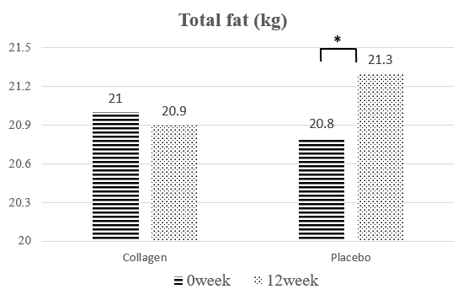
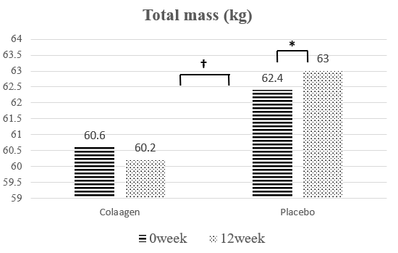
(a) (b)

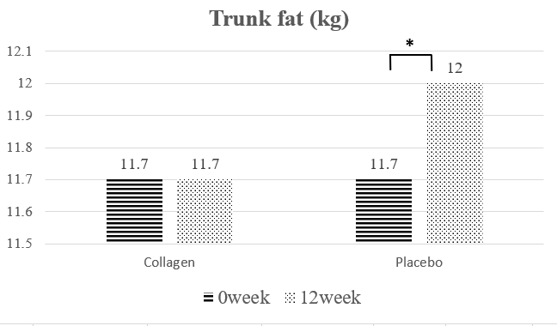
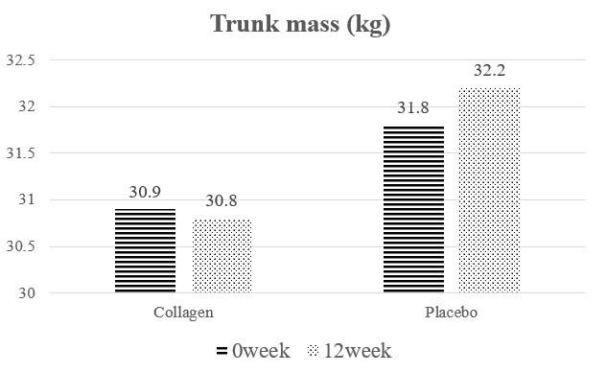
(c) (d)

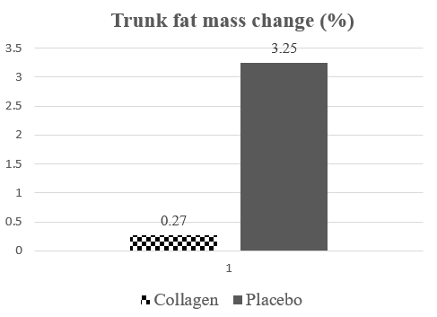
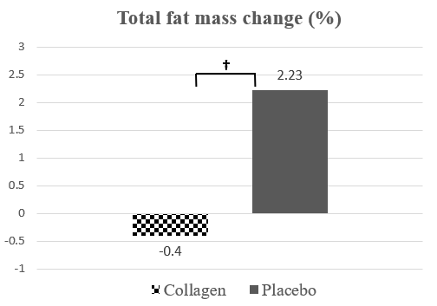
(e) (f)

Figure 2. Changes of body composition measured by dual energy x-ray absorptiometry

(a): Total mass (kg); (b): Total fat (kg); (c): Trunk mass (kg); (d): Trunk fat (kg); (e): Total fat mass change (%): {(12 week Total fat (kg) - Baseline Total fat (kg)/ 12 week Total fat (kg)} x 100; (f): Trunk fat mass change (%): {(12 week Trunk fat (kg) - Baseline Trunk fat (kg)/ 12 week Trunk fat (kg)} x 100
· Placebo: Participants ingested the placebo product
· Collagen: Participants ingested 15grams/day of collagen peptide supplementation
* Significantly different at p<0.05 by Paired t-test or Wilcoxon signed rank test, *p<0.05
† Significantly different at p<0.05 by Independent t-test, †p<0.05

