Supplementary Information

1. Discussion: Sensitivity Tests
Study quality and validity is an important consideration when synthesizing evidence from multiple studies. Since traditional meta-analyses synthesize the results of experimental studies, the standard errors or variance of the effect estimates are often used in weighting, such as the popular inverse-variance method¹. The studies in our dataset use a much wider variety of methods, with only 9 studies (3.8%) using experimental methods and 8 studies that included any form of error metrics with their reported emissions reductions. We tested three additional bootstrapping specifications to ensure the robustness of our results. To ensure that results are not affected by a change in the bootstrapping methodology, our first sensitivity test uses standard, non-parametric bootstrapping rather than the cluster bootstrapping method. We also estimate two specifications using clustered bootstrapping with emissions reduction impacts weighted to control for study quality. In lieu of standard errors or other error metrics to capture the uncertainty around study estimates, we developed two weights using known study characteristics that might indicate more or less certainty around a study estimate. One characteristic we considered was the impact type – if the study reported ex post (achieved) or ex ante (potential) impacts and how many years into the future an impact is projected compared to the study year (publication year – the last year of the impact time period). Over one third of total studies used simple emissions accounting methods, meaning that emissions factors were applied to secondary data. We consider studies using these methods to be subject to greater uncertainty compared to other methods where statistical analyses or simulations were conducted or primary data was collected, such as building energy modeling or life cycle assessment. This assumption mirrors the methodological “tiers” established in IPCC guidelines for greenhouse gas inventories, where higher tier methods using detailed emissions models or measurements are considered to reduce uncertainties and bias and better represent complexity². We also considered studies that reported any type of error metrics to have higher certainty than those that reported no error metrics. The first weight used a combination of these four factors to assign a weight between zero and one. A zero score would indicate a study that reported potential impacts 100 years in the future that used emissions accounting and did not report error metrics, while a score of one would indicate a study that reported ex post impacts and error metrics, using a method other than emissions accounting. For the second weight, we considered that the number of years projected into the future is the strongest indicator of study certainty. Thus, the second weight also assigned a value between zero and one, where a score of one indicates an ex-post impact and the score declines for ex-ante impacts as they project farther into the future, with a score of zero for studies projecting 100 years into the future. The distribution of these weights across the standardized dataset are shown in SI Figure 1.1.
The results from the three sensitivity tests compared to the main bootstrapping specification are presented in SI Figure 1.2. Overall, the size and uncertainty of estimates is fairly consistent across specifications. The estimates from the standard bootstrapping have slightly smaller confidence intervals. This aligns with our expectations, since this standard bootstrapping method treats each individual impact as independent, rather than accounting for interdependence between impacts that come from the same study. Across all strategy categories, weight 1 yields consistently smaller estimates compared to the main specification, while weight 2 has slightly smaller impacts and similar uncertainty across all specifications. The general ranking of categories is also consistent across categories, with rankings only switching places in 3 places where estimated emissions reductions between categories were very similar (land use and development and market-based mechanisms, waste and water treatment practices and agriculture and farm practices, building energy and heat systems and clean vehicle transportation.
SI Figure 1.1: Weight Distributions
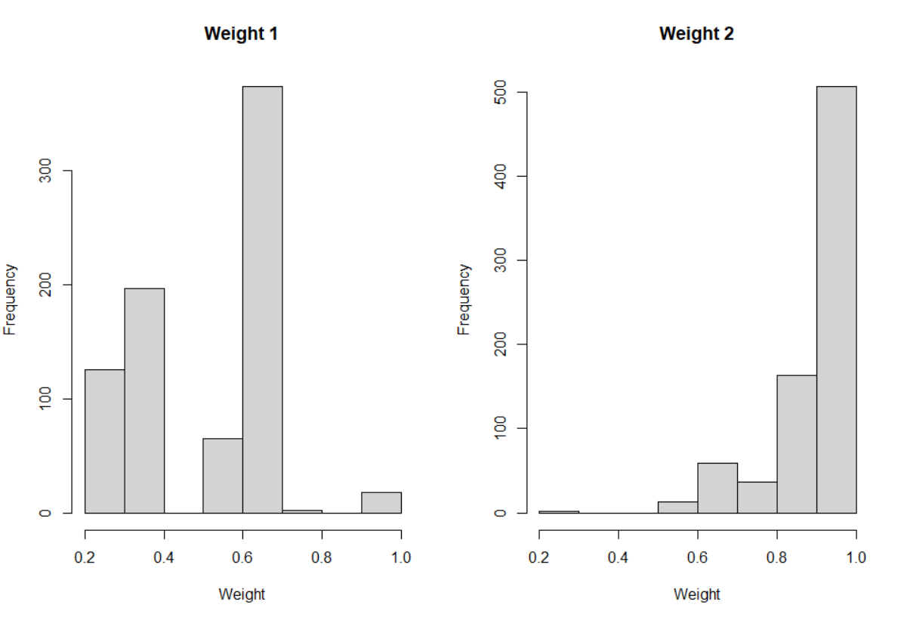
SI Figure 1.2: Bootstrapping Sensitivity Test Results
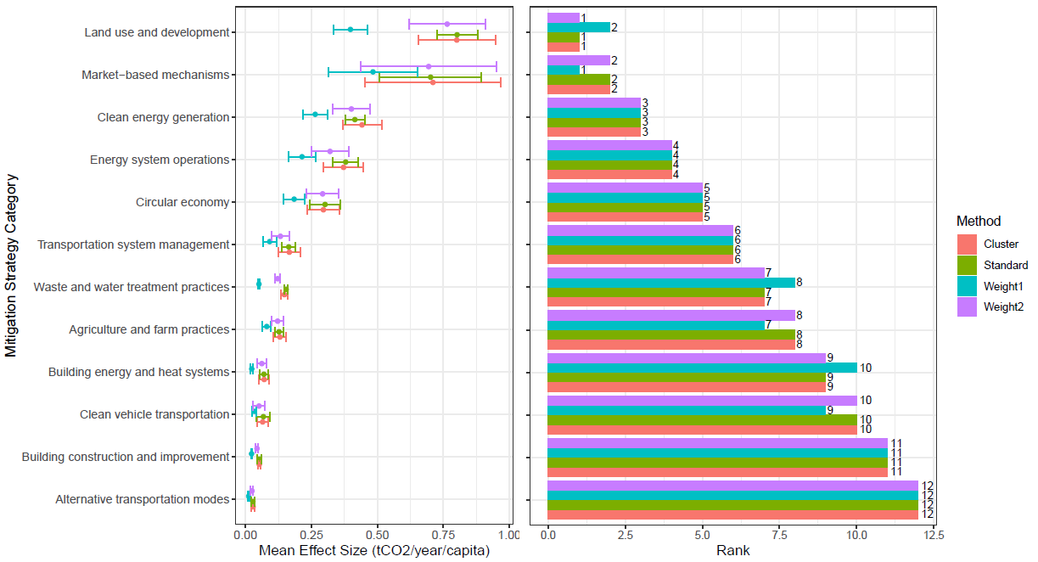

2. Discussion: Fixed-Effects Regression Analysis
The results of the bootstrapping analysis indicate that there is considerable variation in the certainty of expected emissions reductions by category. To investigate how different factors contributed to within-category variation in impacts, we estimated a regression model with category fixed effects and standard errors clustered at the study level on the synthesis dataset³. We considered 7 model specifications using variables related to the subnational context (global region, global south classification, subnational type, population) and the study design (methodology, ex post vs. ex-ante, number of years impact was projected into the future). We identified relevant independent variables following similar meta-analyses that have employed regression analysis to explore mediating factors^{3–6}. While most independent variables were based on data that we extracted from the articles, we also collected data on country-level sectoral emissions from two sources: the World Emissions Clock for 2022 and ClimateWatch for 2019^{7,8}. These sources were chosen for the alignment of sector definitions with our analysis and availability of data across countries and sectors. Neither of the data sources covered our dataset entirely - the World Emissions Clock does not include waste sector emissions and Climate Watch was missing data for Taiwan and certain sectors in Rwanda. The intuition for including sectoral emissions was that some sectors have more emissions to reduce, so differences in the initial level of sectoral emissions within and between countries might be associated with emissions reductions impacts. While sectoral emissions at the subnational level is preferable, this data is not widely available. We chose country-level sectoral emissions as a proxy, assuming that sectoral emissions patterns of subnational actors would generally follow country-level patterns. We used country-level population data from the World Bank to estimate per-capita versions of the country-level sectoral emissions variables. and estimated models across all sectors and within each sector. Definitions of all independent variables used in the regressions are provided in SI Table 2.1 and the results across all sectors for seven model specifications are reported in SI Table 2.2.
The results indicate that only a few contextual and study design variables are associated with the size of reported emissions reductions within each strategy category. We find that per-capita country-level sectoral emissions were significantly and positively associated with emissions reductions in Models 5 and 7. This finding follows the intuition that higher impacts are expected in areas with higher existing levels of emissions, assuming that subnational emissions patterns generally follow country-level emissions patterns. Studies using energy modeling reported higher impacts compared to studies using emissions accounting. This result was statistically significant at the 90% confidence level or higher across all model specifications. Energy modeling was only applied to studies within seven categories - mostly building and electricity and heat sector studies - and was not used for any ex post studies. In the synthesis dataset, energy modeling appears to be used to analyze more extensive mitigation strategies, such as applying energy efficiency measures to all commercial buildings or implementing new district heating systems, which could explain why this methodology was associated with higher emissions impacts. In the last three model specifications, we included variables to capture relative sectoral emissions patterns within and between countries. In the two model specifications that accounted for per-capita country-sector emissions, emissions reduction impacts from mitigation strategies in Asia and the Pacific were significantly higher compared to impacts in North America. The significant results are likely capturing the relevance of other factors not explicitly included in these models. For example, the higher impacts associated with energy modeling studies appear to be related to the scale of implementation. Certain features of the subnational context (population, subnational type, Global South/North) and study design (years projected into future) were not related to the size of emissions reductions. The direction and size of the moderating effects of these variables may be sector-dependent, leading to null results across all sectors³. More data is needed to explore the variation in expected impacts and this would be a useful direction for future research. The results also show that ex ante studies reported slightly higher impacts compared to ex post studies in Models 1 and 2, although less than 5% of observations reported ex post impacts and the number of years the impact was projected into the future was not significant in any of the remaining model specifications. Across all models, there were no significant differences in emissions reduction by the size or type of the subnational actor or between actors located in the Global North and Global South.
SI Table 2.1: Fixed Effects Regression - Independent Variable Definitions
Variable Name | Symbol | Type | Description
Impact Type | impact_type | Categorical | Indicates if the reported emissions reduction impact was evaluating the results of a previously implemented intervention ("Achieved/Ex Post") or predicting the impacts of an intervention that has not been implemented ("Potential/Ex Ante"). The omitted category is "Achieved/Ex Post".
Years Projected | years_projected | Continuous | The number of years into the future that the impact was projected if the reported impact was a potential/ex ante impact. For achieved/ex ante impacts, this variable is equal to zero.
Subnational Size | subnational_size | Categorical | Indicates the size of the subnational actor based on population, grouped into four categories: "Small" (0-299,999), "Medium" (300,000-999,999), "Large" (1,000,000-9,999,999), and "Mega" (10,000,000+). The omitted category is "Large".
Subnational Type | subnational_context | Categorical | Indicates if the subnational actor is a city or municipal government ("City or Municipal Government") or regional government ("Regional Government"). The omitted category is "City or Regional Government"
Global Region | region_grp | Categorical | Indicates the broader global region where the subnational actor is located. Includes 5 regional categories that are based on the 8 global regions used in the ClimActor dataset: "Europe and Central Asia", "Asia and the Pacific", "Africa and the Middle East", "North America", "Latin America and the Caribbean". The omitted category is "North America".
Global South | global_south | Indicator | Indicates if the subnational actor is located in the Global South (1) or Global North (0), based on the definition established by The Finance Center for South-South Cooperation⁹.
Method Group | method_group | Categorical | Indicates the methodology used to estimate a given impact, grouped into four possible methodology types: "Emissions Accounting", "Energy modeling", "Life cycle assessment", and "Other". Emissions accounting refers to any studies that applied emissions factors to secondary data or described their methodology as "emissions accounting". Life cycle assessment includes any studies that specifically used the terms "life cycle assessment" or "LCA" in describing their methodology. Energy modeling includes studies that used specific energy modeling software or platforms or specifically referred to energy in their methodology, such as "energy simulation" or "energy optimization". Other includes methodologies that did not fit into the other three categories, such as field experiments, quasi-experimental methods, or non-energy simulation and modeling. The omitted category is "Emissions Accounting".
County-Level Sectoral Emissions: World Emissions Clock (Per-Capita) | weclock_pc | Continuous | Per-capita, sectoral emissions for the country where the subnational actor is located, based on World Emissions Clock data for 2022. Converted to per-capita using country-level population from the World Bank.
County-Level Sectoral Emissions: Climate Watch (Aggregate) | cw_mtco2e | Continuous | Aggregate sectoral emissions for the country where the subnational actor is located, based on Climate Watch data for 2019. Reported in million metric tonnes CO2 equivalent.
County-Level Sectoral Emissions: Climate Watch (Per-Capita) | cw_pc | Continuous | Per-capita, sectoral emissions for the country where the subnational actor is located, based on Climate Watch historical GHG emissions data for 2019. Converted to per-capita using country-level population from the World Bank.

SI Table 2.2: Fixed Effects Regression Results
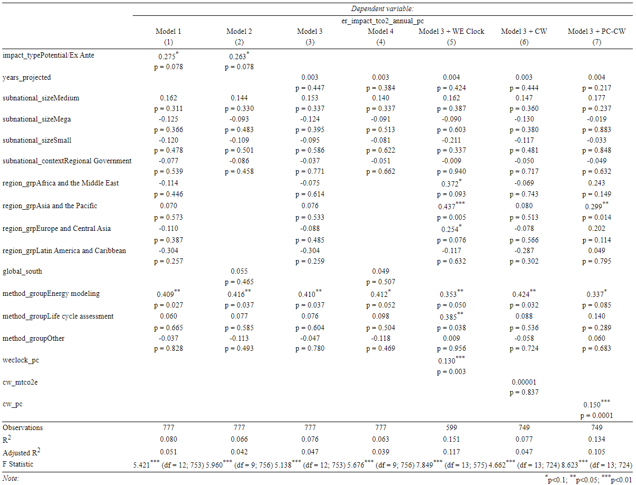

3. Tables: Policy Instruments

SI Table 3.1: Details on Implemented and Planned Policy Instruments by Sector and Instrument Type (n=134)
 | AFOLU | Buildings | Electricity and Heat | Industry | Transport | Waste | Cross-Sectoral
Direct Investment |  | • Upgrading energy systems in public buildings (2)  • Retrofit project for high-rise residential buildings (1) | • District cooling network (1)  • Adjustments to energy supply for municipal utility (1) | • Waste heat recovery in water treatment facility (1)  • Move water treatment energy supply to renewables (1) | • Public transportation infrastructure investments (7)  • Alternative transportation infrastructure investments (3)  • Bike sharing system (9)  • Fuel switching for public transport (6)  • Smart parking system (1) | • Waste management facility investments (6)  • Rainwater utilization improvements (2)  • Implement waste-to-energy system for wastewater treatment facility (1) | • Greening and installation of green infrastructure (4)
Economic Instruments |  | • Financial incentives for retrofitting and green building projects (4)  • Financial incentives for ground-source heat pumps (2) | • Subsidies for renewable energy (1) |  | • Parking pricing (2)  • Electric vehicle incentives (1) | • Pay-as-you-throw incentive program (1)  • Community waste prevention and recycling grants (1) | • Implement carbon tax (1)  • Increase carbon tax (1)  • Emissions trading scheme (8)
Information and Education |  |  |  |  | • Mobility information and tools (2)  • Marketing and awareness campaign (2)  • Idling reduction, right-sizing, and preventative maintenance for public vehicle fleet (1) | • Technical assistance outreach (1)  • Behavioral marketing campaign (1)
Policy Support |  | • Development of strategic plan and guidelines for GSHP implementation (1) | • Create a solar development roadmap (1) |  | • Service and accessibility improvements for public and alternative transport (4)  • Improved traffic management (1)  • Forum and office for stakeholder engagement (1) | • Strategic planning to encourage source-separated waste collection and recycling (2)  • Water efficiency program (1)  • Water distribution optimization (1)  • Support for composting (4)  • Improved waste collection services (3)  • Strategic planning to reduce landfilling (1) | • Strategic planning to align land use and emissions goals (1)  • Establish industrial symbiosis networks (3)  • Strategic planning to restrict vehicle access to certain areas (1)  • Strategic planning for goods distribution (1)
Regulatory Instruments | • Organic or integrated production requirement (1) | • Building codes and efficiency standards (5)  • Implementation ordinance requiring each district to initiate GSHP projects (1)  • Regulations for administering licenses to GSHP implementers (1)  • Ban on inefficient technologies (1) | • Restrict once-through cooling for electricity generators (1) |  | • Low carbon fuel standards (3)  • Vehicle efficiency standards (3)  • Local food procurement requirement (1) | • Requirements for the diversion of certain waste types from landfill (1)  • Ban on problematic packaging in stores and restaurants (1)  • Require landfill methane capture (1) | • Cap on emissions from oil and gas development (1)
Targets | • Forest carbon sequestration target (1) | • Green roof target (1) | • Renewable portfolio standards (2) |  | • Low carbon fuel target (1)  • Electric vehicle deployment target (2)  • VMT reduction target (1) | • Water conservation target (1) | • Tree planting target (1)
Voluntary Approaches |  |  |  |  | • Voluntary benefit scheme for improved vehicle goods delivery (1)

4. Tables: Online Methods
SI Table 4.1: Keyword Search Strings
Subnational Terms | Mitigation Terms
"subnational" OR "sub national" OR "non-state" OR "nonstate" OR "non state" OR "region*" OR "provinc*" OR "urban" OR "city" OR "cities" OR "local*" OR "prefecture" OR "county" OR "municipal*" OR "parish" OR "council" OR "state" OR "community" OR "town*" OR "village" OR "borough" OR "reservation" OR "territory" OR "district" OR "canton" OR "suburb*" OR "metropoli*" | "low carbon" OR "dicarboni*ation" OR ("emission*" OR "greenhouse gas*" OR "GHG" OR "climat*" OR "CO2*" OR "CH4" OR "N2O" OR "HFCs" OR "PFCs" OR "SF6" OR "NF33" OR "*carbon*" OR "methane" OR "air pollut*" OR "PM2.5" OR "particulate matter") W/3 ("policy" OR "program" OR "law" OR "target" OR "govern*" OR "regulat*" OR "legislation" OR "strategy" OR "instrument" OR "intervention" OR "approach" OR "action" OR "protocol" OR "code" OR "order" OR "rule" OR "scheme" OR "plan*" OR "case" OR "reduc*" OR "mitigation")

SI Table 4.2: Keywords Used in Automated Abstract Screening
Topical Terms | Positive Terms | Stop Terms | Broad Subnational Terms
"climate", "greenhouse", "gas", "ghg", "mitigat", "carbon", "CO2", "CO 2", "CH4", "CH 4", "methane","N20", "N 2 O", "N2 O", "energy", "electricity", “fossil", "fuel" | "emission(s){0,1}" , "avoid", "effective", "abate", "reduc", "quanti", "efficie", "impact" | "air pollut", "PM2.5", "meta-analysis", "literature review", "the proceedings contain(s){0,1}", "isotope", "meteorolog", "corrigendum", "erratum", "Correction", "bacteria", "oxid", "health" | "University", "Park", "LES", "^West$" , "^Western$", "^East$", "^Eastern$", "^North$", "^Northern$", "^South$", "^Southern$"

SI Table 4.3: Bigrams Used in Automated Abstract Screening
Bigram | Frequency
gas emissions | 1520
carbon emissions | 1454
co2 emissions | 1408
ghg emissions | 1181
energy efficiency | 898
carbon emission | 776
co2 emission | 570
ghg emission | 362
reduce greenhouse | 336
gas emission | 279
carbon reduction | 262
reduce carbon | 250
energy efficient | 228
reducing greenhouse | 210
reduce co2 | 205
climate impacts | 174
reducing carbon | 158
reduce ghg | 152
co2 reduction | 133
ghg reduction | 133
ch4 emissions | 127
reducing co2 | 127
reduce energy | 126
methane emissions | 121
emission mitigation | 102
reducing energy | 92
emissions mitigation | 80
gas reduction | 74
effective climate | 71
reducing ghg | 64
reduced carbon | 63
methane emission | 62
climate impact | 61
ch4 emission | 60
fuel efficiency | 52
gases emissions | 51
ghg reductions | 49
effective mitigation | 43
fuel emissions | 41
reduce climate | 41
reduce fuel | 37
reduced co2 | 37
greenhouse emissions | 36
emissions energy | 34
energy reduction | 32
effective energy | 31
efficient energy | 31
carbon abatement | 29
gas reductions | 29
ghgs emissions | 29
co2 reductions | 27
gaseous emissions | 27
gases emission | 24
reduced energy | 23
reduced greenhouse | 23
reduce fossil | 22
emissions climate | 21
emissions co2 | 21
emissions ghg | 21
reduces co2 | 21
reducing climate | 20
carbon efficiency | 18
carbon reductions | 18
fuel reduction | 18
reduces carbon | 17
co2e emissions | 16
energy emissions | 16
ghg abatement | 16
mitigate emissions | 16
reduces greenhouse | 16
effective carbon | 15
emissions fuel | 15
fuel efficient | 15
ghgs emission | 15
reduce methane | 15
reduce ghgs | 14
co2 abatement | 13
co2 avoided | 13
co2eq emissions | 13
efficiency energy | 13
emissions carbon | 13
reducing fuel | 13
avoided co2 | 11
emission ghg | 11
energy reducing | 11
ghg impacts | 11
reducing electricity | 11
reduction energy | 11
effectively mitigate | 10
energy efficiencies | 10
energy impact | 10
quantify carbon | 10
quantify climate | 10
reduced ghg | 10
carbon impacts | 9
effective co2 | 9
gas abatement | 9
greenhouse emission | 9
reduced ch4 | 9
reducing fossil | 9
carbon reducing | 8
efficient carbon | 8
efficient climate | 8
emissions ghgs | 8
hydrocarbon emissions | 8
impact climate | 8
reduce electricity | 8
reduce gas | 8
reduces ghg | 8
reducing ch4 | 8
carbon impact | 7
efficient mitigation | 7
energy emission | 7
quantifying carbon | 7
reduced fuel | 7
avoid climate | 6
avoided ghg | 6
co2e emission | 6
emissions electricity | 6
emissions greenhouse | 6
energy impacts | 6
energy reductions | 6
fuels reduction | 6
gas efficiency | 6
mitigate impacts | 6
reducing methane | 6
carbon efficient | 5
efficiency carbon | 5
emission climate | 5
emission energy | 5
emissions ghge | 5
ffco2 emissions | 5
gas emissionsÃ£ | 5
gas impacts | 5
gases reduction | 5
ghg impact | 5
quantify co2 | 5
reduced electricity | 5
reduces fuel | 5
avoided greenhouse | 4
climate emissions | 4
co2 impact | 4
co2 photoreduction | 4
co2 reduced | 4
efficiency fuel | 4
electricity emissions | 4
emission electricity | 4
emission fuel | 4
emissions ch4 | 4
energy inefficient | 4
energy reduce | 4
ffco2 emission | 4
fuel emission | 4
gaseous emission | 4
ghgs reduction | 4
halocarbon emissions | 4
impact mitigation | 4
impacts climate | 4
impacts energy | 4
methane reduction | 4
mitigation impact | 4
quantify methane | 4
quantifying climate | 4
reduce ch4 | 4
reduce co2e | 4
reduced climate | 4
reduced methane | 4
reducing gas | 4
reduction climate | 4
reduction mitigation | 4
avoided fossil | 3
avoiding climate | 3
carbon emissionsÃ£ | 3
ch4 reduction | 3
climate effectiveness | 3
climate reduced | 3
co2 emissionsÃ£ | 3
co2 impacts | 3
co2e reduction | 3
effective greenhouse | 3
effectively mitigated | 3
electricity efficiency | 3
emission fossil | 3
energy inefficiency | 3
energy reduced | 3
fossil emissions | 3
gasses emissions | 3
ghg reducing | 3
greenhouse reduction | 3
impact carbon | 3
impacts carbon | 3
impacts mitigation | 3
mitigate emission | 3
mitigating emissions | 3
mitigation effectiveness | 3
mitigation impacts | 3
quantified carbon | 3
quantified climate | 3
quantifies greenhouse | 3
quantify energy | 3
quantify ghg | 3
quantify greenhouse | 3
quantifying ghg | 3
reduces energy | 3
reducing ghgs | 3
reduction fuel | 3
abate climate | 2
abate co2 | 2
avoid carbon | 2
avoid ghg | 2
avoid greenhouse | 2
avoidable co2 | 2
avoidable greenhouse | 2
avoided carbon | 2
avoided climate | 2
avoiding methane | 2
biogas emissions | 2
biogas reducing | 2
carbon effectiveness | 2
carbon reduces | 2
carbonyl emissions | 2
carbonyl reductase | 2
climate effective | 2
climate impacted | 2
climate reducing | 2
climate reduction | 2
co2 electroreduction | 2
co2 reduces | 2
co2 reducing | 2
co2emission reduction | 2
effective fuel | 2
effective ghg | 2
effectively co2 | 2
efficiency electricity | 2
efficiency greenhouse | 2
efficiency mitigation | 2
efficient co2 | 2
efficient gas | 2
efficient ghg | 2
electricity emission | 2
emission co2 | 2
emission fuels | 2
emission mitigations | 2
emissions ffco2 | 2
emissions lcco2 | 2
emissions methane | 2
energy effectiveness | 2
energy efficiently | 2
energy quantity | 2
fuel inefficient | 2
ghg efficiency | 2
ghg efficient | 2
ghg emissionsÃ£ | 2
greenhouse abatement | 2
hydrofluorocarbon emissions | 2
impact decarbonization | 2
impact energy | 2
impact fuel | 2
impacting carbon | 2
impacting energy | 2
impacts greenhouse | 2
inefficient fossil | 2
lcco2 reduction | 2
mitigated emissions | 2
mitigating impacts | 2
mitigation emission | 2
mitigation quantitative | 2
quantify fuel | 2
quantifying co2 | 2
quantitative carbon | 2
quantitative climate | 2
reduce co2emissions | 2
reduce co2eq | 2
reduce nonclimate | 2
reduced co2eq | 2
reduced fossil | 2
reduced gas | 2
reduced hydrocarbon | 2
reduces ch4 | 2
reducing co2emissions | 2
reducing gaseous | 2
reducing gasoline | 2
reduction carbon | 2
reduction co2 | 2
reduction ghg | 2
14co2 emissions | 1
abate greenhouse | 1
abatement climate | 1
aghg emission | 1
aghg emissions | 1
anthropogenic co2emissions | 1
avoid energy | 1
avoid fuel | 1
avoid gas | 1
avoided energy | 1
avoiding carbon | 1
avoiding energy | 1
avoiding fossil | 1
avoiding gas | 1
avoids carbon | 1
avoids co2 | 1
avoids ghg | 1
avoids greenhouse | 1
avoids methane | 1
bioenergy efficiency | 1
bioenergy impacted | 1
biofuels reduces | 1
biofuels reducing | 1
biogas effectively | 1
biogas emission | 1
carbon abated | 1
carbon emission.npv | 1
carbon emissions.despite | 1
carbon emissionsassociated | 1
carbon highefficiency | 1
carbon quantifications | 1
carbon quantity | 1
carbon reduce | 1
carbon reductive | 1
carbonate reduction | 1
carbonates impact | 1
carbonates reduces | 1
carbonation coefficient | 1
carbonation efficiency | 1
carbonation reduces | 1
carbone emissions | 1
carbonization efficiency | 1
ch4 impacts | 1
ch4 reductions | 1
ch4emission rate | 1
ch4emission reduction | 1
climate abatement | 1
climate efficient | 1
climate emission | 1
climate impactsÃ£ | 1
climate quantification | 1
climate quantifying | 1
climate quantitatively | 1
climate quantities | 1
climate reduce | 1
climate reductionism | 1
climate reductions | 1
climatechange impacts | 1
climates impacts | 1
co2 abatements | 1
co2 avoidance | 1
co2 efficiency | 1
co2 efficiently | 1
co2 emissioncoefficient | 1
co2 emissionsto | 1
co2 inefficiency | 1
co2 reduce | 1
co2 reductive | 1
co2capture efficiency | 1
co2emissions 77 | 1
co2emissions compared | 1
co2emissions generated | 1
co2emissions intensity | 1
co2emissions peak | 1
co2emissions ranged | 1
co2emissions rate | 1
co2equivalent emissions | 1
co:ch4 emission | 1
coefficient carbonation | 1
coefficients energy | 1
coemissions mitigation | 1
created co2emissions | 1
decarbonization emission | 1
degassing emissions | 1
dicarbonyl reductase | 1
eco2 reductions | 1
effective ch4 | 1
effective decarbonisation | 1
effective degasification | 1
effective electricity | 1
effective gas | 1
effectively greenhouse | 1
effectively mitigating | 1
efficiencies fuel | 1
efficiency co2 | 1
efficiency ghg | 1
efficiency methane | 1
efficient decarbonisation | 1
efficient electricity | 1
efficient gasoline | 1
efficient greenhouse | 1
efficient methane | 1
efficient syngas | 1
efficiently decarbonised | 1
electricity reduce | 1
electricity reduced | 1
electricity reduces | 1
emission 449ggco2eq | 1
emission bioenergy | 1
emission carbon | 1
emission ch4 | 1
emission co2e | 1
emission ffco2 | 1
emission gases | 1
emission ghgs | 1
emission greenhouse | 1
emissions co2e | 1
emissions fossil | 1
emissions fuels | 1
emissions gas | 1
emissions gaseous | 1
emissions gasification | 1
emissions gasoline | 1
emissions mitigate | 1
emissions mitigations | 1
emissions monochlorodifluoromethane | 1
emissions tonco2eq | 1
emissions.implications methane | 1
energy avoid | 1
energy avoids | 1
energy coefficient | 1
energy coefficients | 1
energy effectively | 1
energy efficiency.members | 1
energy quantification | 1
energy reduces | 1
energy sefficiency | 1
energy's impact | 1
estimated ch4emission | 1
fuel efficiencies | 1
fuel quantities | 1
fuel reductions | 1
fuels emissions | 1
fuels reduce | 1
gas avoidance | 1
gas avoiding | 1
gas emissions.the | 1
gas emissions.these | 1
gas emissions.Ã£ | 1
gas emissions1 | 1
gas impact | 1
gas quantities | 1
gas reduces | 1
gas reducing | 1
gasco emissions | 1
gasemissions similarly | 1
gases reductions | 1
gasoline effectively | 1
gasoline emissions | 1
ghg abated | 1
ghg abatements | 1
ghg avoidance | 1
ghg avoidances | 1
ghg emissions.comprehensive | 1
ghg emissions.in | 1
ghg emissions.we | 1
ghg emissionÃ£ | 1
ghg quantification | 1
ghg's emission | 1
ghge reduction | 1
ghgs abatement | 1
ghgs reducing | 1
ghgs reductions | 1
greenhouse gasemissions | 1
greenhousegas emissions | 1
hydrocarbon reduction | 1
hydrocarbons emissions | 1
hydrocarbons reduced | 1
hydroclimate impacts | 1
impact chlorofluorocarbons | 1
impact climates | 1
impact co2 | 1
impact electricity | 1
impact gas | 1
impact hydrocarbon | 1
impacted climate | 1
impacted gasoline | 1
impacting electricity | 1
impacts biogas | 1
impacts co2 | 1
impacts electricity | 1
incarbon emissions | 1
increased co2emission | 1
indirect co2emissions | 1
industrial co2emissions | 1
ineffective energy | 1
inefficiency co2 | 1
inefficient climate | 1
inefficient co2 | 1
inefficient electricity | 1
inefficient energy | 1
inefficient fuel | 1
level ch4emission | 1
lineco2 emissions | 1
market.ghg emissions | 1
medium ch4emissions | 1
meeting co2emission | 1
methane avoidance | 1
methane emissions.implications | 1
methane reduce | 1
methane reducing | 1
methane reductions | 1
microclimate coefficient | 1
mitigates emissions | 1
mitigating efficiencies | 1
mitigation coefficients | 1
mitigation quantifying | 1
mitigation reduction | 1
mtch4 emissions | 1
onenergy efficiency | 1
pco2 reduced | 1
photoreduction co2 | 1
predictions co2emissions | 1
quantifiable ghg | 1
quantifiable greenhouse | 1
quantification climate | 1
quantified decarbonization | 1
quantified degassing | 1
quantified electricity | 1
quantified ffco2 | 1
quantified fuel | 1
quantified ghg | 1
quantified mitigation | 1
quantifies fossil | 1
quantifies fuel | 1
quantifies ghg | 1
quantify fossil | 1
quantify gas | 1
quantify ghgs | 1
quantify microclimate | 1
quantify mitigation | 1
quantifying ch4 | 1
quantifying greenhouse | 1
quantitative energy | 1
quantitative fuel | 1
quantitative greenhouse | 1
quantitative palaeoclimate | 1
quantity energy | 1
quantity greenhouse | 1
reduce biofuels | 1
reduce carbone | 1
reduce decarbonization | 1
reduce fuels | 1
reduce gaseous | 1
reduce gasoline | 1
reduce ghg's | 1
reduce ghge | 1
reduced carbonate | 1
reduced carbonic | 1
reduced carbonyl | 1
reduced co2e | 1
reduced gaseous | 1
reduced gasifier | 1
reduced gasoline | 1
reduced mitigation | 1
reducegreenhouse gas | 1
reduces electricity | 1
reduces ghgs | 1
reduces mitigation | 1
reducing biofuel | 1
reducing co2eq | 1
reducing fuels | 1
reducing gases | 1
reducing ghge | 1
reducing greenhousegas | 1
reduct ghg | 1
reduction co2rr | 1
reduction ebghg | 1
reduction gases | 1
reduction greenhouse | 1
reduction hydrocarbons | 1
reduction incarbon | 1
reduction tco2e | 1
reductions carbon | 1
reductions energy | 1
reductions mitigation | 1
reductive carbon | 1
refueling emission | 1
refueling emissions | 1
regardingco2 emissions | 1
revolution co2emissions | 1
russia's co2emissions | 1
tco2 emissions | 1
tco2 reduction | 1
tco2e avoided | 1
tco2e emission | 1
tco2e emissions | 1
tco2e reduced | 1
tons co2emissions | 1
transport co2emissions | 1
unabated climate | 1
unabated fossil | 1
unabated gas | 1
unavoidable carbon | 1
unavoidable climate | 1
used.ghg emission | 1
Ã«Å“carbon reduction | 1
Ã«Å“energy efficiency | 1

SI Table 4.4: Variables Collected in Data Extraction
Variable Description | Variable Name
What is the emissions reduction impact? | emissions_reduction_impact
What units are the emissions reduction impacts reported in? | units
What is the time frame of the impact in years? | impact_time_frame
What time period do these impacts apply to? | impact_time_period
Does the article provide any error metrics associated with this impact? | any_error_metrics
What PDF page was the impact reported on? | impact_page
Please provide a short description of the climate change mitigation strategy (intervention) associated with this impact. | intervention
Please select the climate mitigation strategy category of this intervention. | mitigation_strategy_cat
Please select the sector that this intervention applies to. | sector
Provide a general description of the subject of the study. | study_subject_general
Provide a detailed description of the subject of the study. | study_subject_detail
If applicable, what kind of study subject is provided in the study? | study_subject_type
If applicable, what is the value of the study subject provided? | study_subject_value
If applicable, what is the unit of the study subject provided? | study_subject_units
Does the intervention apply to the entire subnational area or population? | subnational_wide
Does the impact measure results of an intervention that has already occurred (achieved) or project the impact if the intervention took place in the future (potential)? | impact_type
Please describe the methodology that the authors used to evaluate impacts in the study. | methodology
If applicable, please list the specific model or software that the authors used in the study. | model
Does the article mention that they used emissions factors to calculate emissions impacts? | emissions_factors
If you answered “Yes” to I15, what PDF page were the emissions factors mentioned on? | emissions_factors_page
Did the study use a survey to estimate impacts? | survey
If the study used a survey, how many individuals were surveyed? | survey_respondents
What changes to emissions are included in the emissions impact? | impact_components
Do the impacts apply to a city or regional government? | subnational_context
Please list the name of the subnational actor. | subnational_name
Please list the country of the subnational actor. | subnational_country
Please list the page where the subnational actor was reported. | subnational_page
Does the article mention that this intervention is part of a specific government action or policy? | gov_action_or_policy
If applicable, please provide a short description of how the intervention relates to a specific government action or policy | policy_note
If applicable, provide the page number for where the article mentioned the government action or policy. | policy_page

Table 4.5: Mitigation Strategies Definitions
 | Mitigation Strategy | Definition
1 | Afforestation, greening | Establishing or plantings trees in an area where there were previously no trees, increasing vegetation, preventing deforestation
2 | Agricultural land management | Improvements to agricultural practices and land management to reduce greenhouse gas emissions and/or improve soil carbon sequestration.  Ex. Reducing tillage, changing fertilizer, extending harvest rotation.
3 | Biomass, biodiesel, biomass gasification, ethanol production | Activities related to the cultivation and harvest of biomass and the production of biofuels.  Note that this excludes the use of biomass, biofuels for energy production, which could be included under “Other Renewable Energy” if applied to the electricity and heat sector or “Waste to Energy, Energy From Waste” if applied to the waste sector.
4 | Circular economy, industrial symbiosis, use of recycled materials | Efforts to keep materials and products in use for as long as possible, use of by-products or waste of one process as the raw inputs of another process, use of recycled materials in production processes or services
5 | Cogeneration, combined heat and power, tri-generation, combined heat, cooling, and power | Energy systems that produce both electricity and thermal energy for heating and/or cooling (cogeneration, combined heat and power (CHP)), energy systems that produce electricity, thermal energy, and chilled water for AC or refrigeration (trigeneration, combined cooling heat and power (CCHP))
6 | Composting and biological treatment of waste | Natural process of recycling organic matter to produce fertilizer, using biological treatments such as bacteria or other small organisms to break down organic waste
7 | Cool roof/facade, roof garden, green roof | Designing roofs and building facades to be more reflective and absorb less solar energy, thus reducing cooling energy loads, planting vegetation on roofs
8 | Demand side energy management, optimization, peak shifting/ shaving | Program and activities that encourage end-use energy customers to modify their level, pattern, and/or timing of energy consumption
9 | District heating/cooling, expansion | Systems that distribute thermal energy from a central generation location to a network of residential and/or commercial users for heating and/or cooling
10 | Electric Mobility (EV, HEV) | Use or adoption of vehicles that use electric motors for propulsion. Could include various levels of electrification (fully electric, hybrid) and various types of vehicles (light duty, heavy duty, bikes/scooters, commercial and farm vehicles, etc.)
11 | Emissions trading, cap-and-trade, carbon tax | Market-based approaches to reducing greenhouse gas emissions by providing economic incentives for reductions. Trading schemes set a limited number of permits for emissions and incentivize actors to either undertake mitigation actions or else pay for permits, while carbon taxes encourage actors to reduce their emissions to avoid a tax on emissions that occurred in the production or consumption of a good or service
12 | Energy efficiency measures | Installation or adoption of technologies that reduce the energy required to perform a task.  Ex. Installation of more energy efficient lighting such as LED light bulbs, improving building insulation, purchasing ENERGY STAR certified appliances and equipment, conducting air sealing to reduce air leakage, installing double or triple glazed windows, improved HVAC system efficiency
13 | Energy storage, batteries | Systems and technologies that capture energy produced at one time for use at a later time
14 | Energy system efficiencies | Improvements to the efficiency and management of energy systems  Ex. implementation of smart grid technologies, improvements to energy recovery in systems
15 | Fuel switching and fuel efficiency | Transition to lower-emitting fuels, such as compressed natural gas (CNG), liquified natural gas (LNG), and liquified petroleum gas (LPG), improvements in a technology to use less fuel to complete the same amount of work
16 | Geothermal heat pumps, ground source heat pump | Highly efficient technologies that utilizes natural ground heat for space heating, cooling, and water heating
17 | Green building, passive solar building design, net zero emission building, carbon neutral building | Buildings whose design, construction, and/or operation reduces or eliminates greenhouse gas emissions, buildings that are designed to collect, store, reflect and distribute solar energy (without the use of solar PV panels)
18 | Intelligent transportation system | Models, tools, frameworks, or systems that optimize transportation networks and traffic management or assist decision makers in choosing low-emissions options,  Examples: Traffic signal management to reduce emissions from stopping and idling, variable speed limits based on road conditions, tools that identify delivery routes with the lowest emissions
19 | Low-carbon energy generation | Changes to the energy system that reduce use of high-emitting generators and/or increase use of low-emissions, low carbon generators (including lower-carbon fuels, nuclear energy, efficiency and technology improvements, use of imports and exports)  Ex. Removing or reducing generation from fossil fuel plants, transitioning from oil to a lower-carbon fuel such as natural gas, increasing efficiency of plants (such as a combined cycle plant), installing emissions mitigation technologies
20 | Master planning, integrated planning, urban form, design, planning | Activities and regulations that modify the land use and/or design of a city in a way that reduces emissions.  Ex. Land redevelopment, zoning regulations, mixed land use development that combines multiple uses (industrial, commercial, residential, recreational) where functions are integrated
21 | Non-motorized transport | Forms of travel that do not rely on any energy or motor for movement, such as bicycles, skates, skateboards, and push scooters or activities that promote non-motorized transportation.
22 | Other renewable energy | Energy produced from sources that are naturally replenished. This category covers renewable energy not covered in other specific categories (Wind energy, Solar PV), such as biomass, geothermal energy, and hydropower, combinations of multiple renewable energy sources, activities that promote the adoption of renewable energy
23 | Parking management-expansion, park & ride | Strategies that improve parking systems in a way that reduces greenhouse gas emissions.  Ex. Park and ride systems encourage drivers to use public transportation for a portion of their trip.
24 | Public transport | Building new infrastructure for, increasing capacity of, or promoting the use of transportation systems and services that are available to the public, such as buses, light rail, trolleys, trains, and ferries.
25 | Retrofitting | Multiple modifications or additions to the technology and/or systems of existing buildings in order to improve energy efficiency or reduce energy demand.
26 | Ride sharing, carpooling | Activities that promote or enable shared car journeys so that more than one person travels in a single vehicle and the individuals do not need to take separate vehicles to reach the same destination,  Ex. ride sharing or car sharing services
27 | Smart meters, intelligent controls, thermostats, building information and monitoring systems | Implementation of digital energy technologies in buildings to optimize energy usage and improve building energy management
28 | Solar PV energy | Use of solar photovoltaic panels to convert solar energy to electricity
29 | Solar PV thermal, Solar PV cooling, Solar trigeneration CPVT | Use of solar photovoltaic panels to convert solar energy to usable thermal energy for heating and/or cooling, or hybrid systems that produce both thermal and electrical energy
30 | Transit oriented development | Type of urban development that maximizes the amount of residential, commercial, and recreational space within walking distance of public transportation
31 | Travel demand management | Strategies intended to reduce or modify private or commercial vehicle transportation.  Examples: Remote working/telecommuting, taxes on vehicle miles traveled, parking charges, modifications to distribution and delivery routes
32 | Urban agriculture | Practice of cultivating, processing, and distributing agricultural products in urban settings.
33 | Walkability & pedestrianization | Strategies that increase people’s ability to access essential services and amenities by foot, such as extending sidewalks or dedicating certain areas for pedestrians only
34 | Waste heat recovery | Systems that capture waste heat energy from processes and use it to fulfill another purpose or task
35 | Waste system management | Modifications to waste management processes  Ex. source or mechanical separation and sorting of waste to facilitate recycling and appropriate disposal, improvements to waste transfer and storage processes, promotion of waste reduction, changes to overall waste management practices such as landfilling, incineration, composting, recycling
36 | Waste to energy, energy from waste | Process of generating electric or thermal energy from waste, or processing waste into a fuel source
37 | Water and wastewater system efficiencies | Improvements to water and wastewater management systems to reduce energy usage or promote other efficiencies that could reduce greenhouse gas emissions
38 | Wind energy | Use of wind turbines to generate electricity

SI Table 4.6: Mitigation Categories by Sector and Strategy
Mitigation Strategy Category | Sector | Mitigation Strategy
Agriculture and farm practices | Agriculture, Forestry, and Other Land Use (AFOLU) | - Agricultural land management  - Biomass, biodiesel, biomass gasification, ethanol production  - Urban agriculture
Land use and development | Agriculture, Forestry, and Other Land Use (AFOLU) | - Afforestation, greening  - Master planning, integrated planning, urban form, design, planning  - Transit oriented development  - Walkability and pedestrianization
Building construction and improvement | Buildings | - Cool roof/facade, roof garden, green roof  - Demand side energy management, optimization  - Energy efficiency measures  - Green building, passive solar building design, net zero emission building, carbon neutral building  - Retrofitting
Building energy and heat systems | Buildings | - Cogeneration, combined heat and power, tri-generation, combined heat, cooling, and power  - District heating/cooling, expansion  - Energy storage, batteries  - Fuel switching and fuel efficiency  - Geothermal heat pumps, ground source heat pumps  - Other renewable energy  - Smart meters, intelligent controls, thermostat, building information and monitoring systems  - Solar PV energy  - Solar PV thermal, Solar PV cooling, Solar trigeneration CPVT
Clean energy generation | Electricity and heat | - Low-carbon energy generation  - Other renewable energy  - Solar PV energy  - Wind energy
Energy system operations | Electricity and heat | - Cogeneration, combined heat and power, tri-generation, combined heat, cooling, and power  - District heating/cooling, expansion  - Energy storage, batteries  - Energy system efficiencies
Circular economy, industrial symbiosis, use of recycled materials | Cross-Sectoral (Industry, Waste) | - Circular economy, industrial symbiosis, use of recycled materials
Emissions trading, cap-and-trade, carbon tax | Cross-Sectoral (Buildings, Electricity and heat, Industry) | - Emissions trading, cap-and-trade, carbon tax
Alternative transportation modes | Transport | - Non-motorized transport  - Public transport  - Ridesharing, carpooling
Clean vehicle transportation | Transport | - Electric Mobility (EV, HEV)  - Fuel switching and fuel efficiency
Transportation system management | Transport | - Intelligent transportation system  - Travel demand management  - Parking management-expansion, park and ride
Waste and water treatment practices | Waste | - Composting and biological treatment of waste  - Waste system management  - Waste to energy, energy from waste  - Water and wastewater system efficiencies
Industrial facility improvements | Industry | - Cogeneration, combined heat and power, tri-generation, combined heat, cooling, and power  - Electric Mobility (EV, HEV)  - Fuel switching and fuel efficiency  - Solar PV energy  - Other renewable energy  - Waste heat recovery

SI Table 4.7: Summary Statistics – Annualized Per-Capita Emissions Reductions
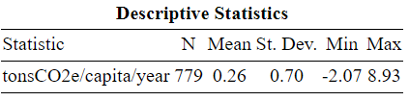

5. References for Supplementary Information

1. Deeks, J., Higgns, J. & Altman, D. Chapter 10: Analysing data and undertaking meta-analyses. (2022).
2. Buendia, E. et al. 2019 Refinement to the 2006 IPCC Guidelines for National Greenhouse Gas Inventories. (IPCC Task Force on National Greenhouse Gas Inventories, 2019).
3. Ivanova, D. et al. Quantifying the potential for climate change mitigation of consumption options. Environ. Res. Lett. 15, 093001 (2020).
4. Khanna, T. M. et al. A multi-country meta-analysis on the role of behavioural change in reducing energy consumption and CO2 emissions in residential buildings. Nat. Energy 6, 925–932 (2021).
5. Hoffmann, R., Dimitrova, A., Muttarak, R., Crespo Cuaresma, J. & Peisker, J. A meta-analysis of country-level studies on environmental change and migration. Nat. Clim. Change 10, 904–912 (2020).
6. Nisa, C. F., Bélanger, J. J., Schumpe, B. M. & Faller, D. G. Meta-analysis of randomised controlled trials testing behavioural interventions to promote household action on climate change. Nat. Commun. 10, 4545 (2019).
7. Historical GHG Emissions 2019. Climate Watch https://www.climatewatchdata.org/ghg-emissions (2022).
8. World Data Lab. World Emissions Clock. https://worldemissions.io/ (2022).
9. The Finance Center for South-South Cooperation. Global South Countries (Group of 77 and China) - Partnership Program. The Finance Center for South-South Cooperation: Organization in Special Consultive Status with ECOSOC of the United Nations http://www.fc-ssc.org/en/partnership_program/south_south_countries.

In R, the syntax “(X){0,1}” matches terms with and without “X”.
In R, the syntax “^X$” matches any terms beginning and ending with “X”.

